Telco Customer Churn
Predictive Modeling, Deployment Architecture, and Governance

Prepared by: Munmun
Date: August 2026
Dataset: IBM/Kaggle Telco Customer Churn

This document accompanies the analysis notebook (notebooks/telco_churn_analysis.ipynb) and the deployment blueprint (deployment/) delivered alongside it. It does not restate every step shown in the notebook -- it summarizes results, states the reasoning behind the choices made, and covers the deployment, governance, and monitoring design that sits outside the notebook itself.

Contents
Part I -- Analysis Write-Up
1. Executive Summary
2. Assumptions
3. Methodology Summary
4. Results
5. Model Selection and Recommendation
6. Model Interpretation -- Drivers of Churn
7. Post-Deployment Monitoring
8. Limitations and Next Steps
Part II -- Deployment Architecture and Governance Blueprint
9. Solution Architecture
10. MLOps Pipeline -- Retraining and Promotion
11. Serving Layer -- Managed Online Endpoint
12. AI Governance and Accountability
13. Immutable Prediction Logging
14. Continuous Improvement Strategy
15. Marketing Mix Model -- Applicability Assessment
16. Azure Platform Capabilities Referenced
17. Deliverable Manifest

Part I -- Analysis Write-Up

1. Executive Summary
This document evaluates whether Telco customer churn can be predicted from account and service data, which factors drive that risk, and how a model built for this purpose should be deployed, monitored, and governed once it is making or informing real retention decisions.
- Approach: three models were built and compared -- a Logistic Regression baseline, a Random Forest (bagging), and an XGBoost (boosting) model -- evaluated with threshold-independent metrics (ROC-AUC, PR-AUC) and a cost-sensitive threshold analysis, not accuracy alone.
- Result: all three models perform comparably (ROC-AUC 0.845-0.847); a bootstrap analysis confirmed the cost differences between them are not statistically distinguishable on this dataset. XGBoost is recommended for deployment on secondary grounds -- its native fit with the interaction effects found in EDA and with SHAP-based explainability at serving time -- not because it wins outright on a single metric.
- Drivers: contract type, tenure, internet service type, and the presence or absence of protective add-ons (tech support, online security) are the dominant churn drivers, confirmed independently through mutual information ranking and SHAP.
- Deployment: Part II of this document specifies how the recommended model would be deployed as a governed Azure ML service, including the MLOps retraining pipeline, an immutable audit-logging design for every prediction, and the guardrails needed before this model is allowed to influence an automated retention decision.

2. Assumptions
- The dataset is a single snapshot, not a longitudinal panel. Tenure at the time of the snapshot is used as a proxy for time-to-churn; the survival-curve analysis in the notebook should be read as directionally correct rather than a precise hazard estimate a true panel dataset would support.
- Cost figures used for threshold selection ($400 per missed churner, $50 per unnecessary retention offer) are illustrative, stated assumptions -- the dataset contains no acquisition-cost or campaign-cost fields. These should be replaced with Finance-provided figures before the recommended operating threshold is used in production.
- No marketing-spend or campaign data exists in this dataset. This directly affects the scope of Section 15 -- a Marketing Mix Model was considered and found not applicable to this dataset for that reason.
- "Development done locally" (per the assignment brief) is interpreted as executed in a local Python virtual environment with saved outputs, delivered as a notebook that can additionally be opened in a hosted notebook environment for ease of review.
- This dataset is a single cross-sectional snapshot with no defined observation/prediction/outcome window -- no field is generated after a churn decision (no leakage in that specific sense), but a production system would need that temporal structure explicitly, and would use a time-based train/test split rather than the random stratified split used here, once timestamped data exists. See the notebook's Section 1 leakage assessment for the full reasoning.

3. Methodology Summary
Full detail, code, and narrative justification for every step below is in notebooks/telco_churn_analysis.ipynb. This section summarizes what was done and why; it is not a substitute for the notebook.
- Data cleaning: the 11 blank TotalCharges values were identified as a structural zero (all have tenure = 0, i.e. day-one customers with no completed billing cycle) and set to 0.0, rather than imputed with a median or dropped. An IQR outlier scan on tenure, MonthlyCharges, and TotalCharges found no outliers -- explicitly checked, not assumed.
- EDA beyond the standard view: a Kaplan-Meier survival curve showed churn hazard is front-loaded in the first several months rather than uniform across tenure; a revenue-at-risk analysis found churned customers are, on average, higher-value than retained customers ($893/year vs. $735/year), not lower-value as might be assumed; a mutual-information ranking (not Pearson correlation, which is the wrong tool for nominal categories) identified Contract, OnlineSecurity, TechSupport, and InternetService as the strongest categorical predictors; and a bundling analysis showed churn declines close to monotonically with the number of add-on services held.
- Feature engineering: a service-count feature, an implied average-monthly-spend feature, and a tenure-bucket feature were derived, each justified against a specific EDA finding rather than added speculatively.
- Class imbalance: handled via class_weight/scale_pos_weight inside each estimator rather than synthetic oversampling -- with 1,869 real churn examples in the dataset, resampling was judged unnecessary and would add synthetic-data risk without a clear benefit.

4. Results
Threshold-independent performance on the held-out test set:
Model | ROC-AUC | PR-AUC | Precision@0.5 | Recall@0.5 | F1@0.5
Logistic Regression | 0.845 | 0.652 | 0.505 | 0.802 | 0.620
Random Forest | 0.846 | 0.662 | 0.527 | 0.797 | 0.634
XGBoost | 0.847 | 0.659 | 0.517 | 0.805 | 0.630

At the cost-minimizing threshold from the cost-sensitive analysis (illustrative cost assumptions: $400 false negative, $50 false positive):
Model | Threshold | Precision | Recall | F1 | Median Cost ($) | 95% CI ($)
Logistic Regression | 0.27 | 0.423 | 0.936 | 0.582 | 33,500 | 29,648 - 37,950
Random Forest | 0.22 | 0.389 | 0.960 | 0.554 | 34,200 | 30,998 - 37,650
XGBoost | 0.30 | 0.425 | 0.930 | 0.583 | 33,850 | 29,800 - 38,450

The bootstrapped 95% confidence intervals overlap substantially across all three models. That overlap is itself the key result of this table: there is no statistically defensible cost winner among the three models on this dataset and this cost assumption -- a conclusion that would have been missed by reporting the point estimates alone.
The cost-sensitive threshold assumes the retention team can act on every flagged customer. In practice, contact capacity is usually fixed, so the notebook (Section 9.4) also evaluates a capacity-constrained view: all three models capture close to 28% of actual churners within the top 10% of customers ranked by risk -- a lift of roughly 2.8x over random targeting. This is the number to hand to a team with a fixed weekly contact capacity; it is a distinct question from what the cost-sensitive threshold above answers.
Model output was also translated into a risk-tier scheme (Low / Medium / High / Critical), validated against observed test-set churn rate rather than left as an arbitrary label:
Tier | Customers | Observed Churn Rate
Low | 590 | 4.4%
Medium | 363 | 23.7%
High | 291 | 48.8%
Critical | 165 | 72.7%

Churn rate rises monotonically from Low to Critical, which is the check that matters -- a tier scheme where "Critical" customers do not actually churn more often than "Low" customers would be a broken segmentation regardless of how intuitive the cut points look. Note that even the Critical tier is 27.3% non-churners, which is why the recommended action for that tier (Section 6) is a retention offer, not a certainty-based action.
Finally, ranking customers by churn probability alone is not the same as ranking by revenue protected. Weighting each customer's probability by their projected annual value (probability x MonthlyCharges x 12) and comparing the resulting top 10 against the top 10 by raw probability found only 1 customer in common between the two lists -- a far larger divergence than intuition would suggest. For a capacity-constrained retention team, the value-weighted ranking is the more defensible prioritization metric, since it directly answers "where does intervention protect the most revenue" rather than only "who is statistically most likely to leave."

5. Model Selection and Recommendation
Recommendation: XGBoost, operated at its cost-minimizing threshold (0.30), with Logistic Regression and Random Forest retained as documented, statistically-tied alternatives.
Because the bootstrap analysis rules out choosing a winner on cost alone, the recommendation rests on criteria the point estimate cannot capture:
- Robustness to interaction effects. Churn risk in this data depends on combinations of features -- bundled services, fiber internet without protective add-ons -- not single variables in isolation. XGBoost and Random Forest capture these natively; Logistic Regression would need every such interaction hand-engineered to compete, adding maintenance burden as new interactions are discovered.
- Interpretability infrastructure fit. XGBoost pairs directly with SHAP's efficient tree explainer, fast enough to support the confidence-based human-review routing specified in the serving layer (Section 11). Random Forest shares this property but explains more slowly at comparable tree counts.
- Operational fit. XGBoost's training and scoring cost, and its compatibility with Azure ML managed online endpoints and the champion/challenger promotion gate (Section 10), make it a practical default for the retraining cadence in Section 14.
Logistic Regression is not discarded: it remains the standing baseline, the fastest model to retrain for a sanity check, and the most directly auditable model if a regulator or internal model-risk review needs a coefficient-level explanation rather than a SHAP approximation. This recommendation should be re-run once real Finance-provided cost figures replace the illustrative assumption in Section 4.

6. Model Interpretation -- Drivers of Churn
SHAP values on the recommended XGBoost model were used to decompose predictions into per-feature contributions -- this answers "what drives churn and in which direction," which a raw feature-importance ranking does not. The ranking independently agrees with the mutual-information ranking computed directly from the raw data in EDA, which is a useful cross-check rather than a coincidence.
- Contract type: month-to-month contracts push predictions toward churn; one- and two-year contracts push firmly the other way -- consistent with the survival curve showing hazard concentrated in early tenure, which month-to-month customers are exposed to every renewal cycle.
- Tenure: low tenure pushes toward churn, consistent with the survival analysis.
- Internet service and add-ons: fiber-optic customers without security or tech-support add-ons show materially elevated churn risk compared to DSL customers or fiber customers with those add-ons -- an interaction effect, not a standalone service effect.
- Payment method: electronic-check payment pushes toward churn, persisting across paperless-billing status -- read as a proxy for a less-engaged, more price-sensitive customer segment rather than a friction effect of paperless billing itself.
A SHAP summary plot is an analyst's view, not a retention agent's. The notebook (Section 11.1) also includes a small function that turns a single prediction into a decision card -- risk tier, the specific drivers behind that customer's score, and a recommended action tied to those drivers, not a generic one. The same logic is exposed interactively in a small prototype delivered alongside this analysis: app.py, a Streamlit application that lets a user enter a customer profile and see the prediction, risk tier, top SHAP drivers, and recommended action in real time, loading the exact model persisted by the notebook rather than retraining. It is a decision-support prototype, not the production serving surface -- the production equivalent of the same logic is deployment/score.py behind the managed online endpoint described in Part II. Setup and run instructions are in README.md.

7. Post-Deployment Monitoring
A model that scores well today degrades silently in production for two distinct reasons, each needing its own monitor:
- Data drift -- the distribution of incoming records diverges from training (a new pricing plan, a new payment provider). Tracked via Population Stability Index (PSI) per feature, computed daily (deployment/monitoring_job.yml) against the training-set reference distribution. A PSI above 0.2 on a top-ranked feature (Contract, tenure, InternetService, PaymentMethod) triggers investigation before it triggers a retrain.
- Concept drift -- the relationship between features and churn itself shifts (competitor pricing changes what "expensive" means to customers). PSI cannot detect this since input distributions can stay stable while the true relationship moves. Tracked via rolling 7/30-day recall and precision once true outcomes are observed and joined back to historical predictions, compared to the Section 4 baseline. A sustained drop, not a single noisy week, triggers retraining.
- Operational monitors -- prediction-volume and class-rate drift (often a pipeline issue before a model issue), endpoint latency and error rate, and feature-level null-rate monitoring (a silent upstream schema change would not be caught by PSI if imputation quietly absorbs it).
Retraining cadence: quarterly as a floor, with an unscheduled retrain triggered immediately by a PSI breach on a top-ranked feature or a sustained recall/precision drop -- whichever comes first. Every retrained candidate is evaluated against the current production model on the cost-sensitive metric before promotion (champion/challenger), never deployed automatically on training completion. Full implementation detail is in Part II.

8. Limitations and Next Steps
Limitations:
- Single-snapshot data limits how confidently the survival analysis generalizes; a true panel dataset with observed churn dates would support a full Cox proportional hazards model instead of a snapshot-based approximation.
- All three models cluster closely on every metric, including the bootstrapped cost estimate. The larger remaining lever is more likely additional features (support-ticket history, usage trend, competitor pricing exposure) than a different algorithm.
Next steps:
- Uplift modeling. Rather than only predicting who will churn, estimate the incremental effect of a specific retention action per customer (a T-learner or causal forest against historical campaign data, once such data exists). This is the correct tool for "where does retention spend move the needle" -- see Section 15 for why this supersedes a Marketing Mix Model for this use case.
- A/B test the recommended model's retention-targeting policy against the current process before full rollout, rather than deploying on offline metrics alone.
- Revisit the cost matrix in Section 4 with actual Finance-provided acquisition-cost and offer-cost figures, and rerun the bootstrap threshold analysis before committing to a production operating point.
- Extend monitoring with the governance and audit-logging design in Part II before this model is exposed to any automated retention decision.

Part II -- Deployment Architecture and Governance Blueprint
This part goes beyond what the assignment strictly requires, to show how the recommended model would actually be operated as a governed service on Azure -- the environment this role is centered on. Full, runnable configuration files referenced below are delivered in the deployment/ folder alongside this document; this section explains the design decisions behind them rather than reproducing every file in full.

9. Solution Architecture
The model is deployed as a scoring service behind a stable API, with training, serving, and governance kept as separate, independently scalable concerns rather than bundled into one pipeline.
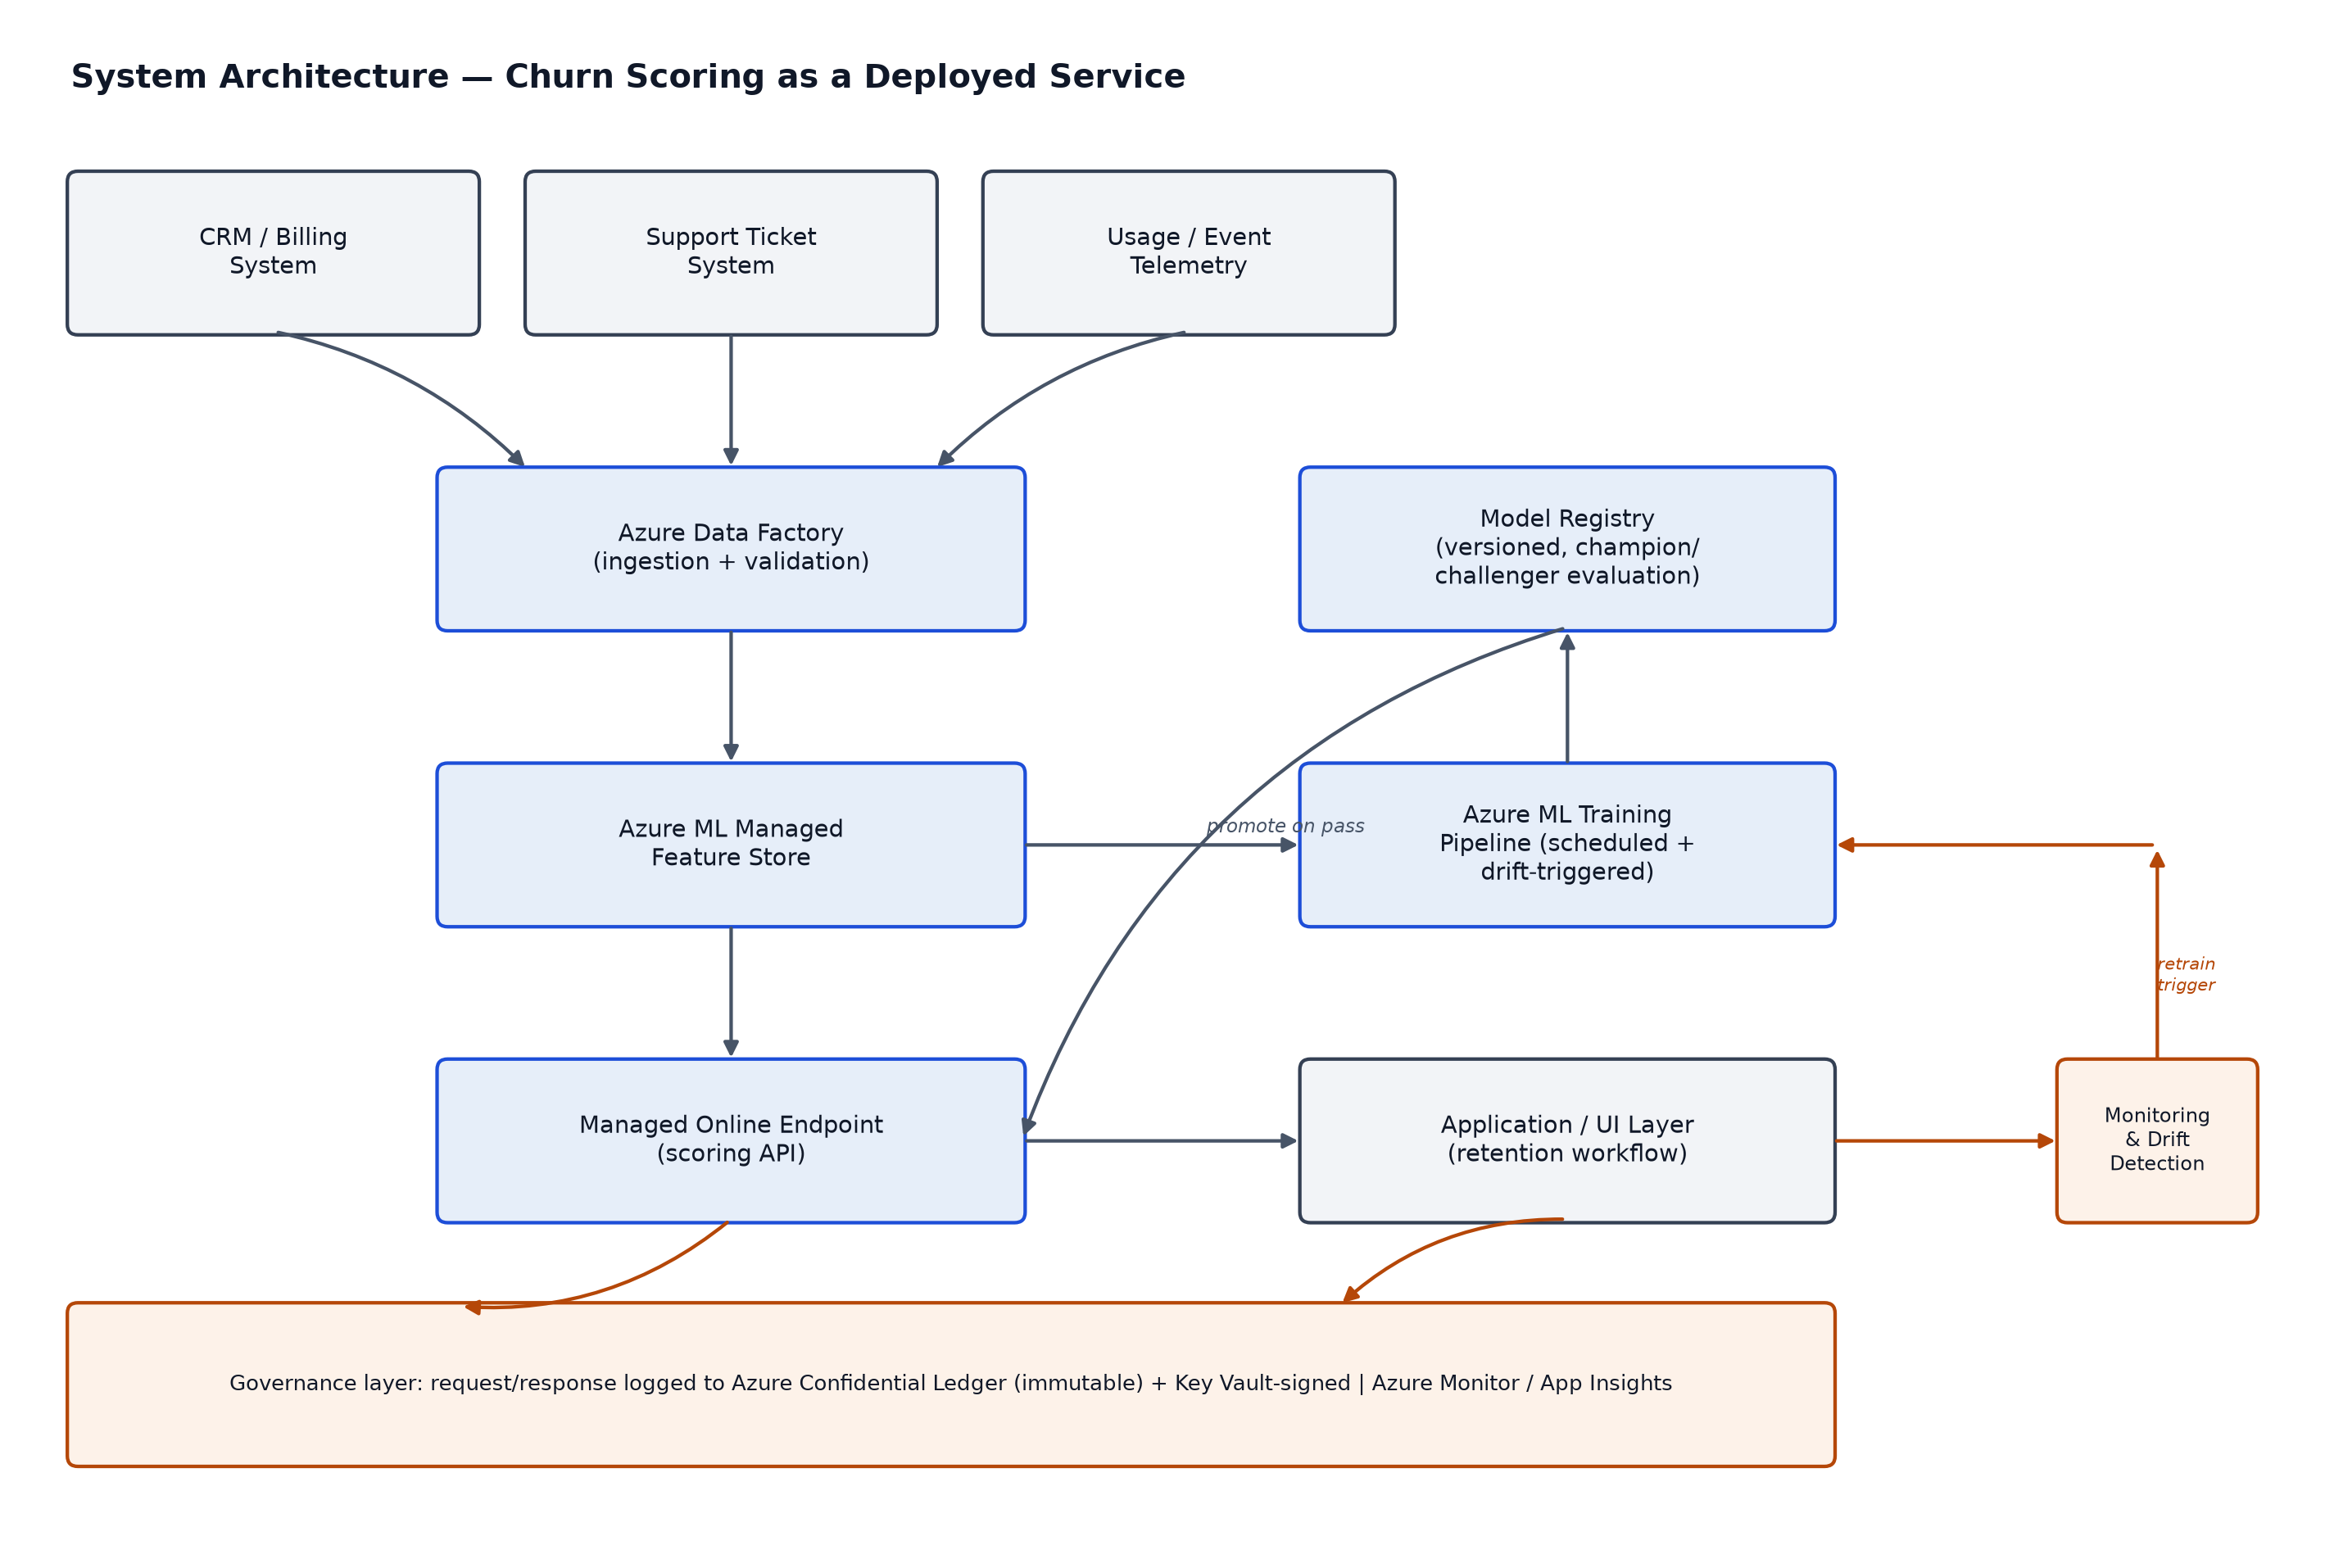
- Ingestion. Azure Data Factory pulls from CRM/billing, support tickets, and usage telemetry, validating schema before anything reaches the feature store -- the same validate-before-clean discipline used in the notebook's data audit, applied at the pipeline level.
- Feature store. Azure ML's managed feature store, so training and serving compute the same features from the same definitions -- the most common source of train/serve skew is a feature computed one way in a notebook and a subtly different way in the serving code, and a shared feature store removes that gap by construction.
- Training and registry. the training pipeline (Section 10) writes candidate models to the registry only after a champion/challenger comparison against the current production model; promotion to production is a separate, gated step.
- Serving. a managed online endpoint fronts the scoring API; the application/UI layer (the retention workflow) consumes predictions from it, never calling the model directly.
- Governance layer. every request/response pair is logged through the immutable-logging path (Section 13) before the response reaches the caller, and Azure Monitor / Application Insights feed the drift-detection job that can trigger an unscheduled retrain.

10. MLOps Pipeline -- Retraining and Promotion
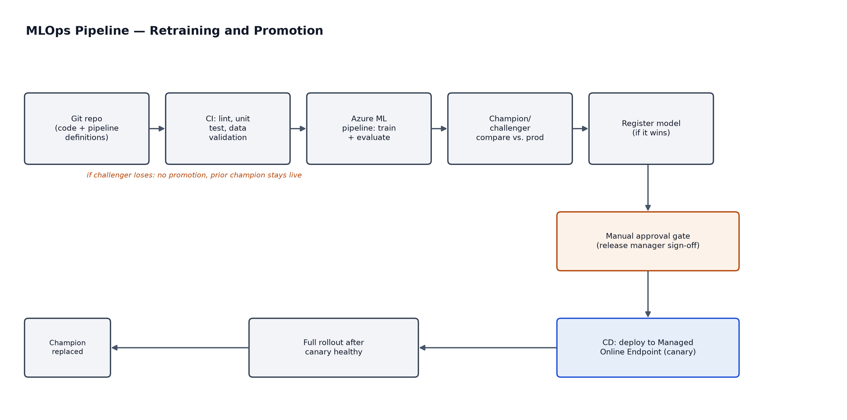
The pipeline is deliberately structured so a retrained model cannot reach production without passing two independent gates: an automated one (does it beat the current champion on the cost-sensitive metric) and a human one (does a release manager sign off). Automating the comparison and keeping the sign-off manual is a deliberate choice -- the comparison is objective and should not depend on a person remembering to run it, but promotion to production is a business risk decision that should not be fully automated.
Training pipeline (deployment/training_pipeline.yml) -- key structure:
jobs:
validate_data: ...
engineer_features: ... # writes to the managed feature store
train_candidate: ... # XGBoost, cost-aware evaluation
champion_challenger_compare: # compares vs. current production model
inputs:
challenger_model: ${{parent.jobs.train_candidate.outputs.model}}
production_model_name: telco-churn-xgboost
production_model_stage: production
outputs:
decision: ... # {"promote": true/false, "reason": "..."}
register_if_better: ... # only registers if decision.promote == true
schedule:
frequency: week
interval: 1
CI/CD pipeline (deployment/azure-pipelines.yml) -- stage sequence:
CI (lint, unit test, data validation)
-> TrainAndEvaluate (submits training_pipeline.yml)
-> ApprovalGate (Azure DevOps environment, required reviewers)
-> CanaryDeploy (10% traffic to the new model version)
-> HealthCheck (monitor error rate / latency for 30 minutes)
-> FullRollout (100% traffic, only if the canary is healthy)
The canary stage exists because the champion/challenger comparison in the training pipeline is evaluated on historical test data -- it cannot catch a production-only failure mode (a missing environment variable, a serving-time schema mismatch) that only shows up under real traffic. A canary at 10% traffic limits the blast radius of exactly that class of failure.

11. Serving Layer -- Managed Online Endpoint
The endpoint and its deployment are defined separately (deployment/managed_online_endpoint.yml and managed_online_deployment.yml) so the public-facing endpoint name and auth stay stable across model versions, while individual deployments underneath it carry the traffic split used for canary rollout.
The scoring entry script (deployment/score.py) does more than call predict() -- it is where the guardrails from Section 12 are actually enforced, not just described:
- Input validation before scoring. a malformed or out-of-range request (negative tenure, a missing required field) is rejected before it reaches the model, rather than producing an unpredictable prediction from bad input.
- Confidence-based review routing. predictions within a defined margin of the operating threshold are flagged needs_human_review, so the application layer can route borderline cases to a person instead of an automated action -- an explicit accountability guardrail, not just a UI nicety.
- Fail-closed audit logging. if the immutable-logging call in Section 13 fails, the request fails -- the service never returns a prediction it could not log. This is a deliberate choice: a brief scoring outage during a logging incident is judged preferable to a silent gap in the audit trail.
def _log_prediction_event(input_hash, prediction, probability):
event = {"input_hash": input_hash, "model_version": MODEL_VERSION,
"prediction": prediction, "probability": round(probability, 6),
"timestamp_utc": datetime.now(timezone.utc).isoformat()}
try:
append_to_ledger(event) # signed via Key Vault, written to
# Azure Confidential Ledger -- see Section 13
except Exception as exc:
raise RuntimeError(
"Prediction could not be recorded to the audit trail; "
"refusing to return an unlogged prediction"
) from exc

12. AI Governance and Accountability
A churn model that influences who receives a retention offer is a model risk, not just an analytics artifact, once it is deployed. The governance design below follows that framing.

Model risk management framework
- Every model version is documented with a model card: training data snapshot, features used, evaluation metrics, known limitations (Section 8), and the cost assumptions behind its operating threshold.
- No model reaches production without passing the pre-deployment validation gate: the champion/challenger comparison (Section 10) plus the bias and fairness check below.
- Every production promotion is signed off by a named release manager (the Azure DevOps approval-gate environment in Section 10), so a specific deployment can always be traced to a specific accountable person, not just a pipeline run.

Bias and fairness testing
This dataset includes SeniorCitizen and gender -- fields that require explicit disparate-impact testing before this model is allowed near a pricing or retention decision, not just a performance check. The recommended pre-deployment gate: compute recall, precision, and the predicted-positive rate separately for each SeniorCitizen and gender subgroup, and flag for review if any subgroup's predicted-positive rate differs by more than a defined tolerance (a standard disparate-impact check) from the overall population. If a gap is found, the response is not necessarily to drop the field outright -- SeniorCitizen in particular may carry genuine, non-discriminatory signal about service needs -- but the gap must be explained and documented before deployment, not discovered afterward from a complaint or an audit.

Guardrails
- Input schema validation at the API boundary (Section 11) -- malformed requests never reach the model.
- Confidence-based human review for predictions near the operating threshold, rather than fully automated action on every prediction regardless of certainty.
- Fail-closed behavior on both inference failure and audit-logging failure -- the system prefers no answer over an unaccountable one.
- Explainability on demand, not on every request: SHAP explanations are computed in the batch monitoring job and cached, with a separate, lower-traffic endpoint for a retention agent to pull an explanation for a specific disputed or reviewed customer, rather than adding explanation latency to every scoring call.

13. Immutable Prediction Logging
This is the direct answer to "how are model predictions and the decisions based on them logged so they cannot be altered after the fact." A normal application log can be edited or deleted by anything with write access, including automated processes -- which is a governance gap for a model that can influence a customer-facing decision. If a prediction is later disputed by a customer, a regulator, or an internal audit, there needs to be a record that provably was not altered afterward.
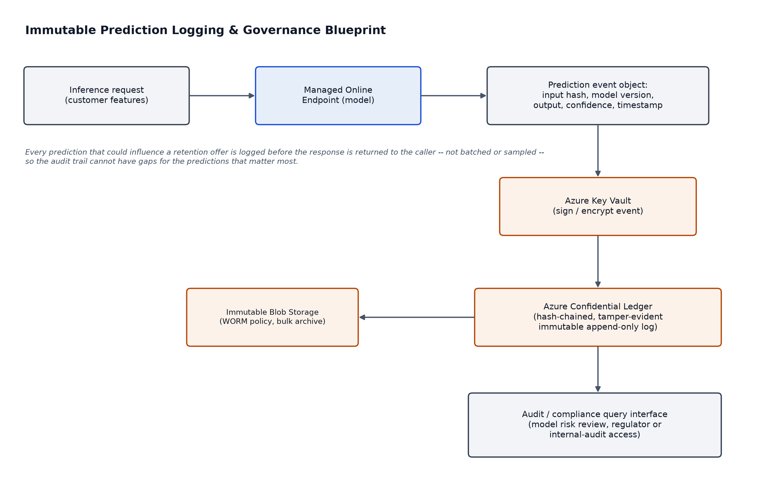
- Azure Confidential Ledger is the Azure-native service for this: entries are cryptographically hashed and chained, and the service runs inside hardware-backed confidential compute, so tampering is detectable rather than merely discouraged by access controls. This is the direct, real Azure equivalent of the "blockchain-type immutability" requirement -- a managed ledger service, not a custom-built blockchain, which is the appropriate scope for this.
- Azure Key Vault holds the signing key used to sign each prediction event before it is written, a separate permission boundary from the scoring service's own identity, so the signature cannot be forged by anything that only has scoring-service access.
- What is logged: a SHA-256 hash of the input (not the raw record, so the ledger does not become a second copy of customer PII needing its own retention policy), the model name and version, the prediction and probability, and a UTC timestamp. The raw input record itself is written separately to the scored-data store used for drift monitoring, under normal data-retention policy -- the ledger is the tamper-evident proof a prediction happened and what it was, not the system of record for customer data.
- Fail-closed: if the ledger write fails, the scoring request fails (Section 11) -- there is no code path that returns a prediction without also recording it.
Full design rationale: deployment/governance_logging.md. This specific design covers integrity and non-repudiation of the prediction record. It does not, on its own, cover bias/fairness testing (a separate pre-deployment gate, above) or the downstream retention action taken on a prediction -- that action should be logged by the application/UI layer with the same immutable pattern if the full decision chain is to be auditable end to end.

14. Continuous Improvement Strategy
How this model gets better over time, and where reinforcement learning genuinely fits versus where it does not:
- Champion/challenger retraining loop (Section 10) -- scheduled weekly plus drift-triggered, with every candidate evaluated against the live production model before promotion. This is the primary mechanism by which the model improves as new data accumulates.
- Active learning on low-confidence predictions -- the needs_human_review flag from score.py (Section 11) naturally produces a queue of the cases the model is least certain about. Prioritizing these for outcome review and labeling improves the training set specifically where the model is weakest, rather than labeling uniformly at random.
- Ground-truth feedback capture. actual churn outcomes are joined back to historical predictions to compute the rolling recall/precision used for concept-drift detection (Section 7) -- this feedback loop is what makes drift detection possible at all, not an optional add-on.
On reinforcement learning specifically, stated directly rather than implied: churn prediction is a supervised classification problem, and reinforcement learning is not the right tool for it -- there is no sequential decision process to optimize inside "will this customer churn." Where RL, specifically contextual bandits, genuinely does fit is one level downstream: once a customer is flagged at-risk, which retention offer to send is a repeated decision with observable reward (did the offer work), which is exactly the contextual-bandit setting. This is not built in this deliverable because the dataset contains no historical record of retention offers made or their outcomes -- there is nothing to learn a policy from yet. It is scoped here as the correct next step once that data starts to exist, not retrofitted onto the churn classifier where it does not belong.
On generative AI specifically, also worth stating directly: an LLM is not the right tool for the core prediction problem here either -- this is structured tabular classification, and XGBoost/Random Forest/Logistic Regression are the appropriate tools for it, not a language model. Where an LLM could add real value is a layer above the analytics, not inside it: taking the SHAP-driven decision card from Section 6 and the customer risk profile, and generating a natural-language summary and suggested talking points for a retention agent, via Azure AI Foundry sitting on top of the SHAP output rather than replacing it. That is a scoped future extension, not part of this deliverable.

15. Marketing Mix Model -- Applicability Assessment
Addressed directly rather than force-fitted: a Marketing Mix Model (MMM) was considered for this engagement and is not applicable to this dataset.
- What MMM needs: aggregated marketing spend by channel over time, regressed against a revenue or conversion KPI, typically at a weekly or monthly granularity across many campaign cycles.
- What this dataset has: customer-level, cross-sectional account and service data with no spend, channel, or campaign fields, and no time series at all -- a single snapshot. Building an MMM on it would not produce a fitted model with a fabricated result; it would produce a fabricated result presented as if it were fitted.
The applicable analogue for what MMM is generally used for -- "where does spend actually move the outcome" -- in a retention context is uplift modeling: estimating the incremental effect of a specific retention action on a specific customer, using a T-learner or causal forest trained against historical treatment/outcome data. This requires the same kind of data MMM would need (recorded retention actions and their outcomes), which does not yet exist for this dataset either. It is scoped as future work in Section 8 for the same reason RL-based offer selection is scoped as future work in Section 14 -- both are the correct tool for a question this specific dataset cannot yet answer, and both should be built once the underlying data exists rather than approximated now.

16. Azure Platform Capabilities Referenced
Capability | Role in this architecture
Azure ML Managed Feature Store | Shared feature definitions between training and serving, preventing train/serve skew
Azure ML Managed Online Endpoints | Serving layer with built-in canary/traffic-split support used for safe rollout
Azure ML Pipelines + Model Registry | Training, evaluation, and champion/challenger versioning
Azure Automated ML (AutoML) | Available as a faster baseline-search step inside the training pipeline for future feature sets; not required here since the three-model comparison already covers baseline, bagging, and boosting
Azure AI Foundry | Current unified Azure AI platform surface; relevant if this model is later composed with a generative or agentic retention workflow
Azure Confidential Ledger | Immutable, tamper-evident prediction audit trail (Section 13)
Azure Key Vault | Signing/encryption keys for audit events, held in a separate permission boundary from the scoring service
Azure Monitor / Application Insights | Operational monitoring feeding the drift-detection job and canary health checks
Azure DevOps Environments | Manual approval gate for production promotion (Section 10)

17. Deliverable Manifest
Path | Contents
notebooks/telco_churn_analysis.ipynb | Full executed analysis: EDA, feature engineering, 3 models, evaluation, lift/risk-segmentation, SHAP interpretation, monitoring plan
docs/Telco_Churn_Writeup_and_Architecture.docx | This document
README.md | Setup and run instructions for every deliverable in this repository
app.py | Streamlit decision-support prototype (Section 6)
src/churn_features.py | Shared cleaning/feature-engineering module used by app.py
models/churn_xgboost_pipeline.joblib, model_metadata.json | Persisted recommended model and its metadata, produced by the notebook
deployment/training_pipeline.yml | Azure ML CLI v2 training pipeline definition
deployment/managed_online_endpoint.yml, managed_online_deployment.yml | Serving endpoint and deployment definitions
deployment/score.py | Scoring entry script with guardrails and audit logging
deployment/scoring_env.yml | Pinned conda environment for the serving container
deployment/monitoring_job.yml | Scheduled drift/performance monitoring job
deployment/azure-pipelines.yml | CI/CD pipeline: CI, train/evaluate, approval gate, canary, full rollout
deployment/governance_logging.md | Immutable prediction logging design rationale
assets/*.png | Architecture, MLOps, and governance diagrams
requirements.txt | Pinned Python dependencies for local reproduction
data/WA_Fn-UseC_-Telco-Customer-Churn.csv | Source dataset

