COMPUTER INVESTIGATORY PROJECT

By: Dhruv Arya and Madhav Gupta

FLIGHT



ENQUIRY



SYSTEM

**SOURCE CODE:**

#include<fstream.h> // cin, cout and file related functions

#include<iostream.h>

#include<string.h> // strcmp, strcmpi, strcpy

#include<conio.h> // clrscr, getch

#include<stdlib.h>

#include<stdio.h>

// Flight Enquiry System

class flight

{

int fltno;

char from[25];

char to[25];

long fare;

public:

void input();

void output();

int getFltno();

char * getFrom();

char * getTo();

long getFare();

};

// User-Defined Functions

int login();

void menu();

void addNewFlight();

void modifyFlight();

void deleteFlight();

void displayFlights();

void search_flightno();

void search_source();

void search_dest();

void search_srcdest();

// Member functions of the class

void flight :: input()

{

cout << "\nEnter flight number: ";

cin >> fltno;

cout << "\nEnter source: ";

cin >> from;

strupr(from);

cout << "\nEnter destination: ";

cin >> to;

strupr(to);

cout << "\nEnter Fare (Rs): ";

cin >> fare;

}

void flight :: output()

{

cout << "\nFlight No: " << fltno;

cout << "\nSource: " << from;

cout << "\nDestination: " << to;

cout << "\nFare (Rs): " << fare << endl;

}

int flight :: getFltno()

{

return fltno;

}

char * flight :: getFrom()

{

return from;

}

char * flight :: getTo()

{

return to;

}

long flight :: getFare()

{

return fare;

}

int main()

{

if (login())

menu();

else

cout << "\nInvalid user.";

return 0;

}

int login()

{

char pwd[15], ch;

cout << "\nWelcome to Flight Enquiry System";

cout << "\n================================\n";

int total = 3;

for (int attempts = 1; attempts <= total; attempts++)

{

cout << "\n\nCaution! You have " << (total - attempts + 1) << " attempts left\n";

cout << "\nEnter password: ";

int i = 0;

while(1)

{

ch = getch();

cout << "*";

if (ch == '\r')

{

break;

}

pwd[i] = ch;

i++;

}

pwd[i] = '\0';

if (strcmp(pwd, "flight")==0)

return 1;

}

return 0;

}

void menu()

{

int choice;

do

{

system("cls");

cout << "* *\n";

cout << " * *\n";

cout << " ********\n";

cout << " * *\n";

cout << "* *\n";

cout << "\nWelcome to Flight Enquiry System";

cout << "\n================================\n";

cout << "\nMain Menu";

cout << "\n=========";

cout << "\n1. Add new flight";

cout << "\n2. Modify flight";

cout << "\n3. Delete flight";

cout << "\n4. Display all flights";

cout << "\n5. Search on flight number";

cout << "\n6. Search on source";

cout << "\n7. Search on destination";

cout << "\n8. Search on source and destination";

cout << "\n0. Exit";

cout << "\n\nEnter choice [0-8]: ";

cin >> choice;

switch(choice)

{

case 1: addNewFlight(); break;

case 2: modifyFlight(); break;

case 3: deleteFlight(); break;

case 4: displayFlights(); break;

case 5: search_flightno(); break;

case 6: search_source(); break;

case 7: search_dest(); break;

case 8: search_srcdest(); break;

case 0: break;

default: cout << "\n\nInvalid choice\n"; break;

}

} while (choice != 0);

}

void addNewFlight()

{

system("cls");

ofstream f ("flt.dat", ios::binary | ios::app);

if (!f)

{

cout << "\nFile not opened....... Press any key to continue\n";

getch();

return;

}

cout << "\nFlight Addition Screen";

cout << "\n======================\n";

flight t;

t.input();

char choice;

cout << "\nSave the record (y/n): ";

cin >> choice;

if (choice == 'y' || choice == 'Y')

{

f.write((char *)&t, sizeof(t));

cout << "\nRecord saved successfully";

}

f.close();

cout << "\nPress any key to continue...";

getch();

}

void modifyFlight()

{

system("cls");

ifstream f1 ("flt.dat", ios::binary);

ofstream f2 ("t.dat", ios::binary);

if (!f1 || !f2)

{

cout << "\nFile not opened....... Press any key to continue\n";

getch();

return;

}

cout << "\nFlight Modification Screen";

cout << "\n==========================\n";

flight t;

int fno, flag = 0;

cout << "\nEnter flight number to modify: ";

cin >> fno;

while (f1.read((char *)&t, sizeof(t)))

{

if (t.getFltno() == fno)

{

flag = 1;

t.output();

cout << "\n\nEnter new details: ";

t.input();

}

f2.write((char *)&t, sizeof(t));

}

f1.close();

f2.close();

if (flag == 0)

{

cout << "\nInvalid flight number";

}

else

{

char choice;

cout << "\nSave the record (y/n): ";

cin >> choice;

if (choice == 'y' || choice == 'Y')

{

remove("flt.dat");

rename("t.dat", "flt.dat");

cout << "\nRecord modified successfully";

}

}

cout << "\nPress any key to continue...";

getch();

}

void deleteFlight()

{

system("cls");

ifstream f1 ("flt.dat", ios::binary);

ofstream f2 ("t.dat", ios::binary);

if (!f1 || !f2)

{

cout << "\nFile not opened....... Press any key to continue\n";

getch();

return;

}

cout << "\nFlight Deletion Screen";

cout << "\n======================\n";

flight t;

int fno, flag = 0;

cout << "\nEnter flight number to delete: ";

cin >> fno;

while (f1.read((char *)&t, sizeof(t)))

{

if (t.getFltno() != fno)

{

f2.write((char *)&t, sizeof(t));

}

else

{

t.output();

flag = 1;

}

}

f1.close();

f2.close();

if (flag == 0)

{

cout << "\nInvalid flight number";

}

else

{

char choice;

cout << "\nSure to delete the record (y/n): ";

cin >> choice;

if (choice == 'y' || choice == 'Y')

{

remove("flt.dat");

rename("t.dat", "flt.dat");

cout << "\nRecord deleted successfully";

}

}

cout << "\nPress any key to continue...";

getch();

}

void displayFlights()

{

system("cls");

ifstream f ("flt.dat", ios::binary);

if (!f)

{

cout << "\nFile not opened....... Press any key to continue\n";

getch();

return;

}

flight t;

cout << "\nDetails of flights";

cout << "\n==================\n";

while (f.read((char *)&t, sizeof(t)))

{

t.output();

cout << "\n=====================================\n";

}

f.close();

cout << "\nPress any key to continue...";

getch();

}

void search_flightno()

{

system("cls");

ifstream f ("flt.dat", ios::binary);

if (!f)

{

cout << "\nFile not opened....... Press any key to continue\n";

getch();

return;

}

cout << "\nFlight Searching Screen";

cout << "\n=======================\n";

int fno, flag = 0;

cout << "\nEnter flight number to search: ";

cin >> fno;

flight t;

while (f.read((char *)&t, sizeof(t)))

{

if (t.getFltno() == fno)

{

flag = 1;

break;

}

}

if (flag == 1)

{

t.output();

cout << "\n=====================================\n";

}

else

{

cout << "\nInvalid flight number";

}

f.close();

cout << "\nPress any key to continue...";

getch();

}

void search_source()

{

system("cls");

ifstream f ("flt.dat", ios::binary);

if (!f)

{

cout << "\nFile not opened....... Press any key to continue\n";

getch();

return;

}

cout << "\nFlight Searching Screen";

cout << "\n=======================\n";

int flag = 0;

char src[25];

cout << "\nEnter source to search: ";

cin >> src;

flight t;

while (f.read((char *)&t, sizeof(t)))

{

if (strcmpi(t.getFrom(), src)==0)

{

flag = 1;

t.output();

cout << "\n=====================================\n";

}

}

if (flag == 0)

{

cout << "\nInvalid source";

}

f.close();

cout << "\nPress any key to continue...";

getch();

}

void search_dest()

{

system("cls");

ifstream f ("flt.dat", ios::binary);

if (!f)

{

cout << "\nFile not opened....... Press any key to continue\n";

getch();

return;

}

cout << "\nFlight Searching Screen";

cout << "\n=======================\n";

int flag = 0;

char dst[25];

cout << "\nEnter destination to search: ";

cin >> dst;

flight t;

while (f.read((char *)&t, sizeof(t)))

{

if (strcmpi(t.getTo(), dst)==0)

{

flag = 1;

t.output();

cout << "\n=====================================\n";

}

}

if (flag == 0)

{

cout << "\nInvalid destination";

}

f.close();

cout << "\nPress any key to continue...";

getch();

}

void search_srcdest()

{

system("cls");

ifstream f ("flt.dat", ios::binary);

if (!f)

{

cout << "\nFile not opened....... Press any key to continue\n";

getch();

return;

}

cout << "\nFlight Searching Screen";

cout << "\n=======================\n";

int flag = 0;

char src[25], dst[25];

cout << "\nEnter source to search: ";

cin >> src;

cout << "\nEnter destination to search: ";

cin >> dst;

flight t;

while (f.read((char *)&t, sizeof(t)))

{

if (strcmpi(t.getFrom(), src)==0 &&

strcmpi(t.getTo(), dst) == 0)

{

flag = 1;

t.output();

cout << "\n=====================================\n";

}

}

if (flag == 0)

{

cout << "\nInvalid source/destination";

}

f.close();

cout << "\nPress any key to continue...";

getch();

}

**OUTPUT:**

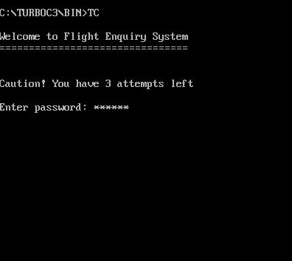

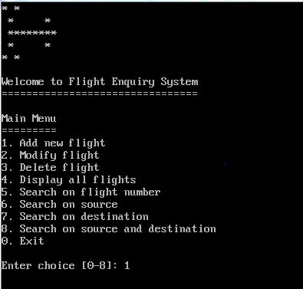

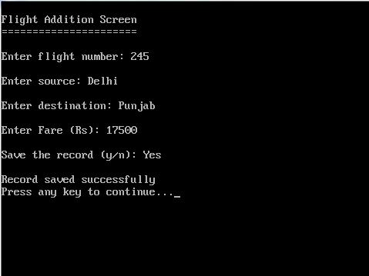

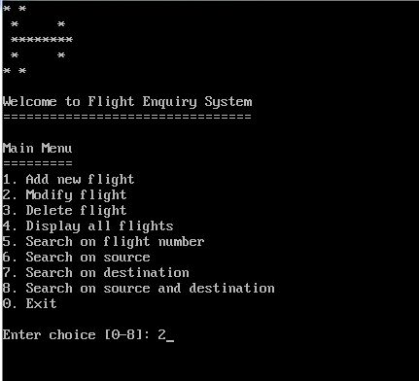

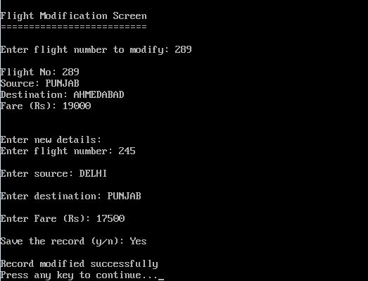

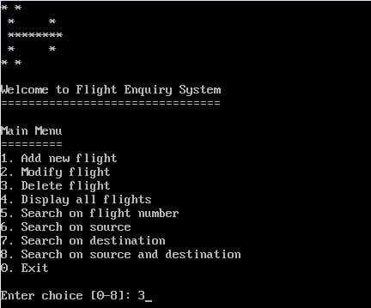

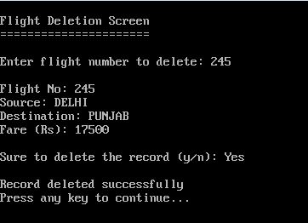

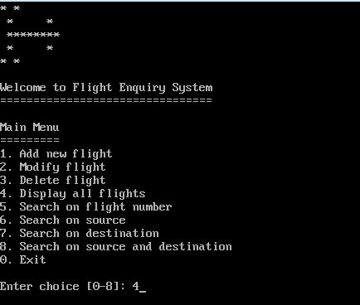

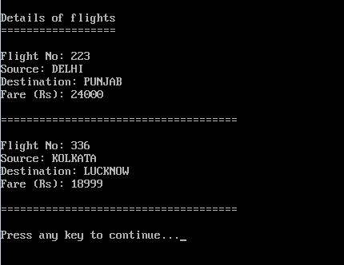

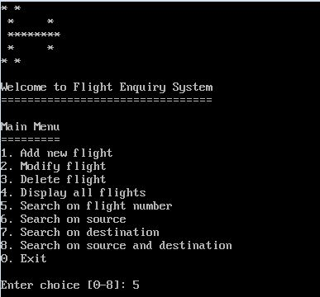

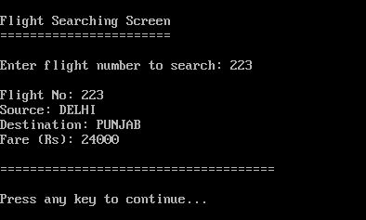

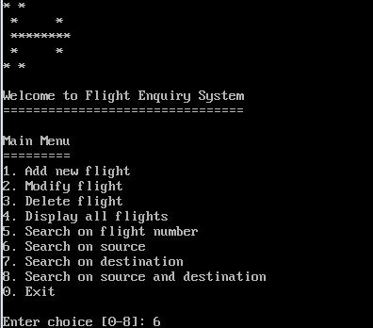

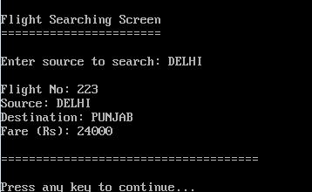

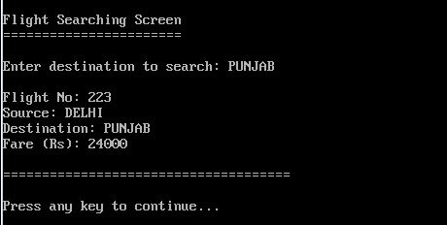

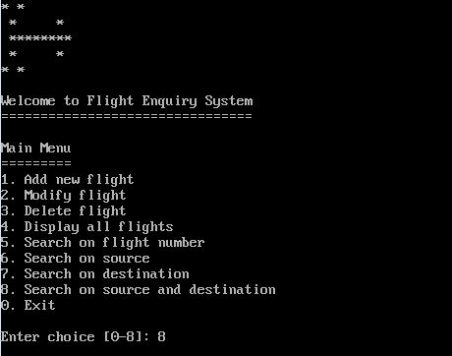

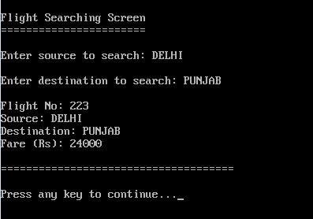

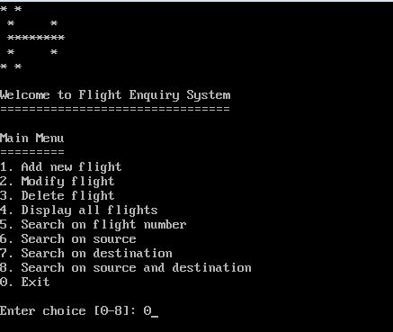

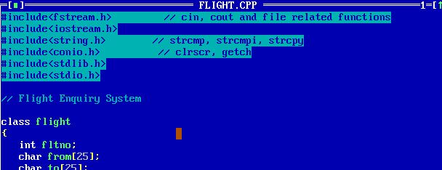

CERTIFICATE

This is to certify that _________ of Class XIIth Science A/B along with his research partner ________ has successfully completed the Computer Science investigatory project under the guidance of Mrs. ___________ (subject teacher) during the year 2019-20.

**ACKNOWLEDGEMENT**

I would like to express my special thanks of gratitude to my teacher __________ who gave me the golden opportunity to do this wonderful project on the topic which also helped me in doing a lot of research and I came to know about so many new things I am really thankful to them.

Secondly I would also like to thank my parents and friends who helped me a lot in finalizing this project within the limited time frame.