REATE TABLE accounts (
id SERIAL PRIMARY KEY,
name VARCHAR(100) NOT NULL,
balance DECIMAL(10,2) DEFAULT 0.00
);
CREATE TABLE products (
id SERIAL PRIMARY KEY,
shop VARCHAR(100) NOT NULL,
product VARCHAR(100) NOT NULL,
price DECIMAL(10,2) NOT NULL
);
INSERT INTO accounts (name, balance) VALUES
('Alice', 1000.00),
('Bob', 500.00),
('Wally', 750.00);
INSERT INTO products (shop, product, price) VALUES
('Joe''s Shop', 'Coke', 2.50),
('Joe''s Shop', 'Pepsi', 3.00);
--1
begin;
update accounts set balance=balance-100 where name='Alice';
update accounts set balance=balance+100 where name='Bob';
commit;
--a. alice=900,bob=600
--b. to ensure atomicity: both operations succeed or none
--c. crash - money disappears
--2
begin;
update accounts set balance=balance-500 where name='Alice';
select *
from accounts
where name='Alice';
rollback;
select *
from accounts
where name='Alice';
--a. 400
--b. 900
--c. used when an error happens mid-transaction

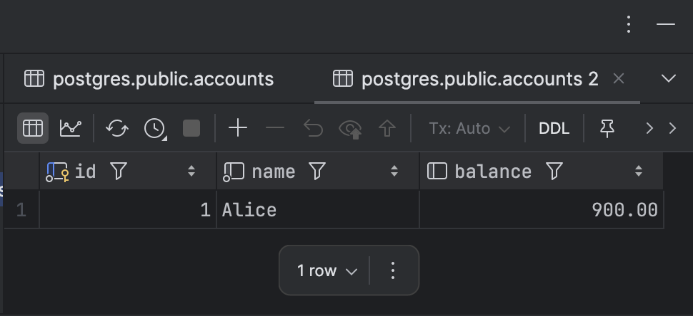
--3
begin;
update accounts set balance=balance-100 where name='Alice';
savepoint my_savepoint;
update accounts set balance=balance+100 where name='Bob';
rollback to my_savepoint;
update accounts set balance=balance+100 where name='Wally';
commit;
--a. alice 800, bob 600, wally 850
--b. bob was credited temporarily but rolled back,so final=unchanged
--c. savepoints avoid restarting whole transaction
--4
begin transaction isolation level read committed;
select *
from products
where shop='Joe''s Shop';
select *
from products
where shop ='Joe''s Shop';
commit;
begin;
delete from products where shop='Joe''s Shop';
insert into products (shop,product,price)
values ('Joe''s Shop','Fanta',3.50);
commit;
--a. read commited: before = coke/pepsi; after=fanta only
--b. serializable: always sees original data
--c. read commited allows phantoms
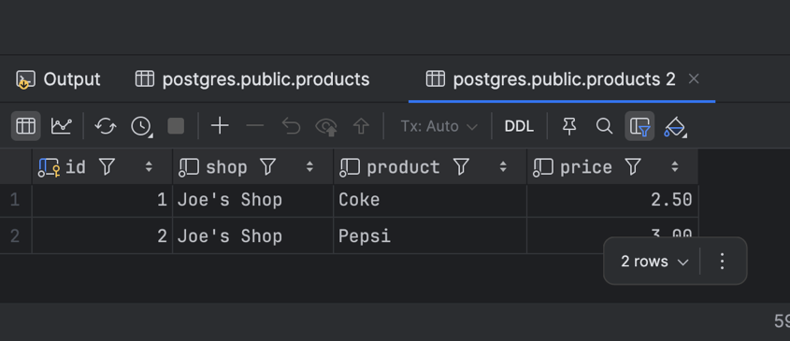
--5
begin transaction isolation level repeatable read;
select max(price), min(price)
from products
where shop='Joe''s Shop';
select max(price), min(price)
from products
where shop='Joe''s Shop';
commit;
begin;
insert into products(shop,product,price)
values('Joe''s Shop','Sprite',4.00);
commit;
--a. terminal 1 does not see sprite
--b. phantom read=new rows appear between two reads
--c. serializable prevents phantoms
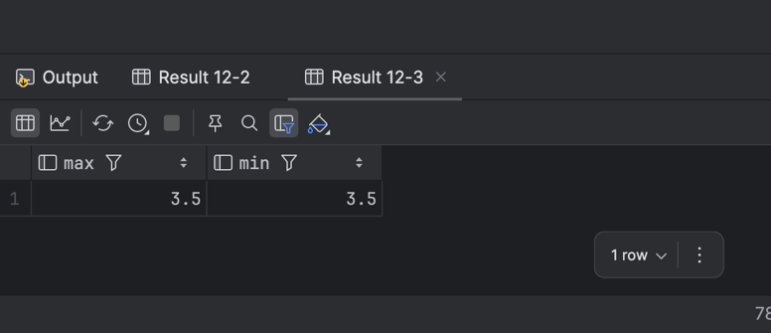
--6
begin transaction isolation level read uncommitted;
select *
from products;
select *
from products;
select *
from products;
commit;
begin;
update products set price=99.99 where product='Fanta';
rollback;
--a. yes, t1 sees 99.99-dirty read
--b. dirty read=reading uncommitted data
--c. read uncommited is unsafe should be avoided
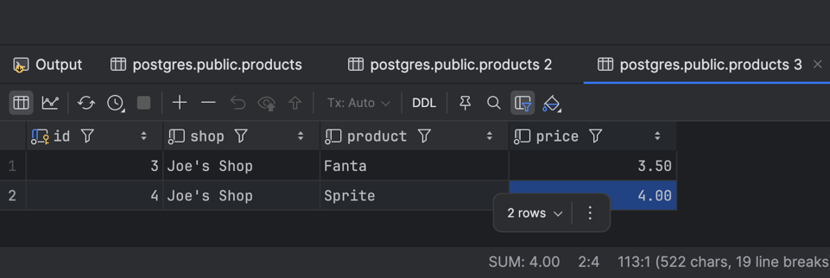
--exercise
--1
do $$
DECLARE bal NUMERIC;
begin
select balance
into bal
from accounts
where name='Bob';
if bal >=200 then
begin
update accounts set balance =balance-200 where name='Bob';
update accounts set balance=balance+200 where name='Wally';
commit;
exception when others then
rollback;
end;
else
raise notice 'Insufficient funds';
end if;
end;
$$;
--2
begin;
insert into products (shop,product,price)
values('Joe''s Shop','Water',1.00);
savepoint sp1;
update products set price=2.00 where product='Water';
savepoint sp2;
delete from products where product='Water';
rollback to sp1;
commit;
--final state: water exists
--3
begin transaction isolation level read committed;
select balance
from accounts
where name='Alice';
update accounts set balance=balance-300 where name='Alice';
commit;
begin transaction isolation level read committed;
select balance
from accounts
where name='Alice';
update accounts set balance=balance-300 where name='Alice';
commit;
--read commited: both see same initial balance -overdraft possible
--serializable- second one gets serialization error
--4
select max(price)
from products;
select min(price)
from products;
begin;
select max(price) from products;
select min(price) from products;
commit;
--1
-- Atomic: either full transfer or none
-- Consistent: constraints stay valid
-- Isolated: concurrent users don’t interfere
-- Durable: committed data survives crash
--2
-- COMMIT = save changes; ROLLBACK = undo
--3
-- SAVEPOINT = partial rollback inside transaction
--4
-- Read uncommitted – dirty reads allowed
-- Read committed – no dirty reads
-- Repeatable read – no non-repeatable reads
-- Serializable – no phantoms
--5
-- Dirty read = uncommitted read; allowed in READ UNCOMMITTED
--6
-- Non-repeatable read → same row read twice → values differ
-- 7
-- Phantom read = new rows appear; prevented only in SERIALIZABLE
-- 8
-- READ COMMITTED is faster; SERIALIZABLE is slow
-- 9
-- Transactions prevent race conditions & inconsistent updates
-- 10
-- Uncommitted data is lost on crash

