|  |  |
| --- | --- |
| **Project Case** |  |
| COMP6583001  Computer Graphics |
| **Computer Science** | **O222-COMP6583-JX02-00** |
| ***Valid on*** *Odd Semester Year 2021/2022* | **Revision 00** |

1. Seluruh kelompok tidak diperkenankan untuk:

*The whole group is not allowed to:*

* + - Melihat sebagian atau seluruh proyek kelompok lain,

*Seeing a part or the whole project from another groups*

* + - Menyadur sebagian maupun seluruh proyek dari buku,

*Adapted a part or the whole project from the book*

* + - Mendownload sebagian maupun seluruh proyek dari internet,

*Downloading a part or the whole project from the internet,*

* + - Mengerjakan soal yang tidak sesuai dengan tema yang ada di soal proyek,

*Working with another theme which is not in accordance with the existing theme in the matter of the project,*

* + - Melakukan tindakan kecurangan lainnya,

*Committing other dishonest actions,*

* + - Secara sengaja maupun tidak sengaja melakukan segala tindakan kelalaian yang menyebabkan hasil karyanya berhasil dicontek oleh orang lain / kelompok lain.

*Accidentally or intentionally conduct any failure action that cause the results of the project was copied by someone else / other groups.*

1. Jika kelompok terbukti melakukan tindakan seperti yang dijelaskan butir 1 di atas, maka **nilai kelompok** yang melakukan kecurangan (menyontek maupun dicontek) akan di – **NOL** – kan.

*If the group is proved to the actions described in point 1 above, the score of the group which committed dishonest acts (cheating or being cheated) will be “Zero”*

1. Perhatikan jadwal pengumpulan proyek, segala jenis pengumpulan proyek di luar jadwal tidak dilayani.

*Pay attention to the submission schedule for the project, all kinds of submission outside the project schedule will not be accepted*

1. Bila Anda tidak membaca peraturan ini, maka Anda dianggap telah membaca dan menyetujuinya

*If you have missed to read these regulations, so you are considered to have read and agreed on it*

1. Persentase penilaiaan untuk matakuliah ini adalah sebagai berikut:

*Marking percentage for this subject is described as follows:*

|  |  |
| --- | --- |
| **Tugas Mandiri**  *Assignment* | **Proyek**  *Project* |
| 40% | 60% |

1. Software yang digunakan pada matakuliah ini adalah sebagai berikut:

*Software will be used in this subject are described as follows:*

|  |
| --- |
| **Software**  *Software* |
| • Visual Studio Code  • Three JS  • Chrome / Firefox / Microsoft Edge |

## Ekstensi file yang harus disertakan dalam pengumpulan tugas mandiri dan proyek untuk matakuliah ini adalah sebagai berikut:

*File extensions should be included in assignment and project collection for this subject are described as follows:*

|  |  |
| --- | --- |
| **Tugas Mandiri**  *Assignment* | **Proyek**  *Project* |
| HTML, CSS, JS, Image Files (JPG / PNG), GLB | HTML, CSS, JS, Image Files (JPG / PNG), GLB |

## Soal

*Case*

**X-Sword**

Mr. X, a game developer is currently building a new fantasy game called X-Sword. The game will feature a knight who searching for a legendary sword. The game is scheduled to be completed in 5 months, but Mr. X is still having a bad time picturing what the final game scene will look like. As an **three.js** expert, you are asked by Mr. X to design the scene using the **three.js** library. Given detailed specifications on below, you are obligated to create the scene using **three.js** library.

1. **Project Structure**

Your project should contain a main **HTML file, several JavaScript files, Assets, and the three.js library**. You are to acquire **three.js** either from the three.js [official website](https://threejs.org/), [github repository](https://github.com/mrdoob/three.js/), or [CDN link](https://cdnjs.com/libraries/three.js).

You are required to include the following piece of code in your html file.

|  |
| --- |
| <style>  * { margin: 0; padding: 0; }  body { width: 100vw; height: 100vh; overflow: hidden; }  canvas { display: block; }  </style>  <script src="[path to index.js file]" type="module"></script> |

You are free to split your code into several different JavaScript file, but code the main logic for creating the scene inside “index.js” file.

1. **Scene**

Create a **full screen** scene **(with color code 0x303030)** that can be **dynamically resized** to **fit the window**. The scene also has **shadow map** **enabled** using **PCFSoftShadowMap** as the shadow map **type** and **anti-aliasing** turned on.

1. **Camera**

Create **two cameras** whose details will be specified below. By default, the scene will use the **Third person PoV camera** to start.

* 1. **Third Person PoV Camera**
     1. This camera will be initialized by following the specifications below

|  |  |
| --- | --- |
| Property | Value |
| Type | Perspective Camera |
| FoV | 45 |
| Position | Vector3 (0, 5, 50) |
| Look At | Vector3 (0, 5, 0) |

* + 1. This camera **will follow the character** whenever the character is moving
    2. If user presses **Space** key, change camera view to **Free Look PoV Camera**

**Figure 1. Viewing using Third Person FoV Camera**

* 1. **Free Look PoV Camera**
     + This camera will be initialized by following the specifications below

|  |  |
| --- | --- |
| Property | Value |
| Type | Perspective Camera |
| FoV | 45 |
| Position | Vector3 (0, 5, 200) |
| Look At | Vector3 (0, 5, 0) |

* + - This camera **will orbit around the skybox cube.** You can achieve this using the **OrbitControls**.
    - If user presses **Space** key, change camera view to **Third Person PoV Camera**

**Figure 2. Viewing using Free Look PoV Camera**

1. **Lighting**

There will be two global lights to illuminate the entire scene

* 1. **Ambient Light**
     + This camera will be initialized by following the specifications below

|  |  |
| --- | --- |
| Property | Value |
| Type | AmbientLight |
| Intensity | 1 |
| Color | 0xFFFFFF |

* 1. **Directional Light**
     + This camera will be initialized by following the specifications below

|  |  |
| --- | --- |
| Property | Value |
| Type | DirectionalLight |
| Intensity | 1 |
| Color | 0xFFFFFF |
| Position | Vector3 (10, 10, 10) |
| Shadow Camera Left | -100 |
| Shadow Camera Right | 100 |
| Shadow Camera Top | 100 |
| Shadow Camera Bottom | -100 |
| Shadow Map Width | 5120 |
| Shadow Map Height | 5120 |

1. **Objects**
   1. **Ground**
      1. This ground will be formed by creating (7 x 10) boxes
      2. Each box will be initialized by following the specifications below

|  |  |
| --- | --- |
| Property | Value |
| Geometry Type | BoxGeometry |
| Size | 10 x 1 x 10 |
| Material Type | MeshPhongMaterial |
| Color | Grey |
| Opacity | 0.5 |
| Transparent | True |
| Side | DoubleSide |
| Position | If column index is equal to 4 or 5 then the position will be  Vector3 ((ColumnIndex – 4.5) * 10, -3.5, (RowIndex – 1.5) * 10)  else the position will be  Vector3 ((ColumnIndex – 4.5) * 10, Random from -3 to 3, (RowIndex – 1.5) * 10) |
| Receive Shadow | True |

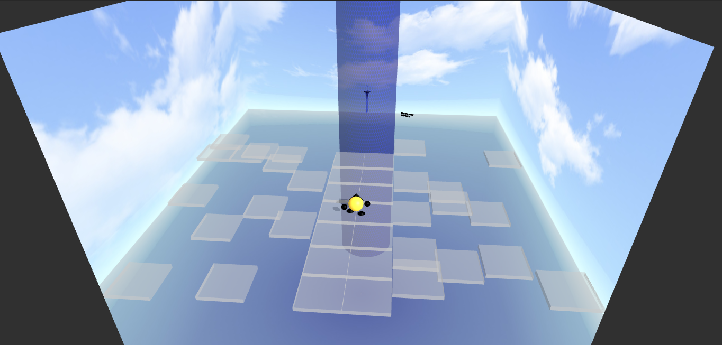

**Figure 3. The Ground**

* 1. **Character**
     1. This character consists of several **different part grouped** together. The parts are specified below
        1. **Head**

|  |  |
| --- | --- |
| Property | Value |
| Geometry Type | OctahedronGeometry |
| Radius | 2 |
| Material Type | MeshPhongMaterial |
| Color | 0x000000 |
| Position | Vector3 (0, 0.3, -1.5) |
| Cast Shadow | True |

* + - 1. **Body**

|  |  |
| --- | --- |
| Property | Value |
| Geometry Type | SphereGeometry |
| Radius | 2 |
| Width Segments | 30 |
| Height Segments | 30 |
| Material Type | MeshPhongMaterial |
| Color | 0xD4AF37 |
| Position | Vector3 (0, 0, 0) |
| Cast Shadow | True |

* + - 1. **Right Arm**

|  |  |
| --- | --- |
| Property | Value |
| Geometry Type | SphereGeometry |
| Radius | 0.8 |
| Width Segments | 30 |
| Height Segments | 30 |
| Material Type | MeshPhongMaterial |
| Color | 0x000000 |
| Position | Vector3 (3, -0.5 0) |
| Rotation | Euler (0, 0, 1) |
| Cast Shadow | True |

* **Left Arm**

|  |  |
| --- | --- |
| Property | Value |
| Geometry Type | SphereGeometry |
| Radius | 0.8 |
| Width Segments | 30 |
| Height Segments | 30 |
| Material Type | MeshPhongMaterial |
| Color | 0x000000 |
| Position | Vector3 (-3, -0.5 0) |
| Rotation | Euler (0, 0, -1) |
| Cast Shadow | True |

* + - 1. **Right Leg**

|  |  |
| --- | --- |
| Property | Value |
| Geometry Type | CylinderGeometry |
| Radius Top | 0.5 |
| Radius Bottom | 1 |
| Height | 0.5 |
| Radial Segments | 50 |
| Material Type | MeshPhongMaterial |
| Color | 0x000000 |
| Position | Vector3 (1.5, -2.5 0) |
| Cast Shadow | True |

* + - 1. **Left Leg**

|  |  |
| --- | --- |
| Property | Value |
| Geometry Type | CylinderGeometry |
| Radius Top | 0.5 |
| Radius Bottom | 1 |
| Height | 0.5 |
| Radial Segments | 50 |
| Material Type | MeshPhongMaterial |
| Color | 0x000000 |
| Position | Vector3 (-1.5, -2.5 0) |
| Cast Shadow | True |

**Figure 4. Preview of character**

* + 1. If **‘W’ is pressed** the character **will move forward**
    2. **Validate** the character will not go any further if it near the shield (**animation can still be triggered**)
    3. The hand and leg **will have animation that follow the character move**
* When moving the right hand and the left leg will move forward at the same time
* Vice versa the left hand and right leg will move forward at the same time

**Figure 5. Preview when character move forward (with animation) – Pt. 1**

**Figure 6. Preview when character move forward (with animation) – Pt. 2**

* 1. **Text**
     1. This text will be initialized by following the specifications below

|  |  |
| --- | --- |
| Property | Value |
| String | Click the shield to break it! |
| Typeface | Helvetiker Regular |
| Size | 0.5 |
| Height | 0.5 |
| Material | MeshPhongMaterial |
| Position | Vector3 (12, 8, -30) |
| Rotation | Euler (0, π/8, 0) |

* 1. **Sword**
     1. This sword will be initialized by load the given **3D Model** with following specifications below

|  |  |
| --- | --- |
| Property | Value |
| Position | Vector3 (0, 8, -30) |
| Rotation | Euler (π/2, 0, π/2) |
| Scale | Vector3 (0.01, 0.005, 0.005) |

* + 1. This sword will have an **animation where it will move up and down repeatedly**

**Figure 7. Preview of sword 3D Model and animation – Pt. 1**

**Figure 8. Preview of sword 3D Model and animation – Pt. 2**

* 1. **Shield**
     1. This shield will be initialized by following the specifications below

|  |  |
| --- | --- |
| Property | Value |
| Geometry Type | CylinderGeometry |
| Material Type | MeshPhongMaterial |
| Radius Top | 10 |
| Radius Bottom | 10 |
| Height | 100 |
| Radial Segments | 50 |
| Texture Map  (You can ignore the top and bottom side) |  |
| Texture Repeat | 10 x 10 |
| Color | 0x0000FF |
| Side | FrontSide |
| Opacity | 0.5 |
| Transparent | True |
| Position | Vector3 (0, 0, -30) |

* + 1. This shield **will vanish by clicking it (**Validate the shield will only vanish **if the character cannot go any further)**
    2. This shield will have a **slow fade animation**

**Figure 9. Preview of Shield**

**Figure 10. Preview of Shield start vanishing after clicked**

**Figure 11. Preview of Shield vanish**

1. **Background**

Create a **skybox** as background using **cube mapping technique** with the following specifications below

|  |  |
| --- | --- |
| Property | Value |
| Geometry Type | BoxGeometry |
| Size | 100 x 100 x 100 |
| Position | Vector3 (0, 0, 0) |
| Texture  (With sequence: px, nx, py, ny, pz, nz) |  |
| Side | BackSide |

**Figure 12. Preview from far**

**References**

skybox texture:

https://opengameart.org/content/sky-box-sunny-day

zone texture:

https://www.youtube.com/watch?v=uQlDfDsWiMs&t=8s