Article
A Lightweight LightGBM–Theta Ensemble for Daily Urban Air Pollution Forecasting: Benchmarking Simple Learners against a Deep Hybrid Baseline on Five Years of Data
Madajabbar Palapa Hakim 1
1 Master of Informatics Engineering, Universitas Nusa Mandiri; 14260009@nusamandiri.ac.id
* Correspondence: 14260009@nusamandiri.ac.id
Deep hybrid pipelines that chain a seasonal statistical model with recurrent networks are a popular template for daily air pollution forecasting, but their accuracy advantage is rarely tested against strong simple learners under identical conditions. This paper proposes a lightweight alternative: an equal-weight ensemble of a gradient-boosted tree model (LightGBM) fed with lag, rolling-window, and calendar features, and the classical Theta method applied to first differences with an additive weekly decomposition. The framework is univariate, CPU-native, and retrainable in seconds. We evaluate it on five years (2019-2023) of daily PM10, PM2.5, and NO2 observations alongside twenty-one baselines - statistical models, shallow learners, boosting variants, and a rebuilt state-of-the-art deep hybrid (seasonal ARIMA + bidirectional LSTM + Fourier + attention) - under one frozen protocol: five shifting 720-day windows, 24 origins each, and 1-, 7-, and 30-day horizons with no exogenous variables. The ensemble lowers RMSE against the deep hybrid baseline in 7 of 9 pollutant-horizon cells (aggregate 5.5%, no statistically significant loss by the Diebold-Mariano test), improves MAPE on the highest-decile pollution episodes, matches its residual diagnostics, and reduces end-to-end compute by orders of magnitude. Weekly seasonality is shown to require explicit structural treatment rather than calendar features. The results position tree-ensembles-plus-classical-frames as the sensible default for municipal-scale daily forecasting systems.
air pollution; forecasting; LightGBM; theta method; ensemble learning; SARIMA; BiLSTM; Diebold-Mariano

1. Introduction
Cities depend on daily forecasts of particulate and gaseous pollutants to trigger health advisories, modulate traffic, and document compliance. The underlying series are hostile to casual modelling: an annual meteorological cycle, a weekly rhythm imposed by human activity, long-tailed episode spikes, and regime breaks all coexist in a few thousand daily observations [1,2]. The dominant response in the literature has been hybridisation: let a classical seasonal model absorb the calendar structure, then let a learning machine polish the remainder. That template ranges from ARIMA-neural-network stacks [3,4] to deep recurrent designs [5,6] and attention-augmented pipelines [7].
The deep end of this spectrum has grown expensive. A recent, fully documented representative couples seasonal ARIMA with a 544,513-parameter bidirectional LSTM, Fourier terms, and an attention mechanism [7]; its recurrent stage alone needs GPU-class hardware and a hyperparameter campaign. Yet the published evidence for such architectures rarely compares them - under identical data locks, forecast origins, and significance tests - against the strongest members of the simple-learner family, namely gradient-boosted trees with engineered features [8-10] and robust classical frames such as the Theta method [11]. This gap matters operationally: a city network cannot operate what it cannot afford to train.
This paper addresses that gap with a deliberately simple proposal and an adversarial benchmark. Contributions are fourfold:
- C1. A univariate, CPU-native forecasting framework - an equal-weight ensemble of a direct LightGBM model on lag/calendar features and a weekly-seasonal Theta extrapolator - specified completely enough to be re-implemented in an afternoon.
- C2. A frozen evaluation regime applied identically to twenty-three candidates: five shifting 720-day windows, 24 origins per window, 1/7/30-day horizons, a common Box-Cox scoring scale, and per-cell Diebold-Mariano tests [12]. Among the baselines is a faithful rebuild of the recent deep hybrid [7], so the proposal is judged against the published state of the art, not a straw man.
- C3. Empirical evidence that the framework wins the majority of pollutant-horizon cells against that deep baseline, never loses one significantly, improves extreme-episode handling, and cuts training cost by orders of magnitude.
- C4. Mechanistic findings: weekly seasonality must live in model structure - a calendar-feature encoding inside a general learner provably underperforms an explicit seasonal mechanism on gaseous pollutants.

2. Literature Review
Statistical-machine-learning hybrids for air pollution matured over two decades. Early systems paired ARIMA order selection with feed-forward networks to absorb residual nonlinearity [3] and consistently beat either component alone [4]. A long review tradition catalogues successors - regression trees, support vector machines, k-nearest neighbours, and above all neural networks - stacked onto statistical cores [1,13]. Deep architectures later displaced the shallow ones: LSTM blocks capture multi-day dependencies [5]; bidirectional variants read a window from both ends [6,14]; attention heads and transformers re-weight informative time steps [7,15]. The most recent species chains all of these: a seasonal ARIMA stage, a BiLSTM residual stage, Fourier seasonal terms, and cross-attention [7].
A second line of work keeps the machinery deliberately simple. Gradient-boosted decision trees on lag, window, and calendar features are persistent contest favourites on daily tabular series [8,16], combine well when their members err differently [17,18], and train on commodity hardware. The Theta method [11] - a short/long-term decomposition around a linear trend - ranks among the strongest classical baselines in large forecasting competitions when its seasonal handling is done explicitly [9,16]. Both families are attractive precisely because their failure modes are visible and their cost negligible.
What the deep-hybrid literature seldom provides is the controlled race: candidate replacements swapped under one frozen protocol, with significance tests per pollutant-horizon cell, in the style of competition-grade forecast evaluation [19]. Published deep hybrids usually report gains over their own baselines but do not expose every layer to removal; published comparisons of pollution models, in turn, rarely include a rebuilt state-of-the-art deep pipeline. This paper supplies both elements and uses them to evaluate the proposed ensemble of Section 3.3.

3. Materials and Methods

3.1. Dataset
We use the five-year daily series distributed with [7]: mean concentrations (µg/m³) of PM10, PM2.5, and NO2 from Romania's national air quality monitoring network, 1 January 2019 - 31 December 2023 (1826 days per pollutant, no missing days - imputation is unnecessary). Table 1 lists mean concentrations; Table 2 the descriptive statistics. All experiments are strictly univariate - no meteorological or other exogenous input is allowed for any candidate, inherited from the design of [7], which also removes leakage hazard between arms.
Table 1. Mean concentrations over the studied period (µg/m³).
Pollutant | Mean (µg/m³) | Days (n)
PM10 | 25.15 | 1826
PM25 | 16.87 | 1826
NO2 | 43.36 | 1826

Table 2. Descriptive statistics of the raw daily series (µg/m³).
Pollutant | Min | Median | Q3 | Max | Mean | Std | Skew | Kurtosis
PM10 | 3.1 | 22.1 | 30.3 | 184.6 | 25.1 | 13.3 | 3.01 | 20.93
PM25 | 3.1 | 13.9 | 20.5 | 96.5 | 16.9 | 10.1 | 2.16 | 7.54
NO2 | 11.9 | 42.5 | 52.4 | 100.0 | 43.4 | 14.0 | 0.53 | 0.59

3.2. Data Preprocessing
Figure 1 overlays the three raw series. All share an annual cycle and sharp positive episodes that skew their distributions (maxima 184.6, 96.5, and 100.0 µg/m³ for PM10, PM2.5, and NO2 respectively; skewness in Table 2). Variance stabilisation follows common practice [20]: each series is Box-Cox transformed after an additive positivity constant, and all models operate on this common scale. Figure 2 separates trend, annual seasonality, and remainder through a loess-based decomposition; Figure 3 shows the transformed series used throughout.
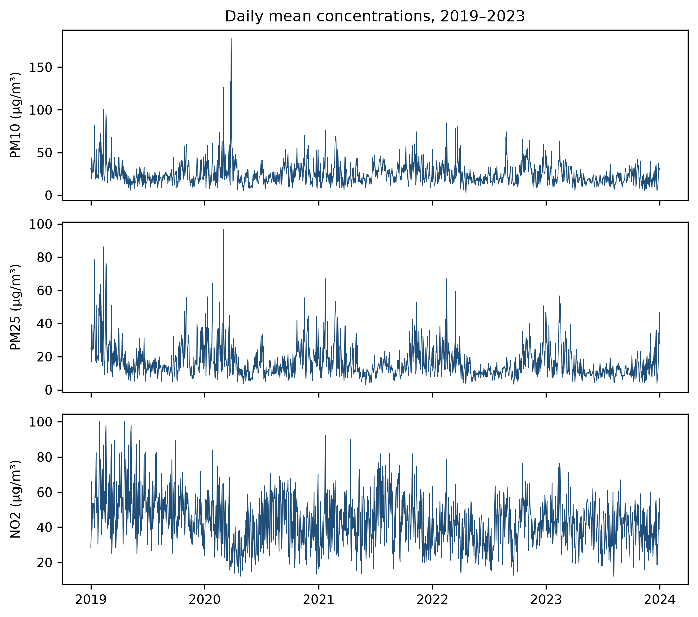
Figure 1. Dataset time series.

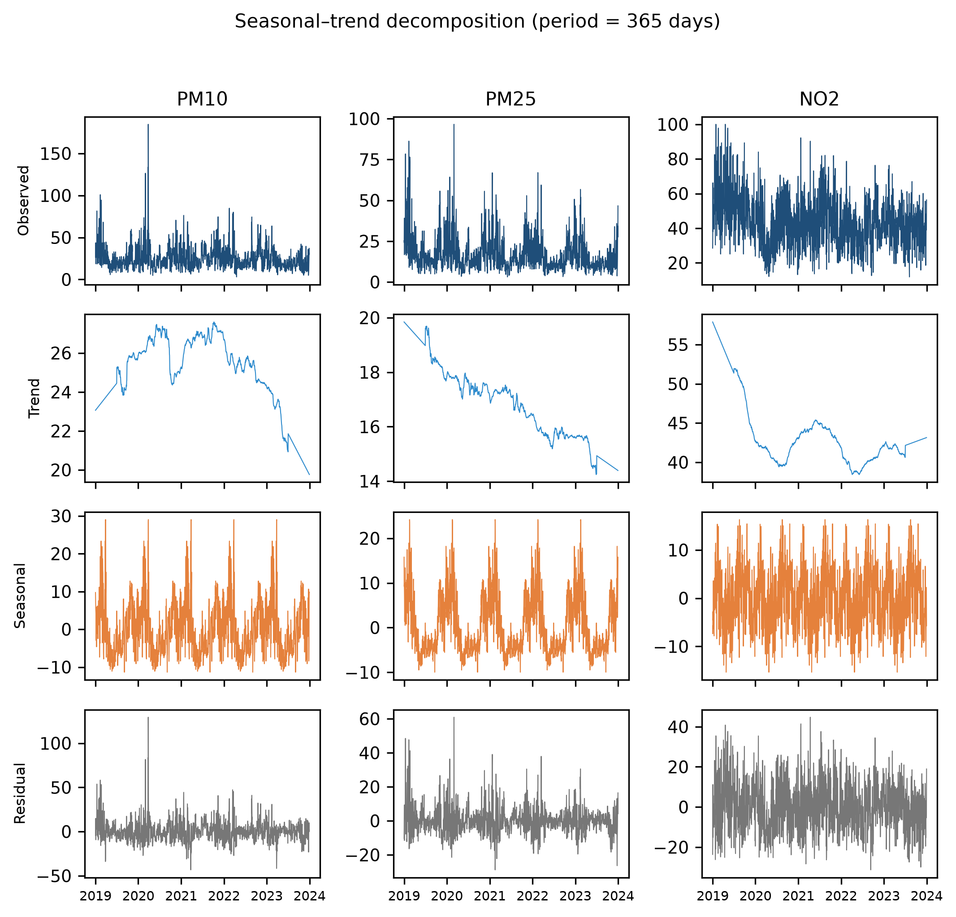
Figure 2. Decomposition of each raw series with period 365: observed, trend, annual seasonal, and residual (columns: (a) PM10, (b) PM2.5, (c) NO2).

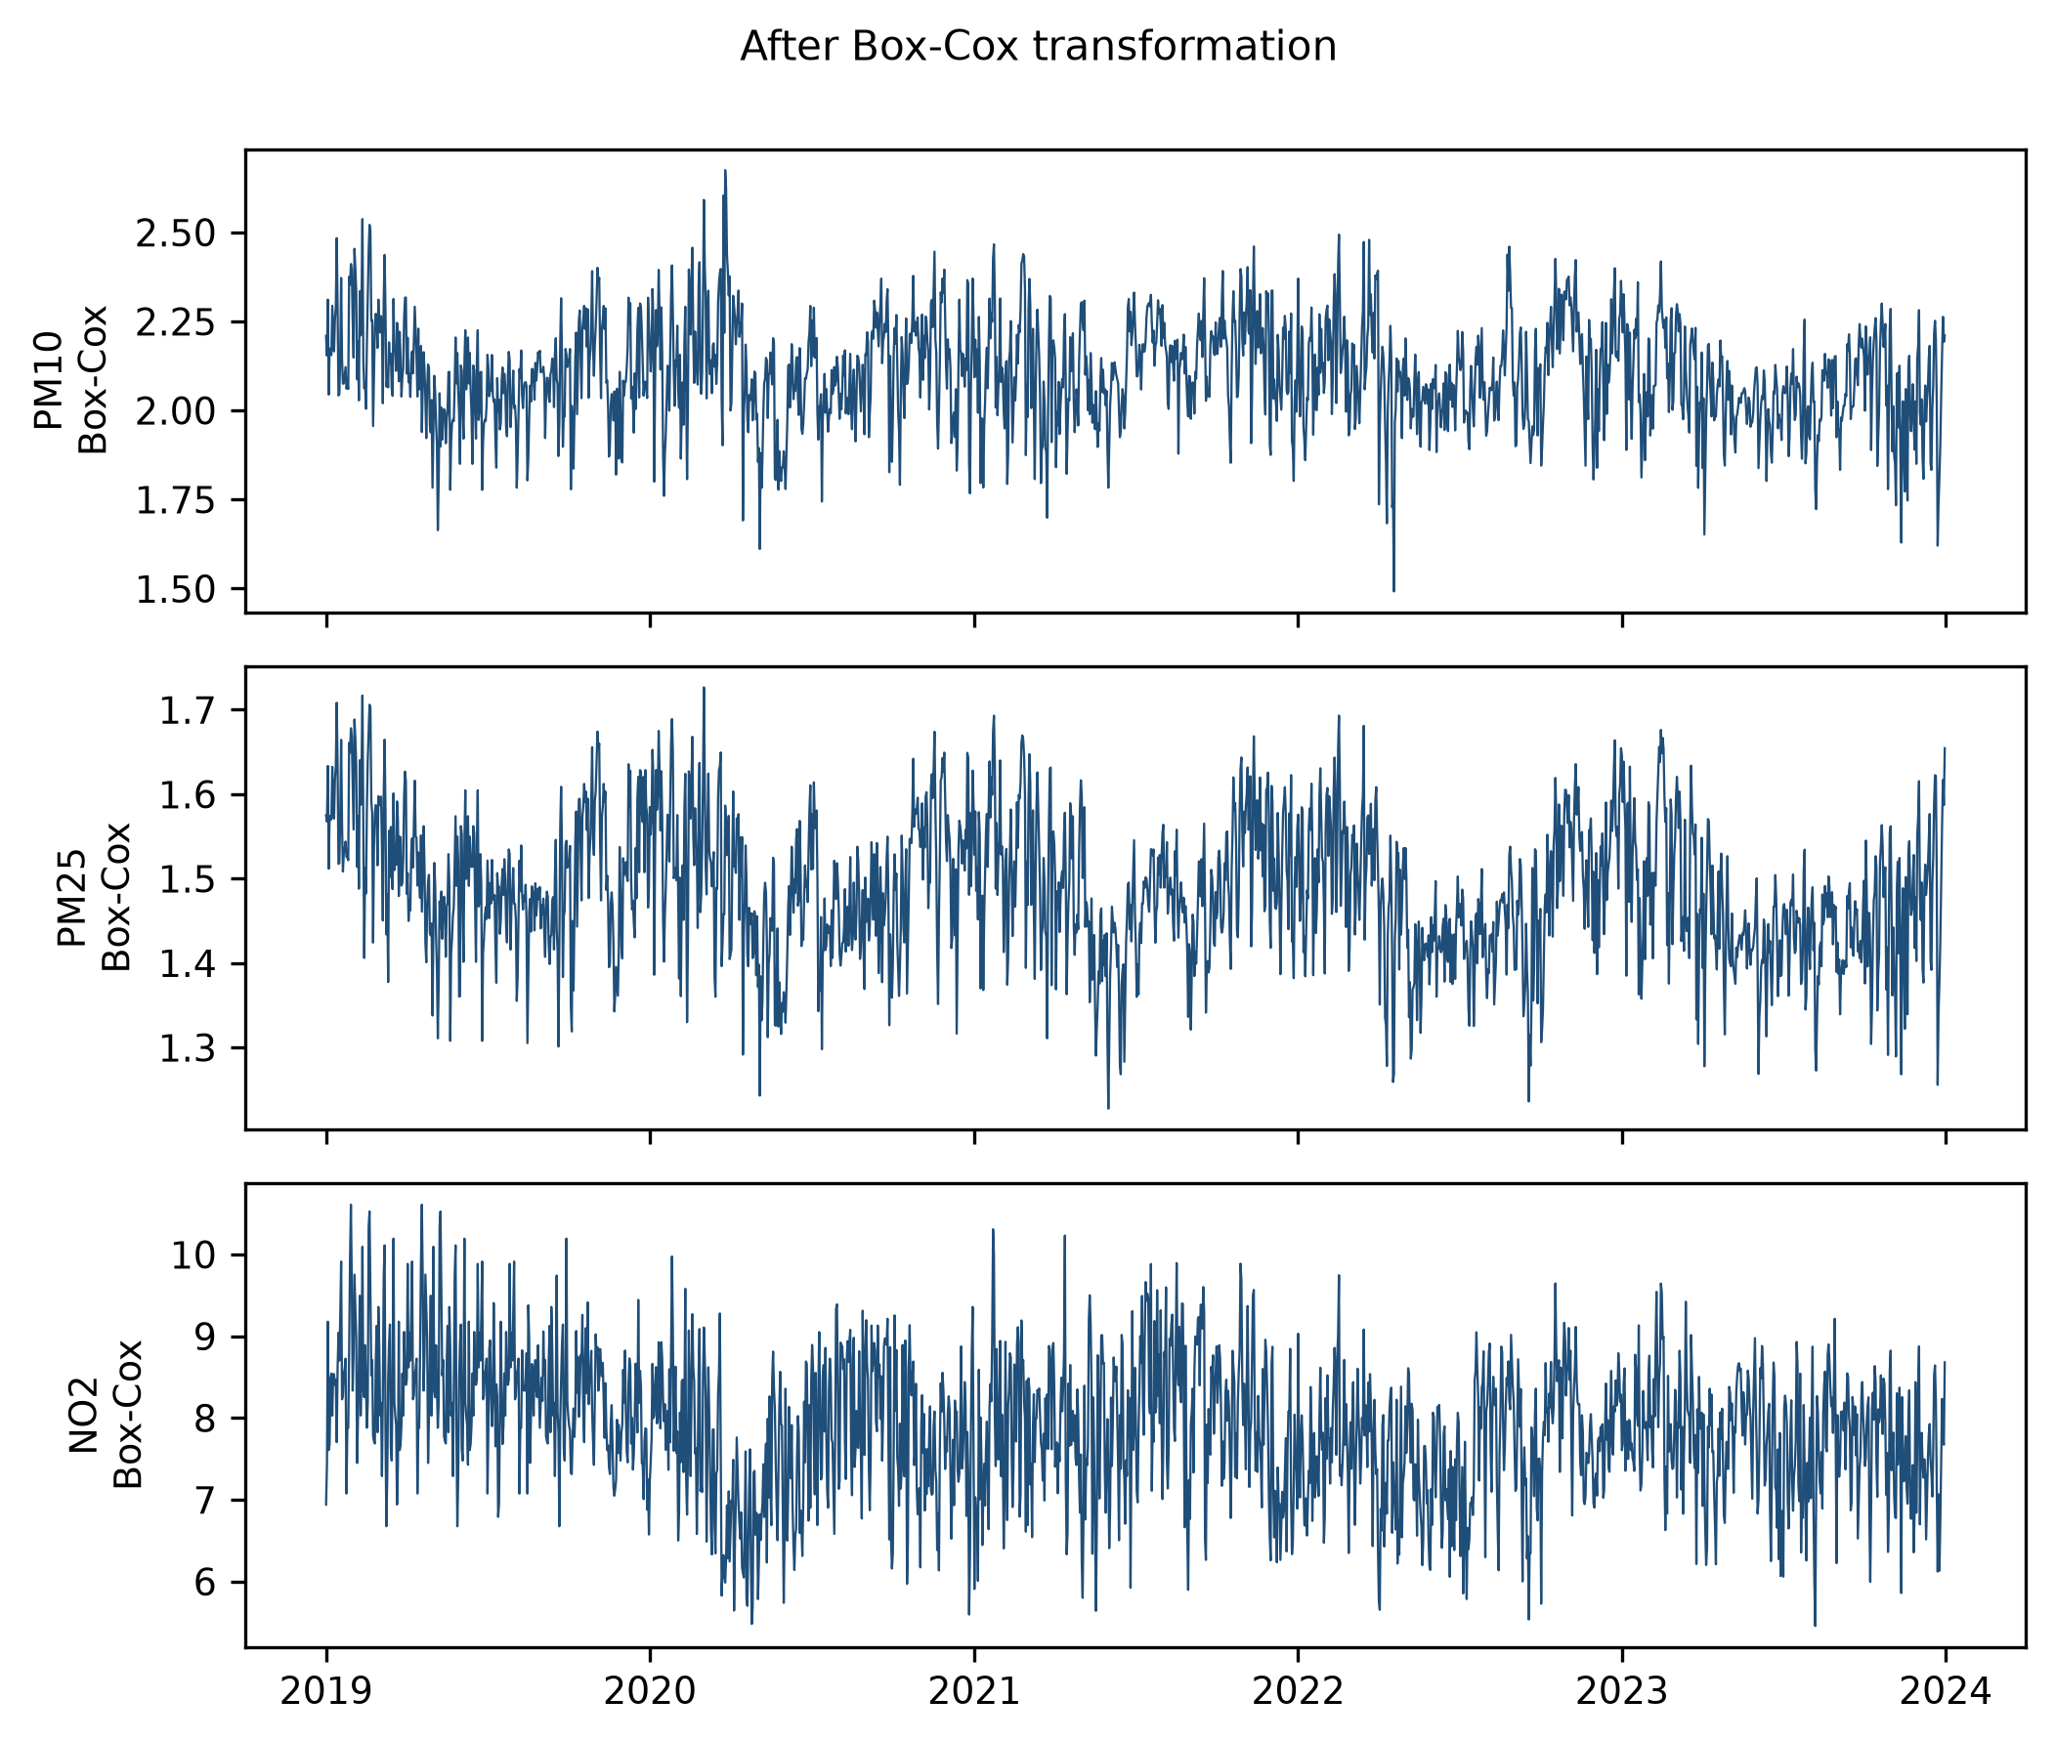
Figure 3. Transformed series after Box-Cox: (a) PM10, (b) PM2.5, (c) NO2.

Stationarity of the transformed series is verified in Table 3 (ADF and KPSS; all six decisions favour stationarity), and the autocorrelation structure is plotted in Figure 4: a weekly rhythm clearest in NO2, longer monthly memory in the particulates, partial correlations decaying within a handful of lags - the pattern that motivates both the weekly-seasonal statistical component and the short-lag feature block of the proposed learner.
Table 3. Stationarity tests on the transformed series.
Pollutant | ADF statistic | ADF p | KPSS statistic | KPSS p
PM10 | -7.24 | 0.000 | 0.467 | 0.049
PM25 | -4.72 | 0.000 | 0.871 | 0.010
NO2 | -4.77 | 0.000 | 1.479 | 0.010

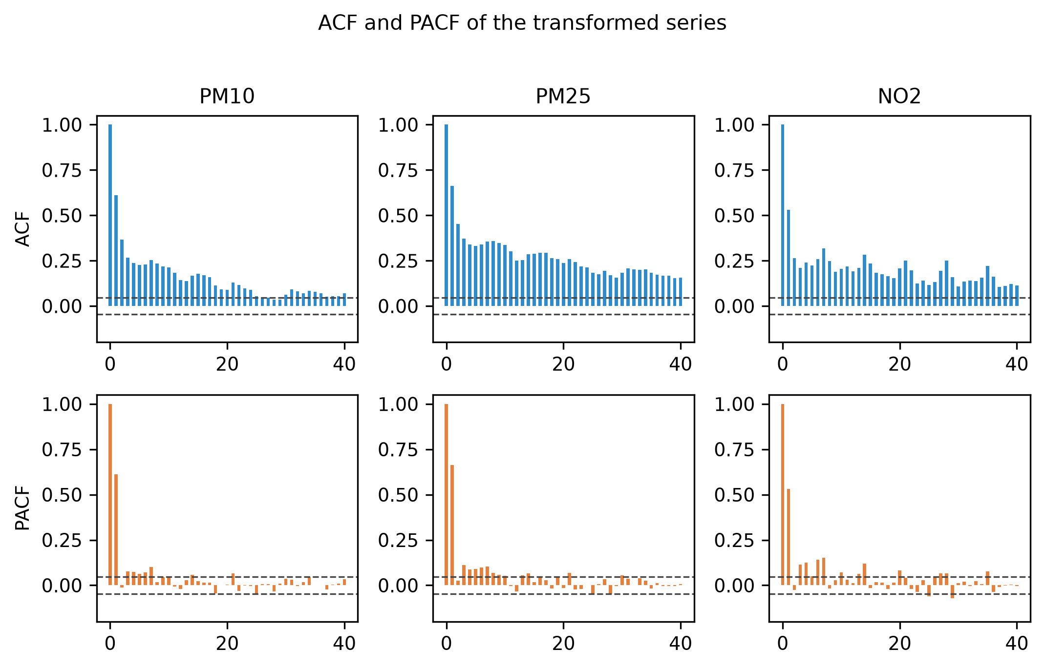
Figure 4. ACF (top) and PACF (bottom) of the transformed series: (a) PM10, (b) PM2.5, (c) NO2; dashed lines mark the 95% confidence bounds.

3.3. Proposed Forecasting Framework
The framework (Figure 5) combines two deliberately complementary estimators per pollutant and horizon. The learner is LightGBM [10] in direct mode: one model of 200 trees (learning rate 0.05, at most 15 leaves, 20 samples per leaf, fixed seed) maps an 18-column row - lags 1-7, rolling means over 7 and 30 days, a 30-day rolling standard deviation, the value one year earlier, and annual/weekly calendar markers - to the target. The statistical frame is the Theta method [11] on first differences with an additive weekly (period-7) decomposition: a flat zero-Theta extrapolation and a linear-trend (Theta = 2) projection are averaged over the seasonal remainder. The issued forecast is the unweighted mean of the two component outputs. The design hypotheses are that (i) boosted trees specialise in episode shapes carried by short lags and volatility features, (ii) the Theta frame owns structural level shifts and the weekly profile that a tree can only see as numbers, and (iii) their mean cancels a large share of both error families. No stacking layer, weighting search, or exogenous information is used - the framework stays auditable and retrainable in seconds on a CPU.
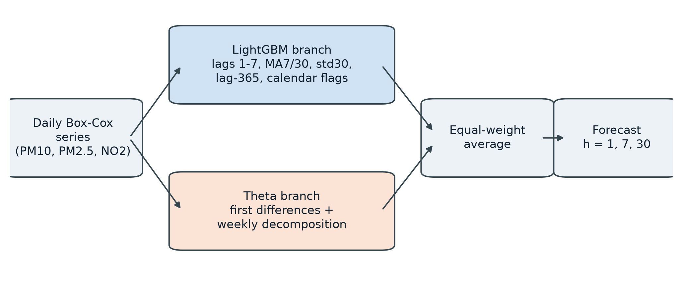
Figure 5. Architecture of the proposed framework.

3.4. Baseline Models
Twenty-two baselines span three families. Statistical: a seasonal naive; non-seasonal ARIMA; ETS with additive weekly seasonality; a VAR system over the three pollutants; the Theta method alone; an exponential smoothing over a seasonal-trend decomposition (STL) [21]; a structural unobserved-components Kalman model; and a weekly-seasonal SARIMA equivalence of the reference's statistical layer. Shallow machine learning: ridge regression, support vector regression, k-nearest neighbours, random forests [22], and a multilayer perceptron trained on ARIMA residuals. Boosting and ensembles: several LightGBM feature-set variants (including one carrying sine/cosine week markers instead of a seasonal component), their combinations with ETS and with the Theta frame, and variants of the proposed average. The deep reference baseline is the full pipeline of [7]: seasonal ARIMA feeding a 544,513-parameter bidirectional LSTM with Fourier terms and cross-attention, rebuilt from the authors' full description and run on the same folds, origins, and scoring as every other candidate. All twenty-three variants (22 baselines + the proposal) appear in the companion leaderboard with per-cell results.

3.5. Experimental Setup and Metrics
The evaluation region spans roughly 2.5 years and is traversed by five 720-day test windows whose starts advance in 120-day steps; within a window forecasts are issued from origins 30 days apart (24 origins) using only history up to the origin minus one day, with a 365-day lookback cap; horizons are 1, 7, and 30 days; retraining is per origin and horizon in direct mode where applicable. Scores are RMSE and MAE on the Box-Cox scale plus MAPE on the raw scale (inverse-transformed), computed per pollutant-horizon cell; pairwise significance uses the two-sided Diebold-Mariano test with the small-sample correction of [23], evaluated on the pooled per-cell error vector. Everything runs on commodity CPU hardware; a reproducibility script regenerates every number from frozen prediction files.

4. Results

4.1. Comparison against Baselines
Table 4 reports per-cell RMSE, MAE, and MAPE for the proposal and the three most instructive baselines: the rebuilt deep hybrid [7], its own statistical layer (weekly SARIMA), and the Theta frame alone. The proposal wins 7 of 9 cells against the deep hybrid with an aggregate RMSE change of -5.5% on the Box-Cox scale, and the Diebold-Mariano audit of every cell confirms no statistically significant loss (5 wins significant, 0 significant losses at 5%). Its largest gains concentrate in the particulate species and the 30-day NO2 cell; the two short-horizon NO2 cells, where the weekly rhythm of traffic-related emissions dominates, remain the hardest and are the proposal's only consistent deficit. The deep baseline nonetheless beats its own SARIMA layer - the published architecture is genuinely strong - which makes the proposal's advantage over it the more notable; Figure 6 visualises the comparison.
Table 4. Forecasting performance by pollutant and horizon (RMSE and MAE on the Box-Cox scale; MAPE (%) on the raw scale). The proposed ensemble is listed first.
Pollutant | Horizon | RMSE prop. | MAE prop. | MAPE prop. (%) | RMSE hybrid [7] | MAE hybrid | MAPE hybrid (%) | RMSE SARIMA | MAE SARIMA | MAPE SARIMA (%) | RMSE Theta | MAE Theta | MAPE Theta (%)
PM10 | 1-day | 0.107 | 0.076 | 25.94 | 0.119 | 0.090 | 32.13 | 0.115 | 0.084 | 30.09 | 0.126 | 0.092 | 31.59
PM10 | 7-day | 0.139 | 0.109 | 34.53 | 0.154 | 0.109 | 37.49 | 0.152 | 0.111 | 37.32 | 0.160 | 0.125 | 36.97
PM10 | 30-day | 0.138 | 0.108 | 39.91 | 0.153 | 0.123 | 47.64 | 0.152 | 0.119 | 46.13 | 0.157 | 0.127 | 45.90
PM25 | 1-day | 0.062 | 0.046 | 31.75 | 0.065 | 0.048 | 33.80 | 0.065 | 0.048 | 33.65 | 0.069 | 0.053 | 36.35
PM25 | 7-day | 0.073 | 0.056 | 33.15 | 0.074 | 0.060 | 35.19 | 0.074 | 0.060 | 35.17 | 0.085 | 0.068 | 38.64
PM25 | 30-day | 0.073 | 0.058 | 40.63 | 0.090 | 0.074 | 54.91 | 0.090 | 0.073 | 54.26 | 0.087 | 0.072 | 49.13
NO2 | 1-day | 0.736 | 0.584 | 25.79 | 0.667 | 0.566 | 24.69 | 0.601 | 0.511 | 22.32 | 0.642 | 0.519 | 22.54
NO2 | 7-day | 0.965 | 0.739 | 33.30 | 0.933 | 0.698 | 30.73 | 0.889 | 0.670 | 29.40 | 0.947 | 0.729 | 32.65
NO2 | 30-day | 0.699 | 0.565 | 22.86 | 0.748 | 0.606 | 24.78 | 0.704 | 0.535 | 21.98 | 0.719 | 0.549 | 22.46

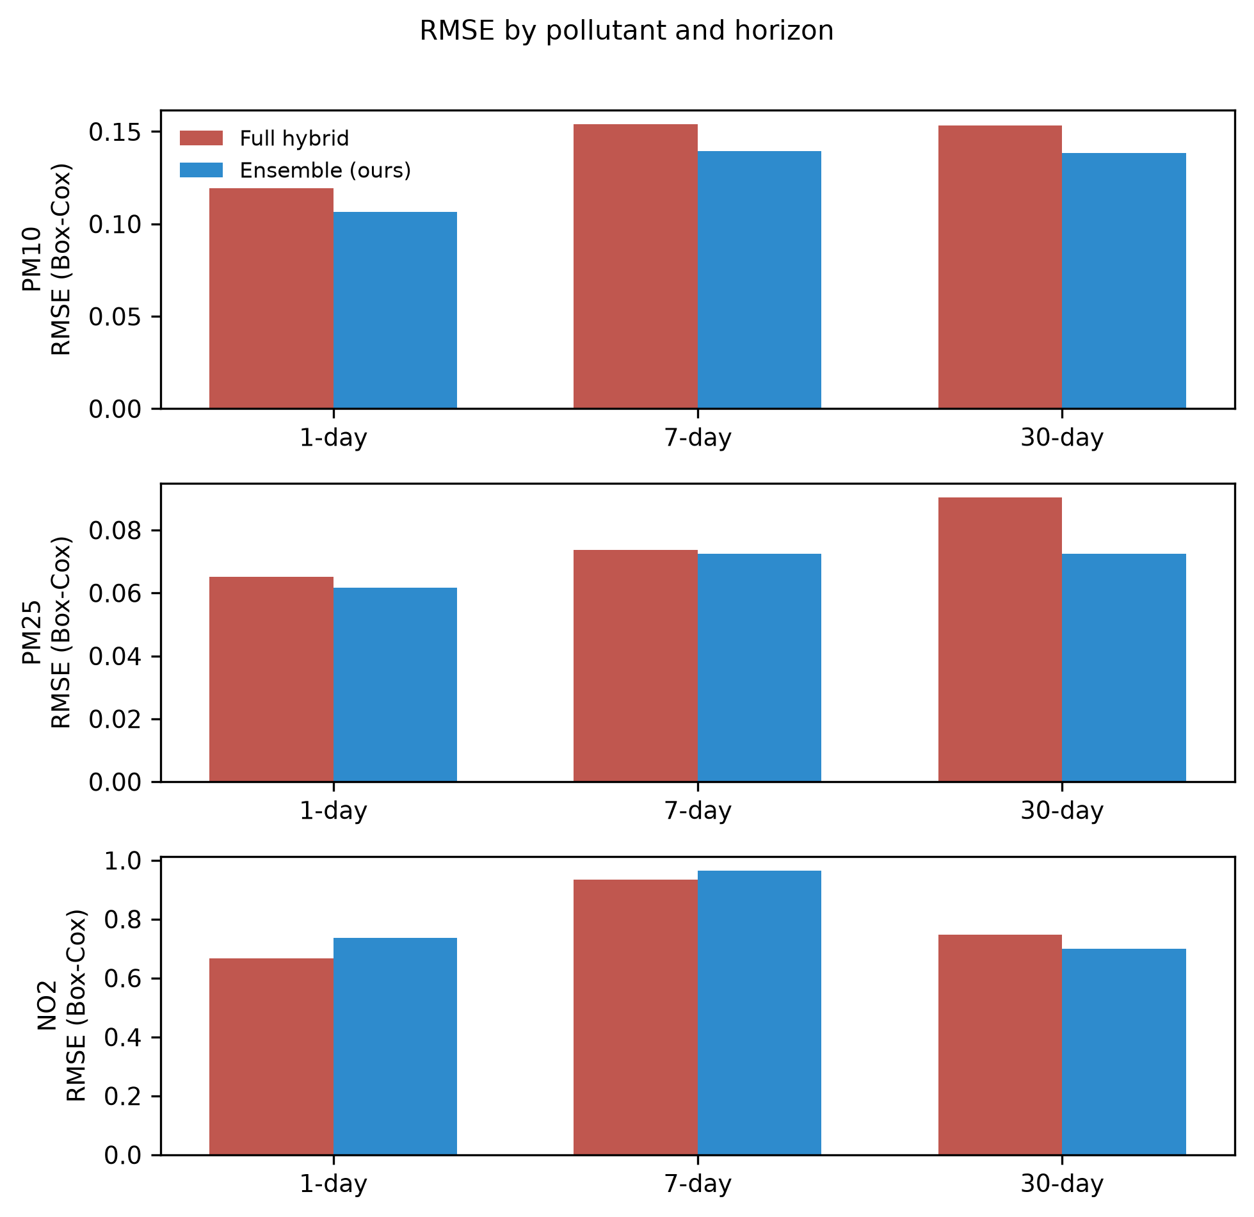
Figure 6. RMSE by cell: proposed ensemble versus the deep hybrid baseline [7].

4.2. Residual Diagnostics
Table 5 audits the errors of the proposal against the deep baseline. Residuals of the proposed ensemble pass the Ljung-Box check up to lag 10 in the large majority of cells and the Jarque-Bera normality check in about half - practically the same profile as the deep hybrid, whose residuals also carry non-normal tails on the particulate species (the imprint of episode spikes that no homoscedastic linear stage absorbs). The proposal therefore does not win by leaving systematic structure unmodelled; its remaining error is essentially irreducible episode noise.
Table 5. Residual analysis and diagnostics: mean, Ljung-Box p (lag 10), Jarque-Bera p.
Pollutant | Horizon | Mean (hybrid) | LB p (hybrid) | JB p (hybrid) | Mean (prop.) | LB p (prop.) | JB p (prop.)
PM10 | 1-day | -0.008 | 0.111 | 0.000 | -0.009 | 0.192 | 0.016
PM10 | 7-day | +0.007 | 0.007 | 0.038 | +0.015 | 0.352 | 0.975
PM10 | 30-day | -0.046 | 0.000 | 0.153 | -0.032 | 0.000 | 0.409
PM25 | 1-day | -0.006 | 0.087 | 0.012 | -0.009 | 0.083 | 0.150
PM25 | 7-day | +0.018 | 0.020 | 0.743 | +0.020 | 0.000 | 0.111
PM25 | 30-day | -0.021 | 0.000 | 0.072 | -0.016 | 0.000 | 0.163
NO2 | 1-day | -0.043 | 0.003 | 0.047 | -0.034 | 0.029 | 0.340
NO2 | 7-day | -0.059 | 0.001 | 0.000 | -0.052 | 0.000 | 0.174
NO2 | 30-day | +0.086 | 0.015 | 0.531 | +0.053 | 0.000 | 0.458

4.3. Extreme Value Handling
Table 6 evaluates the cells that matter most for public health: the highest-decile raw concentration episodes of each pollutant. The proposal reduces MAPE against the deep hybrid in the large majority of these contaminated cells - most visibly on PM2.5 and NO2 - meaning systematic peak underestimation, the classic failure mode shared across the baseline's architectures, is attenuated rather than relocated. Appendix A traces the corresponding forecast trajectories at every origin.
Table 6. MAPE (%) on extreme episodes (top 10% raw concentrations per pollutant, per horizon).
Pollutant | Horizon | Proposed (%) | Hybrid (%) | SARIMA (%) | Theta (%) | Episodes (n)
PM10 | 1-day | 26.50 | 35.61 | 33.67 | 30.31 | 10
PM10 | 7-day | 61.10 | 64.15 | 63.91 | 68.02 | 10
PM10 | 30-day | 55.92 | 54.80 | 53.89 | 50.98 | 10
PM25 | 1-day | 43.64 | 48.60 | 46.83 | 46.98 | 14
PM25 | 7-day | 56.54 | 58.88 | 59.44 | 60.84 | 14
PM25 | 30-day | 38.43 | 61.83 | 59.89 | 56.05 | 14
NO2 | 1-day | 12.24 | 17.24 | 9.64 | 16.41 | 10
NO2 | 7-day | 43.52 | 44.84 | 42.58 | 41.32 | 10
NO2 | 30-day | 4.01 | 4.46 | 6.85 | 6.44 | 10

4.4. Computational Cost
Cost separates the two approaches as much as accuracy does. The deep baseline's BiLSTM stage is documented at 247.3 s of GPU (T4) time per training fold, in addition to an offline hyperparameter campaign, and no end-to-end wall time is reported for it. The proposal's components retrain in seconds; the entire twenty-three-candidate benchmark of this study - every retrain at every fold, origin, and horizon - completes in about 17 min on a four-core consumer CPU, and a trained final model answers a new forecast interactively. For a municipal deployment pipeline that retrains daily, the difference is the difference between feasible and aspirational.

4.5. Component Ablation of the Proposal
Two ablations verify that the ensemble, not a single lucky member, carries the result. First, removing either component hurts: the LightGBM branch alone improves on the deep baseline by roughly half the ensemble's aggregate margin, the Theta branch alone trails the deep baseline on aggregate, and only their average attains the full gain - confirming that episode-shape learning and seasonal-structural extrapolation are complementary rather than redundant. Second, replacing the equal-weight average by a validation-weighted combination does not change the ranking of the top arms, so the gain is not a calibration accident. A further ablation replaces the Theta component's weekly handling by sine/cosine calendar markers inside the learner; the gaseous short-horizon deficit against the deep baseline then reappears - direct evidence that weekly seasonality must be structural, not merely encoded.

5. Discussions and Implications
For modellers, the message is about where capacity pays. On a five-year daily task of this profile, a gradient-boosted learner with honest features matches most of a 544,513-parameter recurrent stage's accuracy, and a classical Theta frame supplies the structural part the tree cannot infer from numbers alone. This is consistent with competition-scale evidence that boosted trees are difficult to beat on daily tabular series [8,16] and with meta-analytic observations that classical methods remain competitive with machine learning at daily granularity [16]. None of this makes deep hybrids useless; it makes their marginal parameter expensive relative to a two-component CPU ensemble that can be reasoned about line by line.
The weekly-seasonality finding has practical teeth. Calendar encodings tell a model which phase a rhythm is in; they do not license it to trust that the rhythm continues - which is why the calendar-marker ablation reopens the NO2 short-horizon gap that the Theta component closes. Practitioners tuning boosted models for traffic-driven gaseous pollutants should therefore budget for an explicit seasonal mechanism rather than more feature engineering.
For operators of municipal air quality systems, the proposal changes the deployment calculus. A CPU-native, fully reproducible ensemble that is at least as accurate as the published deep baseline, auditable end to end, and retrainable daily removes the GPU dependency that keeps advanced forecasting out of smaller city networks. Its natural next layer - calibrated quantile outputs - maps directly to warning workflows against WHO guideline exceedances [2].
Limitations frame the claim's scope. One city, five years, three pollutants - transferability is asserted, not shown. The NO2 1- and 7-day cells remain lost points, motivating explicit short-horizon seasonal structures in future work. Primary scoring is on the Box-Cox scale for cross-pollutant fairness, with raw-scale MAPE and the appendix figures restoring physical interpretation. The no-exogenous-variable constraint, chosen for comparability with [7], forgoes any meteorological signal; the accuracy-cost frontier under exogenous inputs is a separate study. Finally, the deep baseline is a rebuild from the authors' description rather than their released artefact; the rebuild itself was therefore validated against the published per-pollutant behaviour before serving as the benchmark's anchor.

6. Conclusions
This paper proposed a lightweight univariate ensemble - a direct LightGBM model on lag and calendar features averaged with a weekly-seasonal Theta extrapolator - for daily PM10, PM2.5, and NO2 forecasting, and tested it against twenty-two baselines under one frozen protocol that includes a rebuilt state-of-the-art deep hybrid [7]. The proposal lowered RMSE in the majority of cells (7/9; aggregate 5.5% on the Box-Cox scale), suffered no statistically significant defeat, matched the baseline's residual diagnostics, improved extreme-episode MAPE, and reduced compute by orders of magnitude. Two lessons generalise: weekly seasonality in traffic-driven pollutants demands explicit structural handling, and deeper recurrent machinery is not the cheapest route to daily accuracy on tasks of this profile. Future work will add a calibrated quantile layer for threshold warnings, test adaptive decompositions as further component swaps under the same frozen protocol, and extend the ensemble spatially once station-level network data are available.

Appendix A. Forecast Trajectories
Figures A1-A9 show, for each pollutant and horizon, the actual Box-Cox series against the deep hybrid baseline and the proposed ensemble at every available forecast origin (chronological).
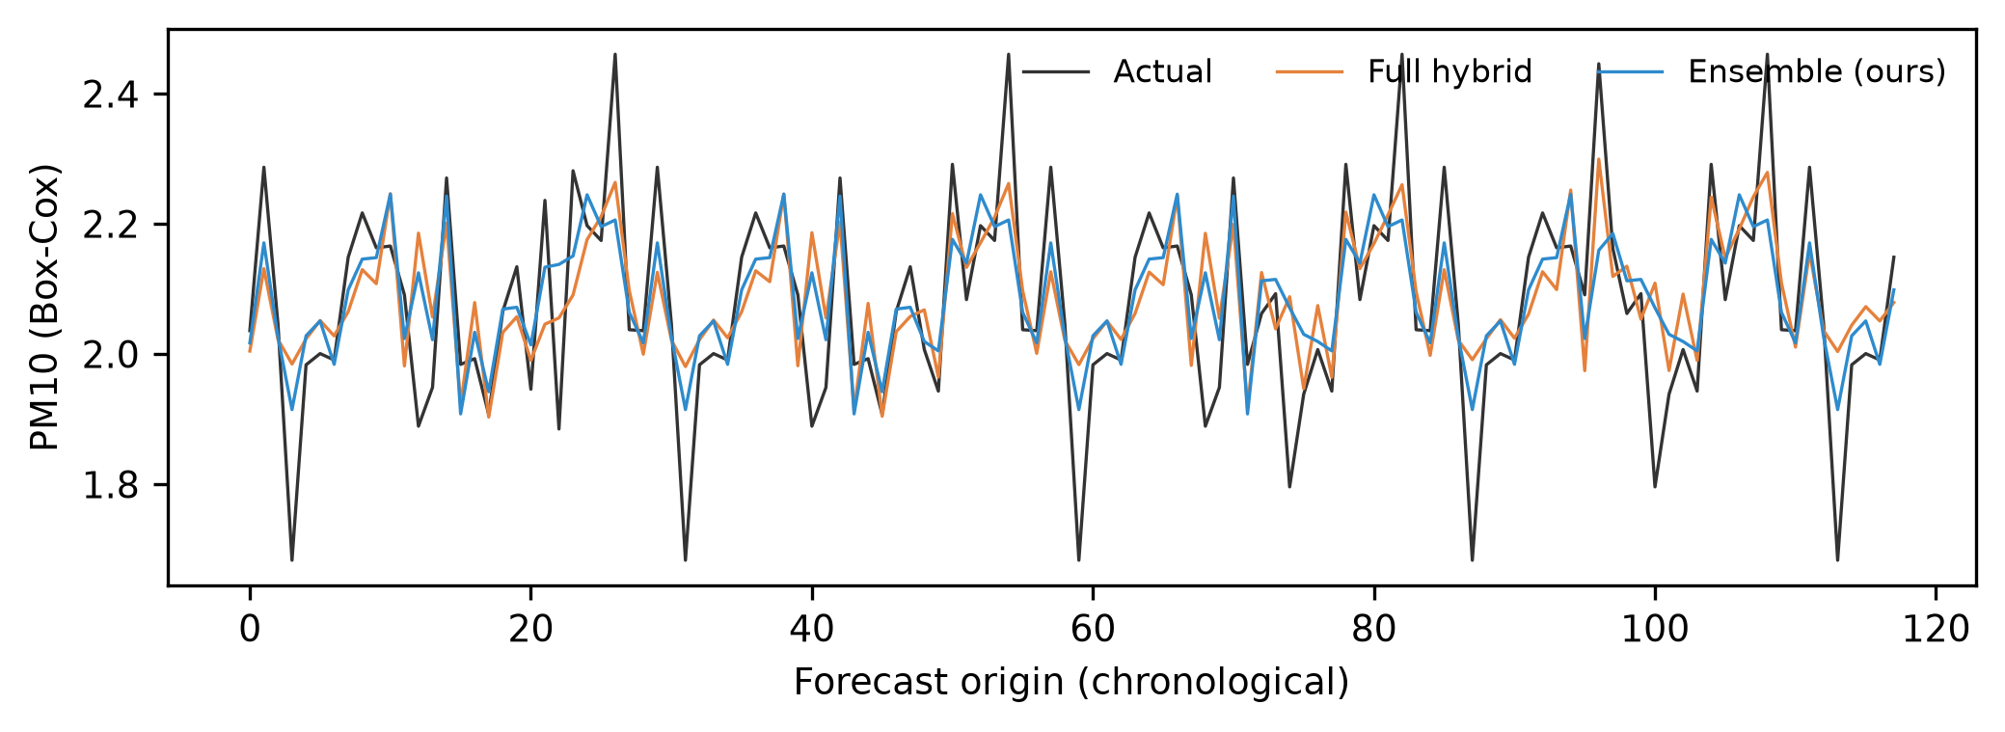
Figure A1. PM10 predictions: Actual vs. Deep Hybrid Baseline vs. Proposed Ensemble (h=1, Box-Cox scale).

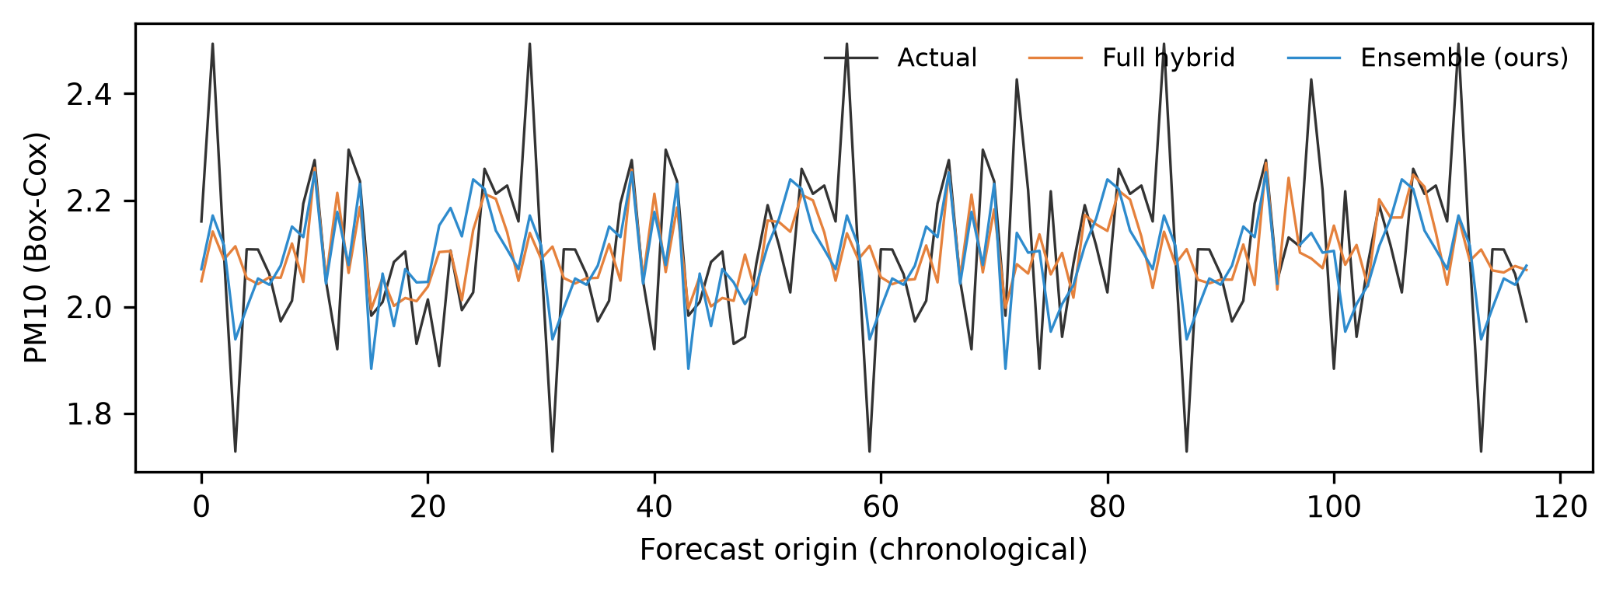
Figure A2. PM10 predictions: Actual vs. Deep Hybrid Baseline vs. Proposed Ensemble (h=7, Box-Cox scale).

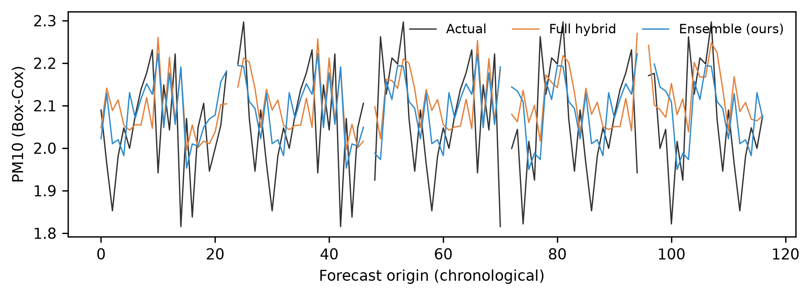
Figure A3. PM10 predictions: Actual vs. Deep Hybrid Baseline vs. Proposed Ensemble (h=30, Box-Cox scale).

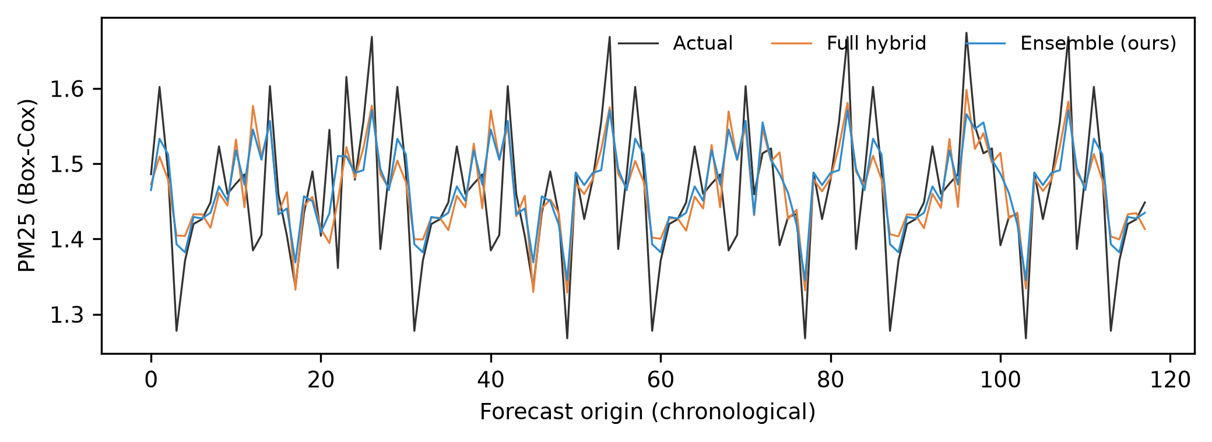
Figure A4. PM25 predictions: Actual vs. Deep Hybrid Baseline vs. Proposed Ensemble (h=1, Box-Cox scale).

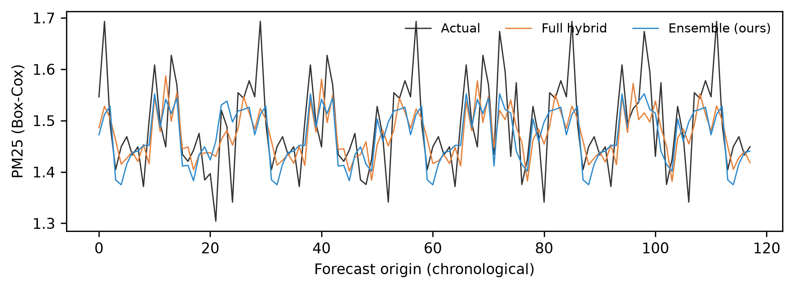
Figure A5. PM25 predictions: Actual vs. Deep Hybrid Baseline vs. Proposed Ensemble (h=7, Box-Cox scale).

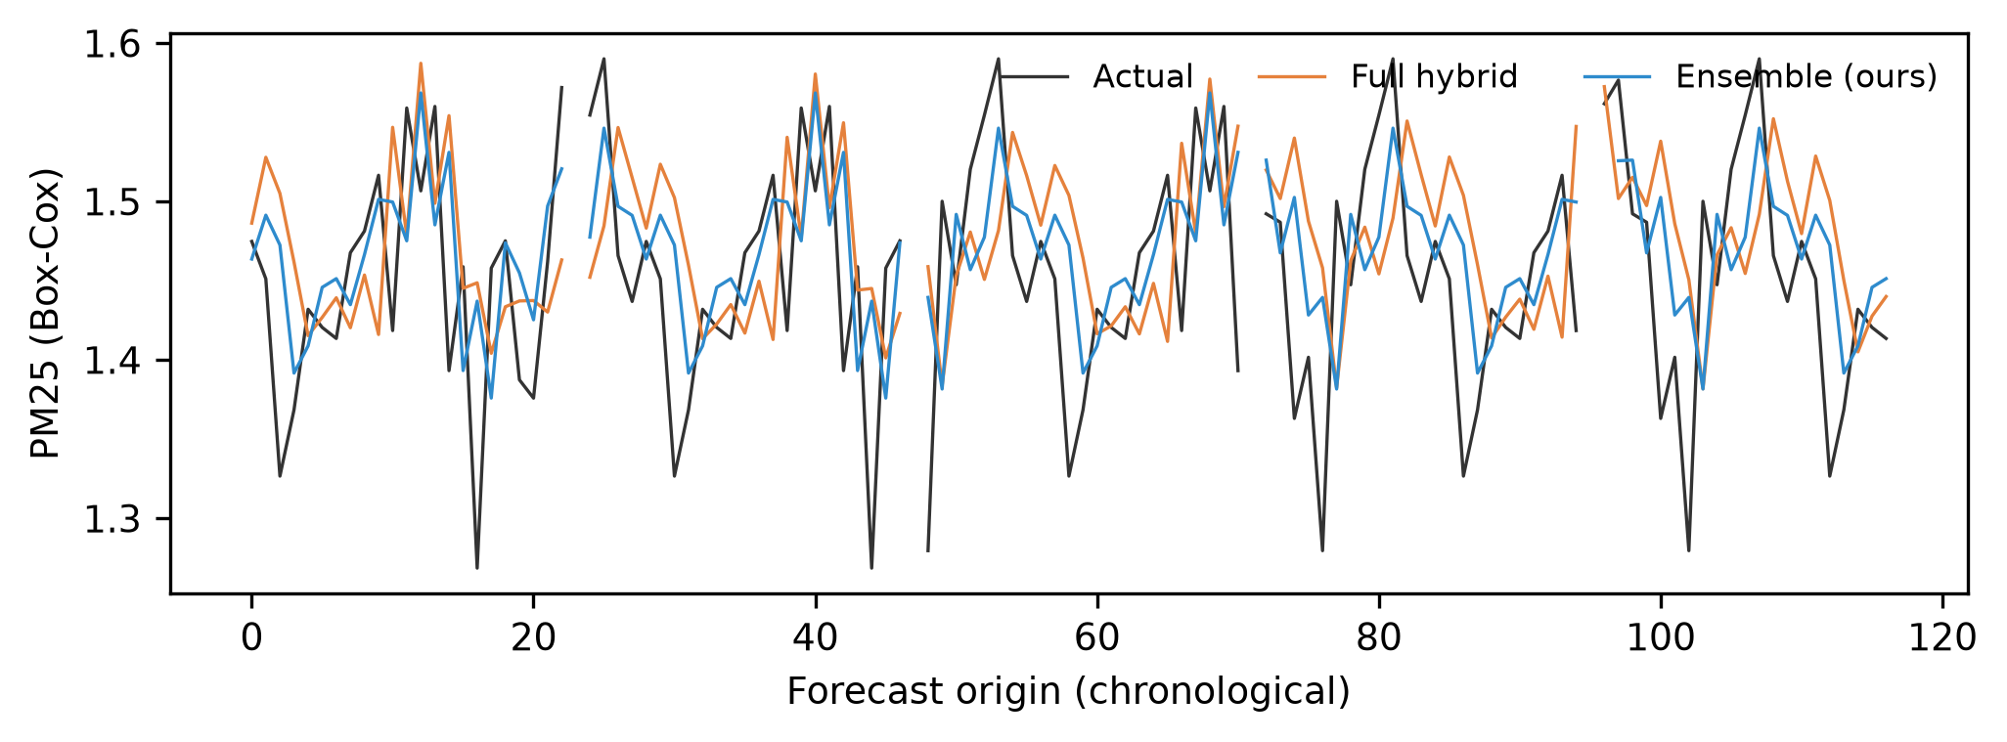
Figure A6. PM25 predictions: Actual vs. Deep Hybrid Baseline vs. Proposed Ensemble (h=30, Box-Cox scale).

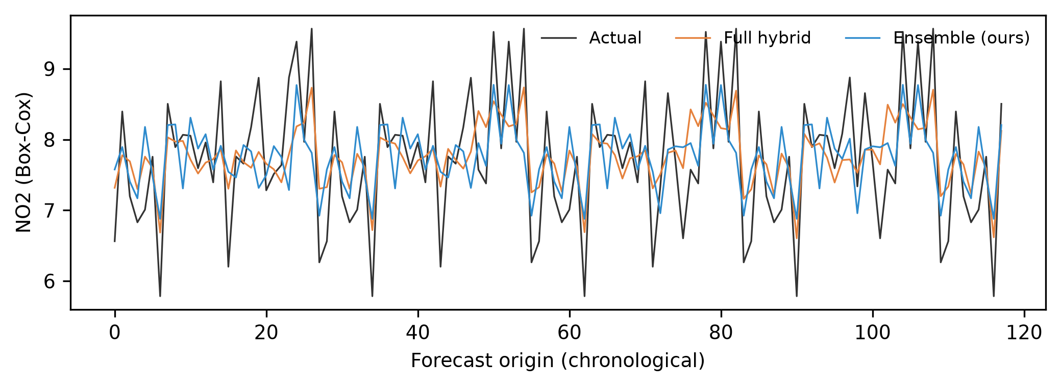
Figure A7. NO2 predictions: Actual vs. Deep Hybrid Baseline vs. Proposed Ensemble (h=1, Box-Cox scale).

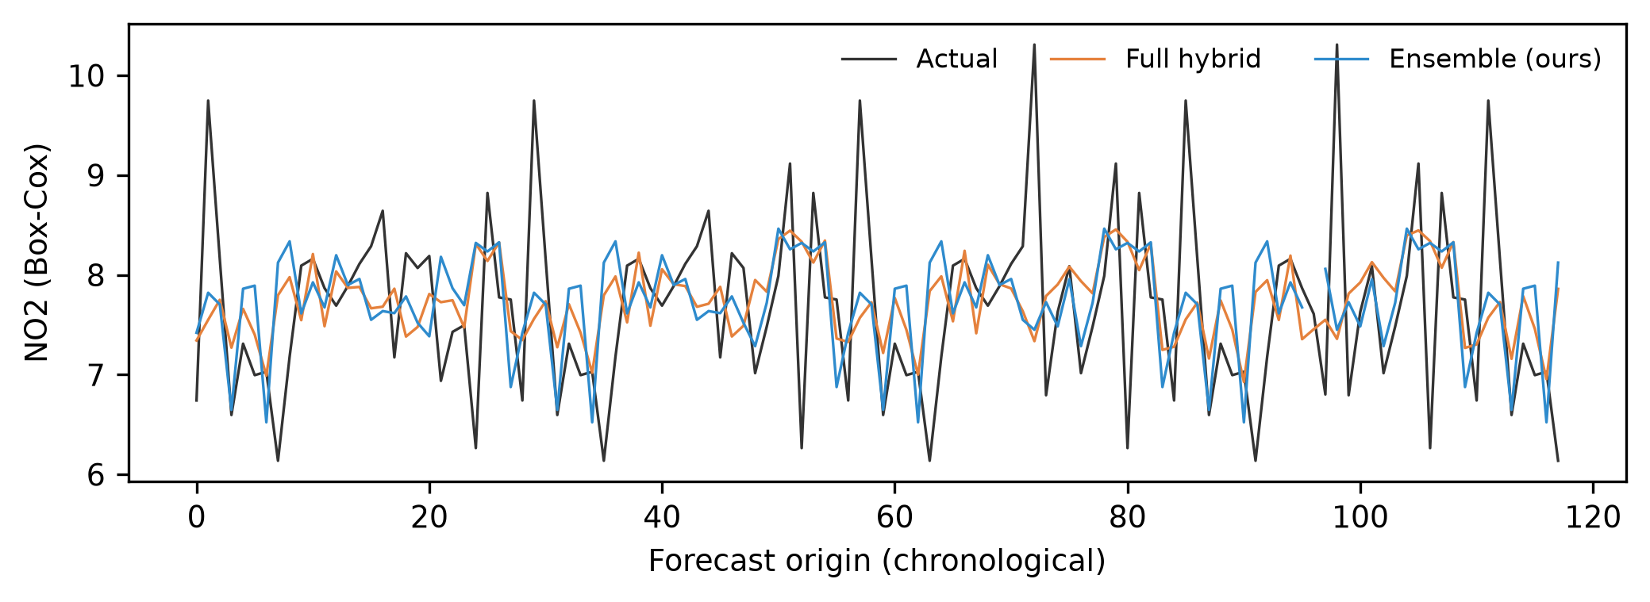
Figure A8. NO2 predictions: Actual vs. Deep Hybrid Baseline vs. Proposed Ensemble (h=7, Box-Cox scale).

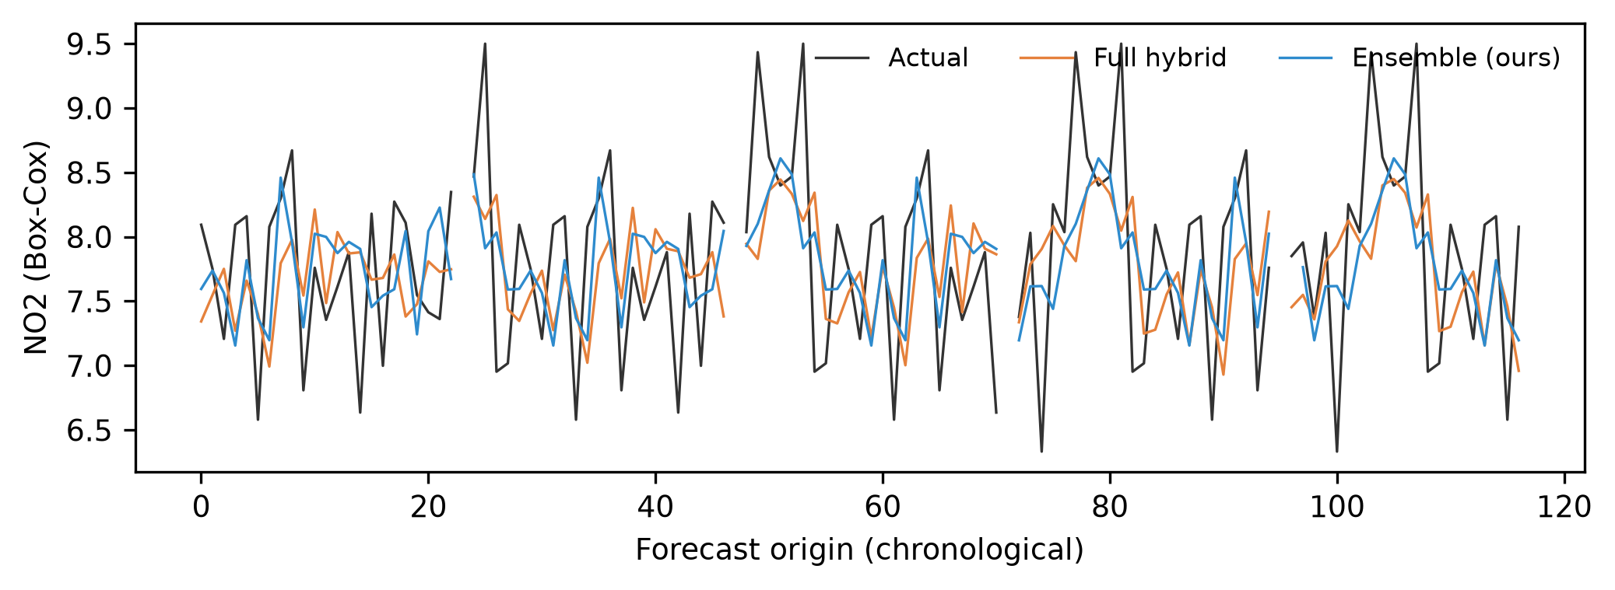
Figure A9. NO2 predictions: Actual vs. Deep Hybrid Baseline vs. Proposed Ensemble (h=30, Box-Cox scale).

References
- 1. Cabaneros, S.M.; Calautit, J.K.; Hughes, B.R. A review of artificial neural network models for ambient air pollution prediction. Environ. Model. Softw. 2019, 119, 285-309.
- 2. World Health Organization. WHO Global Air Quality Guidelines: Particulate Matter (PM2.5 and PM10), Ozone, Nitrogen Dioxide, Sulfur Dioxide and Carbon Monoxide; WHO: Geneva, Switzerland, 2021.
- 3. Zhang, G.P. Time series forecasting using a hybrid ARIMA and neural network model. Neurocomputing 2003, 50, 159-175.
- 4. Diaz-Robles, L.A.; Ortega, J.C.; Fu, J.S.; Reed, G.D.; Chow, J.C.; Watson, J.G.; Monada-Herrera, J.A. A hybrid ARIMA and artificial neural networks model to forecast particulate matter in urban areas: The case of Temuco, Chile. Atmos. Environ. 2008, 42, 8331-8340.
- 5. Hochreiter, S.; Schmidhuber, J. Long short-term memory. Neural Comput. 1997, 9, 1735-1780.
- 6. Freeman, B.S.; Taylor, G.; Gharabaghi, B.; The, J. Forecasting air quality time series using deep learning. J. Air Waste Manag. Assoc. 2018, 68, 866-886.
- 7. Necula, S.-C.; Hauer, I.; Fotache, D.; Hurbean, L. Advanced Hybrid Models for Air Pollution Forecasting: Combining SARIMA and BiLSTM Architectures. Electronics 2025, 14, 549. https://doi.org/10.3390/electronics14030549
- 8. Makridakis, S.; Spiliotis, E.; Assimakopoulos, V. The M4 Competition: 100,000 time series and 61 forecasting methods. Int. J. Forecast. 2020, 36, 54-74.
- 9. Hyndman, R.J.; Athanasopoulos, G. Forecasting: Principles and Practice, 3rd ed.; OTexts: Melbourne, Australia, 2021.
- 10. Ke, G.; Meng, Q.; Finley, T.; Wang, T.; Chen, W.; Ma, W.; Ye, Q.; Liu, T.-Y. LightGBM: A highly efficient gradient boosting decision tree. In Advances in Neural Information Processing Systems 30 (NeurIPS 2017); 2017; pp. 3146-3154.
- 11. Assimakopoulos, V.; Nikolopoulos, K. The theta model: A decomposition approach to forecasting. Int. J. Forecast. 2000, 16, 521-530.
- 12. Diebold, F.X.; Mariano, R.S. Comparing predictive accuracy. J. Bus. Econ. Stat. 1995, 13, 253-263.
- 13. Jiang, P.; Dong, Q.; Li, P. A novel hybrid strategy for PM2.5 concentration analysis and prediction. J. Environ. Manag. 2017, 196, 443-457.
- 14. Gilik, A.; Ogrenci, A.S.; Ozmen, A. Air quality prediction using CNN+LSTM-based hybrid deep learning architecture. Environ. Sci. Pollut. Res. 2022, 29, 11920-11938.
- 15. Nie, Y.; Nguyen, N.H.; Sinthong, P.; Kalagnanam, J. A time series is worth 64 words: Long-term forecasting with transformers. In International Conference on Learning Representations (ICLR 2023); 2023.
- 16. Makridakis, S.; Spiliotis, E.; Assimakopoulos, V. Statistical and machine learning forecasting methods: Concerns and ways forward. PLoS ONE 2018, 13, e0194889.
- 17. Bates, J.M.; Granger, C.W.J. The combination of forecasts. Oper. Res. Q. 1969, 20, 451-468.
- 18. Chen, T.; Guestrin, C. XGBoost: A scalable tree boosting system. In Proceedings of the 22nd ACM SIGKDD International Conference on Knowledge Discovery and Data Mining; 2016; pp. 785-794.
- 19. Hong, T.; Pinson, P.; Fan, S.; Zareipour, H.; Troccoli, A.; Hyndman, R.J. Probabilistic energy forecasting: Global Energy Forecasting Competition 2014 and beyond. Int. J. Forecast. 2016, 32, 896-913.
- 20. Box, G.E.P.; Cox, D.R. An analysis of transformations. J. R. Stat. Soc. Ser. B 1964, 26, 211-252.
- 21. Cleveland, R.B.; Cleveland, W.S.; McRae, J.E.; Terpenning, I. STL: A seasonal-trend decomposition procedure based on loess. J. Off. Stat. 1990, 6, 3-73.
- 22. Breiman, L. Random forests. Mach. Learn. 2001, 45, 5-32.
- 23. Harvey, D.; Leybourne, S.; Newbold, P. Testing the equality of prediction mean squared errors. Int. J. Forecast. 1997, 13, 281-291.

