## **What You’ll be Doing to Earn This Superbadge**

1. Convert Salesforce Lightning Design System markup into a fully functional Lightning component.
2. Theme Lightning components using the Lightning Design System and custom CSS.
3. Surface Lightning components in Lightning App Builder, Lightning Experience, the Salesforce App, and a Lightning application.
4. Create and invoke Apex controller methods to read data from custom objects.
5. Use component events and public methods to enable communication between tightly coupled components.
6. Create and raise application events to enable communication between loosely coupled components.
7. Raise application events to invoke native Salesforce functionality.
8. Dynamically enable and disable application functionality depending on whether a feature is available in the deployment environment.
9. Use Lightning Data Service to read and write custom object data.
10. Create and use external JavaScript in a Lightning component.
11. Troubleshoot your JavaScript and CSS.

## **Concepts Tested in This Superbadge**

* Developing components for use in Lightning App Builder
* Theming components
* Using JavaScript to handle user interactions
* Troubleshooting components
* Dynamically showing and hiding UX controls
* Reading and writing custom object data
* Communicating between components
* Leveraging native Salesforce functionality
* Using external JavaScript in a Lightning component

## **Prework and Notes**

* Grab a pen and paper. You may want to jot down notes as you read the requirements.
* Create a new Trailhead Playground for this superbadge. Using this org for any other modules or tasks can create problems in validating the challenge. Note that your Trailhead Playground already has My Domain turned on. Don’t edit the My Domain settings; you can lock yourself out of your Trailhead Playground.
* In the **Setup > Security Controls > Session Settings** section of Salesforce Classic, disable the component cache by deactivating the setting for **Enable secure and persistent browser caching to improve performance**.
* Install [this unmanaged package](https://login.salesforce.com/packaging/installPackage.apexp?p0=04tf40000011Bh4). (/packagingSetupUI/ipLanding.app?apvId=04tf40000011Bh4) This package contains all schema for the Apex logic needed to complete this challenge. You won’t need to make any changes to the data schema. If you have trouble installing this unmanaged package, follow the steps in [Trailhead Playground Management](https://trailhead.salesforce.com/modules/trailhead_playground_management).
* Sample data will automatically be added to your org after the installation of the unmanaged package is verified in Challenge 1. If you change orgs for any reason after passing the first challenge, you may execute the static method initData() found in GenerateData.apxc.
* Use the naming conventions specified in the requirements document to ensure a successful deployment.
* Review the data schema in your modified org as you read the detailed requirements below.
* When coding controller functions, use the naming convention **function foo(component, event, helper)** as opposed to **function foo(cmp,evt,hlp)**.
* When implementing events, you are required to select the appropriate event type according to best practices as well as the event’s usage in the application.

## **Use Case**

Over the past few years, HowWeRoll Rentals, the world’s largest RV rental company, has come to dominate the recreational vehicle (RV) rental marketplace. Their tagline is, “We have great service, because that’s How We Roll!” Their rental fleet includes every style of camper vehicle, from palatial mobile homes to old-school, chrome Airstream campers. If you’re plagued with wanderlust, they have the cure!

As the lead Salesforce developer for HowWeRoll, you have been instrumental in making the company a huge success. In order to continue to grow revenues, the company’s leadership has decided to expand beyond their core RV market and enter into the recreational boating industry, as surveys have shown that a large share of RV travelers are also boat owners. Instead of making a large investment in acquiring boats of their own, HowWeRoll plans to start a boat-sharing program whereby the company acts as a leasing agent for their customers’ boats. HowWeRoll is calling this new service Friends with Boats.

You’ve been given a week to implement a custom Lightning page, surfaced in Lightning Experience, the Salesforce App, and a Lightning application, that enables sales associates to enter information about their customers’ boats. You’ll also enable your team members to post comments and ratings about their experiences when they inspect each boat.

The custom search engine that you develop enables HowWeRoll’s sales associates to filter the list of boats based on boat type (such as fishing boat, pleasure boat, party boat) in order to match customer requests with the boating inventory.

### **Standard Objects**

You’ll work with the following standard objects:

* **Contact**—Organization contacts and boat owners.
* **User**—The people posting boat reviews and comments.

### **Custom Objects**

* **Boat**—Information about the boats that are owned by your contacts. This object contains a geolocation field so that you can plot its typical dock location on a map. This object has a master-detail relationship with the Contact standard object and a lookup relationship with **BoatType**.
* **BoatType**—A list of the different types of boats, such as fishing boat, power boat, sailboat, party barge.
* **BoatReview**—Comments on and ratings of boats.

### **Entity Diagram**

From Setup, enter Schema Builder in the Quick Find box, then select **Schema Builder** to view an interactive version of the image. For more information, see the Work with Schema Builder unit in the [Data Modeling](https://trailhead.salesforce.com/modules/data_modeling) module.

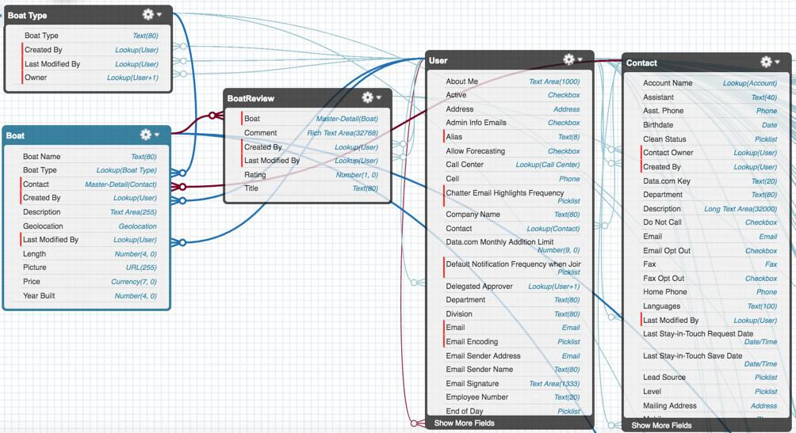

### **Application Design**

The time you spent meeting with key HowWeRoll stakeholders was worth your while. You came up with the following blueprint for the Lightning page.

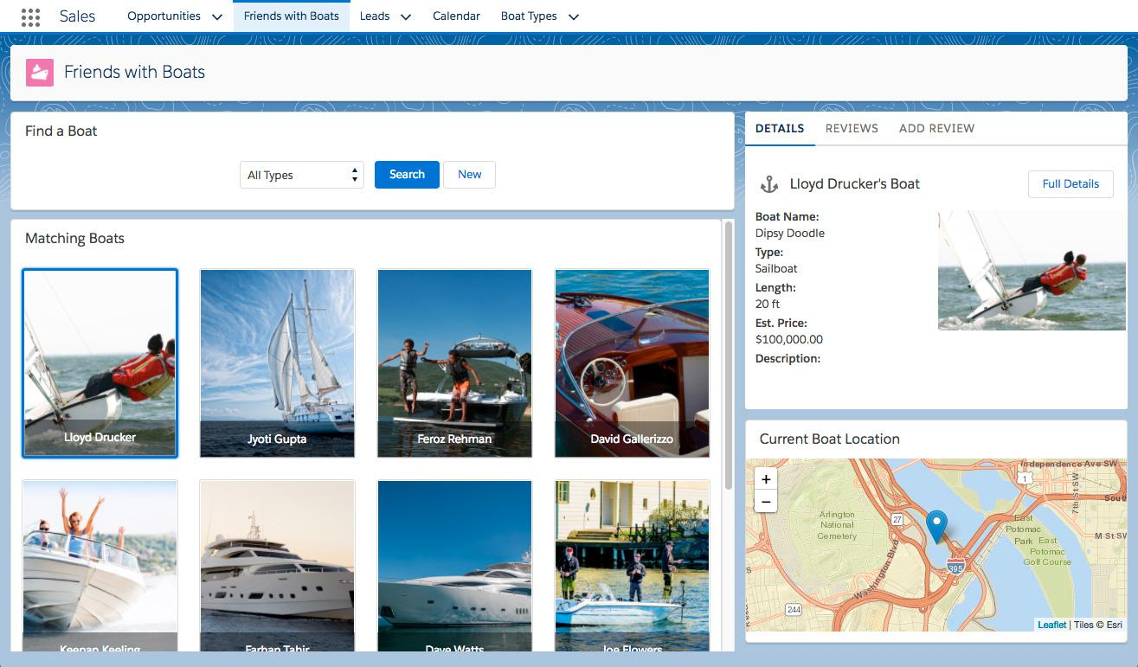

After assessing the size of the task ahead, you guzzle a cup of coffee, and decide that the best way to conquer a big task is to break it into smaller pieces. You plan out the following nine phases which, when completed, will result in a solid finished product.

## **Build the Search Form**

A journey of a million nautical miles begins with a single line of code, right?

Get your motor running by displaying a form with a dropdown that lists each boat type, along with Search and New buttons. The form component contains the dropdown and the buttons.

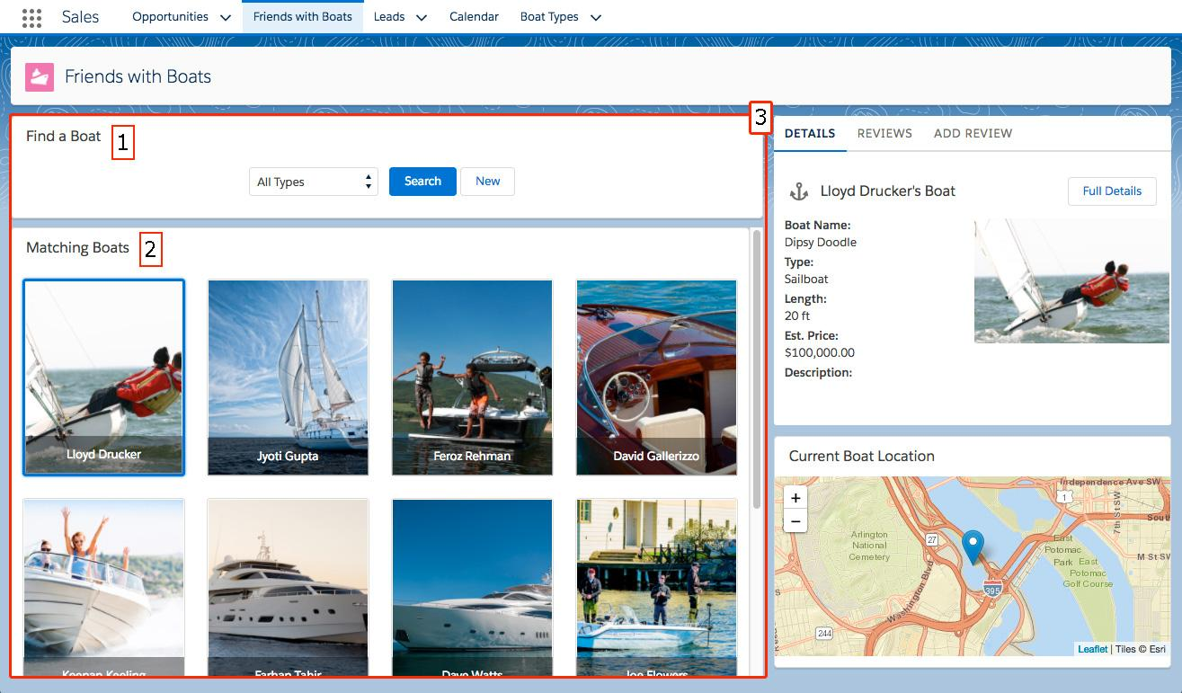

Figure 1.1: Building the Query-By-Example Interface

To build the form, create the following Lightning components. Each component is highlighted with its corresponding number in Figure 1.1.

1. **BoatSearchForm.cmp**—A form that lets users filter results by BoatType using a dropdown menu, with an empty string as the first and default value, and a label **All Types**. Include a Search button (blue variant) and a New button (white variant) that are center-aligned with the dropdown by using a <lightning:layout> component and its horizontalAlign attribute. When a user clicks **New**, a controller function fires the appropriate event to create a new Boat record. If a Boat Type is selected, the new Boat record defaults to the selected Boat Type. The form’s controller checks whether the event.force:createRecord event is supported by a standalone app and either shows or hides the New button according to best practices. When a user clicks **Search**, nothing happens because the filter functionality isn't implemented until the **Implement the Search Filter** phase.
2. **BoatSearchResults.cmp**—This component ultimately displays matching boats in a responsive layout, but we leave it empty for now.
3. **BoatSearch.cmp**—A container component that invokes both BoatSearchForm.cmp and BoatSearchResults.cmp and wraps each with a Lightning card with **Find a Boat** and **Matching Boats** as their respective titles. Add a margin-bottom of **10px** to the Find a Boat card to provide visual separation between the BoatSearchForm and BoatSearchResults components.

Create a Lightning page named **Friends with Boats** that uses the Main Column and Right Sidebar Layout. Put the BoatSearch component in the main column. Activate the page as a new tab in Lightning Experience and the Salesforce App. Lastly, create a Lightning application named FriendswithBoats.app that is directly accessible via its URL, with a layout that is similar to the Lightning page. Use <lightning:layout> to generate the app layout, and make sure that Lightning Design System styles are available to components in the app.

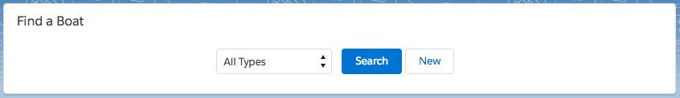Figure 1.2: The beginning of the search form.

Next, you begin displaying unfiltered search results in a responsive layout.

## **Populate the Search Results**

As fun as it is to see a list of boat types, it’s time to start showing off pictures of our beautiful boats! By the end of this phase, your page will display an unfiltered list of every boat in the HowWeRoll inventory.

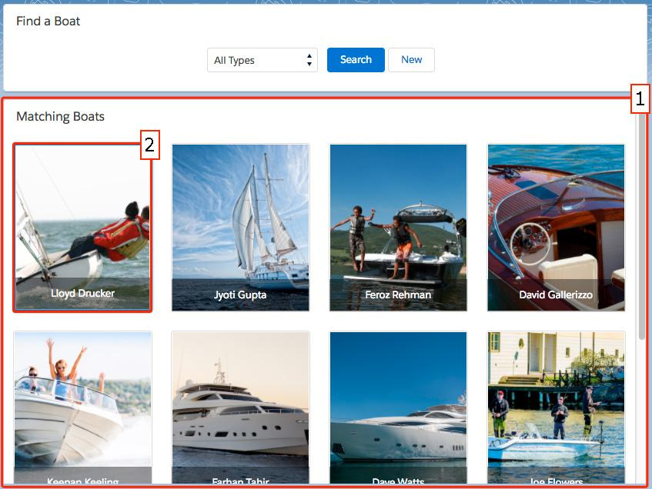Figure 2: The BoatSearchResults component (1) loops through data returned by an Apex method and generates BoatTile (2) components.

Create a Lightning component, BoatTile.cmp, that displays a boat for rent and has attribute boatof type Boat__c. Implement the tile as a themed lightning:button. Assign a class of tile to the lightning:button and use the following markup and CSS as a guide for how to show a boat’s picture inside BoatTile.cmp.

**Markup**

<lightning:button [more code here] > <div style="[set image as background here]" class="innertile"> <div class="lower-third"> <h1 class="slds-truncate">[output contact name here]</h1> </div> </div> </lightning:button>

Copy

**CSS**

.tile { position:relative; display: inline-block; width: 100%; height: 220px; padding: 1px !important; } .innertile { background-size: cover; background-position: center; background-repeat: no-repeat; width: 100%; height: 100%; } .lower-third { position: absolute; bottom: 0; left: 0; right: 0; color: #FFFFFF; background-color: rgba(0, 0, 0, .4); padding: 6px 8px; }

Copy

Use an Apex class, BoatSearchResults, to get the search results. This class uses a method, getBoats(), that takes a boatTypeId of type String and returns a list of boats filtered by that ID. When a user selects “All Types”, the empty string is passed to this function and it returns all boats.

BoatSearchResults.cmp gets the data returned by BoatSearchResults using a helper method named onSearch(), which stores the search results in a component attribute boats. Next, BoatSearchResults.cmp loops through the results and displays each one as a BoatTile.cmp, arranged in a responsive grid with multiple rows as displayed in Figure 2. Use a <lightning:layout>configured to allow multiple rows in order to generate the layout.

If the Apex class doesn’t return any results, display the message “No boats found” in the absolute center of BoatSearchResults.cmp.

In the next section, you make the search filter functional.

## **Implement the Search Filter**

Some people want to sail, some want to fish, and others just want to have fun. Make it easy for your associates to find the boats their customers want by hooking the search form up to the results component.

search form with sailboat selected, showing only sailboats in search resultFigure 3: Implementing the search filter. Selecting a Boat Type and clicking the Search Button filters the results.

Now it’s time to modify three of your components to use an event to let the boatTypeId traverse the following path:

BoatSearchForm -> BoatSearch -> BoatSearchResults -> Apex

Use a new event c:FormSubmit named formsubmit with an Object attribute named formDatato pass the selected boatTypeId—as a property of formData—from BoatSearchForm to its parent component BoatSearch. Do this via a controller function called onFormSubmit() attached to the Search button.

In the BoatSearch component, handle FormSubmit with a controller action named onFormSubmit. Pass formData.boatTypeId from the controller to a public method on the BoatSearchResults component called search.

Have the search method invoke controller function doSearch, which gets the boatTypeIdparameter from the method's arguments and sets the value of the component's boatTypeIdattribute. Then, call helper function onSearch(), which gets the newly updated boatTypeIdcomponent attribute and passes it to the server to request the list of boats. You can now display a list of boats and filter it by selecting a boat category and clicking **Search**.

## **Highlight the Selected Boat**

In order to get boat leases signed, the HowWeRoll sales team needs to do more than simply show some pretty pictures. They need quick access to the details for all of these boats—but first, they need to know which boat they’re looking at.

Make sure it’s clear to the user which boat is selected using a simple CSS rule in conjunction with a component attribute toggled by communication between components. You accomplish this by creating another event, and modifying the BoatTile and BoatSearchResults components.

a list of boats with one highlighted by a blue border to indicate its selectionFigure 4: Clicking a boat places a blue border (1) around the boat tile.

First, modify the BoatTile component. Add a Boolean attribute named selected with a default value of false. In the tile’s lightning:button, use the ternary operator to add a class attribute that sets the class to tile selected if v.selected is true and tile if v.selected is false. Add some CSS to the component bundle by specifying the following value for the border property of the selected class: 3px solid rgb(0, 112, 210);

Continue by defining a click handler on the BoatTile’s lightning:button that invokes controller function onBoatClick. Inside of onBoatClick, raise a new event called BoatSelect—registered on BoatTile—and use the event to send boatId to the BoatSearchResults component.

BoatSearchResults must handle the BoatSelect event by calling a controller function named onBoatSelect, which stores the boatId passed in via the event into a component attribute selectedBoatId. Use an iteration variable named boat and in the BoatSearchResultsinvocation of BoatTile, use a ternary operator to pass a value of true or false for the selectedattribute based on whether the currently output boat.Id is equal to the value stored in the component’s selectedBoatId attribute.

## **Display Boat Details**

Now that it’s clear which boat you’re viewing, it’s time to show details for the selected boat. Create a parent component BoatDetails with a tabset. Instantiate new child component BoatDetailinside of the Details tab. Use Lightning Data Service to make sure that the information is loaded properly and stays in sync with the rest of your application.

clicking tile higlights boatFigure 5.1: The BoatTile component (1) fires an event that the BoatDetails component (2) handles, and the display of the BoatDetail component (3) is updated.

The BoatDetails component is deployed in the top right sidebar of the Lightning page as depicted in Figure 5.1. It has two public attributes: boat (type Boat__c) and id (type Id). The component outputs three tabs labeled **Details**, **Reviews**, and **Add Review**, but hides the tabset if the component’s boat attribute is undefined.

Update the BoatTile component’s onBoatClick handler to fire an additional new event called BoatSelected, passing the selected boat of type Boat__c.

The BoatDetails component must execute a controller function named onBoatSelected when the BoatSelected event is fired from elsewhere within the application. onBoatSelected sets the id attribute of the BoatDetails component to the id of the boat that was transmitted with the event.

The BoatDetails component uses the targetFields syntax of force:recordData with an aura:id of service to load the following fields from the Boat__c object into the boat attribute of the component, based upon the BoatDetails component’s id attribute:

* Id
* Name
* Description__c
* Price__c
* Length__c
* Contact__r.Name
* Contact__r.Email
* Contact__r.HomePhone
* BoatType__r.Name
* Picture__c

The force:recordData calls an empty controller function named onRecordUpdated that is used in a later phase. The BoatDetails onBoatSelected function forces the Lightning Data Service to reload the specified record.

The BoatDetail component is used inside the Details tab of the BoatDetails component, and is invoked with an attribute boat of type Boat__c. It uses a lightning:card with a utility:anchor icon and a two-column layout built using <lightning:layout>. The left column displays text information about the boat, and the right column displays the boat image. The component uses the following markup and CSS to display the boat information, using the US currency format for price and allows embedded HTML in the description.

**Markup - Column 1**

<div class="slds-p-horizontal--small"> <div class="boatproperty"> <span class="label">Boat Name:</span> <span></span> </div> <div class="boatproperty"> <span class="label">Type:</span> <span></span> </div> <div class="boatproperty"> <span class="label">Length:</span> <span> ft</span> </div> <div class="boatproperty"> <span class="label">Est. Price:</span> <span></span> </div> <div class="boatproperty"> <span class="label">Description:</span> <span></span> </div> </div>

Copy

**Markup - Column 2**<div class="imageview" style="[set image as background here]" />

**CSS**

.label { font-weight: bold; display: block; } .boatproperty { margin-bottom: 3px; } .imageview { background-repeat: no-repeat; background-size: contain; height: 200px; margin: 2px; }

Copy

The card’s header is the Boat Contact’s name, concatenated with “’s Boat.” The Actions section of the card outputs a lightning:button labeled **Full Details** that calls a controller method named onFullDetails, which fires the appropriate event to redirect the user to the boat’s default detail page. However, the Full Details button is only output if the event is available on the deployment platform.

Boat Details are displayed as one tab on a card

Figure 5.2: Create a tabset and implement the display of boat details one of the tabs.

At this point, you can browse and filter boats, and view boat details. Next you add and display reviews, write secure JavaScript, and plot your boats on a map.

## **Add Boat Reviews**

Since HowWeRoll doesn’t own all of these boats, it’s important to keep track of positive and negative experiences when leasing them out to clients so that you can weed out the lemons. Accomplish this objective by adding the ability to submit reviews for each boat.

Clicking **Submit** performs the following actions:

* Creates a new record in BoatReview__c (using Lightning Data Service)
* Displays a toast message that the submission was successful
* Activates the Reviews tab, which will not yet display anything

Boat Details are displayed as one tab on a cardFigure 6: The Add Review form

### **Build the Form**

The Add Review tab of the BoatDetails component instantiates a new component AddBoatReview, passing it boat data using the component’s public attribute boat of type Boat__c. The component uses SLDS to define the form layout so that all form fields are arranged vertically. The title and description fields use appropriate Lightning components and are bound to the Name and Comment__c properties of the component’s private attribute boatReview of type BoatReview__c. Font selection options are suppressed from the rich text editor for the description field. The submit button uses the utility:save icon and invokes a controller method, onSave. The rating field is not added until the **Integrate Third-Party Scripts** phase.

### **Create a New BoatReview Record**

The component leverages Lightning Data Service to create a BoatReview__c record. Its call to force:recordData uses the targetFields syntax, has an aura:id with a value of “service”, references the boatReview attribute, and targets the following fields in the boatReview attribute: Id, Name, Comment__c, Boat__c. When the record is updated, it invokes a controller function named onRecordUpdated as detailed later in this section, and it has a private component attribute named recordError to which it writes service errors.

On component initialization, AddBoatReview invokes a helper function named onInit() by way of controller function doInit(), passing along component, event, and helper arguments. The onInit() function invokes the appropriate method of the Lightning Data Service to get a new BoatReview__c record, sets the Boat__c property of the record to the ID of the boat that was passed into the component, and places the result into the BoatReview component attribute, writing any error data to the browser’s JavaScript console using the console.log() command.

The onSave() controller function uses Lightning Data Service to save the record. After the record is saved, it shows a toast message if the force:showToast event is supported. If force:showToast is not supported, it displays a message using JavaScript’s alert() method. Lastly, it invokes helper.onInit() to reset the component to enable the user to add another review. Similar to the onSave() controller function, the onRecordUpdated() controller function uses either a toast message or JavaScript alert to notify the user that the record has been updated.

### **Change the Tab Focus to the Reviews Tab**

After the review has been successfully saved, a new event, BoatReviewAdded, is fired back to the BoatDetails parent component, which listens for the event, calls a controller function named onBoatReviewAdded and sets the currently selected tab to the Reviews tab, which has an id of boatreviewtab.

## **Display Boat Reviews**

Now that we’ve given users the ability to add reviews, let’s display them.highlighted section of boat reviewsFigure 7: Boat Reviews

### **Define the Component**

The Reviews tab of the BoatDetails component instantiates a new component, BoatReviews, passing it the selected boat information as a public attribute named boat of type Boat__c.

### **Load the Reviews for the Selected Boat**

An Apex class, BoatReviews, defines a function named **getAll()** that accepts an argument named **boatId** of type Id and returns a list of Boat Reviews containing the following fields from the BoatReview custom object:

* Id
* Name
* Comment__c
* Rating__c
* LastModifiedDate
* CreatedDate
* CreatedBy.Name
* CreatedBy.SmallPhotoUrl
* CreatedBy.CompanyName

The BoatReviews Lightning component contains a private component attribute named boatReviews as an array of BoatReview__c. The component’s init handler invokes a helper function onInit() by way of controller function doInit(). The onInit() function communicates with Apex, placing the result into the component’s boatReviews array attribute, handling any Apex errors gracefully.

### **Output the Boat Reviews**

The output of the boat reviews is based upon the [feeds component](https://lightningdesignsystem.com/components/feeds/) of the Lightning Design System. The BoatReviews component defines an independently scrolling area with a max height of 250px using a Lightning component that enables native scrolling in the Salesforce app. If no reviews are found, it outputs the text “No reviews available,” absolutely positioned at center within the scrollable region. If boat reviews were found, it uses an iteration variable named boatReview and outputs markup similar to what is described in the feeds component of the Lightning Design System, using all of the fields specified from the BoatReview.getAll() function as illustrated by Figure 7.

Sometimes, you want to know more about the person leaving the review, so the CreatedBy name is hyperlinked, invoking a controller function named onUserInfoClick(). The link contains a data-userid attribute that holds the value of boatReview.CreatedBy.Id. The onUserInfoClick() function retrieves the value from the data-userid attribute that was encoded on the hyperlink and fires an event that takes the user to the detail page of the review’s author.

### **Programmatically Refresh the Output**

The output of the component needs to be refreshed any time a user selects a different boat or adds a new review. The component has an event handler that reloads data from Apex any time that the value of the component’s boat attribute is changed. It defines a public method, refresh, that invokes the component’s doInit() controller method. The refresh() method is invoked from the BoatDetails.onBoatReviewAdded() method and the BoatDetails.onRecordUpdated()method.

## **Integrate Third-Party Scripts**

You’re a forward thinker. When the HowWeRoll inventory grows to thousands of boats (hey, nobody ever accused you of being a pessimist!), you need to be able to see a list of your best boats at a glance. Rather than start from scratch, you begin with a script developed by an associate, because as you know—good programmers write good code, but great programmers reuse good programmers’ code. The script implements a five-star rating scale. Unfortunately, your associate didn’t quite finish the script so you have to fill in a few details.

a rating component with stars is highlightedFigure 8.1: The FiveStarRating component in **edit** mode in the AddBoatReview component.

During this phase, you create the FiveStarRating component, which enables users to assign a rating by clicking a gold star, as illustrated by Figure 8.1.

a rating component with stars is highlightedFigure 8.2: FiveStarRating in read-only mode in the BoatReview component.

The component also has a read-only mode that outputs the rating but is not clickable, as illustrated by Figure 8.2.

### **Create the Component**

Your newest component, FiveStarRating, has a value attribute (Integer default 0) as well as a readonly attribute (boolean default false). Load the rating.css and rating.js files from the fivestar static resource into it. After the script has loaded, invoke a controller function named afterScriptsLoaded.

Add a change event listener that invokes a controller function named onValueChange, which fires when the value attribute of the component is changed. Add a <ul> tag to the component that has an aura:id of ratingarea and uses a ternary operator to set its class attribute to either c-rating or readonly c-rating depending on the value of the readonly attribute.

Use the following code as the basis for your controller logic. Replace the placeholders with the appropriate code.

afterScriptsLoaded : function(component, event, helper) { // var domEl = [get dom element of rating area] // var currentRating = [get value attribute of component] // var readOnly = [get readonly attribute of component] var maxRating = 5; var callback = function(rating) { component.set('v.value',rating); } component.ratingObj = rating(domEl,currentRating,maxRating,callback,readOnly); }, onValueChange: function(component,event,helper) { if (component.ratingObj) { var value = component.get('v.value'); component.ratingObj.setRating(value,false); } }

Copy

### **Deploy the Component**

Instantiate the component in the AddBoatReview component and the BoatReviews component. The value of the component is bound to the Rating__c field of the BoatReview custom object.

## **Plot the Marker on the Map**

Once they sign a lease, HowWeRoll clients need to know where to pick up the boats they’re leasing. For the grand finale, you deploy a mapping component to show where your boat docks, and you also update the component to listen for a PlotMapMarker event from anywhere in the application.

highlighted map componentFigure 9: Clicking the BoatTile component (1) fires the PlotMapMarker event, passing latitude and longitude. The Map component (2) listens for PlotMapMarker and places a marker at the specified latitude and longitude.

The Map component and its controller were included in the unmanaged package that you installed as part of the prework for this superbadge, so you only need to make a few changes. Before you begin, review each of the files that came with the component to get a feel for how it works.

Create a design resource that enables a business user to set the width and height of the map component. Then, add the Map component to the Lightning page, below the BoatDetailscomponent in the right sidebar as illustrated by Figure 9. Update the Map component by wrapping the <div> with aura:id map in a lightning:card with title **Current Boat Location** to keep the UI consistent with the other elements on the page. Remove the map’s 1px dotted border. Then, create a new PlotMapMarker event which includes four string attributes: sObjectId, lat, long, and label. The event is fired when a user clicks a boat from the BoatTile component, but the component also listens for the event from any other component in the application. In the event listener for PlotMapMarker, use the latitude and longitude that were passed through the event to update the boat’s location.

Complete each challenge to earn your superbadge

1

Before you start

Complete all of the prework, including the installation of the unmanaged package.

+500 points

2

Build the query-by-example form

Create a form displaying a dropdown that lists each boat type, along with **Search** and **New** buttons, using **BoatSearchForm.cmp**, **BoatSearchResults.cmp**, and **BoatSearch.cmp**, as described in the business requirements.

Add these components to a Lightning page named **Friends with Boats**, and activate the page as a new tab in Lightning Experience and the Salesforce App. Lastly, create a Lightning application named **FriendswithBoats.app** that has a layout that is similar to the Lightning page.

+500 points

3

Implement the BoatTile and BoatSearchResults components

Create a new **BoatTile** component and update your **BoatSearchResults** container to loop through all the results returned from an Apex controller **BoatSearchResults** to display an unfiltered list of every boat that HowWeRoll leases.

Define the method **getBoats()** in **BoatSearchResults**, to return search results as described in the business requirements. **BoatSearchResults.cmp** displays search results with a helper method, **onSearch()**, and displays each result as a **BoatTile** component.

+500 points

4

Implement the search filter

Create a **FormSubmit** event to allow your **BoatSearchForm**to pass the selected boat type to the **BoatSearchResults**component, which queries Apex and stores the results.

Handle **FormSubmit** with a controller action, **onFormSubmit**, and pass **formData.boatTypeId** from the controller to **search**, a public method on the **BoatSearchResults** component. The search function uses a helper function, **onSearch()**, and controller function, **doSearch()**, to get the list of boats.

+500 points

5

Highlight the selected boat

Fire a new **BoatSelect** event when a **BoatTile** is clicked, which sets the **selectedBoatId** on **BoatSearchResults** and in turn toggles the **selected** attribute on the right **BoatTile**, triggering the addition of a CSS class that shows a dark blue border around the selected boat as shown in the requirements.

Do this by defining a click handler on the BoatTile’s **lightning:button** that invokes controller function **onBoatClick**, and raises the **BoatSelect** event, as laid out in the business requirements.

+500 points

6

Display boat details

Create two new components—**BoatDetails** and **BoatDetail**—as well as a new event **BoatSelected**. Raise the new event from BoatTile, and leverage Lightning Data Service to output boat details. Deploy the **BoatDetails** component in the top right corner of the Lightning page.

+500 points

7

Add boat reviews

Instantiate an **AddBoatReview** component inside the Add Review tab and display the form. When a user clicks **Submit**, save the record using Lightning Data Service and fire a **BoatReviewAdded** event that the **BoatDetails** parent component listens for so that it can switch the active tab to Reviews. Don’t worry about displaying the reviews yet.

+500 points

8

Display boat reviews

Inside the Reviews tab, invoke a **BoatReviews** component that queries Apex and outputs the results based upon the **Feeds** component of the Lightning Design System, as shown in the business requirements. Hyperlink the user’s name to their record in Salesforce when possible.

+500 points

9

Integrate third-party scripts

Create a **FiveStarRating** component with your coworker’s modified JavaScript to enable associates to give the boats a rating from 1–5 stars. Give the component **edit** and **read**modes that are used in the form and output, respectively.

+500 points

10

Plot the Map Marker on the Map

Deploy a mapping component to show where your boat docks. The **Map** component and its controller were included in the unmanaged package you installed as part of this superbadge. The component listens for the **PlotMapMarker**event, which is fired when a user clicks a boat from the **BoatTile** component.