Data Model Documentation
AU Property Data Warehouse
Task 5 - AU Property Data Collection and Consolidation
Prepared by: Srikanth
This document explains, how the database for this task is organised - what tables exist, what each one is for, and how they connect to each other. Just a simple walkthrough of the design.

The Big Picture: Two Layers
The database has two “layers” of tables, and it helps to think of them like a kitchen:
- The staging layer (schema: stg) is like the grocery bags you just brought home from the shops. Nothing's been washed, chopped, or prepped yet - it's just sitting there, roughly sorted into bags (one bag per Excel file, 14 bags/tables in total).
- The data warehouse layer (schema: dw) is like the meal that's actually ready to eat. The ingredients from all those bags have been washed, combined, and organised into 6 final tables that are actually easy to use for reports or analysis.
The reason for splitting it this way: if something goes wrong with the “cooking” step, I can always go back to the raw bags (staging) and try again, without having to re-download anything from the original Excel files.

How the Final Tables Connect
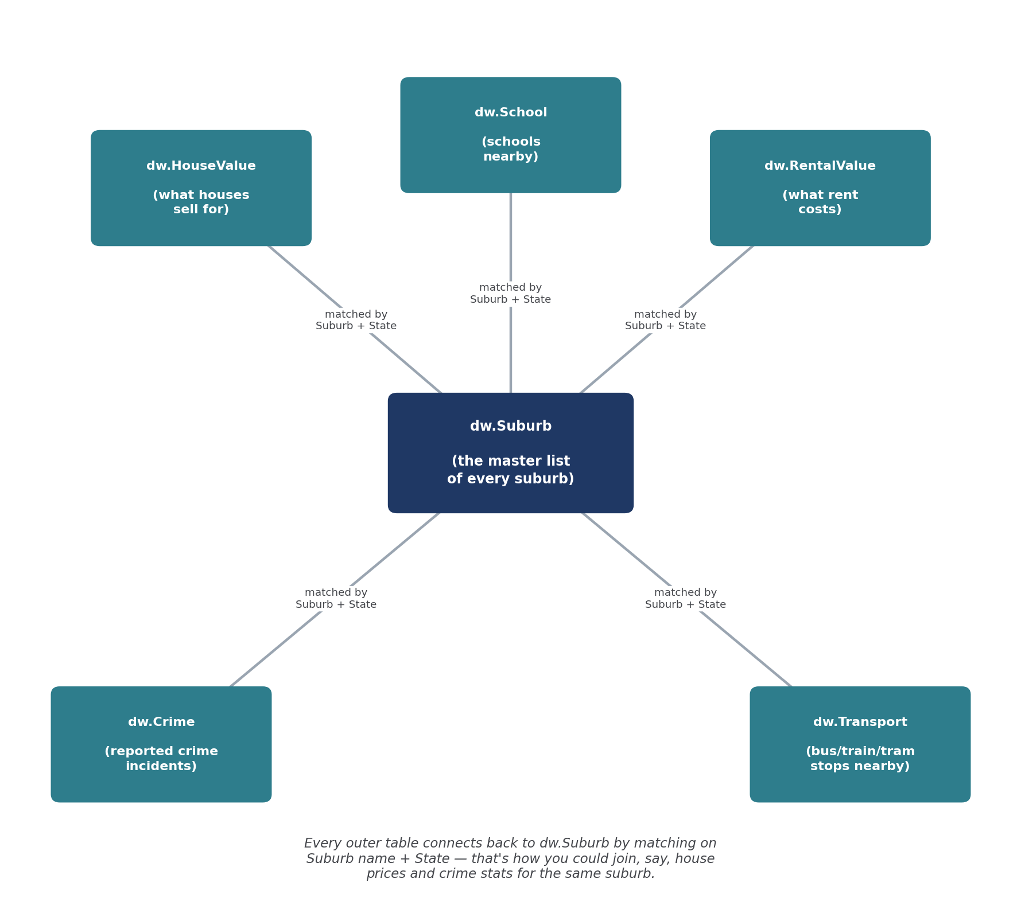
Figure 1. The 6 final (dw) tables, and how they link back to the master suburb list.

The Staging Tables (the “raw grocery bags”)
There are 14 staging tables - basically one for every Excel file I was given. Each one keeps the same column names as its original file, so nothing gets lost or guessed at. I also added 3 extra columns to every staging table: a unique row ID, which file the row came from, and when it was loaded - just so I can always trace a row back to its source if needed.
Staging Table | Comes From | What's In It
stg.Suburb | AUS Suburb Data.xlsx | Every Australian suburb, its city/state, and map coordinates
stg.Crime | AUS Crimes Data.xlsx | Crime incident counts by suburb and offence type
stg.HouseValue_NSW/SA/VIC | House Value files (x3) | Median house sale price per suburb
stg.RentalValue_NSW/SA/VIC | Rental Value files (x3) | Typical rent by suburb and property type
stg.School_NSW/SA/VIC | School files (x3) | Schools by suburb, with type and address
stg.Transport_NSW/SA/VIC | Transport files (x3) | Bus/train/tram stops by suburb

The Final (dw) Tables - one by one

dw.Suburb - the master list
Every suburb in Australia, cleaned up so the name is always uppercase and has no stray spaces. Every other table below links back to this one by matching Suburb name + State.
- Columns: Suburb, City, State, StateCode, Latitude, Longitude

dw.HouseValue - what houses sell for
Combines the NSW, SA and VIC house price files into one table. NSW's file had a postcode column the other two didn't, so postcode is just left blank for SA/VIC rows. I also removed 252 exact duplicate rows that were sitting in the Victoria file.
- Columns: StateCode, Suburb, Postcode, HouseValue

dw.RentalValue - what rent costs
Combines the three states' rental files, which luckily all used the same column layout already, so this was a straightforward merge.
- Columns: StateCode, Suburb, RentalHouseType, RentalAmount

dw.School - schools near each suburb
Combines the three states' school lists. Each state named its columns a bit differently (e.g. one called it “postcode”, another “Post Code”), so I renamed them to match on the way in.
- Columns: StateCode, Suburb, Postcode, SchoolCode, SchoolName, SchoolType, Address

dw.Transport - nearby bus/train/tram stops
Combines the three states' transport stop lists. One small naming quirk here too - NSW called its longitude column “stop_long” while the others called it “stop_lon” - but they both map to the same final column.
- Columns: StateCode, Suburb, StopName, Mode, StopLat, StopLong

dw.Crime - reported crime by suburb
This one only had a single national file to begin with, so there was no merging needed - just cleaning up the suburb name formatting.
- Columns: StateCode, Suburb, Postcode, OffenceCategory, OffenceSubcategory, RecordedIncidents

How You'd Actually Use This
Because every dw table shares the same Suburb + State “key”, you can combine them however you like for analysis. For example, to compare house prices against crime rates for the same suburb, you'd join dw.HouseValue and dw.Crime on matching Suburb and StateCode values. The same idea works for pulling together house prices + nearby schools + nearby transport for a single suburb - which is really the whole point of organising the data this way.

