Star Schema Design Document
AU Property Data Warehouse — Part 2
BI Developer / Data Analyst Advanced Sprint

Why I Needed a Star Schema
In Part 1 I already got all the property data into the warehouse, but it was sitting in six separate “clean” tables (one for house prices, one for rent, one for crime, and so on), all connected loosely by suburb name. That's fine for storing the data, but it's not great for actually asking questions of it. If I wanted to compare house prices against crime rates in the same suburb, I'd have to write a fresh join every single time and remember exactly how each table was structured.
A star schema fixes that. The idea (it comes from a method called Kimball dimensional modeling) is to split everything into two kinds of tables: fact tables, which hold the actual numbers you care about, and dimension tables, which hold the descriptive details you use to slice those numbers up. You put one or more fact tables in the middle and surround them with the dimension tables they need, and visually it looks a bit like a star — hence the name.
I didn't do this randomly. Before building anything, I used a planning tool called a Bus Matrix to work out what my fact tables and dimension tables actually needed to be. That's covered in the next section.

Bus Matrix
A Bus Matrix is just a grid: down the side you list your business processes (basically, the things you want to measure — these become your fact tables), and across the top you list your dimensions. Wherever a process needs a dimension, you put an X. This is what made it obvious that Suburb belongs in the middle of everything — it's the only dimension every single one of my processes needs.
Business Process (Fact) | DimSuburb | DimOffenceType | DimRentalHouseType | DimSchool | DimTransportStop
House Value | X
Rental Value | X |  | X
Crime Incidents | X | X
School Presence (factless) | X |  |  | X
Transport Access (factless) | X |  |  |  | X

The Diagram
This is the finished layout. DimSuburb sits in the middle because every single fact table needs it — that makes it a “conformed dimension”, which just means it's shared and reused instead of rebuilt for each fact.
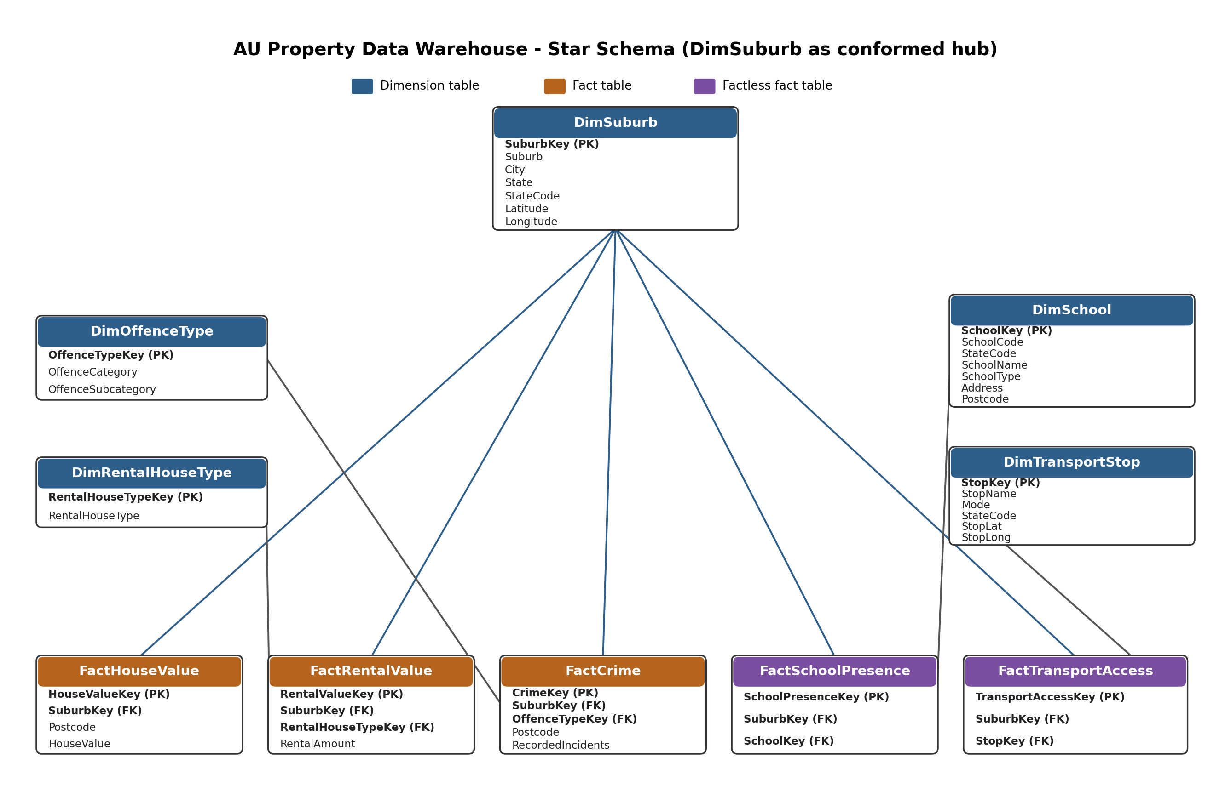

Dimension Tables
Dimension tables are the “who, what, where” tables — they don't hold numbers to add up, they hold descriptions you use to group or filter by.

DimSuburb
The hub of the whole design. Every fact table points back to this one.
- SuburbKey – a made-up ID number I generate myself (a surrogate key), not the actual suburb name. This is standard practice — it keeps the fact tables small and fast, and it means I can add a special “Unknown” row (key = -1) for suburbs that don't match anything, which I explain further down.
- Suburb, City, State, StateCode – the descriptive geography.
- Latitude, Longitude – kept for potential mapping later.

DimOffenceType
Used only by the crime fact. Holds the offence category and subcategory (e.g. “Against justice procedures” / “Other offences against justice procedures”).

DimRentalHouseType
Used only by the rental fact. Just one column really — things like “1 BR Flat” or “3 BR House”.

DimSchool
Used by the school presence fact. Holds the school code, name, type, and address. School codes repeat across states, so I had to use SchoolCode plus StateCode together as the real-world identifier, not SchoolCode alone.

DimTransportStop
Used by the transport access fact. Holds the stop name, transport mode (train/bus/tram), state, and coordinates. Stop names aren't unique across states either, so again I combined several columns together to identify a stop uniquely.

Fact Tables
Fact tables are where the actual measurable numbers live. Before building any of them I wrote down the “grain” for each one — basically a one-line description of what a single row means — because getting that wrong is the easiest way to mess up a star schema.

FactHouseValue
Grain: one row per suburb. Measure: HouseValue (the median house price). Since this is a median, it shouldn't be added up across suburbs — you'd average it instead.

FactRentalValue
Grain: one row per suburb + rental house type. Measure: RentalAmount (weekly rent). Same deal — average it, don't sum it, when combining across suburbs.

FactCrime
Grain: one row per suburb + postcode + offence category + subcategory. Measure: RecordedIncidents. This one actually is safe to add up (a “fully additive” measure), since it's a count of real incidents.

Factless Fact Tables
The task brief specifically asked me to look into factless fact tables, so here's what I found and why I ended up needing two of them.
A factless fact table is exactly what it sounds like — a fact table with no number in it at all. Instead of measuring an amount, it just records that something happened, or that a relationship exists between two dimensions. You don't SUM anything from it, you COUNT the rows instead.
I needed this pattern for School and Transport because the source data for those two doesn't give me anything to measure. A school doesn't have a “value” the way a house does — all the raw data tells me is that a particular school exists in a particular suburb. Same with a transport stop. So instead of forcing a fake number in there, I just record the relationship:
- FactSchoolPresence – one row per school-in-a-suburb. To answer “how many schools does this suburb have” I just COUNT the rows (or COUNT DISTINCT the school key).
- FactTransportAccess – one row per transport-stop-in-a-suburb. Same idea — COUNT the rows to see how many stops (or which modes) a suburb has access to.

How the Tables Relate to Each Other
Every fact table has a foreign key back to DimSuburb, which is what lets me join data from completely different source files (house prices, crime, schools) through one shared column instead of matching on the raw suburb name every time.
- FactHouseValue.SuburbKey → DimSuburb.SuburbKey
- FactRentalValue.SuburbKey → DimSuburb.SuburbKey, FactRentalValue.RentalHouseTypeKey → DimRentalHouseType.RentalHouseTypeKey
- FactCrime.SuburbKey → DimSuburb.SuburbKey, FactCrime.OffenceTypeKey → DimOffenceType.OffenceTypeKey
- FactSchoolPresence.SuburbKey → DimSuburb.SuburbKey, FactSchoolPresence.SchoolKey → DimSchool.SchoolKey
- FactTransportAccess.SuburbKey → DimSuburb.SuburbKey, FactTransportAccess.StopKey → DimTransportStop.StopKey
One thing worth explaining: not every suburb mentioned in the source files actually exists in the official suburb list I used to build DimSuburb (a few, like a naval base and a federal territory, genuinely aren't “real” suburbs). Rather than let those rows break the whole load, I added one extra row to DimSuburb with SuburbKey = -1 and Suburb = “Unknown”, and any fact row that can't find a real match falls back to that instead of getting dropped or crashing the load. This is a standard trick in dimensional modeling, sometimes called the “Unknown member”.

