SSRS Report Documentation
AU Property Data Warehouse - Part 3 (SSRS Reports)
Prepared by: Srikanth
This document covers the five SSRS reports built for this task, what each one shows, how the parameters work, and how each one answers the specific requirement it was built for. The yellow dashed boxes below are placeholders - screenshots go in those spots (design view, the parameter dropdowns, and the rendered report with sample data, same three shots for each report).

Parameters - Same Pattern on Every Report
All five reports use the exact same three parameters, so this only needs explaining once:
- State, City, Suburb - each dropdown has an (All) option sitting at the top, above the real values. City's dropdown only shows cities belonging to whichever State is picked, and Suburb's dropdown only shows suburbs belonging to whichever State + City is picked (cascading parameters).
- Picking (All) for a parameter means "give me everything at this level" - (All) is the default for all three, so running a report with no changes at all just shows every row it has. I originally had this working through a blank/NULL selection instead of a typed (All) value, but switched to (All) after running into an SSRS Report Designer bug where the null-handling on cascading query parameters would randomly refuse to accept no selection (see the Implementation Summary doc, challenge #11, for the full story). (All) does the same job and doesn’t have that problem.
- If a state, city or suburb genuinely has no data for that particular report (most of the country outside NSW, SA and VIC has none at all, since only those three states were collected in Part 1), the report shows a plain message like "No house value data available for the selected suburb." instead of an empty-looking table.

1. House Value Report (RPT_HouseValue.rdl)
Requirement it addresses: “Given state, city, suburb, display house value.”
This is a straightforward Table, grouped State → City → Suburb, showing Postcode and House Value (formatted as currency) for whichever suburb is selected. Data comes from rpt.usp_Rpt_HouseValue, which joins star.FactHouseValue to star.DimSuburb.
Design view
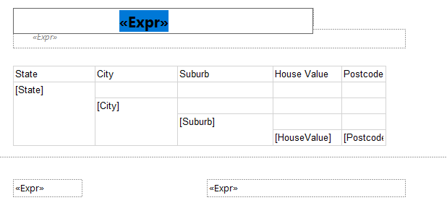
Parameter dropdowns
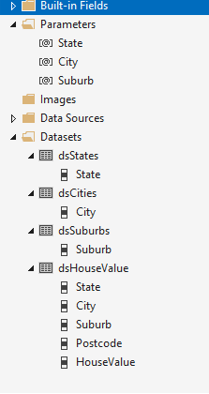
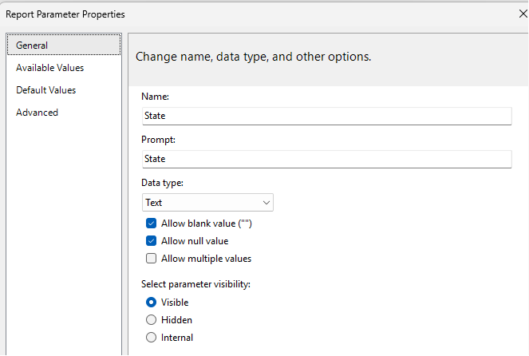
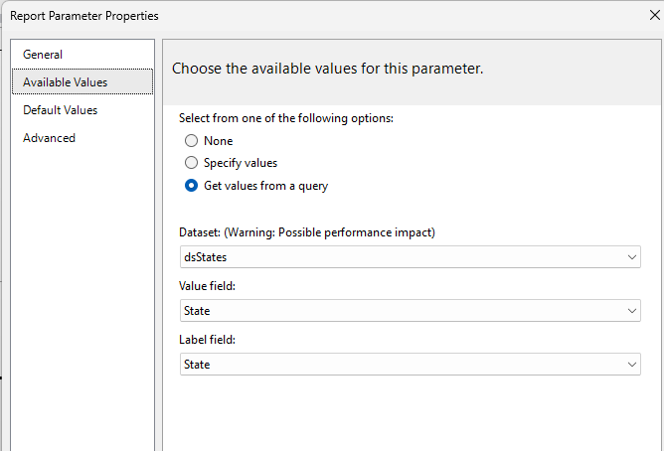
Rendered report with sample data
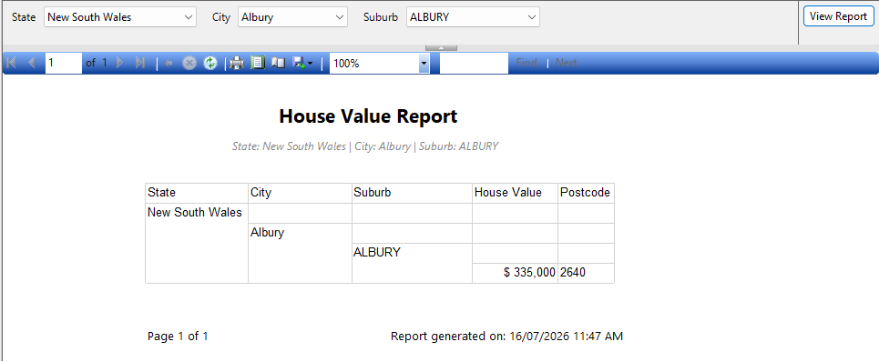

2. Rental Value Report (RPT_RentalValue.rdl)
Requirement it addresses: “Given state, city, suburb, display rental value.”
This one's a Matrix instead of a plain table, because a single suburb usually has rent figures for several house types (1 BR Flat, 2 BR House, and so on). Rows are State → City → Suburb, columns are Rental House Type, and each cell shows the rental amount for that suburb + house type combination. Data comes from rpt.usp_Rpt_RentalValue, joining star.FactRentalValue to star.DimSuburb and star.DimRentalHouseType. Using a matrix here means the rent breakdown by house type is visible at a glance instead of repeating the suburb name on several separate rows.
Design view
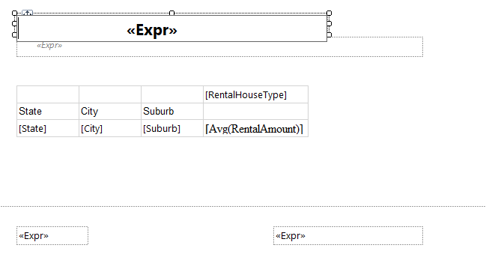
Parameter dropdowns
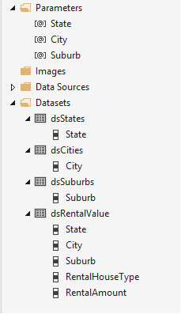
Rendered report with sample data
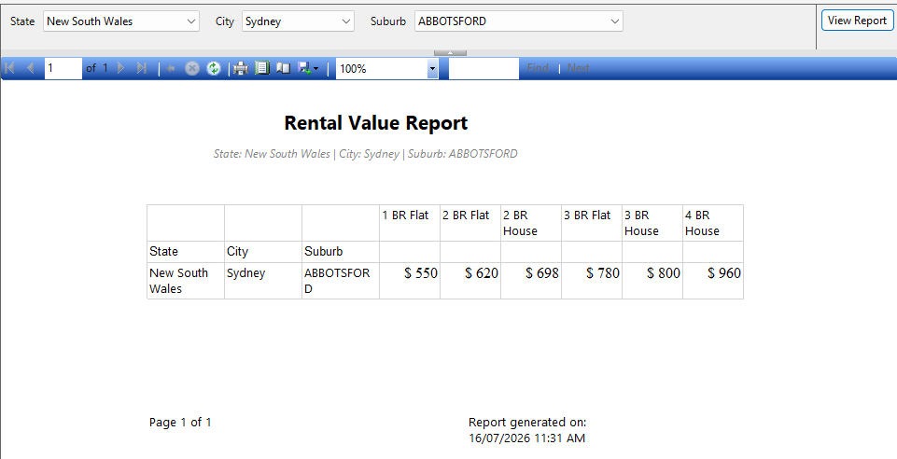

3. Local Transport Stations Report (RPT_TransportStations.rdl)
Requirement it addresses: “Given state, city, suburb, display local transport stations.”
A Table grouped State → City → Suburb → Mode, listing each stop's name and coordinates (StopLat/StopLong) under whichever transport mode it belongs to (train, bus, tram). Data comes from rpt.usp_Rpt_TransportStations, joining star.FactTransportAccess to star.DimSuburb and star.DimTransportStop. Grouping by Mode means a suburb with both train and bus stops shows them as two separate, clearly labelled groups instead of one mixed list.
Design view
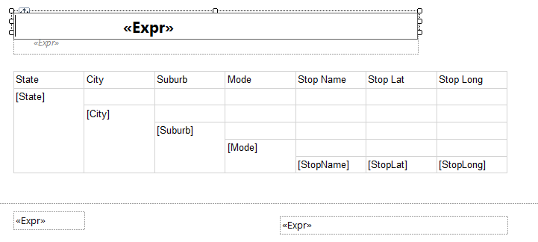
Parameter dropdowns
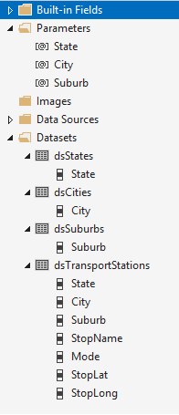
Rendered report with sample data
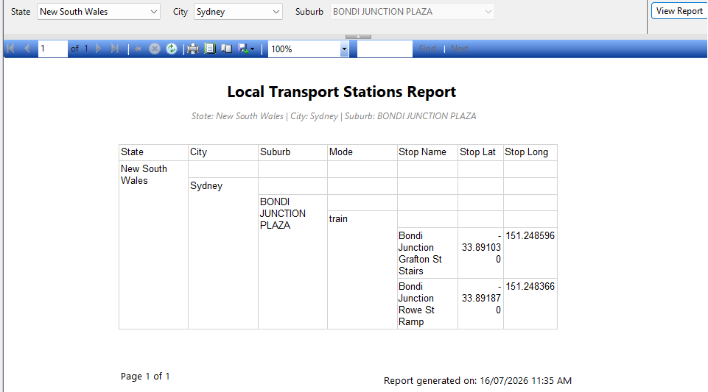

4. Local Schools Report (RPT_LocalSchools.rdl)
Requirement it addresses: “Given state, city, suburb, display local schools.”
A Table grouped State → City → Suburb, listing each school's name, type (primary/secondary), address and postcode. Data comes from rpt.usp_Rpt_LocalSchools, joining star.FactSchoolPresence to star.DimSuburb and star.DimSchool. FactSchoolPresence is a factless fact table (it just records that a school exists in a suburb, with no number attached), so this report is really just listing out those relationships rather than summing anything.
Design view
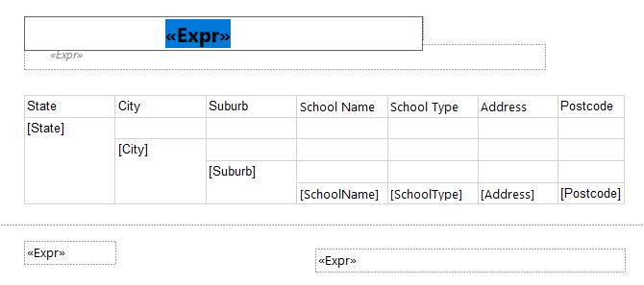
Parameter dropdowns
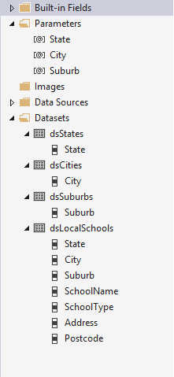
Rendered report with sample data
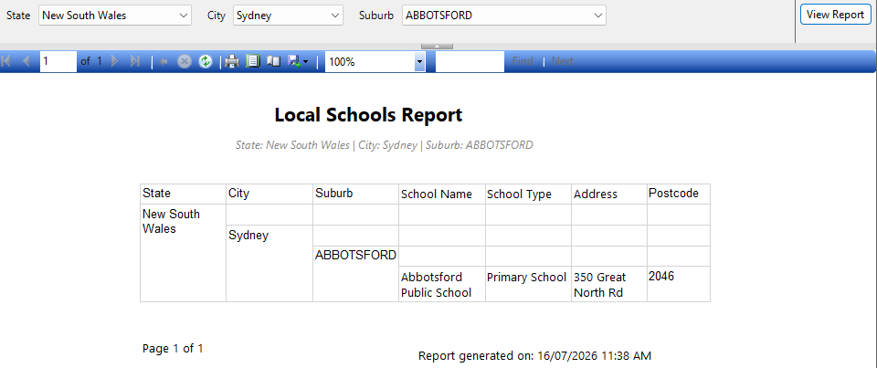

5. Crime Summary Report (RPT_CrimeSummary.rdl)
Requirement it addresses: “Given state, city, suburb, display summarised crime recorded incidents.”
A Matrix, since the brief specifically asks for this one to be summarised rather than a plain row-by-row listing. Rows are State → City → Suburb, columns are Offence Category, and each cell shows SUM(RecordedIncidents) for that suburb + category. A Grand Total column sits at the end of the matrix, giving one overall total recorded incidents figure per suburb across every offence category - that total is the part that most directly answers “summarised”. Data comes from rpt.usp_Rpt_CrimeSummary, which already does the SUM(...) and GROUP BY in SQL, joining star.FactCrime to star.DimSuburb and star.DimOffenceType.
Design view
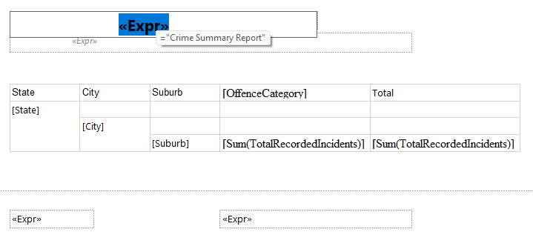

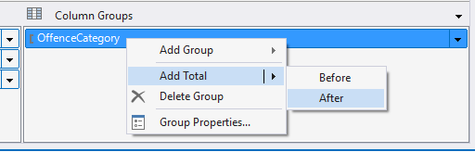
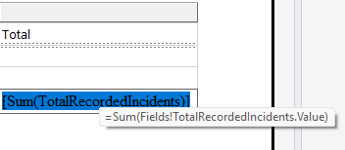
Parameter dropdowns
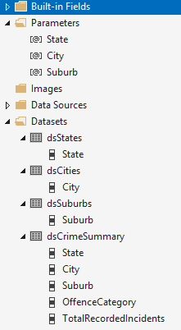
Rendered report with sample data
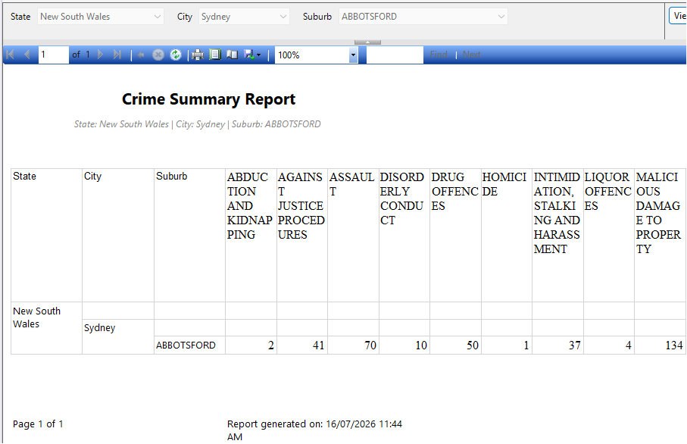
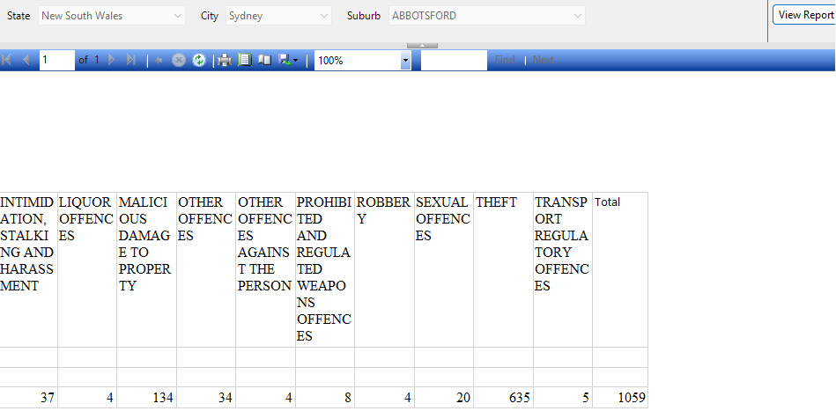

Since only NSW, SA and VIC were collected, and even within those a suburb can be missing from one particular domain, these are the exact combinations already confirmed to return data for each report:
- House Value: New South Wales / Albury / ALBURY
EXEC rpt.usp_Rpt_HouseValue @State = 'New South Wales', @City = 'ALBURY', @Suburb = 'ALBURY';
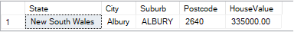
- Rental Value: Victoria / Melbourne / ABBOTSFORD
EXEC rpt.usp_Rpt_RentalValue @State = 'Victoria', @City = 'MELBOURNE', @Suburb = 'ABBOTSFORD';
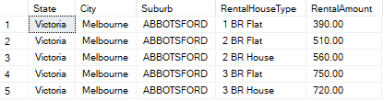
- Transport Stations: New South Wales / Sydney / BONDI JUNCTION PLAZA
EXEC rpt.usp_Rpt_TransportStations @State = 'New South Wales', @City = 'Sydney', @Suburb = 'BONDI JUNCTION PLAZA';
- Local Schools: New South Wales / Sydney / ABBOTSFORD
EXEC rpt.usp_Rpt_LocalSchools @State = 'New South Wales', @City = 'Sydney', @Suburb = 'ABBOTSFORD';
- Crime Summary: New South Wales / Sydney / ABBOTSFORD
EXEC rpt.usp_Rpt_CrimeSummary @State = 'New South Wales', @City = 'Sydney', @Suburb = 'ABBOTSFORD';
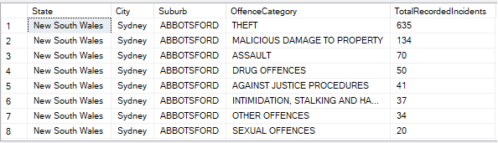
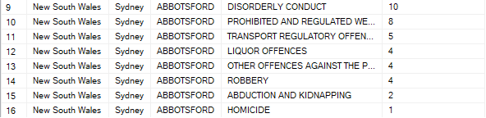

I have deployed the Solution in to SQL Server Reporting Services and below are the screen shots from each report.

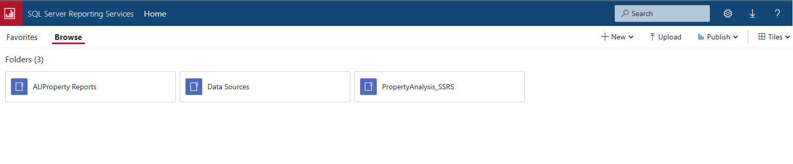
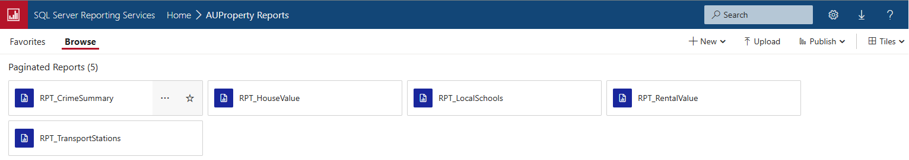

RPT_CrimeSummary:
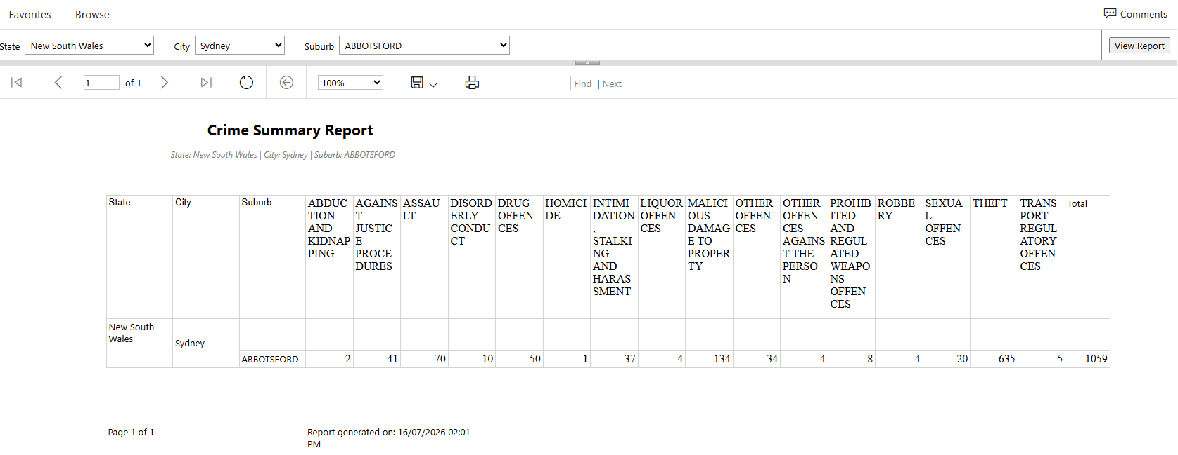
RPT_HouseValue:
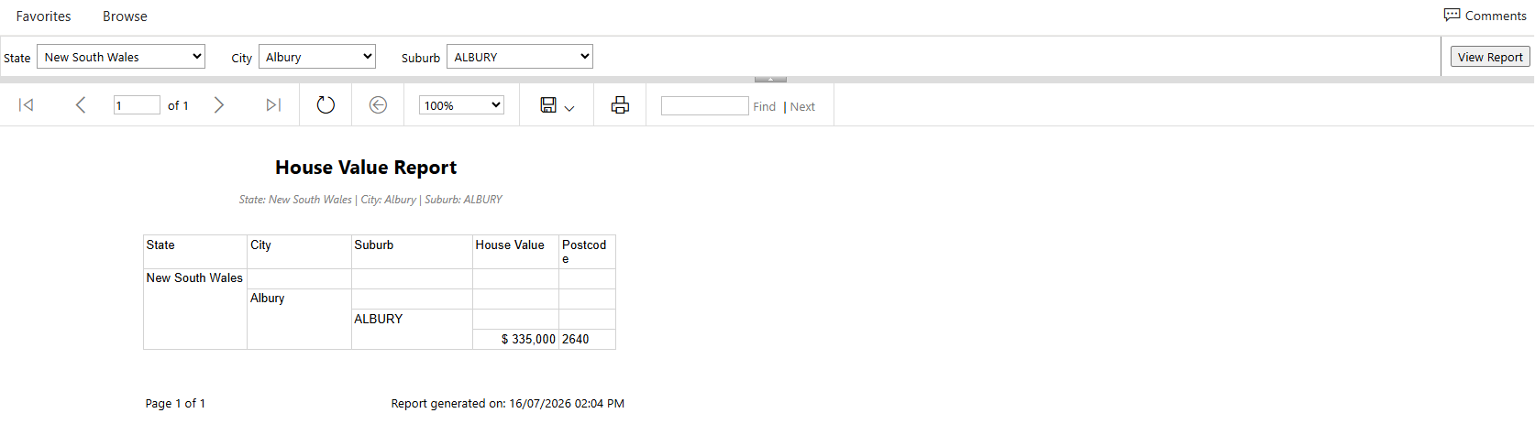
RPT_LocalSchools:
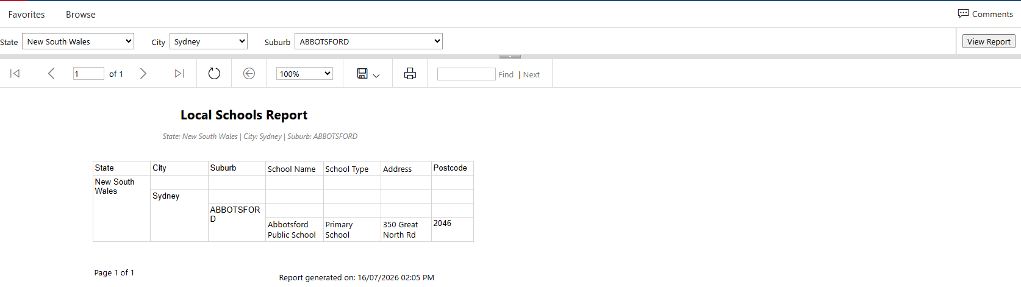
RPT_RentalValue:
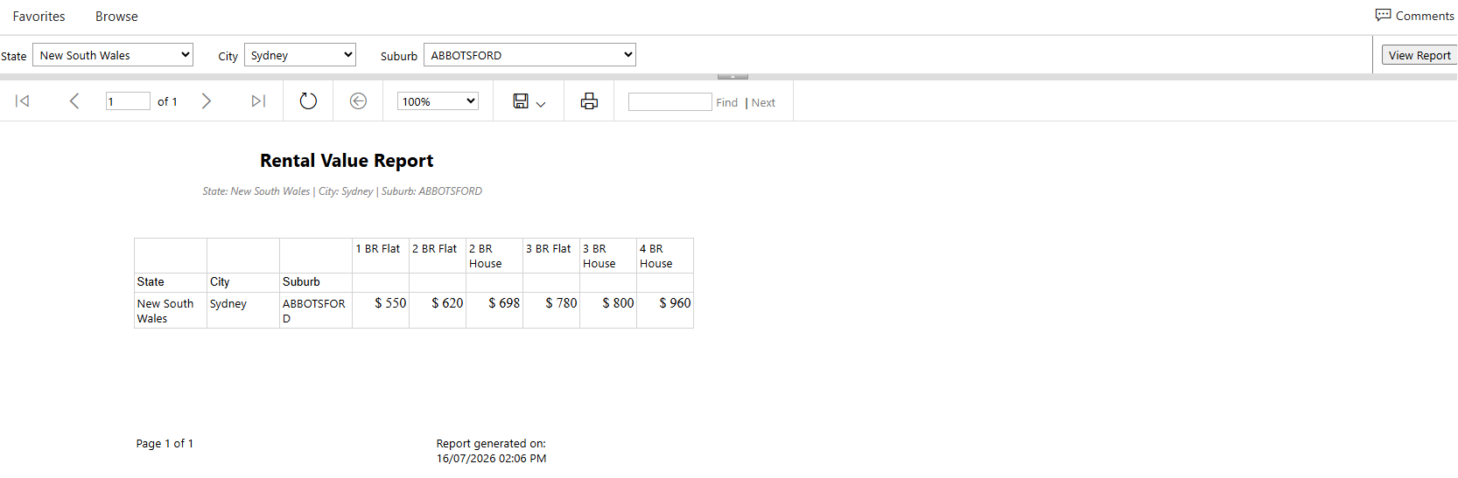
RPT_TransportStations:
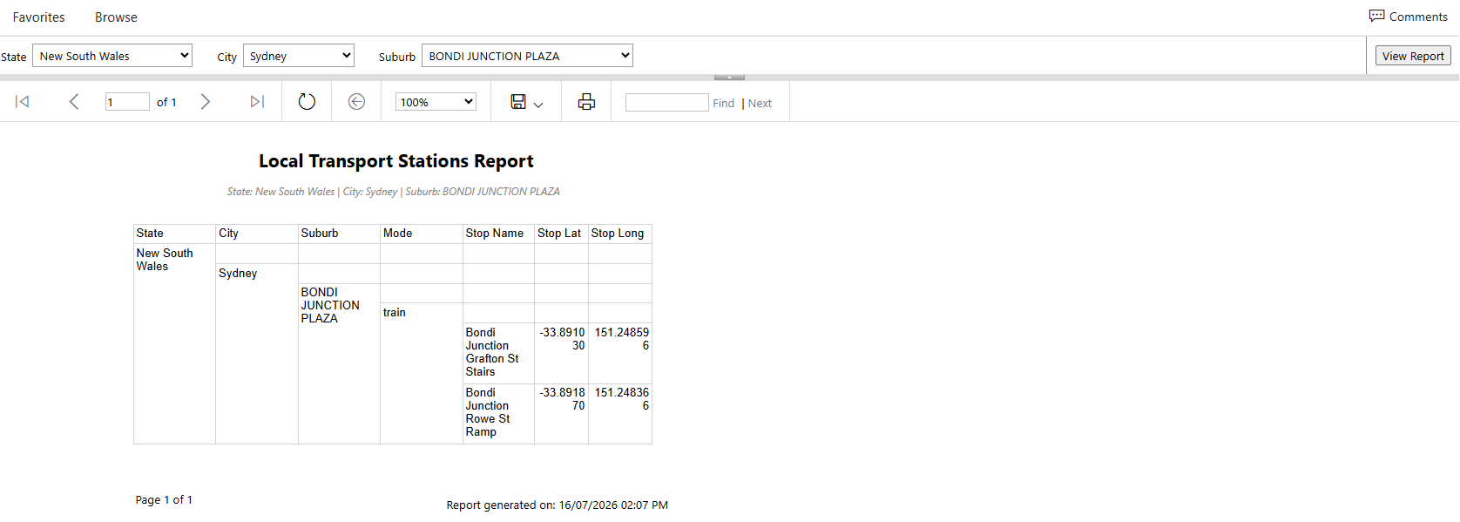
For all the reports I have included NoRowsMessage is there is no visible data.
