AU Property Insights
Power BI Dashboard — Screenshot Documentation
Task 8 — BI Advanced
File: AUProperty_PowerBI_Dashboard.pbix
Prepared by: Srikanth

Introduction
This document provides a comprehensive visual walkthrough of the AU Property Insights Power BI dashboard, built on the AUPropertyDW star schema data warehouse. It covers the data model, every report page, and the special interactive features implemented (drill-through navigation and button-based page navigation).

1. Data Model View
Switch to Model view in Power BI Desktop and capture the full diagram layout, showing all 10 tables (5 dimensions, 5 facts) and the 9 relationships converging on DimSuburb.
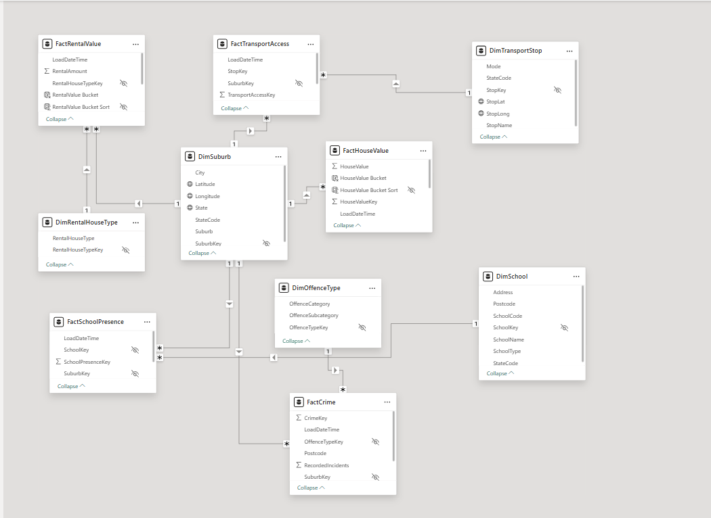Full diagram layout — all 10 tables and 9 relationship lines visible, DimSuburb at the centre.

2. Home Page
The landing page, featuring the report title and six navigation buttons (Summary, House Value, Rental Value, Schools, Transport, Crime), each with a custom icon.
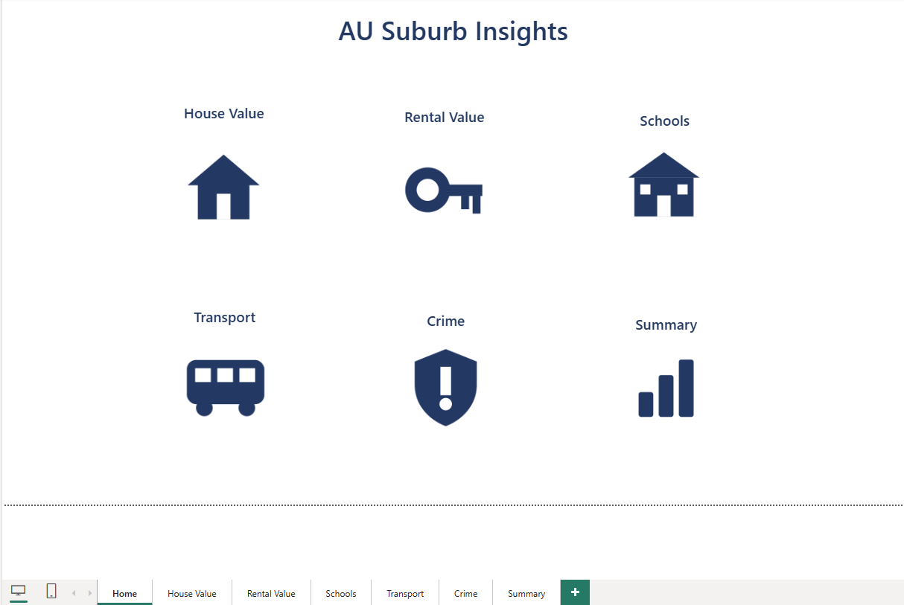Full page view showing the title and all six navigation tiles.

3. Summary Page
Consolidates all five analysis areas into one landing overview: a KPI card and a state-level chart for House Value, Rental Value, Schools, Transport, and Crime.
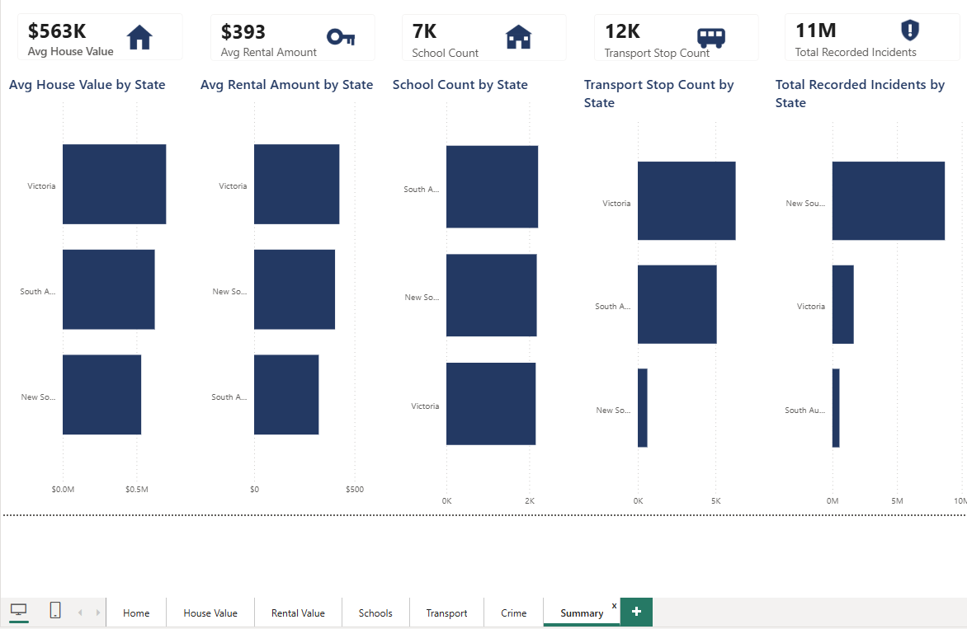Full page view showing all five KPI cards and their accompanying "by State" charts.

3.1 Drill-Through Feature
The Summary page supports drill-through: right-clicking a data point on any of its charts lets a viewer jump directly into the matching detail page, pre-filtered to that context.
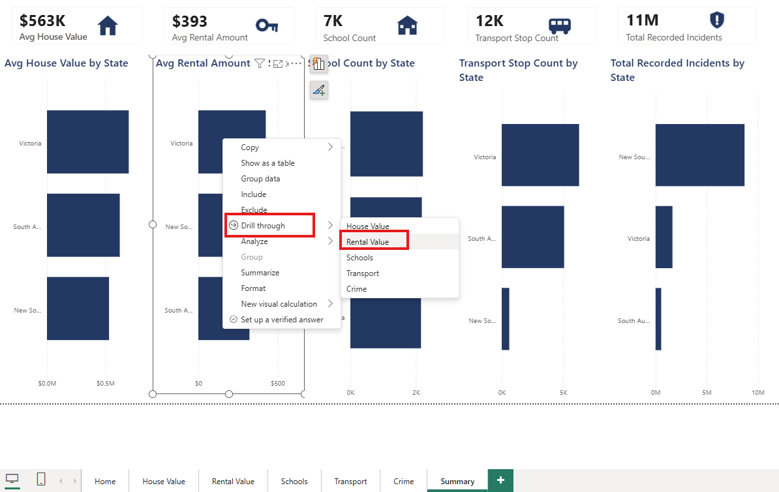Right-click on a bar chart “Avg Rental Amount by State” showing the Drillthrough submenu listing all five detail pages.
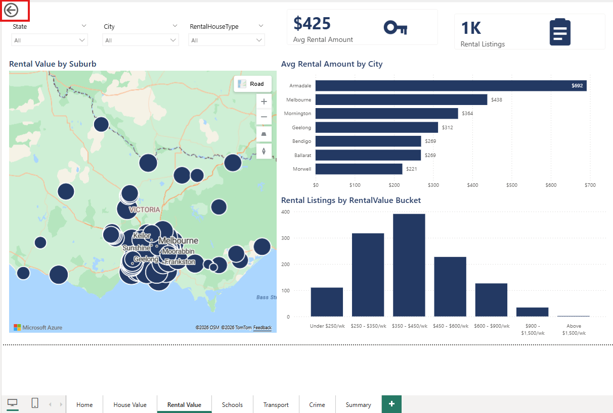The destination detail page after drilling through, showing it filtered to the selected context and the auto-added back button.

4. House Value Page
Analyzes house values by suburb, city, and state: average/median value and listing count KPIs, a geographic map, a top-city comparison, and a price-band distribution.
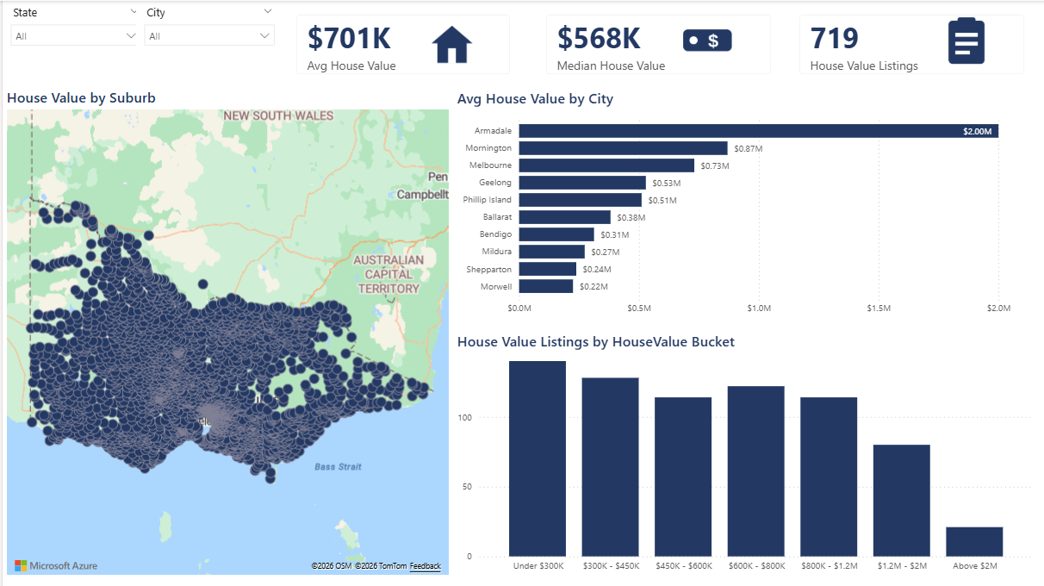Full page view: KPI cards, map, "Avg House Value by City" bar chart, and the HouseValue Bucket column chart.
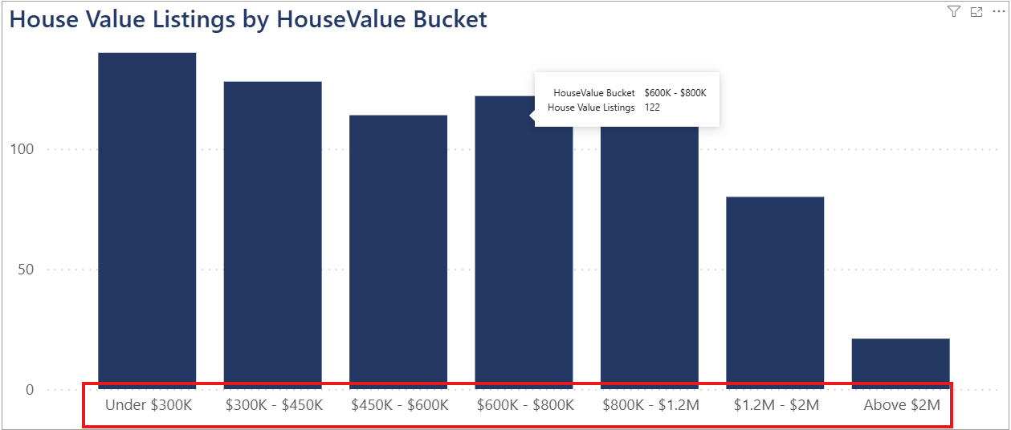Close-up of the HouseValue Bucket column chart, showing listings grouped into price bands in correct ascending order.

5. Rental Value Page
Analyzes weekly rental amounts by suburb, city, and state, plus a breakdown by rental house type.
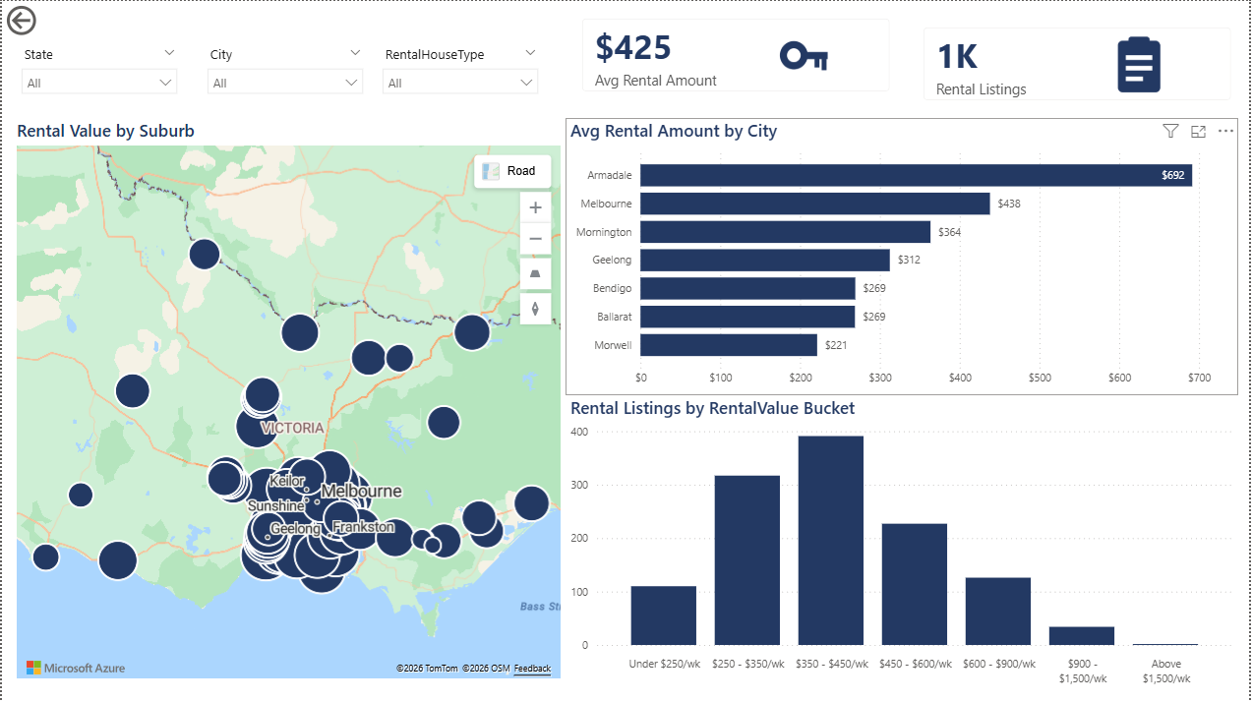Full page view: KPI cards, map, "Avg Rental Amount by City" bar chart, and the RentalValue Bucket chart.
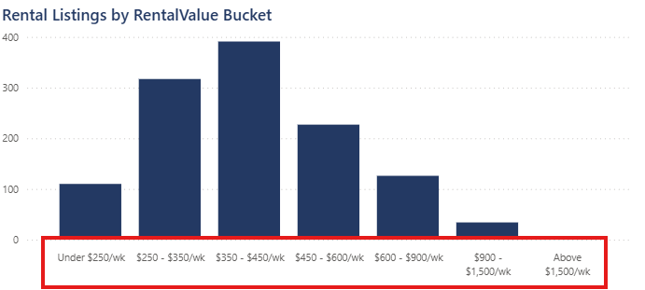Close-up of the RentalValue Bucket chart, showing listings grouped into weekly-rent bands in correct ascending order.

6. Schools Page
Analyzes school presence and type by suburb and city.
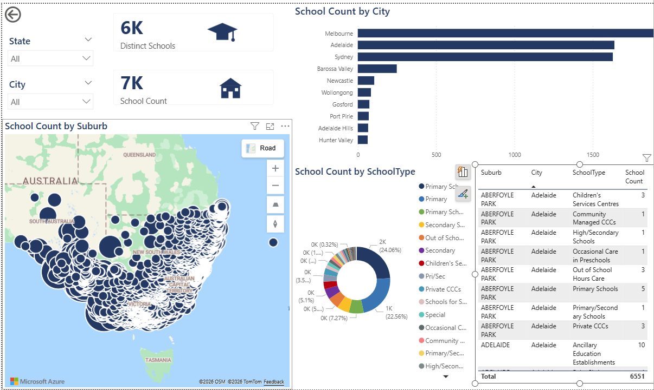Full page view: KPI cards, map, "School Count by City" bar chart, SchoolType donut chart, and the detail table.
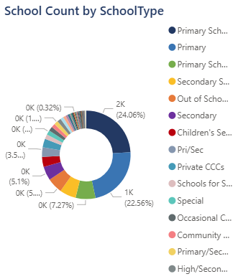
Close-up of the School Count by SchoolType donut chart with its legend visible.

7. Transport Page
Analyzes public transport stop coverage by suburb, city, and state.
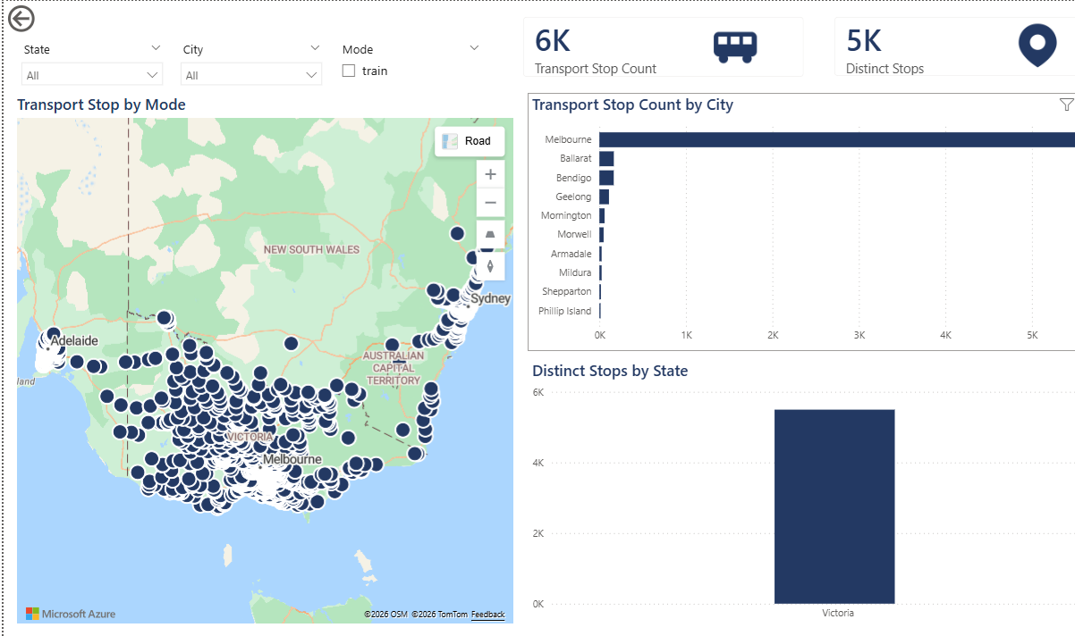Full page view: KPI cards, map (stop locations), "Transport Stop Count by City" bar chart, and the "Distinct Stops by State" chart.

8. Crime Page
Analyzes recorded crime incidents by suburb, city, state, and offence category.
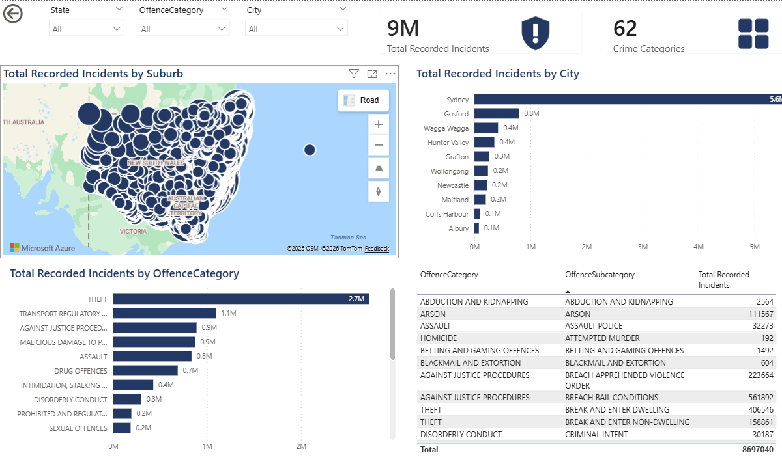Full page view: KPI cards, map, "Total Recorded Incidents by City" chart, "by OffenceCategory" chart, and the detail table.
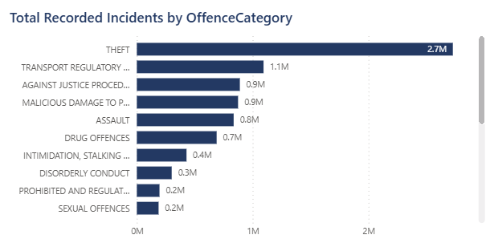Close-up of the Total Recorded Incidents by OffenceCategory bar chart, showing which offence types dominate.

9. Additional Features

9.1 Report-Level Filtering
A report-level filter (applied under "Filters on all pages") excludes three suburbs with known data-quality issues (UNKNOWN, WALL FLAT, RETREAT) from every page and every visual automatically.
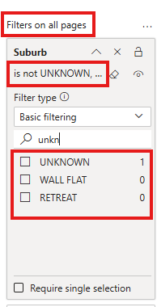
The Filters pane showing the Suburb filter under "Filters on all pages", with UNKNOWN/WALL FLAT/RETREAT excluded.

9.2 Custom Theme and Icons
A custom navy theme (matching colour scheme across every page) and custom flat-icon set (one per KPI metric) were applied throughout the report for visual consistency.
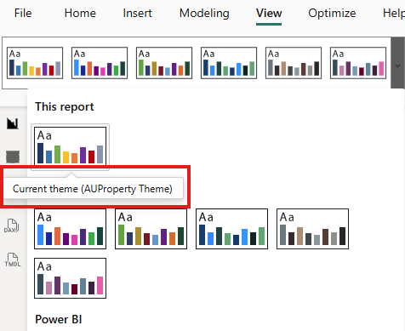View ribbon → Themes, showing the custom "AUProperty Theme" selected as the current theme.

