Power BI to SSRS Integration
Screenshot Documentation
Task 9 — BI Advanced Sprint Part 5
AUProperty Data Warehouse Project

1. How the Integration Works (User Perspective)
Each of the five Power BI dashboard pages offers two ways to reach the matching SSRS paginated report on the web portal (http://sirilenovo:8080/Reports):
- A "View Full Report in SSRS" button — opens the report with State, City, and Suburb defaulting to (All), showing the complete dataset.
- A parameter-passing matrix — every suburb row carries its own hyperlink that opens the same report pre-filtered to that exact State, City, and Suburb.

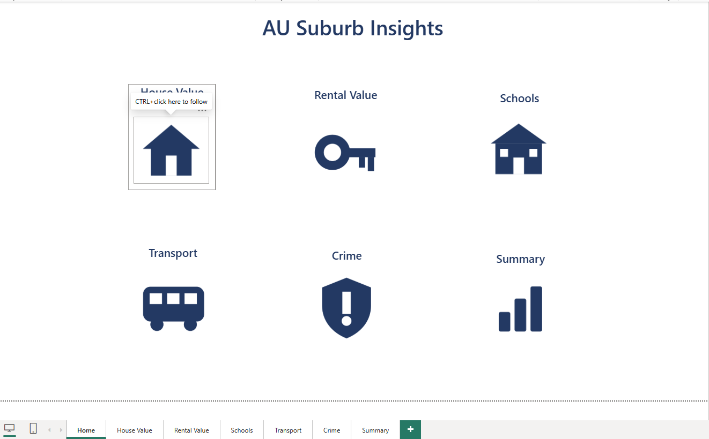 Power BI Home page— overview of the dashboard the links live in

2. SSRS Reports Deployed to the Web Portal
All five paginated reports are deployed to the AUProperty Reports folder on the report server.
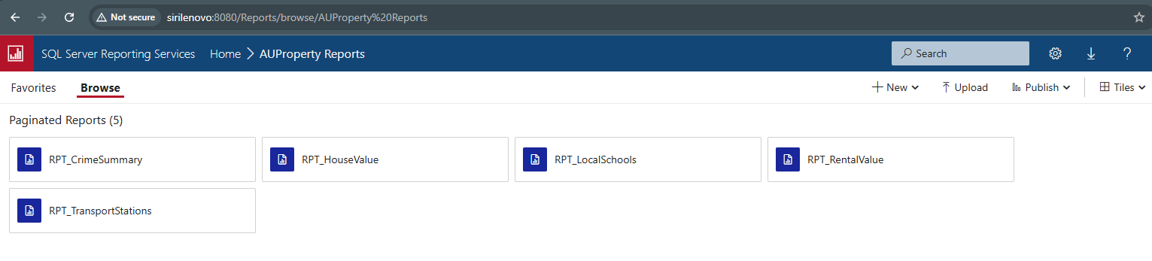Web portal Browse view — AUProperty Reports folder showing all 5 RPT_* reports

3. House Value Page

3.1 Hyperlinks implemented on the page
The House Value page with the "View Full Report in SSRS" button and the parameter-passing matrix (HouseValue SSRS Link column rendered as clickable links at suburb level).
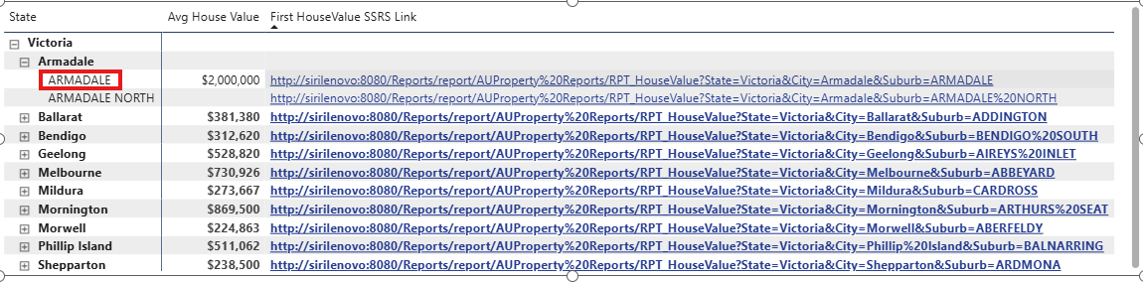House Value page in Power BI — button + matrix with link column visible

3.2 Navigation via button (all data)
Clicking the button opens RPT_HouseValue in the web portal with State/City/Suburb on (All).
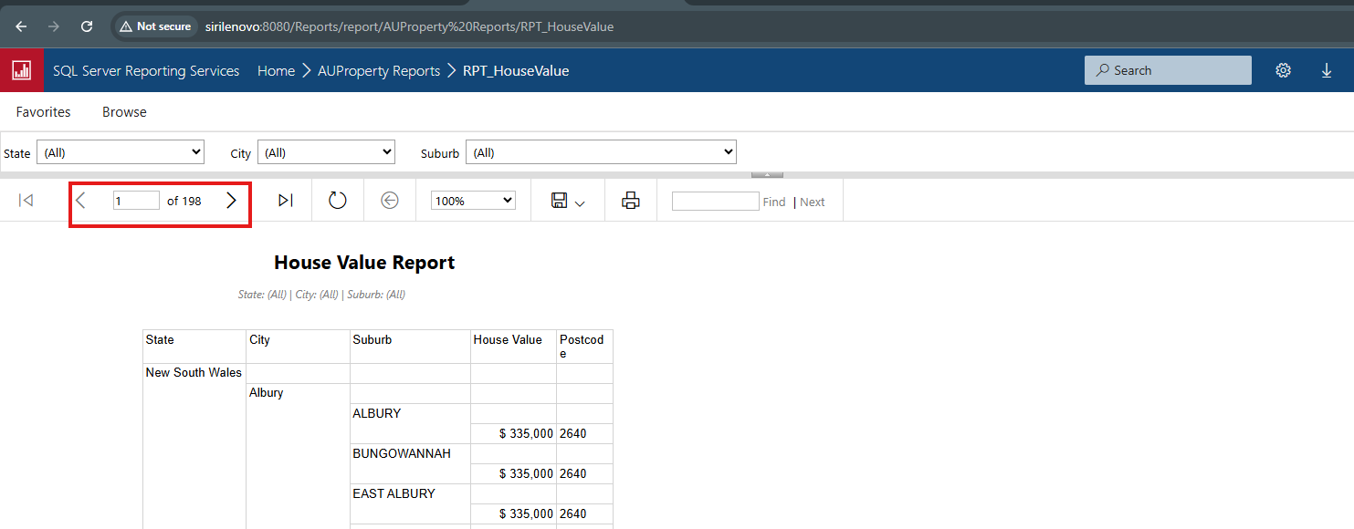RPT_HouseValue open in browser with parameters on (All) after clicking the button

3.3 Parameter passing via matrix (filtered)
Clicking a suburb's link in the matrix opens RPT_HouseValue pre-filtered — the URL carries ?State=...&City=...&Suburb=... and the report's parameter dropdowns arrive already set to those values.
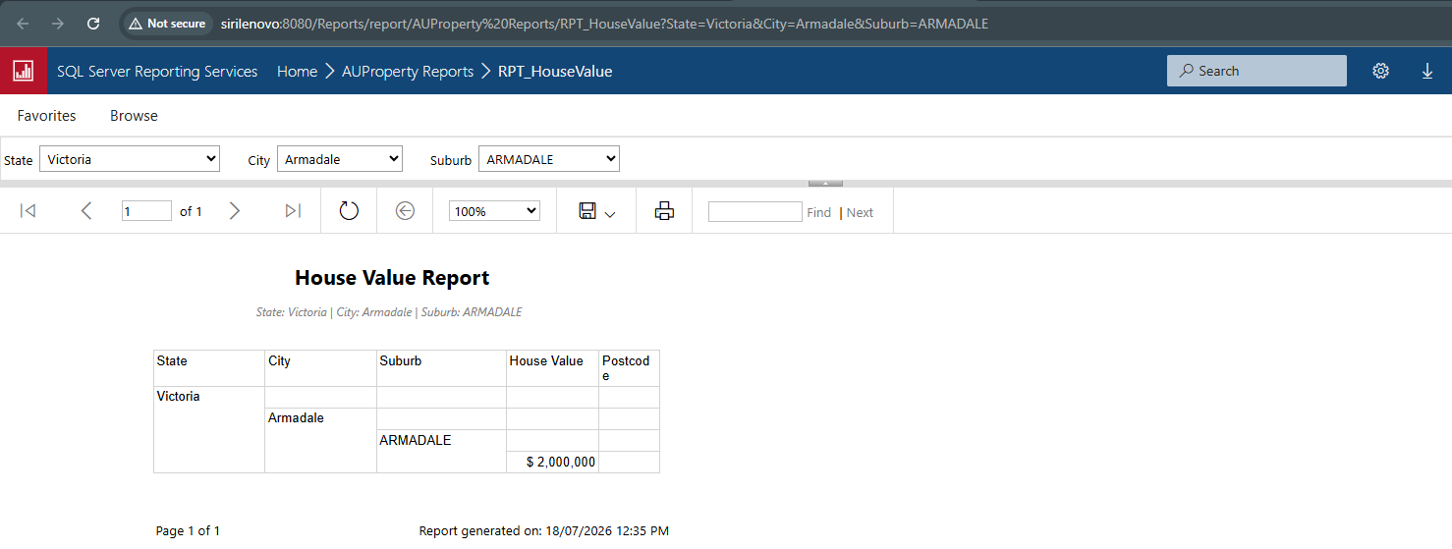RPT_HouseValue opened from a matrix link — parameter bar showing the passed State/City/Suburb and the filtered result (include the URL bar in the screenshot)

4. Rental Value Page

4.1 Hyperlinks implemented on the page
The Rental Value page with the "View Full Report in SSRS" button and the parameter-passing matrix (RentalValue SSRS Link column rendered as clickable links at suburb level).
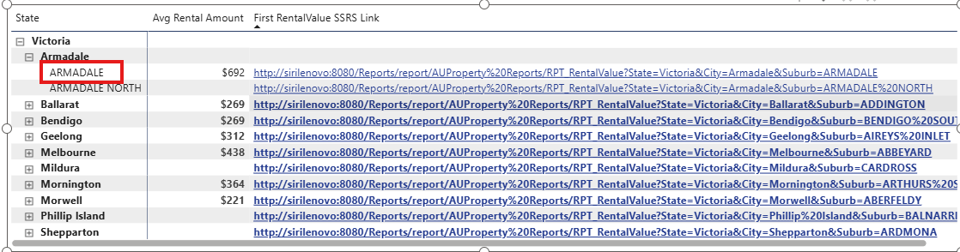Rental Value page in Power BI — button + matrix with link column visible

4.2 Navigation via button (all data)
Clicking the button opens RPT_RentalValue in the web portal with State/City/Suburb on (All).
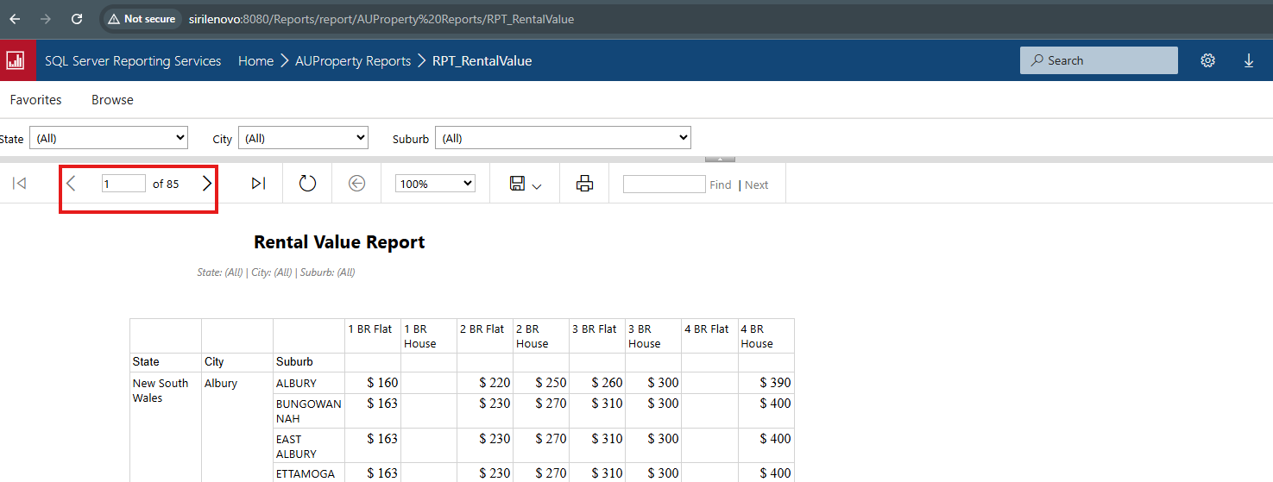RPT_RentalValue open in browser with parameters on (All) after clicking the button

4.3 Parameter passing via matrix (filtered)
Clicking a suburb's link in the matrix opens RPT_RentalValue pre-filtered — the URL carries ?State=...&City=...&Suburb=... and the report's parameter dropdowns arrive already set to those values.
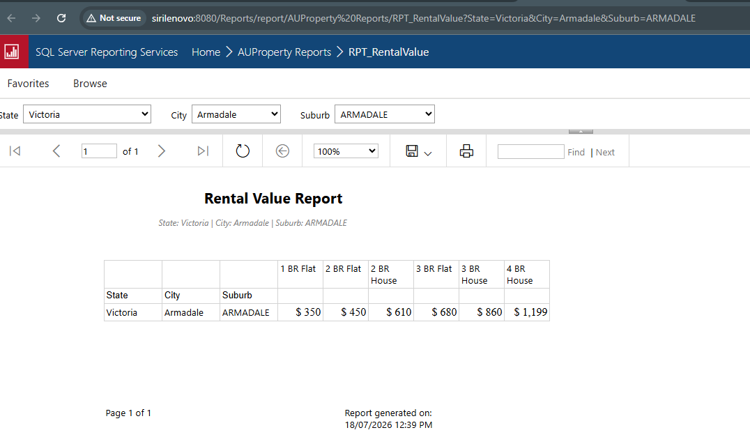RPT_RentalValue opened from a matrix link — parameter bar showing the passed State/City/Suburb and the filtered result (include the URL bar in the screenshot)

5. Transport Page

5.1 Hyperlinks implemented on the page
The Transport page with the "View Full Report in SSRS" button and the parameter-passing matrix (Transport SSRS Link column rendered as clickable links at suburb level).
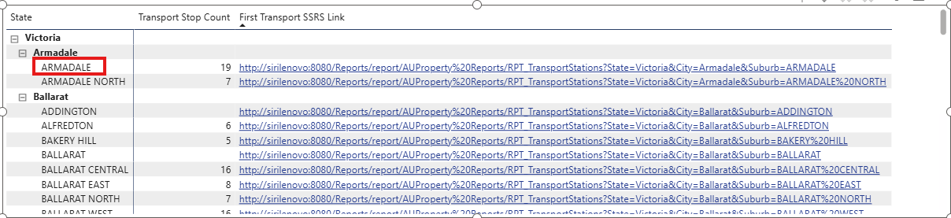Transport page in Power BI — button + matrix with link column visible

5.2 Navigation via button (all data)
Clicking the button opens RPT_TransportStations in the web portal with State/City/Suburb on (All).
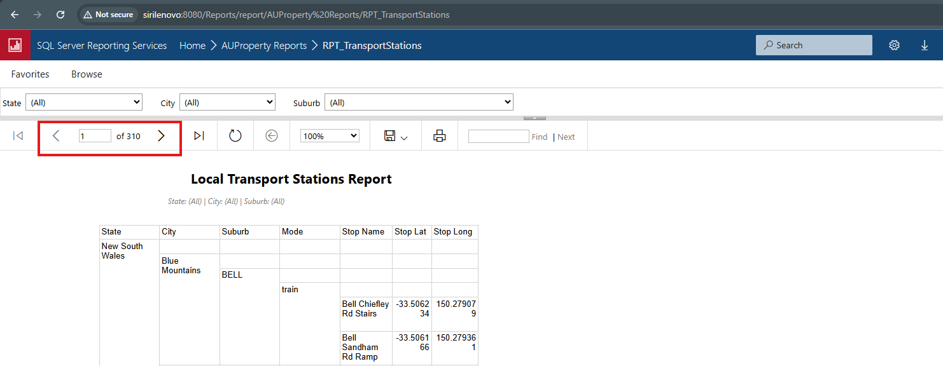 RPT_TransportStations open in browser with parameters on (All) after clicking the button

5.3 Parameter passing via matrix (filtered)
Clicking a suburb's link in the matrix opens RPT_TransportStations pre-filtered — the URL carries ?State=...&City=...&Suburb=... and the report's parameter dropdowns arrive already set to those values.
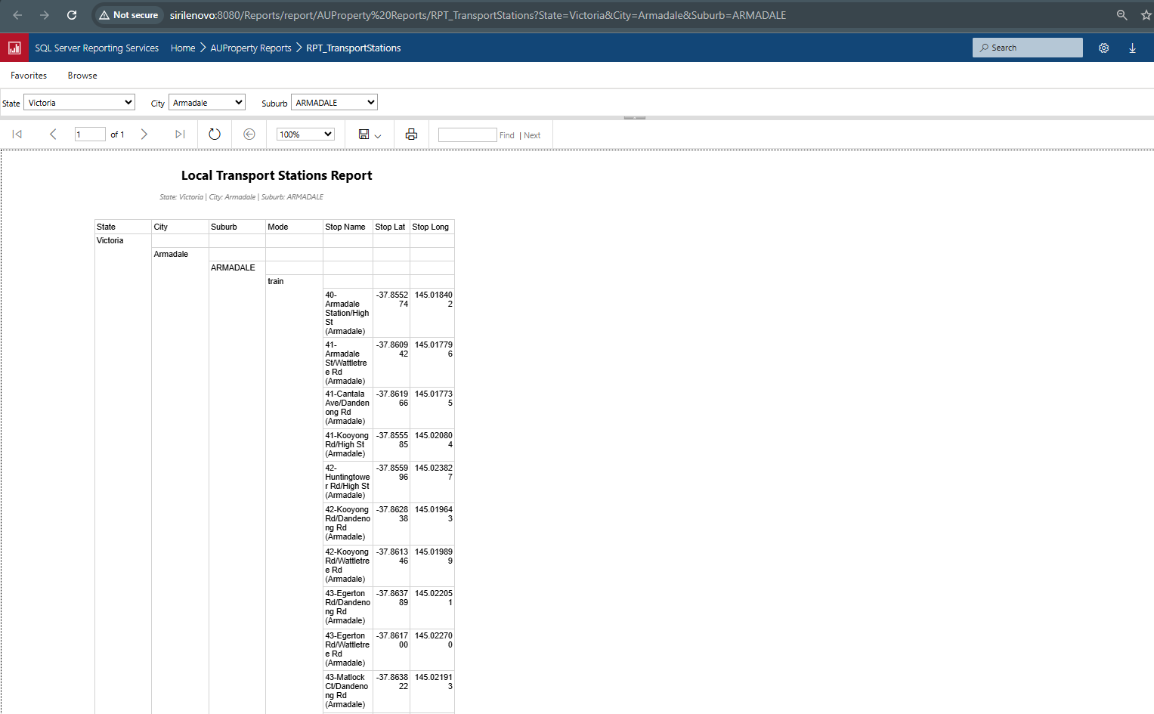
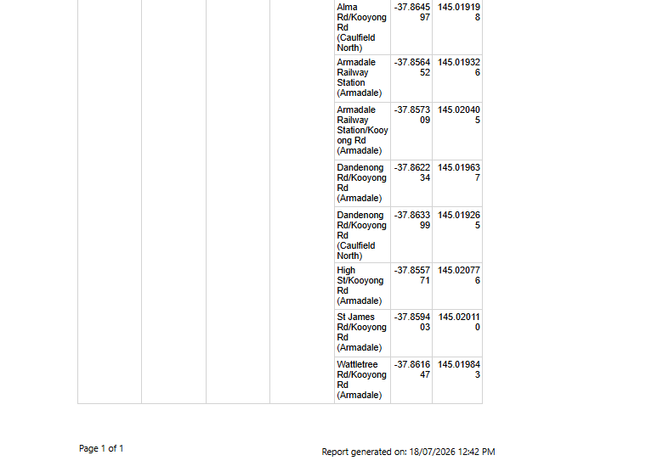
RPT_TransportStations opened from a matrix link — parameter bar showing the passed State/City/Suburb and the filtered result (include the URL bar in the screenshot)

6. Local Schools Page

6.1 Hyperlinks implemented on the page
The Local Schools page with the "View Full Report in SSRS" button and the parameter-passing matrix (Schools SSRS Link column rendered as clickable links at suburb level).
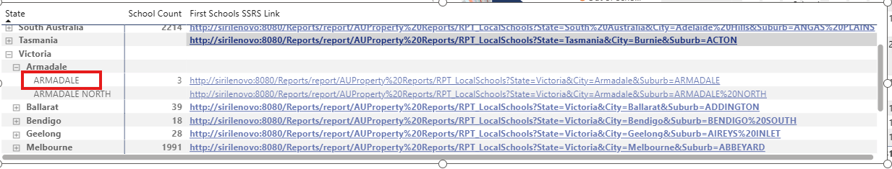Local Schools page in Power BI — button + matrix with link column visible

6.2 Navigation via button (all data)
Clicking the button opens RPT_LocalSchools in the web portal with State/City/Suburb on (All).
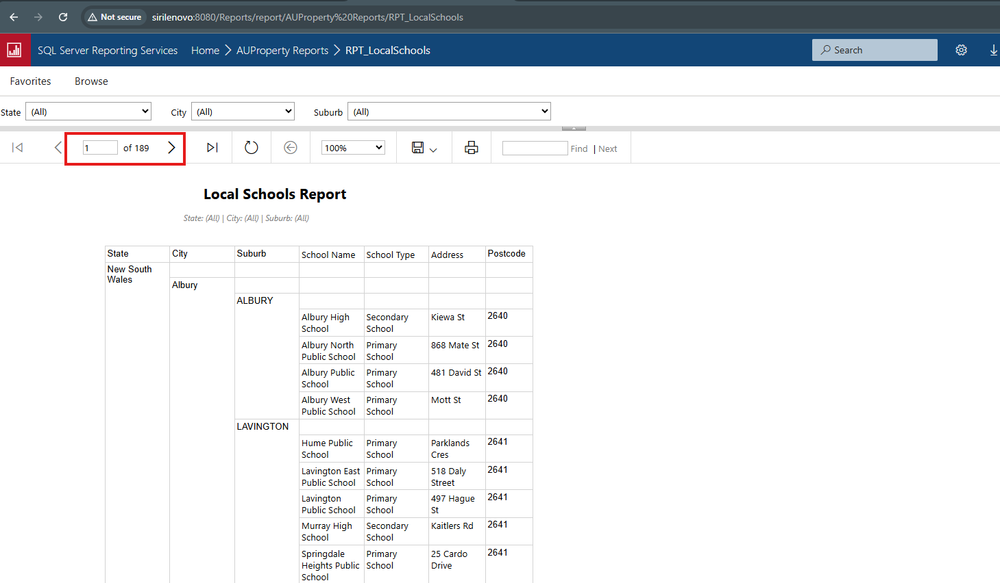RPT_LocalSchools open in browser with parameters on (All) after clicking the button

6.3 Parameter passing via matrix (filtered)
Clicking a suburb's link in the matrix opens RPT_LocalSchools pre-filtered — the URL carries ?State=...&City=...&Suburb=... and the report's parameter dropdowns arrive already set to those values.
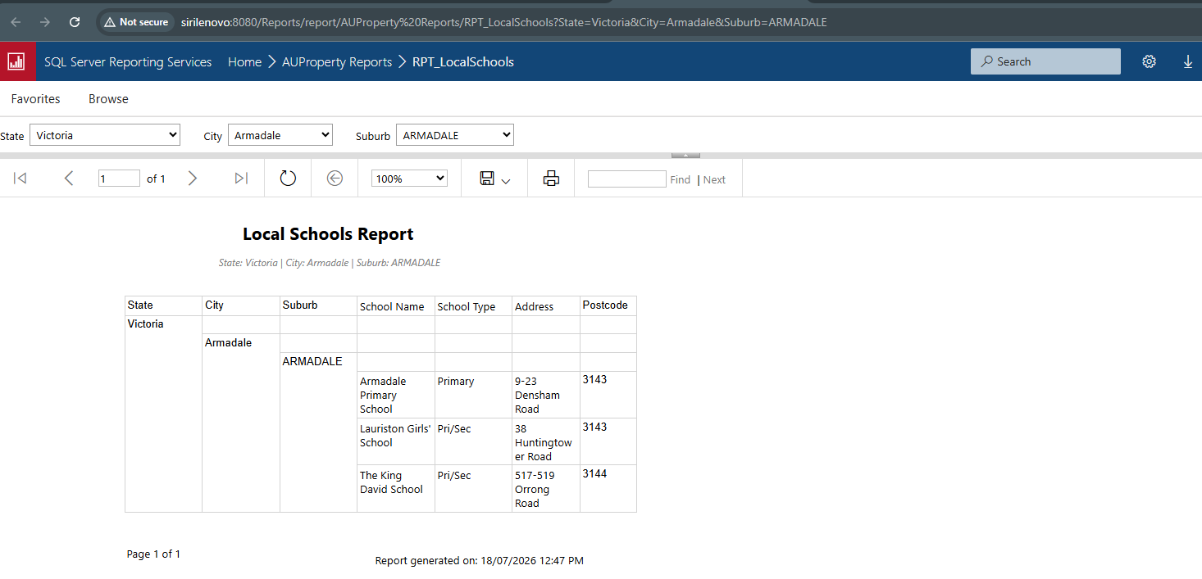RPT_LocalSchools opened from a matrix link — parameter bar showing the passed State/City/Suburb and the filtered result (include the URL bar in the screenshot)

7. Crime Summary Page

7.1 Hyperlinks implemented on the page
The Crime Summary page with the "View Full Report in SSRS" button and the parameter-passing matrix (Crime SSRS Link column rendered as clickable links at suburb level).
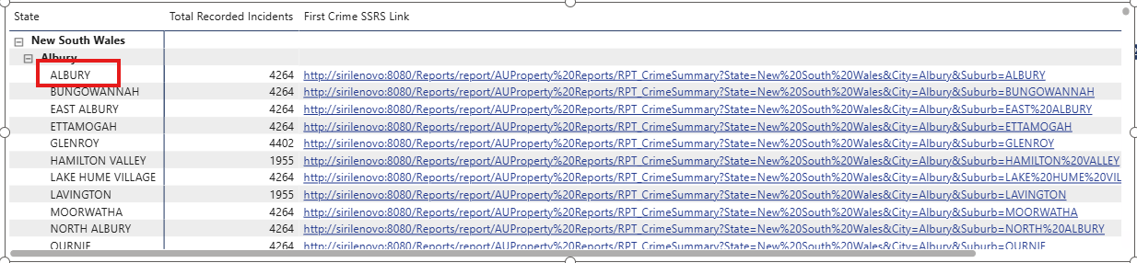Crime Summary page in Power BI — button + matrix with link column visible

7.2 Navigation via button (all data)
Clicking the button opens RPT_CrimeSummary in the web portal with State/City/Suburb on (All).
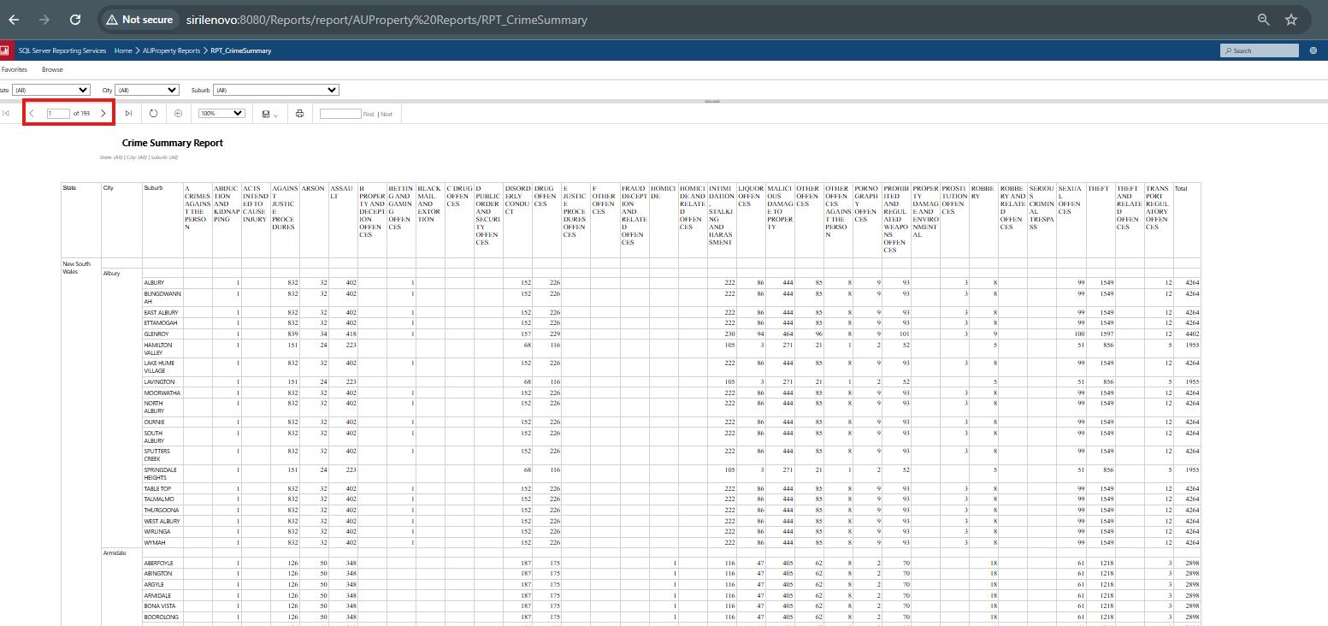RPT_CrimeSummary open in browser with parameters on (All) after clicking the button

7.3 Parameter passing via matrix (filtered)
Clicking a suburb's link in the matrix opens RPT_CrimeSummary pre-filtered — the URL carries ?State=...&City=...&Suburb=... and the report's parameter dropdowns arrive already set to those values.
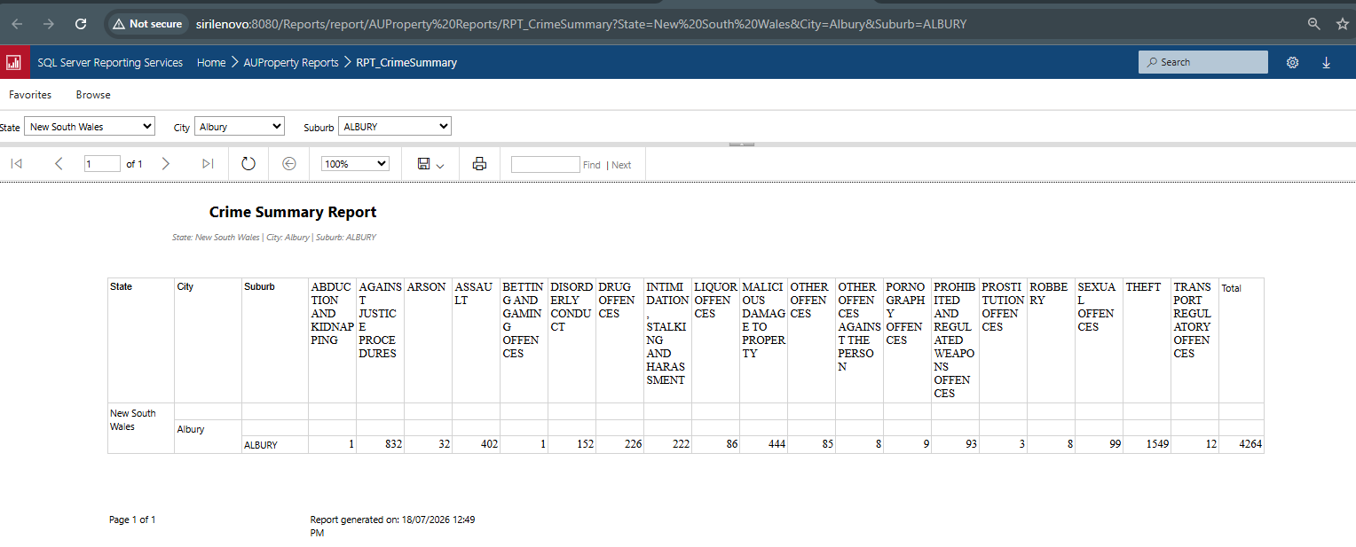RPT_CrimeSummary opened from a matrix link — parameter bar showing the passed State/City/Suburb and the filtered result (include the URL bar in the screenshot)

8. Verified Test Cases
Navigation and parameter passing were verified live during the build:
- House Value — Victoria / Armadale / ARMADALE ($2,000,000 house value returned).
- Rental Value — Victoria / Armadale / ARMADALE (all six house-type rents returned, $350 to $1,199).
- Local Schools — Victoria / Armadale / ARMADALE (3 schools returned).
- Transport — Victoria / Armadale / ARMADALE (train stops returned, including Armadale Railway Station).
- Crime Summary — New South Wales / Albury / ALBURY (4,264 total incidents, matching the matrix's Total Recorded Incidents; also validates %20 URL encoding of a multi-word state).

