SQL Scripts
The scripts that build and load the PropertyDW data warehouse

1. What These Scripts Do
These are all the SQL scripts used to build the PropertyDW database from scratch.creating every table, setting up the four price categories, and the queries used inside the SSIS packages to move and clean the data. I've grouped them in the same order they'd actually run in.

2. Create the Database
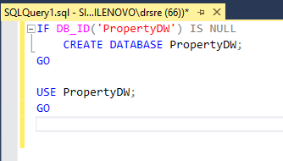
This just makes sure the PropertyDW database exists, and switches into it so all the following commands run inside it.

3. Staging Tables (raw, uncleaned data)
These three tables hold the data almost exactly as it comes out of the original files. Every column is text (NVARCHAR), even ones that are really numbers, because the raw files have messy values like 'np' instead of a number, so text is the safest way to land the data first.
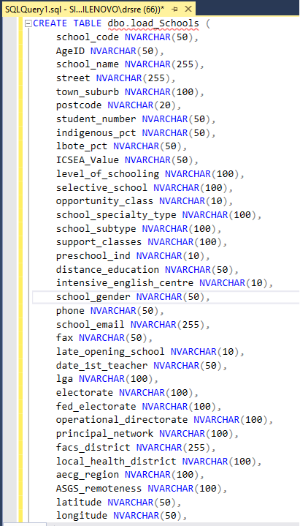
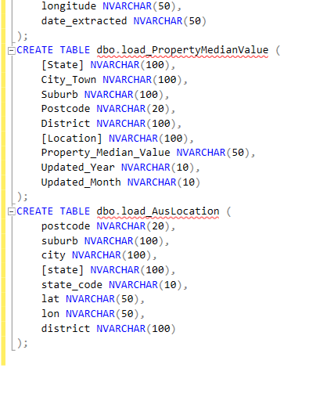

4. Dimension Tables (the clean, final lookup tables)
These are the tables people actually use for reporting — clean, correctly typed, with proper ID columns.
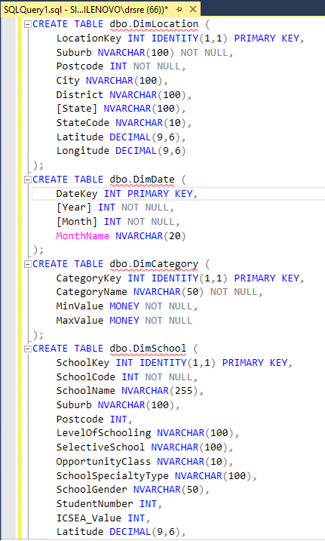
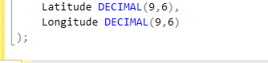

5. Fact Tables (the actual numbers and relationships)

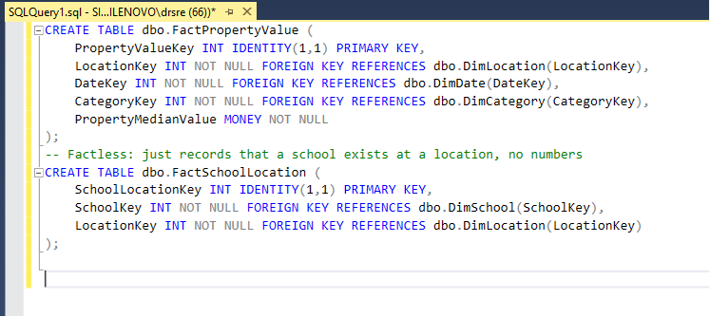6. The Four Price Categories (seed data)
DimCategory only ever needs these 4 fixed rows. they don't come from a file, I just insert them directly.

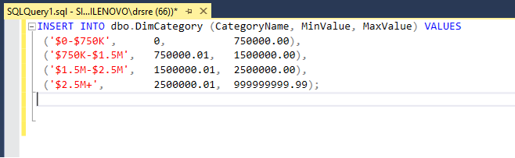

7. Resetting the Warehouse Before Each Load
This runs first every time the load package runs, so every run starts from a clean slate. Facts get deleted before dimensions because of the foreign key links between them.
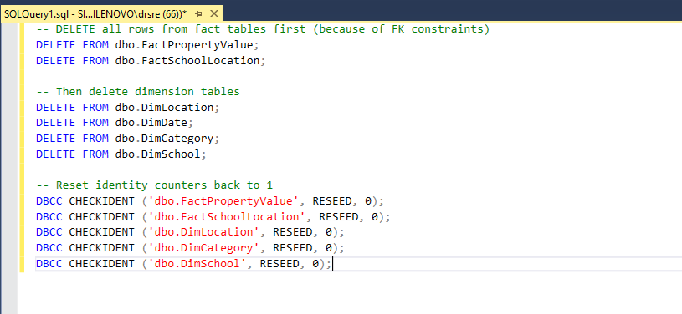
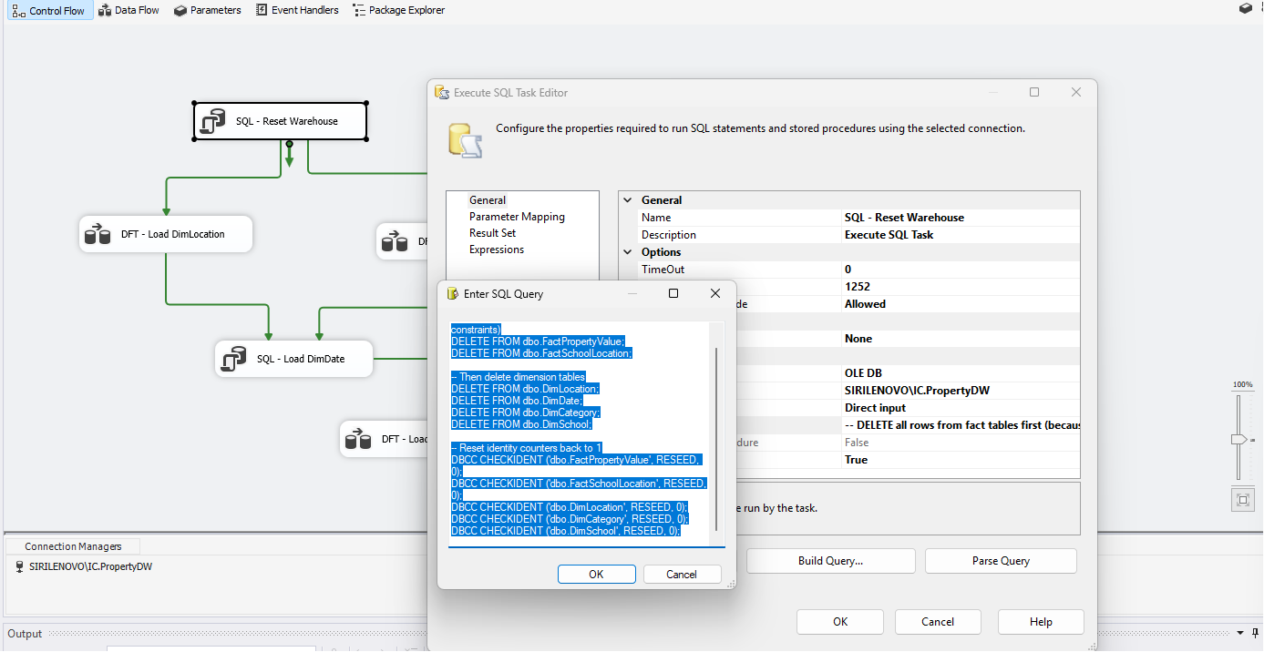

8. Loading DimDate
The property data only covers one month (June 2017), but I generate a full 12-month calendar for the year anyway, since that's the standard way a date table is built.

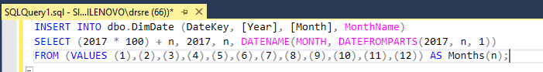

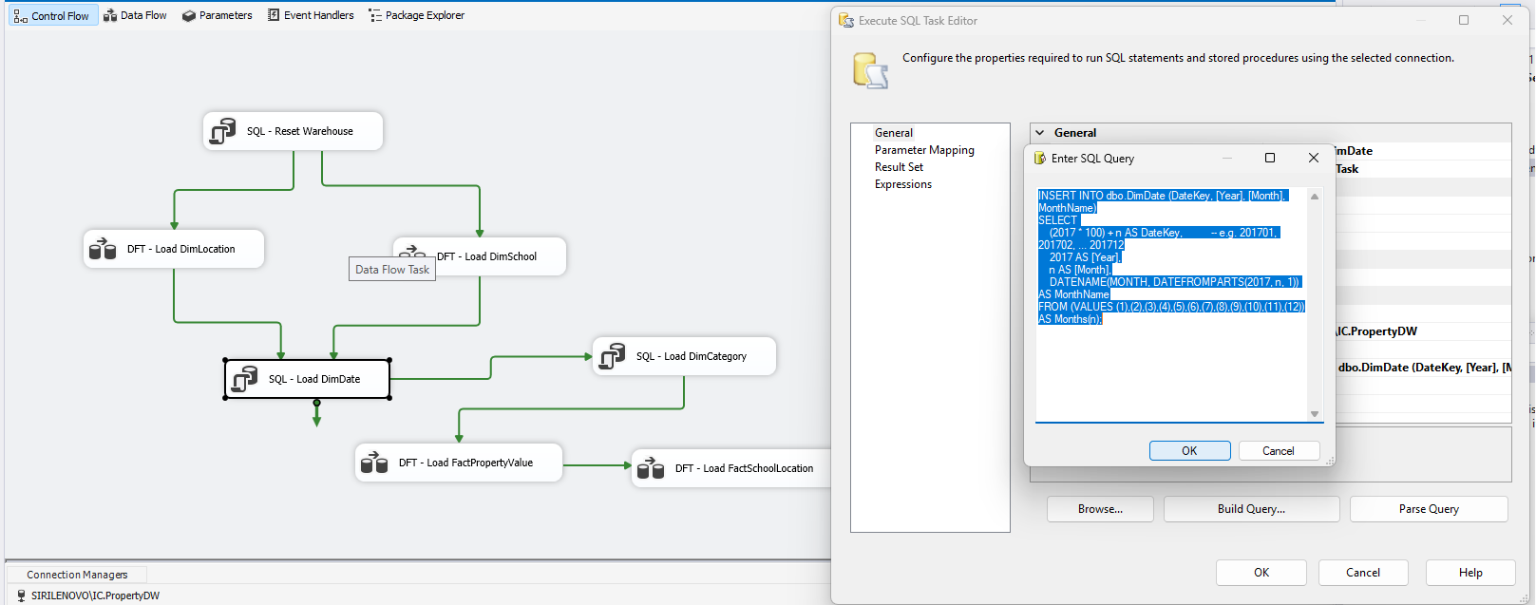9. The Queries That Feed Each SSIS Load
These are the SELECT statements used inside each Data Flow Task's source, cleaning and matching the raw data up to the right dimension keys.

Loading DimLocation:

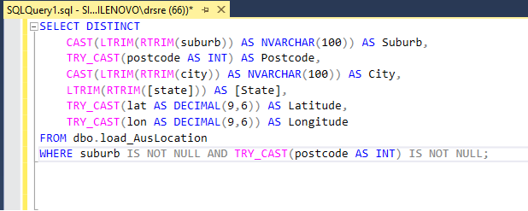

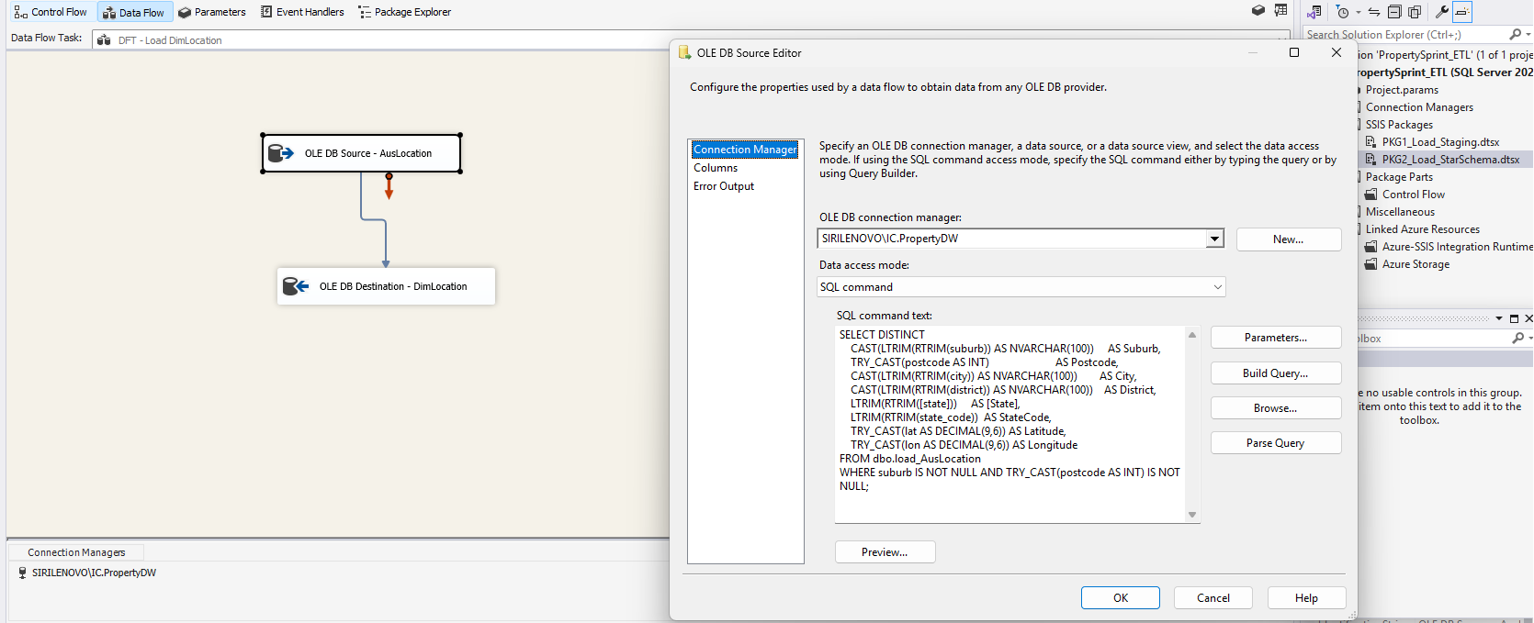Loading FactPropertyValue (category is NOT resolved here anymore — see note below):

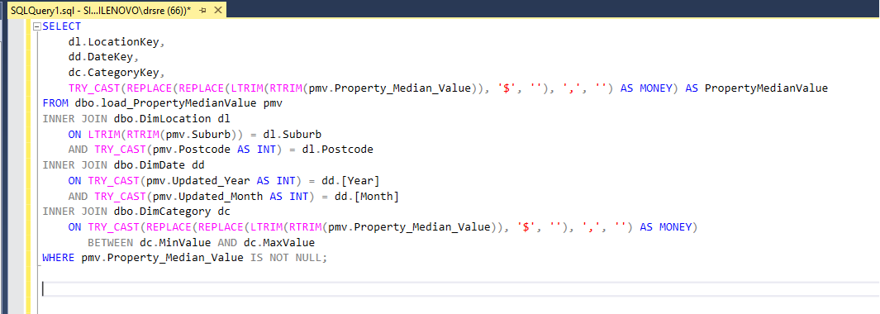
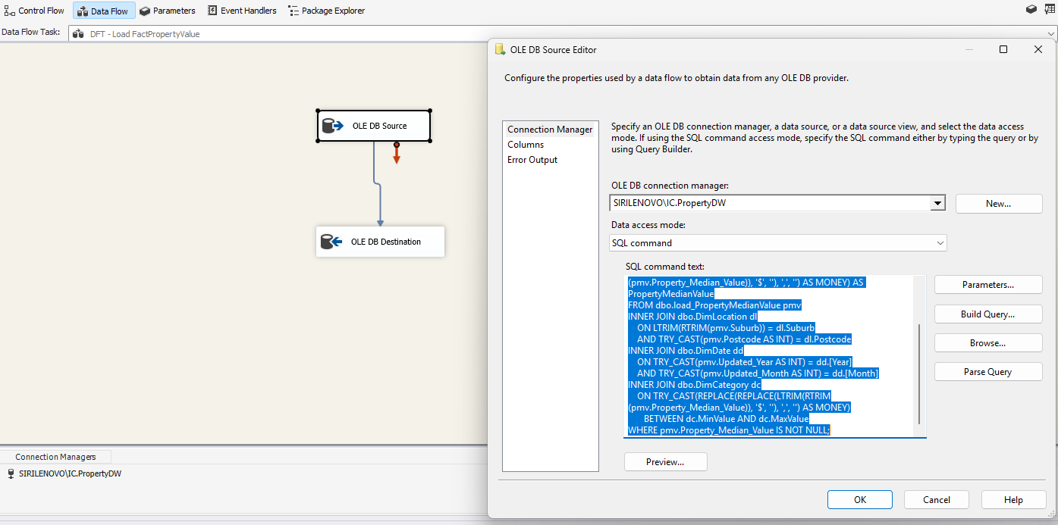

10. Checking the Final Results
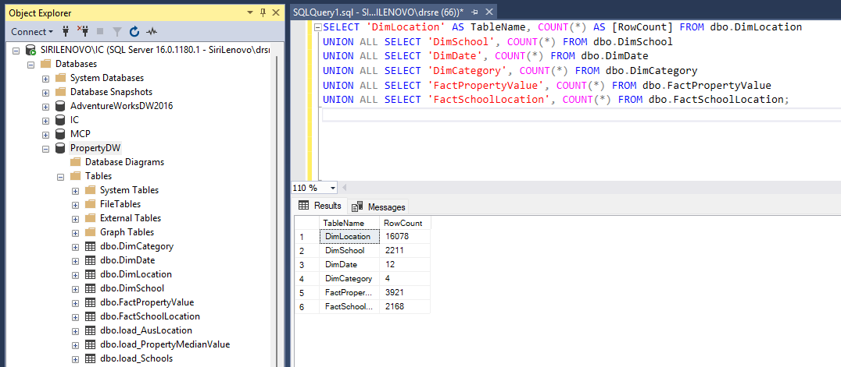This is just a quick way to check every table has the right number of rows after a full run — see the Design Decisions document for the actual final numbers.

