Schema Diagram
The star schema layout for the PropertyDW data warehouse

1. What This Diagram Shows
This is the overall shape of the data warehouse — the two fact tables in the middle (the blue boxes, holding the actual numbers and relationships), surrounded by the four dimension tables (the lighter boxes, the things you can filter or group by). The lines show which dimension connects to which fact table.
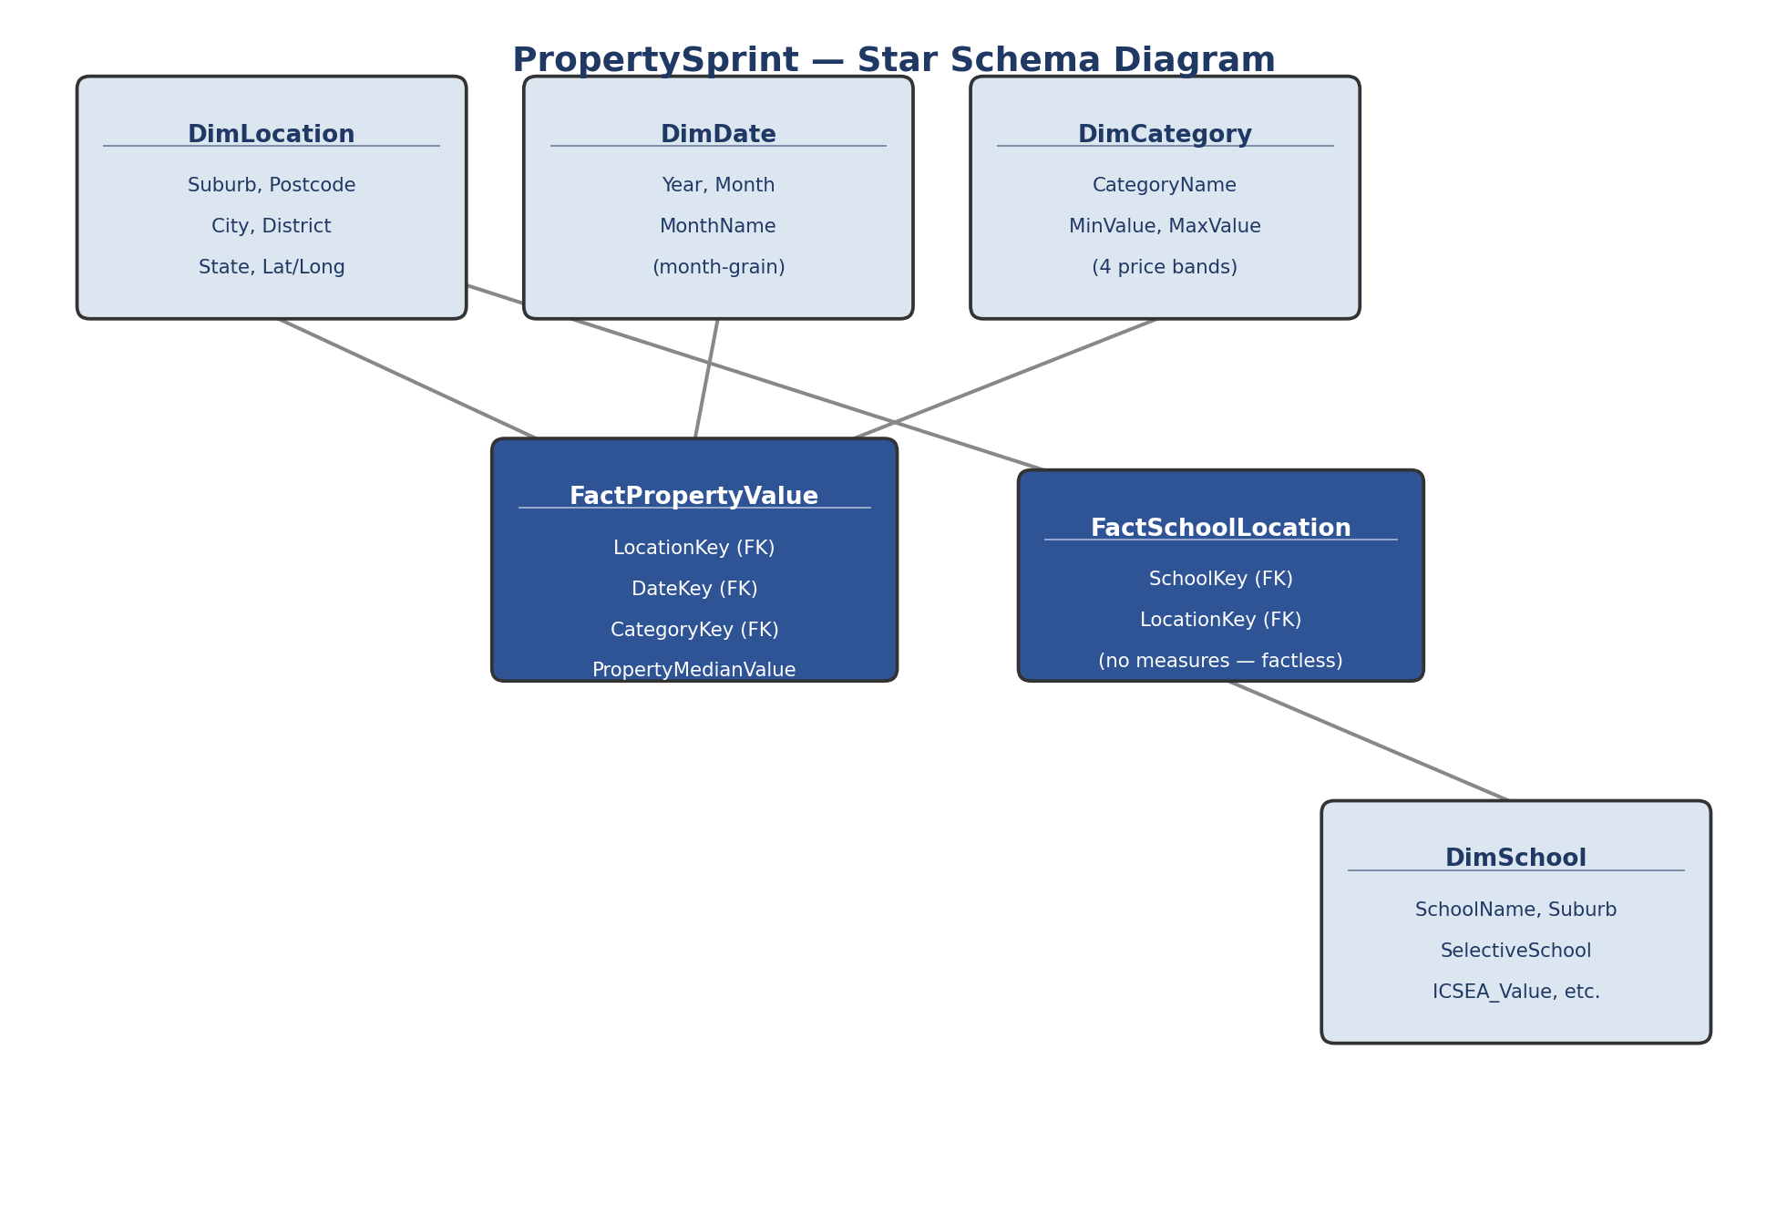

2. Quick Notes on the Layout
- FactPropertyValue sits between DimLocation, DimDate, and DimCategory — every property price row is tagged with a suburb, a month, and a price band.
- FactSchoolLocation sits between DimLocation and DimSchool only — it has no date or category attached, since it's just recording where a school is, not measuring anything over time.
- DimLocation is the one dimension shared across both fact tables — it's the common link between the property data and the schools data.
- This is a classic Kimball star schema shape: fact tables in the center, dimension tables radiating outward, no dimension-to-dimension links, and no dimension left disconnected from every fact table.

