My Data Warehouse Design Decisions
Property Analysis Competition Sprint - Part 1 | Srikanth

What I built
I built a small data warehouse called PropertyDW in SQL Server. It takes three raw files (NSW public schools CSV, NSW property median values Excel, and an Australia-wide locations Excel) and turns them into a star schema that can answer questions like “what is the average property value near each school”. The loading is done with two SSIS packages: package 1 copies the raw files into staging tables as-is, and package 2 cleans the data and fills the dimensions and facts.

The star schema
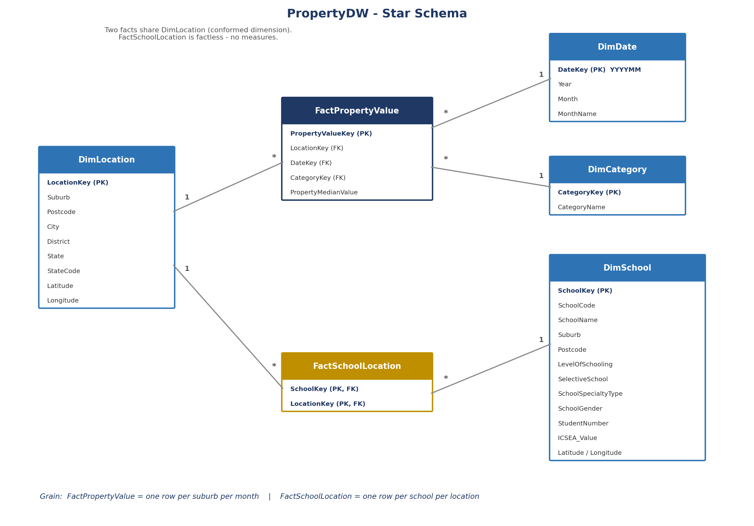
I chose a star schema instead of a snowflake. My main reason: with a star, every question is just “fact join dimension”, one hop. A snowflake would split things like State into its own little table, which saves a tiny bit of space but makes every query longer, and Power BI works best with a plain star anyway.

The grain (I wrote this down first)
- FactPropertyValue: one row per suburb per month. The measure is the median property value.
- FactSchoolLocation: one row per school per location. No measures at all - see below.

Why DimLocation is shared
Both facts point at the same DimLocation table. This is called a conformed dimension. It is the thing that connects the two worlds: property values and schools both know “where”, so I can join through location and ask combined questions. One lesson I learnt the hard way: suburb name alone is not unique - Abbotsford exists in NSW, Victoria and Queensland - so the real business key is suburb + postcode together.

The factless fact table
The task hinted to research factless fact tables, and FactSchoolLocation is mine. It only has two key columns and no numbers. At first that felt wrong (a fact with no facts?), but the row existing is the information: “this school is in this location”. With it I can count things like how many selective schools sit in the $2.5M+ price bucket.

The category buckets
The task asked for a transformation in SSIS that categorises median property values. I made a small DimCategory table with 4 buckets ($0-$750K, $750K-$1.5M, $1.5M-$2.5M, $2.5M+). In the SSIS data flow, a Derived Column with a nested condition assigns the bucket name to each row, and then a Lookup swaps the name for the CategoryKey. I seeded the 4 rows in SQL because they never change.

Surrogate keys
Every dimension has an IDENTITY key (LocationKey, SchoolKey, CategoryKey) instead of using the natural values as keys. The raw values were too messy to trust (spaces, duplicates, typos). The one exception is DateKey, which I build myself as YYYYMM (June 2017 = 201706) so the same month always gets the same key. I only have year and month in the source, no full dates, so a monthly date dimension was enough.

Data quality problems I found (and what I did)
- 'np' inside number columns: the schools file uses the text 'np' (not published) in student_number and ICSEA_Value. I convert it with NULLIF(col,'np') so it becomes a proper NULL instead of crashing the number conversion.
- Trailing spaces in suburb names: 'Abbotsford ' would not match 'Abbotsford', so every suburb goes through LTRIM(RTRIM(...)) on its way out of staging. This one cost me real debugging time - my lookups silently failed before I trimmed both sides.
- Inconsistent state labels: the property file has both 'New South Wales' and 'NEW SOUTH WALES_NSW' for the same state.
- A typo column in the source: the locations file has a column literally called 'Distric'. I map it to 'district' in SSIS and left a comment so nobody thinks it is my typo.
- Missing suburbs: about 43 of the 2,211 school suburbs do not exist in the locations file. I send unmatched rows to a no-match output instead of failing the load, and reports show them as 'Unknown' city.
- Excel quirks: the property file's sheet is literally named 'NSW_PropertyMedainValue.csv' (typo and all), and Excel columns arrive as unicode/float types, so package 1 keeps everything as text in staging and all real conversion happens later with TRY_CAST.

Why staging tables are all text
Every column in the three load_ tables is NVARCHAR on purpose. If I typed them properly, one bad value in the file would fail the whole load. This way the file always lands, and TRY_CAST during the transform step turns bad values into NULLs that I can count and check, instead of errors that stop everything.

What I would improve with more time
- Push the suburb trimming fully into the ETL so no report ever needs to trim again.
- Add a proper reject table for the ~43 unmatched school suburbs and report on it.
- Standardise the state labels in DimLocation into one clean value.

