**EC2 Commands**

**Step 1 : Describes all the regions that are available to you**

# aws configure

# aws ec2 describe-regions --region

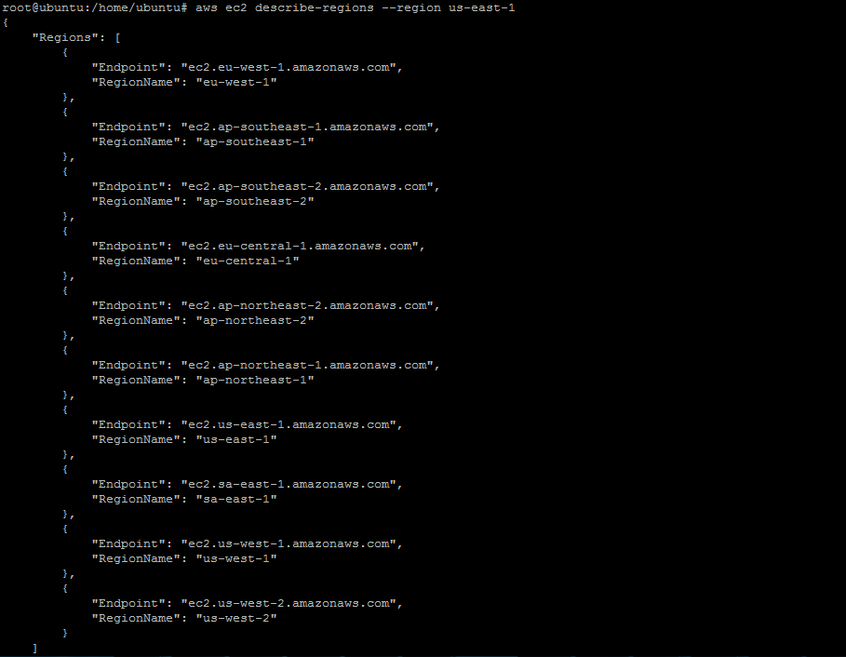

**Step 2.A : create a key pair**

# aws ec2 create-key-pair --key-name final-key --region eu-west-1

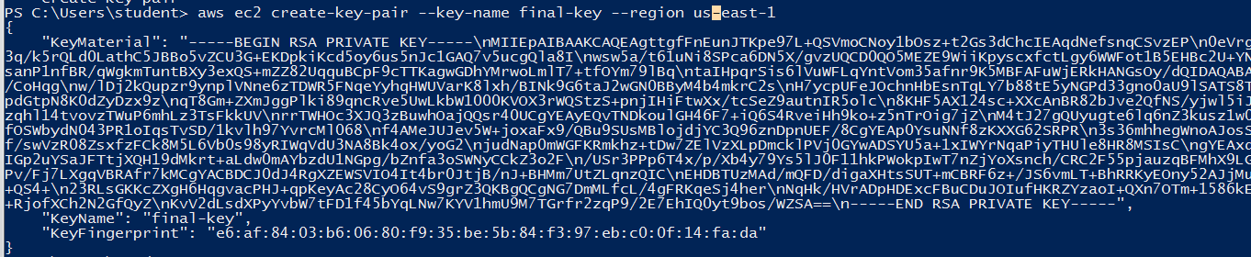

**Step 2.A : Describes VPC**

aws ec2 describe-vpcs --region eu-west-1

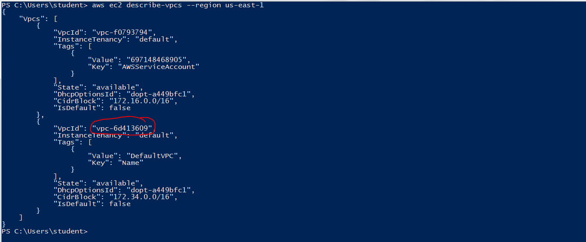

**Create a security group**

aws ec2 create-security-group --group-name final-SG --description "my first cli-security group" --region eu-west-1 --vpc-id vpc-6d413609

aws ec2 authorize-security-group-ingress --group-id sg-14211f6c --protocol tcp --port 22 --cidr 0.0.0.0/0 --region eu-west-1

**Launch in default vpc**

# aws ec2 run-instances --image-id ami- f95ef58a--count 1 --instance-type t2.micro --key-name vpc1-key --security-groups final-SG --region eu-west-1

aws ec2 run-instances --image-id ami-f95ef58a --count 1 --instance-type t2.micro --key-name vpc1-key --security-groups sukkeyfinal --region eu-west-1

**Launch VM in a non default VPC**

aws ec2 run-instances --image-id ami-fce3c696 --count 1 --instance-type t2.micro --key-name final-key --security-group-ids sg-14211f6c --subnet-id subnet-50a2286d --region eu-west-1

**Check VM state**

# aws ec2 describe-instance-status --instance-id i-bcee3d09 --region eu-west-1

**Stop Instance**

aws ec2 stop-instances --instance-ids i-bcee3d09 --region eu-west-1

**Start Instance**

aws ec2 start-instances --instance-ids i-bcee3d09 --region eu-west-1

**Reboot Instance**

# aws ec2 reboot-instances --instance-id i-bcee3d09 --region eu-west-1

**Terminate Instance**

# aws ec2 terminate-instances --instance-id i-bcee3d09 --region eu-west-1

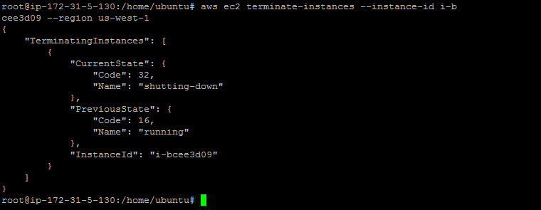

**Load Balancer**

**Step 1 : Creates a HTTP Load Balancer**

# aws elb create-load-balancer --load-balancer-name my-load-balancer --listeners "Protocol=HTTP,LoadBalancerPort=80,InstanceProtocol=HTTP,InstancePort=80" --subnets subnet-d796688f --region eu-west-1

**Step 2 : Delete Load Balancer**

# aws elb delete-load-balancer --load-balancer-name my-load-balancer

**S3 Commands**

**Creating an s3 bucket**

# aws s3 mb s3://samplebucketcloudenbled

**Listing the buckets**

# aws s3 ls

**Check the contents of the bucket**

**aws s3 ls s3://samplebucketcloudenbled**

**Uploading a file to the bucket**

aws s3 cp C:\Users\MJ\Desktop\ajayrole.ppk s3://samplebucketcloudenbled

**Deleting a file to the bucket**

aws s3 rm s3://samplebucketcloudenbled/ajayrole.ppk

**Deleting a bucket**

aws s3 rb s3://samplebucketcloudenbled