Accessibility evaluation and testing report

Web accessibility testing is a subset of usability testing where the users under consideration have disabilities that affect how they use the web. The end goal, in both usability and accessibility, is to discover how easily people can use a web site and feed that information back into improving future designs and implementations.

To test the “Best Deals” application, it was used “WAVE Browser Extensions”. The WAVE extensions allows you to evaluate web content for accessibility issues directly within Chrome and Firefox browsers. Because the extension runs entirely within your web browser, no information is sent to the WAVE server. This ensures 100% private and secure accessibility reporting. The extension can check intranet, password-protected, dynamically generated, or sensitive web pages. Also, because the WAVE extension evaluates the rendered version of your page, locally displayed styles and dynamically-generated content from scripts or AJAX can be evaluated.

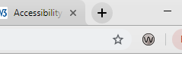

**The first test:**

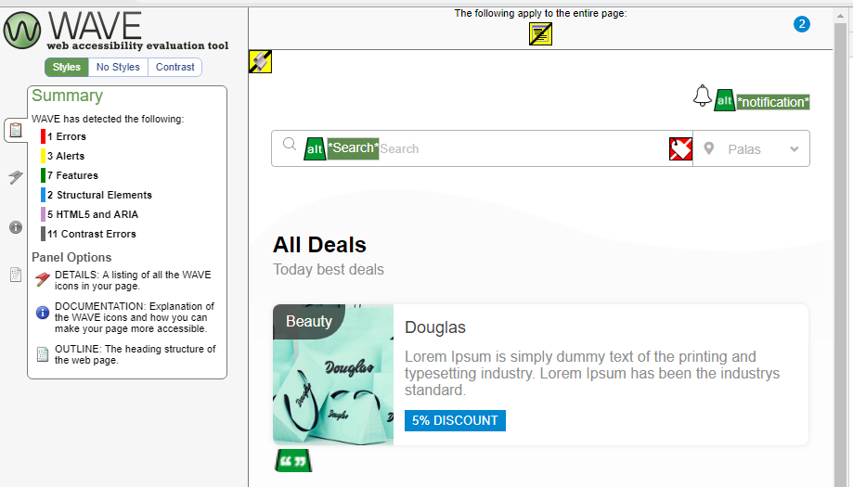

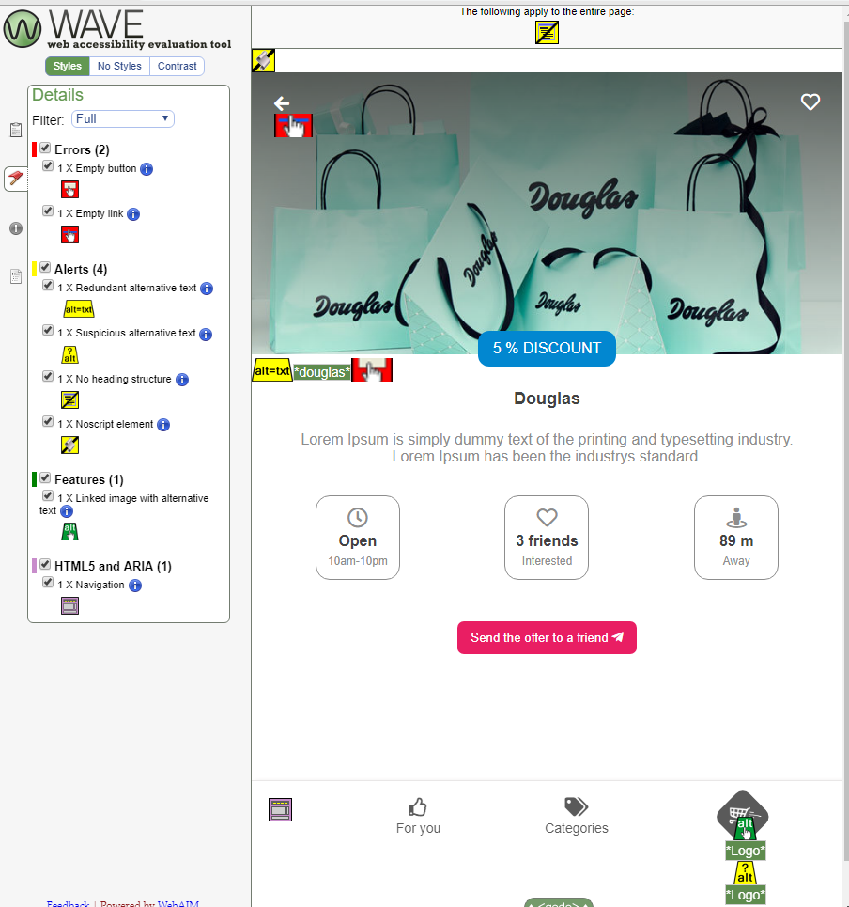

The extensions shows 1-2 errors, 3-4 alerts, some features, some contrast errors.

**After correcting the errors:**

1. Error: A form control does not have a corresponding label.

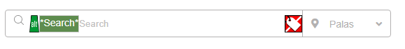

becomes

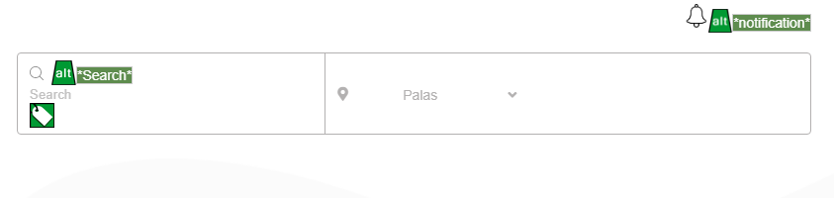

We corrected this by adding a <label> tag.

2)Feature: Null or empty alternative text

becomes



We corrected this by adding a name in <alt> tag,