[Fingerprint Sensor with Raspberry Pi](https://circuitdigest.com/microcontroller-projects/raspberry-pi-fingerprint-sensor-interfacing)

**1.Feature list and user requirements**

 Using this Raspberry Pi FingerPrint System, we can enroll new fingerprints into the system and delete already existing ones. This action can be performed only by admins which are set from the begging. You will see 4 buttons, which are for enrollment, deletion, increment, decrement. If you put your finger on the sensor and you are already enrolled a message like “Access granted”, but if you are not you are going to receive a message like “Permission denied”. Only an admin can enroll or delete fingerprints.

**2.System architecture**

USB to

Serial

Access

Control

Control

Keys

Raspberry

PI

LCD

Fingerprint

Sensor

**3.Hardware overview**

We have used a **4 push buttons**: one for enrolling the new finger pring, one for deleting the already fed finger prints and rest two for increment/decrement the position of already fed Finger prints. Also we need 1 **USB to serial component** to connect **Fingerprint sensor** to our **raspberry pi board.** Also we have used one **LCD** to show messages to the users.

### **Required Components:**

* Raspberry Pi
* USB to Serial converter
* Resistor 150 ohm -1 k ohm (optional)
* Push buttons
* LCD
* Bread Board or PCB (
* Jumper wires
* LED (optional)
* Fingerprint sensor

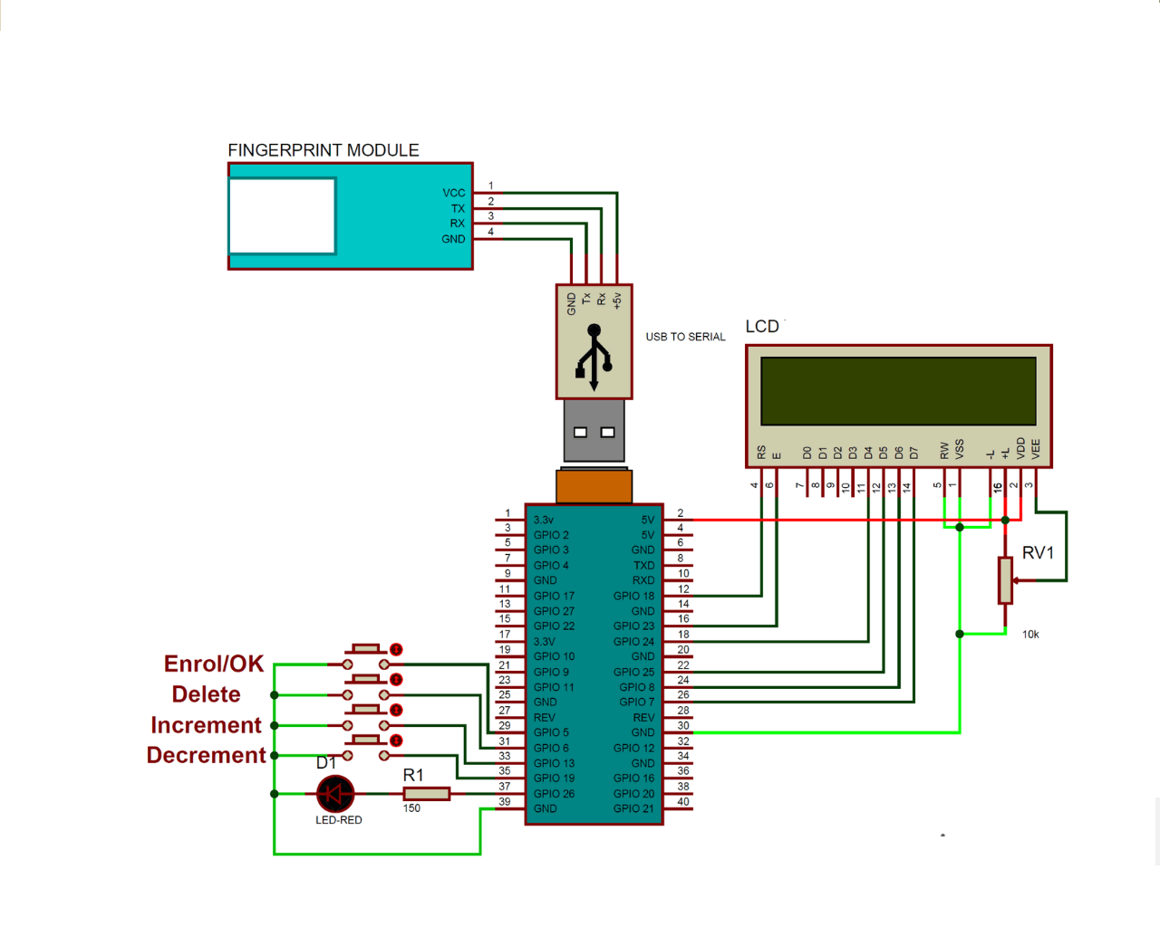

**4. Software overview**

We need to **install fingerprint library for Raspberry Pi** in python:

* Enter sudo: sudo bash
* **download some required packages:**
* wget – [http://apt.pm-codeworks.de/pm-codeworks.list –P /etc/apt/sources.list.d/](http://apt.pm-codeworks.de/pm-codeworks.list%20–P%20/etc/apt/sources.list.d/%20)
* wget –O – http://apt.pm-codeworks.de/pm-codeworks.de.gpsg | apt-key add-
* **update the Raspberry pi and install the downloaded finger print sensor library:**
* sudo apt-get update
* sudo apt-get install python-fingerprint -yes
* **check USB port**on which your finger print sensor is connected:
* ls /dev/ttyUSB*

**1.Define pins for LCD, LED and push buttons**

**2.** **Initialize and give direction to the selected pins**

**3.** **Initialized fingerprint Sensor**

**4.Set a firebase database where you will save users/admins. Set admins.**

**5.** **initialize system** by in “while 1” loop by asking to “Place Finger” on finger print sensor and then system will check whether this finger print it valid or not and display the results accordingly