Project

Tasks:

1. Opened GitHub by accessing <https://github.com/>

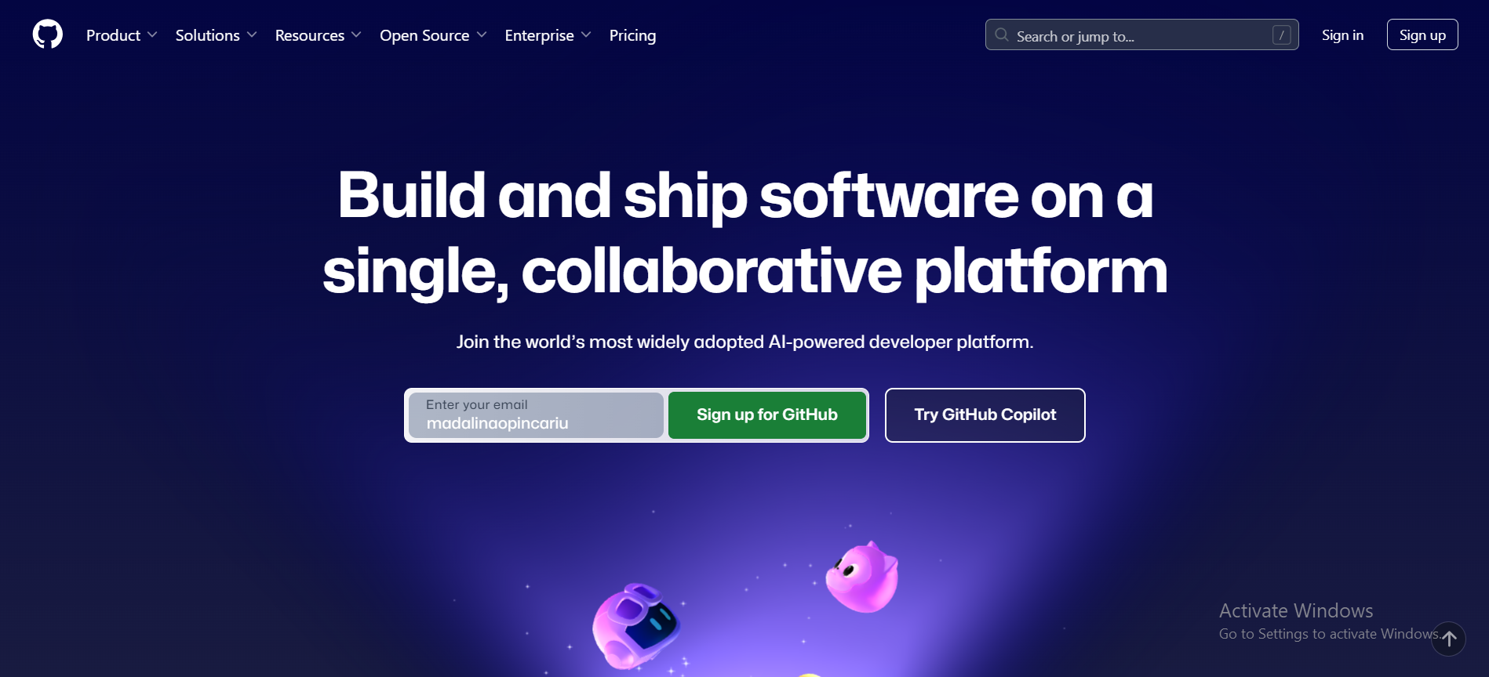

I clicked on the “Sign In” button from the upper right corner of the photo above, because I already have an account.

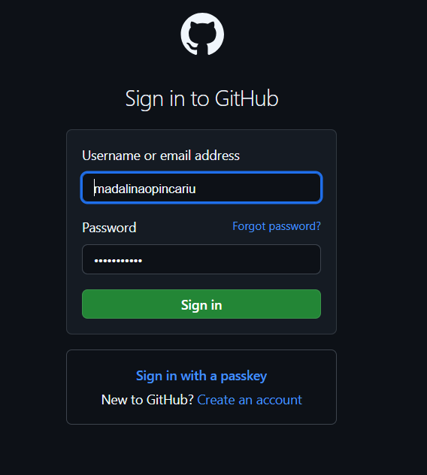

Filled out the labels and clicked on “Sign in”.

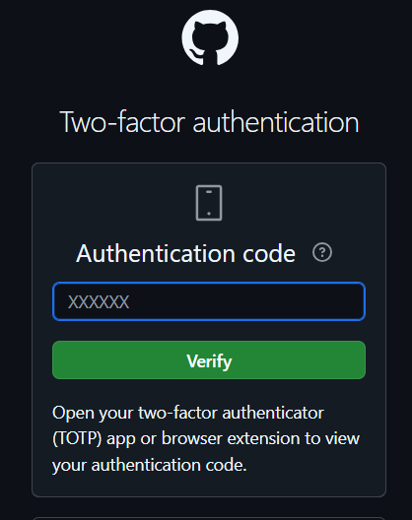

I have Two-factor authentication enabled so I have to do one more step.

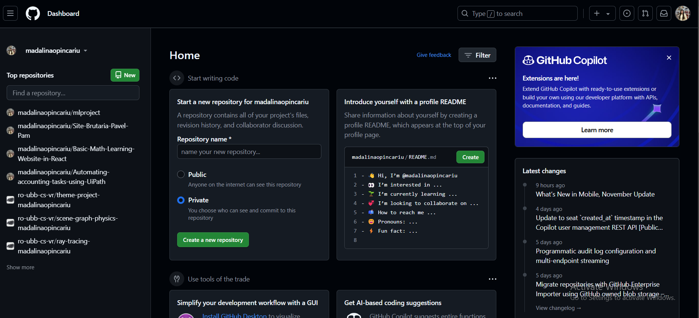

1. Open Command Prompt

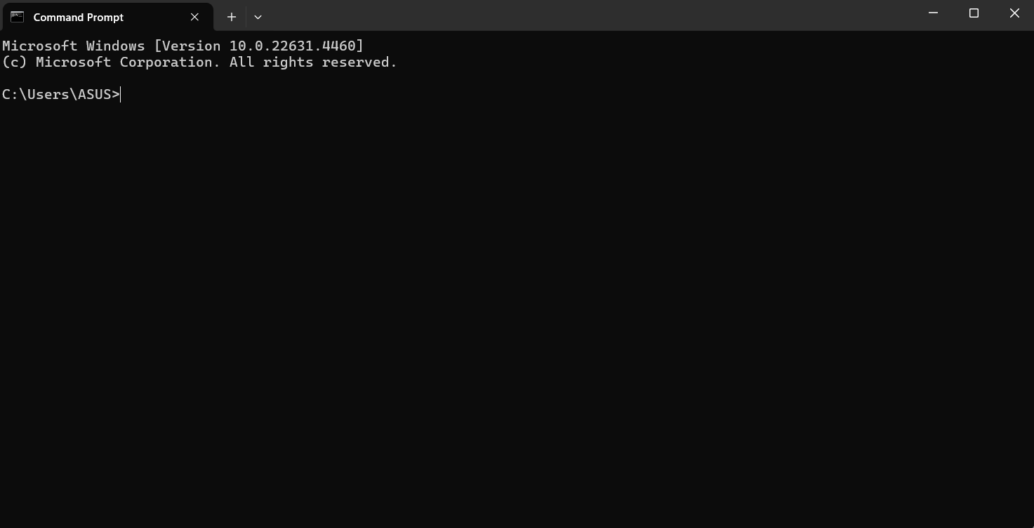

Check if Git is installed on your computer by running:

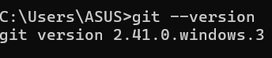

If it’s not installed, download and install Git from [git-scm.com](https://git-scm.com/).

Navigate to the folder where your project files are stored