Project

Tasks:

1. Opened GitHub by accessing <https://github.com/>

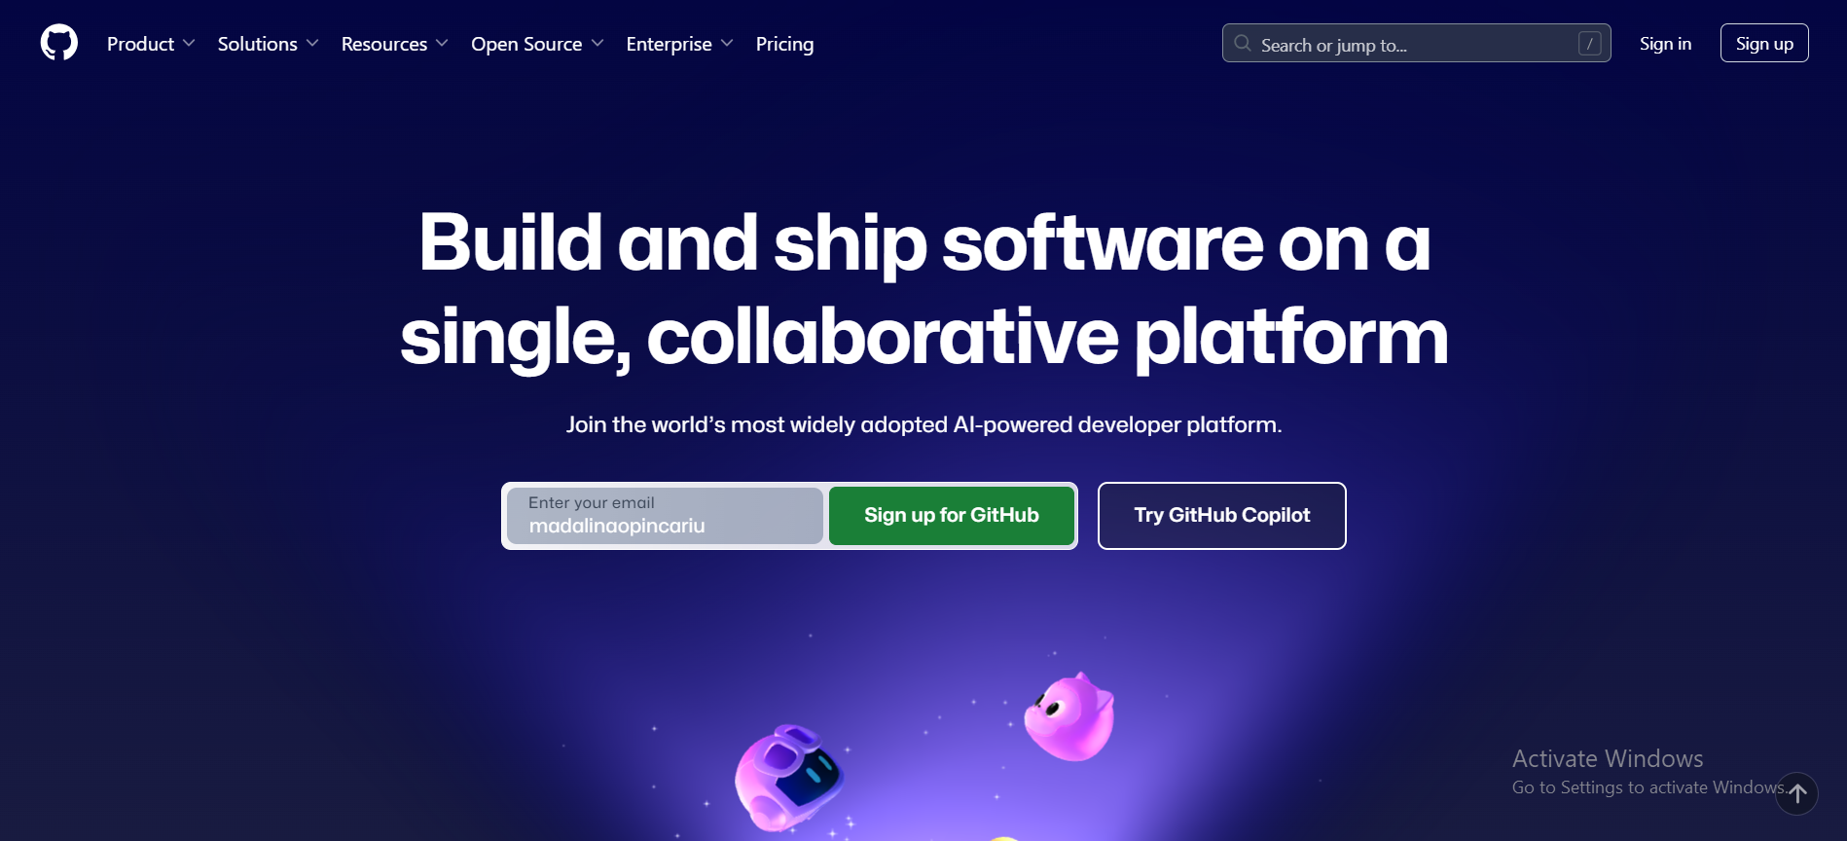

I clicked on the “Sign In” button from the upper right corner of the photo above, because I already have an account.

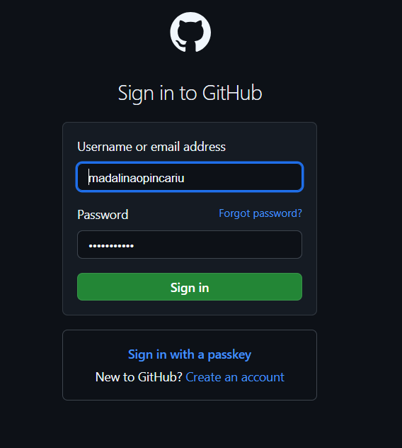

Filled out the labels and clicked on “Sign in”.

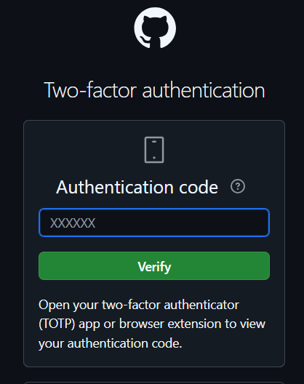

I have Two-factor authentication enabled so I have to do one more step.

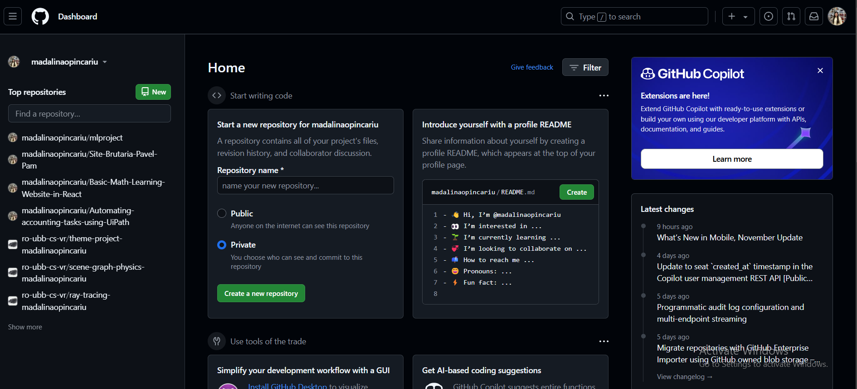

1. Open Command Prompt

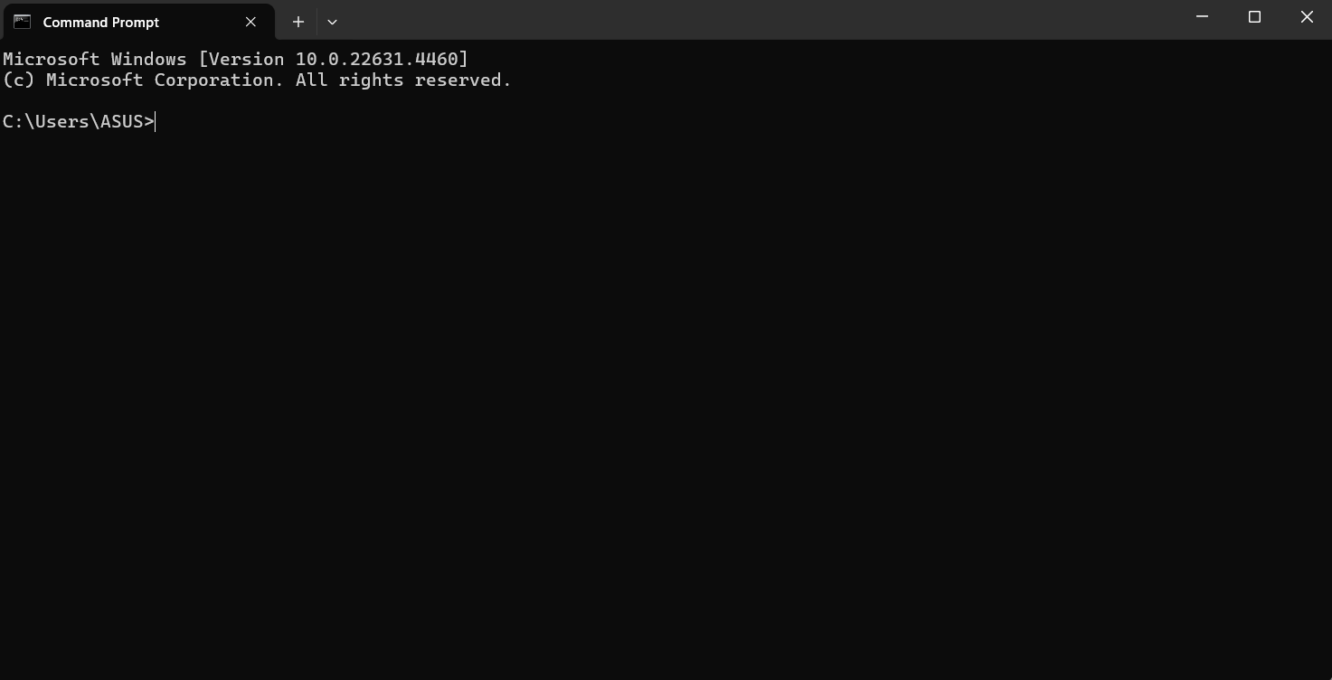

Check if Git is installed on your computer by running:

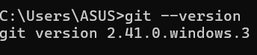

If it’s not installed, download and install Git from [git-scm.com](https://git-scm.com/).

Navigate to the folder where your project files are stored

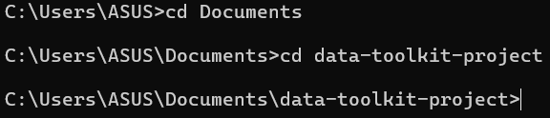

Initialize a Git repository



This creates a hidden .git folder in your project directory, which Git uses to track changes.

1. Add all your existing files to the repository



Commit your files to the repository with a descriptive message

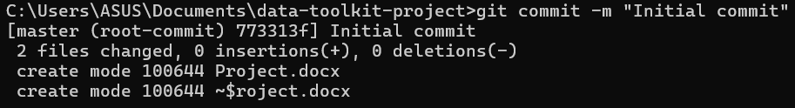4. Go back to Github, click on the “name your new repository” label and add the name of the repository Click on “Public” and on “Create a new repository”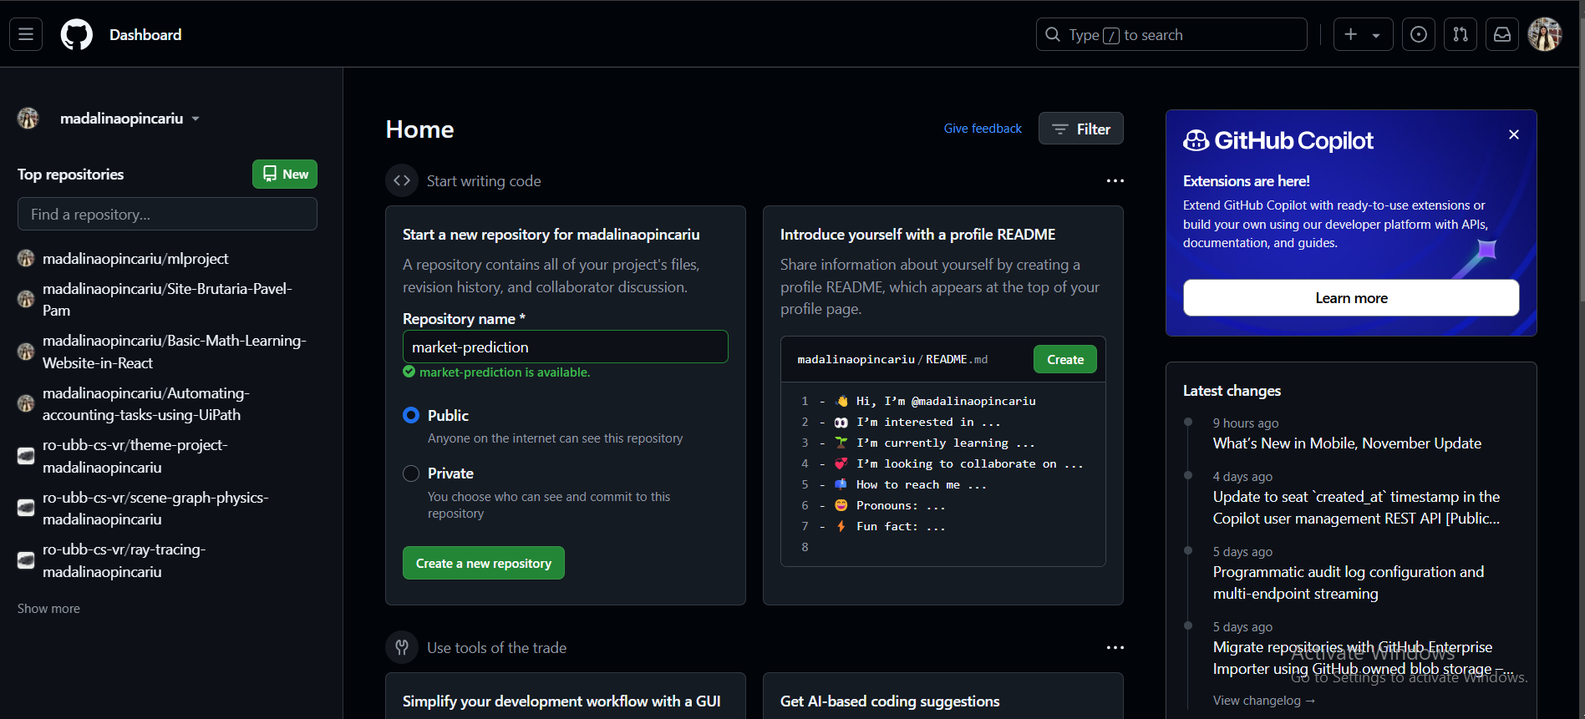

Click on “Public” and on “Create a new repository”

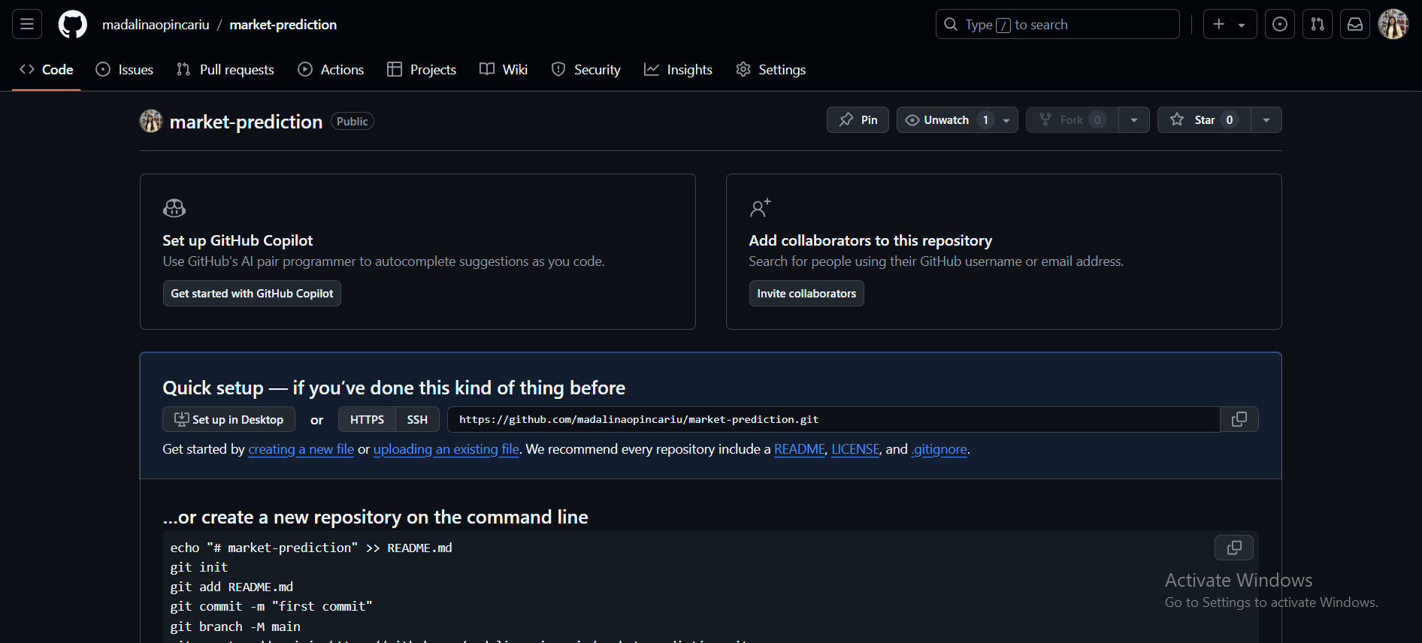

1. Copy the link you see in the photo and go back to cmd



Confirm the remote connection was successful by running



Connection is successful

1. Push your local repository’s content to the remote repository

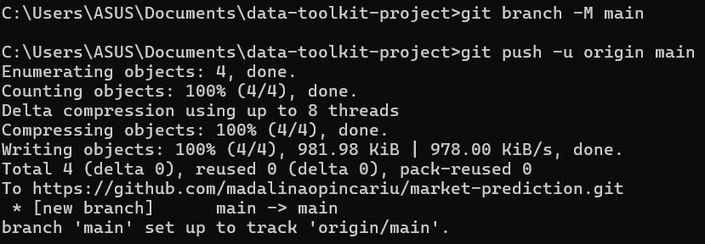

This sets main as the default branch and pushes your local files to the remote.

1. Create a new branch



Switch to the newly created branch



1. Stage the new file for commit



Commit the changes with a meaningful message



1. Switch to the main branch

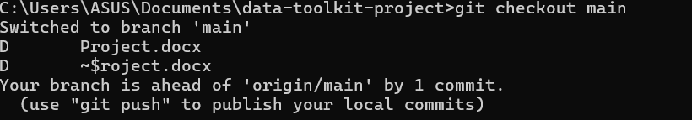

Stage and commit the changes

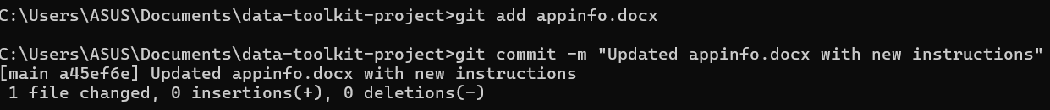

Return to your feature branch

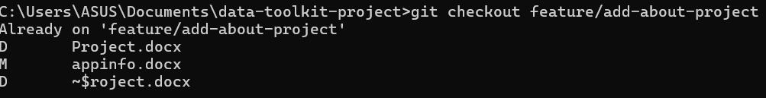

Incorporate the latest updates from the main branch into your current branch