Production Test Coverage Analysis (HW TCA)

What test coverage analysis is
After assembly, a circuit board goes through several test stages: automated optical inspection (AOI), X-ray inspection (AXI), in-circuit test (ICT) and functional test (FT). Each stage sees different defect types. Test coverage analysis (TCA) answers the question: if the board has a given manufacturing defect, does any test catch it before it reaches the customer, and how reliably?
A passed test only says that the measured properties are fine. If ICT measures a resistor, we know it is present, has the right value and is neither open nor shorted; we know nothing about the components we did not measure. That is why the analysis does not count tests; it takes every possible failure mode and gives it a detection value for each test method.
The test methods used in the lab are:
Method | What it does | Good at | Limitations
AOI | A camera compares the board with a reference image. | missing part, polarity, alignment, visible solder bridges | cannot see hidden joints; cannot read the value of unmarked parts
AXI | X-ray image of the solder joints. | hidden joints, shorts, joint quality | cannot see the value or function of a part
ICT | A bed-of-nails fixture contacts the test points and measures the parts one by one. | value, short, open | needs a test point on every net of the part
FT | The board is powered and its functions are checked through the connectors. | function at real speed | often cannot tell which part is faulty

Exercise 1
For each defect below, say which method (AOI, AXI, ICT or FT) catches it most reliably, and why:
- a missing SMD resistor;
- an unmarked SMD capacitor with the wrong value;
- an unconnected pin of a THT connector, soldered on the BOTTOM side;
- a faulty CAN driver inside the transceiver;
- a solder bridge hidden under an IC package.

The PCOLA/SOQ/FAM model
The PCOLA/SOQ model, introduced by Hird, Parker and Follis (ITC 2002), describes which properties a test verifies. For the component: P (presence), C (correctness, the right part), O (orientation, polarity), L (live, the part works), A (alignment on the pads). For the connection: S (shorts), O (opens), Q (quality of the joint). iNEMI added the functional part, FAM: F (feature, the function exists), A (at-speed), M (measurement, the measured performance).

Exercise 2
Assign each defect from exercise 1 to one of the PCOLA, SOQ or FAM letters.

The case study: the front radar's CAN module
A front radar (ARS 408-21; lab assumption: ASIL B) sends its list of detected objects over CAN at 500 kbit/s. The CAN interface uses a module with the MCP2551 transceiver. The board has 13 components and no test points. The THT components (J1, J2, JP1) are soldered on the BOTTOM side, and AOI initially inspects only the TOP side.
Component | Nets | Role
J1 | VDD, TXD, RXD, GND | connector to the sensor (supply and data from the microcontroller)
U1 | TXD, GND, VDD, RXD, VREF (not connected), CANL, CANH, RS | MCP2551 CAN transceiver (SOIC-8)
C3 | VDD – GND | supply decoupling
R3 | RS – GND | selects the operating mode of U1
R4 + JP1 | CANH – N_TERM – CANL | 120 Ω termination, enabled with jumper JP1
R1 / C1 | CANH – N_F1 – GND | RC filter on CANH (EMC)
R2 / C2 | CANL – N_F2 – GND | RC filter on CANL (EMC)
J2 | CANH, CANL, GND | connector to the CAN bus
LED1 + R5 | VDD – N_LED – GND | power indicator

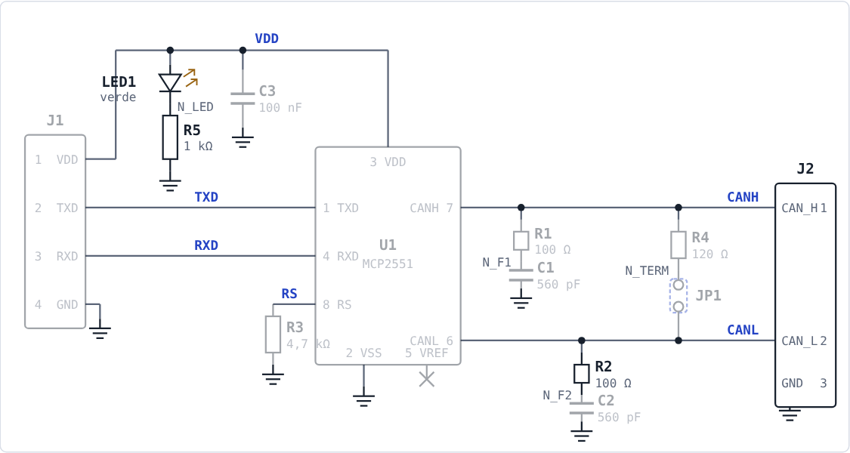
The module schematic as shown in the app (SCHEMATIC button).
You work in the HW TCA Lab web app, in the browser, with nothing to install. Enter your name, group and the variant code you received (H1–H6) and click Load variant. The board and the schematic are interactive: when you click a pin (pad), the app draws that pin's net, and the Connections panel shows where the signal goes, whether the net reaches a connector and whether it has a test point.
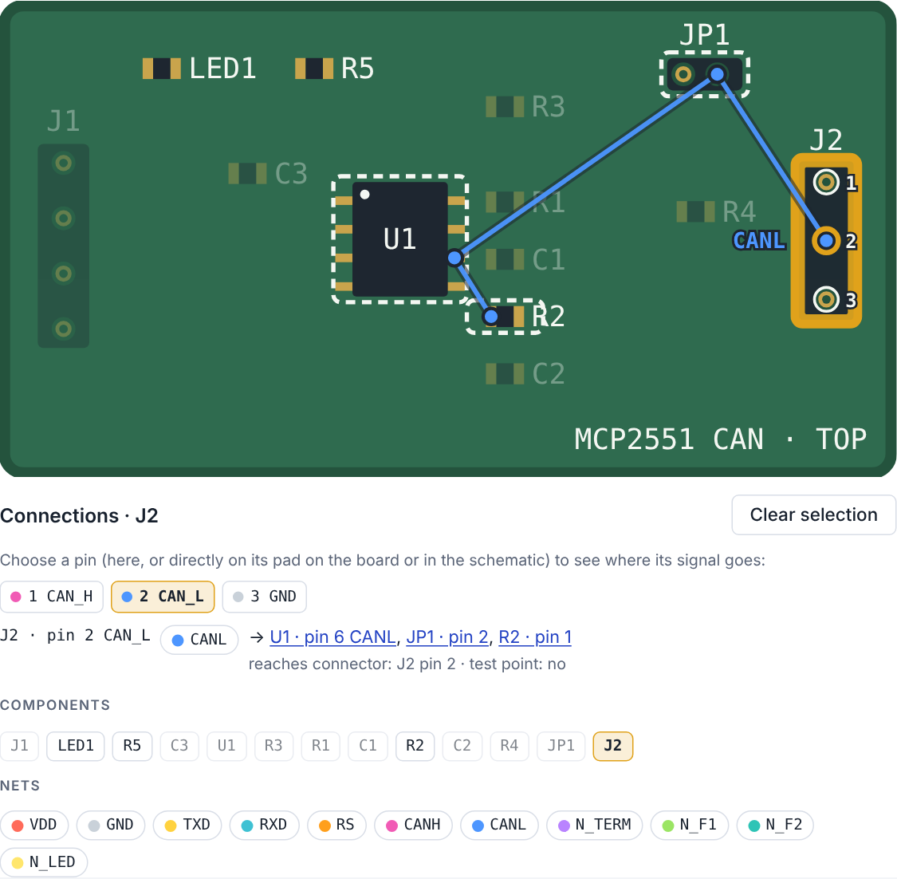
Pin 2 (CAN_L) of J2 selected: the blue line joins all the pins on the CANL net.

Exercise 3
In the app, click pin 7 (CANH) of U1. Write down all the components on the CANH net, the connector the net reaches and whether it has a test point. Repeat for pin 8 (RS). What difference do you see between the two nets, from the functional test's point of view?

Severity (S)
Following the AIAG-VDA FMEA handbook (2019), the risk of each failure mode is described by three ratings from 1 to 10: severity S, occurrence O and detection D. Severity is rated on the effect: how serious the effect is for the customer. In the lab, S follows from the effect class:
Class | S | Description
E10 | 10 | Affects safe operation of the vehicle, occupants or other road users
E9 | 9 | Noncompliance with regulations (EMC: emissions or immunity)
E8 | 8 | Loss of the primary function (no CAN communication or no operation)
E7 | 7 | Degradation of the primary function (corrupted or intermittent communication)
E6 | 6 | Loss of a secondary function (the LED indicator does not work)
E5 | 5 | Degradation of a secondary function (wrong LED indication)
E2 | 2 | Slightly objectionable effect, no functional or EMC effect
E1 | 1 | No discernible effect

Effects that only reduce EMC filtering get E9 (UNECE R10), even if the function is not affected.

Exercise 4
Choose the effect class and severity for:
- the power LED does not light;
- the RC filter on CANH is missing;
- the module does not communicate on CAN;
- CAN frames sometimes arrive corrupted.

Exercise 5
In the app, choose the effect class for all the failure modes of your variant.

Occurrence (O)
Occurrence is rated on the cause: how likely the defect is, given the prevention. For a mature SMT technology with a stable process the value is usually low.
O | Criterion (AIAG-VDA summary)
10 | First application of new technology; no experience, standards or best practices
9 | First use in the company of innovations or new materials
8 | Innovations used in a new application; few applicable standards
7 | New design on similar technology, new application
6 | Similar to previous designs, changed duty cycle or conditions
5 | Detail changes to a proven design; lessons learned applied but not proven
4 | Almost identical design, short field exposure
3 | Detail changes to a known design with comparable test or field experience
2 | Almost identical mature design with long field exposure
1 | Cause eliminated by prevention; not possible by design

Exercise 6
In the app, choose O for each mode. Use the same reasoning for all modes and explain it in the report's conclusion.

Detection at AOI, AXI and ICT
Detection D says how reliably we catch the defect before the board ships: 1 means the method always detects it, 10 that we cannot detect it. For AOI, AXI and ICT, the app calculates D from the detection rules below and shows the reason. The ICT “with TP” value applies only if all the nets of the part have a test point.
Category | Failure mode | AOI | AXI | ICT with TP | ICT without TP
PAS-SMD (R, C) | Missing | 1 | 3 | 1 | 5
PAS-SMD (R, C) | Short | 5 | 5 | 1 | 5
PAS-SMD (R, C) | Open | 1 | 5 | 1 | 5
PAS-SMD (R, C) | Wrong value | 10 | 10 | 1 | 5
DIODE (LED) | Missing | 1 | 3 | 1 | 5
DIODE (LED) | Short | 5 | 5 | 1 | 5
DIODE (LED) | Open | 1 | 5 | 1 | 5
DIODE (LED) | Wrong value | 10 | 10 | 5 | 10
DIODE (LED) | Wrong polarity | 1 | 10 | 1 | 5
IC-LEADED (U1) | Missing | 1 | 1 | 1 | 5
IC-LEADED (U1) | Pin open | 1 | 5 | 1 | 10
IC-LEADED (U1) | Pin short | 1 | 1 | 1 | 10
IC-LEADED (U1) | Pin wrong functionality | 10 | 10 | 10 | 10
CONN-THT (J1, J2, JP1) | Missing | 1 | 1 | 1 | 10
CONN-THT (J1, J2, JP1) | Pin open | 10 | 3 | 1 | 10
CONN-THT (J1, J2, JP1) | Pin short | 10 | 1 | 1 | 10
CONN-THT (J1, J2, JP1) | Wrong value | 1 | 10 | 1 | 5
CONN-THT (J1, J2, JP1) | Short | 1 | 10 | 1 | 5
CONN-THT (J1, J2, JP1) | Open | 10 | 3 | 1 | 5

Two additional rules: C5 – for the THT connectors, solder defects (pin open, pin short, open) are on the BOTTOM side, which AOI does not inspect at first, so AOI = 10; with AOI enabled on BOTTOM it becomes 1. C7 – marked parts (R1–R5, U1) have their value printed on the package, so AOI partly catches a wrong value (D = 5).

Exercise 7
Without the app, using the table and rules C5 and C7, find D AOI, D AXI and D ICT (without test points) for:
- R1 short;
- J2, pin 1 (CAN_H), pin open;
- U1, pin 4 (RXD), pin open;
- R2 wrong value.

Exercise 8
In the app, check the AOI, AXI and ICT values for the modes of your variant. Pick two modes and explain, in your own words, the reason the app shows.

Detection at the functional test (FT)
The functional test runs through the connectors at 500 kbit/s, with the limits below. You decide the FT detection yourselves: choose the test that matches the part and the defect type, or NONE (D = 10), then choose D from the detection scale and write why. The functional test can only see a defect if its net reaches a connector pin, directly or through the module's function.
Test | Name | What is measured | Limits | What it can catch
FT1 | Supply current | IDD on VDD (J1), recessive and dominant | Recessive ≤ 10 mA; dominant ≤ 75 mA | C3 short, LED1 short / wrong polarity, U1 pin short (VDD–GND), U1 missing, VDD wrong functionality
FT2 | Power indicator | LED1 on, checked with an optical sensor | On at nominal VDD | LED1 open / missing / wrong polarity, R5 open / missing
FT3 | Recessive bus voltages | VCANH, VCANL without load, TXD = 1 | 2.0 – 3.0 V | R1/C1, R2/C2 short (line to GND), U1 pin open / short on CANH / CANL
FT4 | Dominant differential voltage | VCANH – VCANL with a 40–60 Ω load, TXD = 0 | 1.5 – 3.0 V | Faulty driver (CANH / CANL wrong functionality), R3 wrong value (standby mode)
FT5 | Loopback TXD → RXD | TXD is toggled; RXD follows the bus state | RXD = 0 dominant, 1 recessive | TXD / RXD pin open on U1 and J1, TXD / RXD wrong functionality, wrong standby mode (R3)
FT6 | Termination resistance | CAN_H–CAN_L on J2, with JP1 fitted and removed | ≈ 120 Ω with JP1; ≥ 20 kΩ without | R4 open / missing / wrong value, JP1 missing / open / short
FT7 | CAN transmission through the connectors | The tester sends frames on TXD (J1); a reference node on J2 acknowledges them (ACK) | All frames correct, no error frames | Pin open / short on J1 (VDD, TXD, GND) and J2 (CAN_H, CAN_L), U1 TXD / CANH / CANL / RS, R3 open / missing / wrong value, R1/C1, R2/C2 short
FT8 | CAN reception through the connectors | The reference node sends frames on J2; the tester reads RXD on J1 | All frames read correctly | Pin open / short on J1 (RXD) and J2 (CAN_H, CAN_L), U1 RXD / CANH / CANL, RXD wrong functionality

The analysis is done on the design, so we use the DFMEA detection scale (AIAG-VDA summary):
D | Criterion (AIAG-VDA summary)
10 | Test procedure not yet developed; method not defined
9 | Test method not designed specifically for this mode or cause
8 | New, unproven test method
7 | Proven method, planned late (pass / fail)
6 | Proven method, planned late (test-to-failure)
5 | Proven method, planned late (degradation testing)
4 | Proven method, in time before release (pass / fail)
3 | Proven method, in time before release (test-to-failure)
2 | Proven method, in time before release (degradation testing)
1 | Prior testing confirms the failure cannot occur, or the method always detects it

Exercise 9
In the app, for each failure mode: click the pin of the part and follow its net in the Connections panel, choose test FT1–FT8 or NONE, choose D FT from the list and write the justification. A value without a justification earns no points.

Combined detection and action priority (AP)
All tests run on every board, so the combined detection is the minimum of the methods' values. S, O and D give the action priority AP (H, M or L) from the AIAG-VDA table. We do not use RPN = S × O × D: the same RPN can hide very different risks (Bowles, 2003).
1 | D = min(D AOI, D AXI, D ICT, D FT)
2 | AP = AIAG-VDA table (S band, O band, D band)

S | O | D 7–10 | D 5–6 | D 2–4 | D 1
9–10 | 8–10 | H | H | H | H
9–10 | 6–7 | H | H | H | H
9–10 | 4–5 | H | H | H | M
9–10 | 2–3 | H | M | L | L
9–10 | 1 | L | L | L | L
7–8 | 8–10 | H | H | H | H
7–8 | 6–7 | H | H | H | M
7–8 | 4–5 | H | M | M | M
7–8 | 2–3 | M | M | L | L
7–8 | 1 | L | L | L | L
4–6 | 8–10 | H | H | M | M
4–6 | 6–7 | M | M | M | L
4–6 | 4–5 | M | L | L | L
4–6 | 2–3 | L | L | L | L
4–6 | 1 | L | L | L | L
2–3 | 8–10 | M | M | L | L
2–3 | 6–7 | L | L | L | L
2–3 | 4–5 | L | L | L | L
2–3 | 2–3 | L | L | L | L
2–3 | 1 | L | L | L | L
1 | 1–10 | L | L | L | L

Here is an example from the demo variant H0 (you can load it in the app with code H0): J2, pin 2 (CAN_L), pin open. The joint is on the BOTTOM side, so AOI = 10 (C5). AXI = 3. ICT = 10, because there is no test point on CANL. The matching test is FT7, but with CAN_L open communication may still work over a short distance, so FT7 does not surely catch the defect. With S = 8 (E8), O = 2 and D FT = 5: D = min(10, 3, 10, 5) = 3 and AP = L. With AOI enabled on BOTTOM, AOI = 1 and D becomes 1.

Exercise 10
Calculate D and AP for:
- S = 8, O = 2; D AOI = 10, D AXI = 3, D ICT = 10, D FT = 5;
- S = 9, O = 4; D AOI = 5, D AXI = 5, D ICT = 5, D FT = 10;
- S = 7, O = 4; D AOI = 10, D AXI = 10, D ICT = 5, D FT = 10.

Exercise 11
Calculate RPN and AP for A: S = 9, O = 4, D = 3 and B: S = 3, O = 6, D = 6. What do you notice? Which risk should be treated first?

Improvements
For the modes with AP H or M we look for improvements: test points (ICT can measure the part), AOI on the BOTTOM side (THT joints) or new FT tests (what is measured, where, which limit). Every improvement has a cost: a test point takes board space and a fixture pin, a new test adds test time. Propose only what reduces a risk.

Exercise 12
On which nets must test points be added so that ICT can measure R1? And C2? Check your answer in the app by clicking the pins of the parts.

Exercise 13
In the app, propose improvements for the modes of your variant with AP H or M. For each, write down AP before and after the improvement.

Residual risk and the report
Risk assessment means identification, analysis and evaluation (ISO 31000). What remains after the improvements is the residual risk: it must be documented, with the reason it remains and the decision taken (risk accepted or action proposed).

Exercise 14
For the modes that stay H or M after the improvements, fill in the “Residual risk assessment” column in the app: choose risk accepted or action proposed and write why.

Exercise 15
In the Report tab, write your improvement proposals and conclusion, check the generated sheet and click Send report. If the submission is not confirmed, download the report (.html) and keep it.

Resources
The HW TCA Lab app
K. Hird, K. P. Parker, B. Follis, “Test Coverage: What Does It Mean When a Board Test Passes?”, ITC 2002
J. B. Bowles, “An Assessment of RPN Prioritization in a Failure Modes Effects and Criticality Analysis”, RAMS 2003
Microchip, MCP2551 High-Speed CAN Transceiver (datasheet)
AIAG & VDA, FMEA Handbook (2019)

