**2D Game Design Document (GDD)**

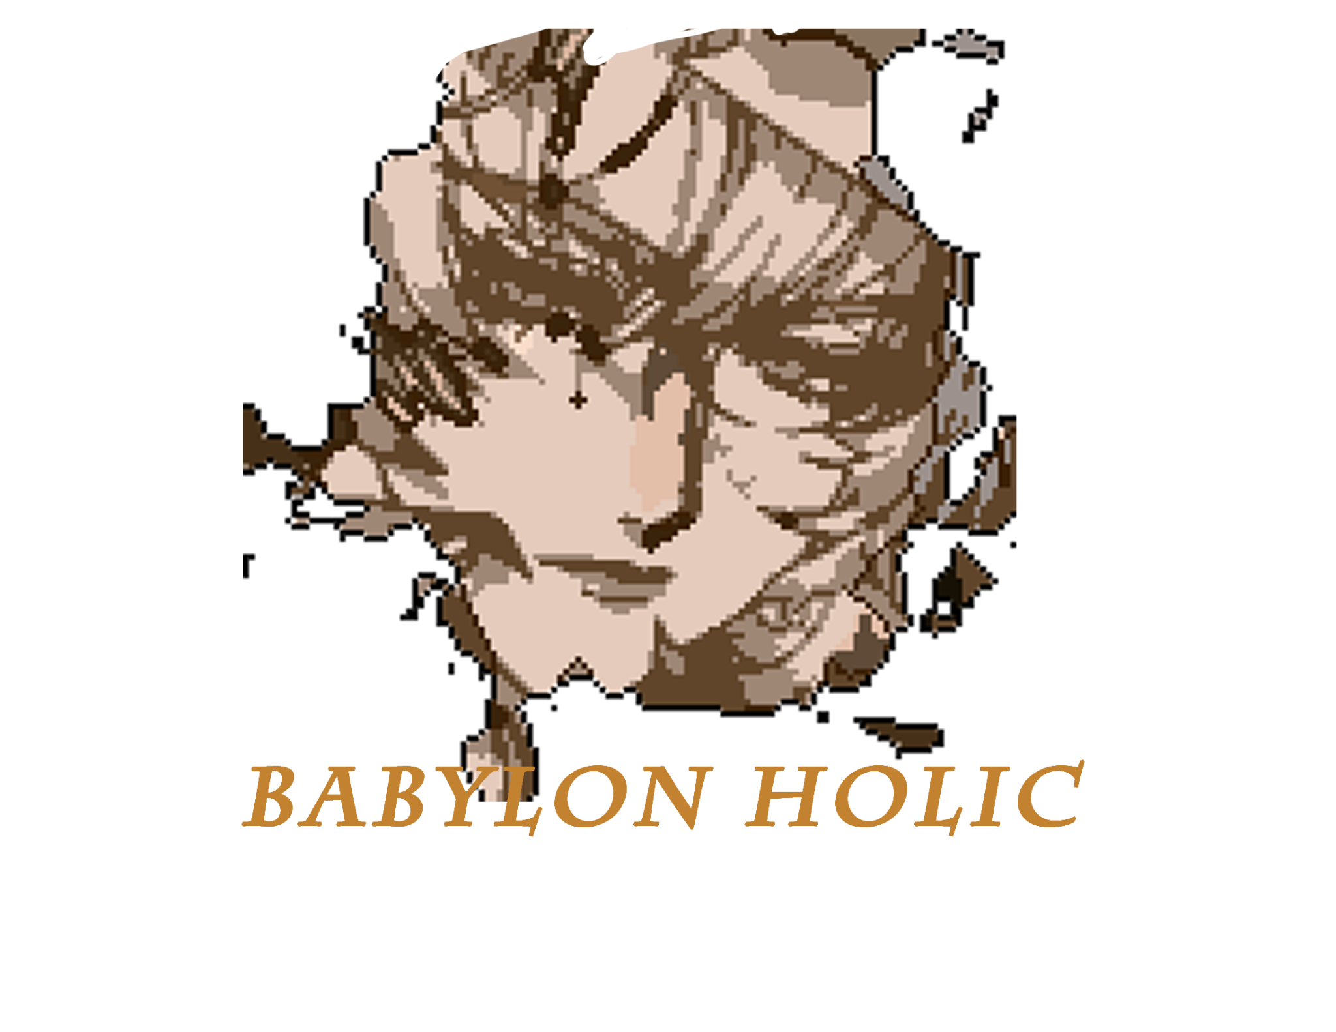

*‘Delve into the magical experience of the world of the undead’ -Jasmine Nguyen*

Table of Contents

1 Game Overview

2 High Concept / Genre

3 Unique Selling Points

4 Platform Minimum Requirements

5 Competitors / Similar Titles

6 Synopsis

7 Game Objectives

8 Game Rules

9 Game Structure

10 Game Play

10.1 Game Controls

10.2 Game Camera

10.2.1 HUD

10.2.2 Maps

11 Players

11.1 Characters

11.2 Metrics

11.3 States

11.4 Weapons

12 Player Line-up

13 NPC

13.1 Enemies

13.1.1 Enemy States

13.1.2 Enemy Spawn Points

13.2 Allies / Companions

13.2.1 Ally States

13.2.2 Ally Spawn Points

14 Art

14.1 Setting

14.2 Level Design

14.3 Audio

15 Procedurally Generated Content

15.1 Environment

15.2 Levels

15.3 Artificial Intelligence NPC

15.4 Visual Arts

15.5 Audio

15.6 Minimum Viable Product (MPV)

16 Wish List

17 Bibliography

Game Development Team Members

PRODUCER

Jasmine Nguyen

PRODUCTION MANAGER

Jasmine Nguyen

PRODUCTION COORDINATOR Jasmine Nguyen

GAME DESIGNERS

Jasmine Nguyen

SYSTEMS/IT COORDINATOR

Jasmine Nguyen

PROGRAMMERS

Jasmine Nguyen, LIST TUTORIALS HERE

TECHNICAL ARTISTS

Jasmine Nguyen

AUDIO ENGINEERS

OPENGAMEART.COM ARTIST: LIST NAMES HERE

UX TESTERS

Jasmine Nguyen

**1 Game Overview**

Title: Spirit Babylon

Platform: PC Standalone + iOS & Android, VR, XBox, Switch,

Genre: RPG

Rating: (14+) ESRB

Target: Casual gamer (aging from 12 - 30)

Release date: MAY 2022

Publisher: Babylon Holic

Description: Experience the world of a nameless character, unknowingly transported into the purgatory world of the undead with no memories. In Asian culture, people burn things for others to give comfort to wandering spirits. Fighting broken souls and doomed creatures, you must try to unlock your memories by collecting parcels burnt by the land of the living while attempting to cross the Celestial River.

**2 High Concept / Genre**

Description: A single-player story-driven RPG. Primarily an exploration-adventure game with elements of survival.

3 Unique Selling Points

* Beautiful scenery
* Storytelling
* Enemies are forsaken spirits
* Unique characters

**4 Platform Minimum Requirements**

PC MINIMUM

Processor (CPU): Intel Core i3/ AMD A8-xxx APU with 3.1 GHz or higher

Memory (RAM): 2 GB of RAM

HDD: At least 1 GB of available hard-disk space

GPU: Intel HD Graphics 4xxx, AMD Radeon R5, Nvidia GeForce 4xx or AMD Radeon HD 7xxx.

Operating system (OS): Microsoft Windows 7, 8.1 10 or Windows 11 64-bit)

Resolution: 1920 x 1080

**5 Competitors / Similar Titles**

Description: Pokemon, Omori, Eastward, Legend of Zelda, EarthBound, Stardew Valley, Harry Potter and the Chamber of Secrets

**6 Synopsis**

Description: A role-playing game based on storytelling and exploration. You’re on a journey of finding the truth of yourself and trying to pass over to the realm of the dead. IT will have a dark, evil, tone.

**7 Game Objectives**

Difficulty: The player will not be able to define a difficulty at the beginning of the game, but they will interact with monsters/creatures that have different levels of strength. There will be no time in the game. The entire game is set at night, no such thing as a day. The player must find burnt parcel offerings to regain their memories. They must enter dungeons and explore the map while fighting corrupt souls to seek offerings. The player must also interact with NPCs for hints and locations.

**8 Game Rules**

Description: Do not die in enemy locations.

**9 Game Structure**

Description: There will a map where there this a town in the center. The rest is mostly forest. There will be a dungeon on the left. A dungeon will have 3 levels total.

**10 Game Play**

Description: There will be a menu screen: Play Game, Settings, About, and Quit. After the player hits the play button, they will start at the beginning and each map will start with a top-down view. When the player starts the game they will be asked to enter a name. They will be able to interact with items. Inventory will be E. Interacting with NPCs and picking up items will be spacebar. The standard attack will be the Q button and the special attack will be W. Movement will be WASD and up, left, right, down keys.

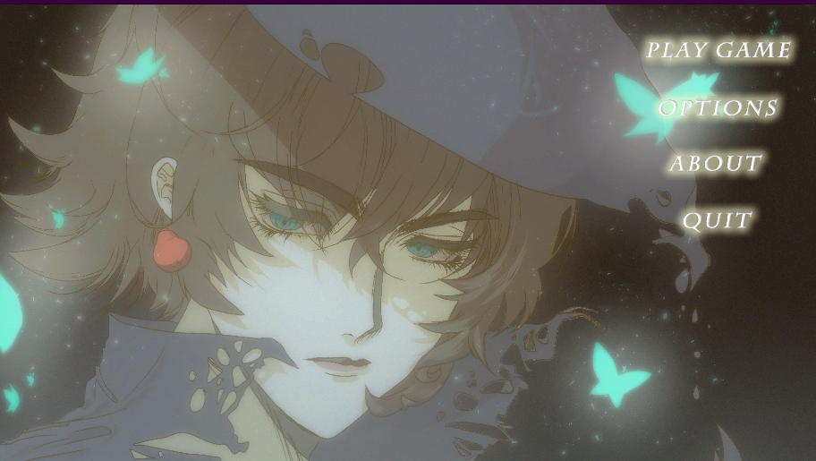

**10.1 Game Controls**

WASD and up and down keys.

**10.2 Game Camera**

Top-Down View

**10.2.1 HUD**

Health bar, spell cast, and weapon toggle display.

**10.2.2 Maps**

Town, dungeon, and rooms of buildings.

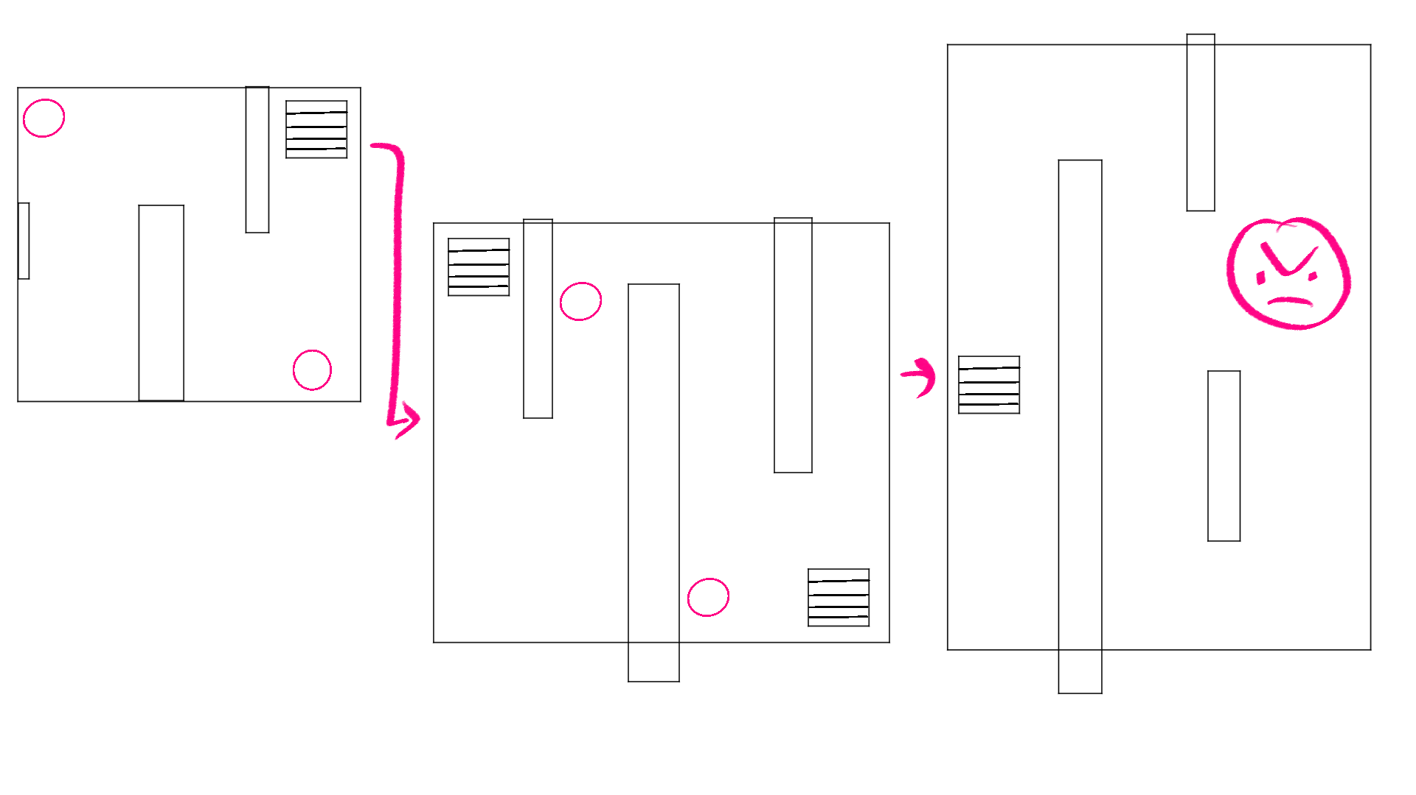

**11 Players**

Single Player

**11.1 Characters**

Main Character: The player enters the name

Merchant: Oz

Purged Souls: Kyrie, Theos, Abel, Faust, Bruno, Clementine

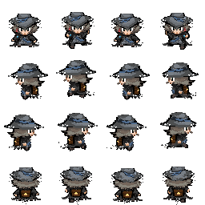

**11.2 Metrics**

Currency, enemies defeated, souls collected, story progression, map coverage.

**11.3 States**

gamestate == 0: Game initialization after loading game. Animation displays the main character on the title screen with butterflies and loads menu buttons

gamestate == 1 Enter game.

gamestate == 3 Play game.

gamestate == 3 Game is over when health bar is at 0. “You Died” will display on the screen.

gamestate == 4 Reverts to last save point

Game behavior: Interactive with environment + presence of performance and socializing goals + high number of failures from enemy defeats + exploration driven and item and soul collecting driven

**11.4 Weapons**

Cane/Staff

**12 Player Line-up**

Only Single player.

**13 NPC**

Merchant: Oz: provides potions, and herbs for healing.

Purged Souls: Kyrie, Theos, Abel, Faust, Bruno, Clementine: Souls for MC to collect and attain memories.

**13.1 Enemies**

Grotesque forms of original beings such as humans, animals, and bugs.

**13.1.1 Enemy States**

Lower difficulty creatures will do -10 damage when touching the player. Stronger enemies will do -20 damage. At the end of the dungeon, the boss will have -30 damage. There will be proximity to the player and collider/hitbox.

**13.1.2 Enemy Spawn Points**

Caves, forests, and dungeons.

There will be random spawn points in certain areas of the map. In each dungeon level, there will be 2 enemy spawn points spread out. Outside of the town, there will be between 4-6 spawn points spread out randomly.

**13.2 Allies / Companions**

Merchant and the purged souls will help the MC progress through the story and finish the game.

**13.2.1 Ally States**

There will be no allies to assist you in battles. Many will be just interactive NPCs that will have chat dialogues with hints on where to find items, where to go to their next destination, and how to complete the game.

**13.2.2 Ally Spawn Points**

After beating enemies in the Caves, forest, and dungeons and reaching the target destination, the allies will be located at the end. Merchant is located in the town.

**14 Art**

Many of the sprites of the characters/NPC will be designed by Jasmine Nguyen. Tilemaps and enemies will be from opengameart.com. The art and aesthetic will reflect a dark and mythical world with a slight evil but whimsical tone. Creatures will follow a sinister but cute theme. Magical items may have a demonic theme. There will be a hint of Asian aesthetic with ancient designs. Some parcels will have modern items.

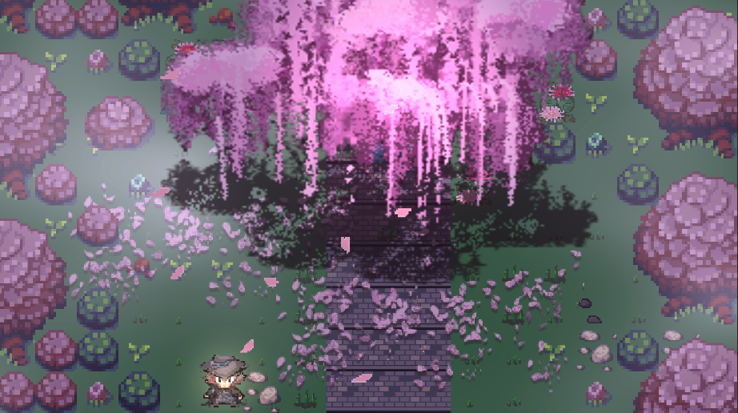

**14.1 Setting**

The game will be set in a foreign land with labyrinth structures to reflect the land of the unknown. The game takes place in the purgatory of the underworld where souls must cross to reach the land of the dead.

**14.2 Level Design**

**14.3 Audio**

Music will have classical romantic minimalist genre with piano, keyboards, and violin. Music will be found on OpenGameArt

**15 Procedurally Generated Content**

None

**15.1 Environment**

Unity Game Engine

**15.2 Levels**

Each enemy location will have two levels(rooms) and a final stage with a larger and stronger boss that they must beat before attaining the purged soul.

**15.3 Artificial Intelligence NPC**

NPCS performing “idle actions” such as pacing, and walking. When interacting they will have a dialogue.

**15.4 Visual Arts**

Digital 2D pixel art created on CLIP STUDIO PAINT and Photoshop CS6.

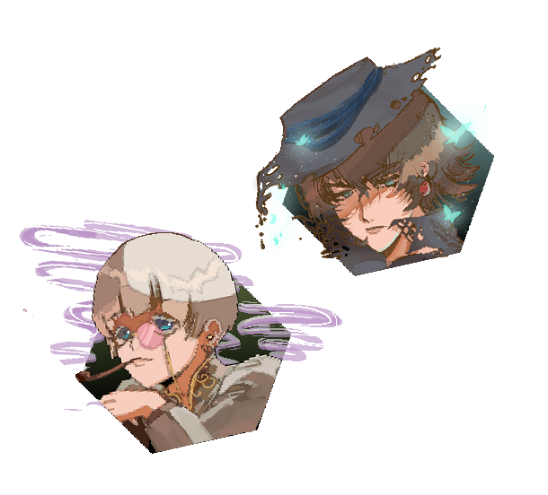

**15.5 Audio**

Audio will be found on OpenGameArt. There will be music playing in each scene change.

* Attack sound
* Rustle sound when opening inventory
* Click sound when picking up items
* Dialogue sound. When there is dialogue there will be blips.
* Pew sounds when striking enemies.
* Enemies crying sound.
* Click sound when browsing items

**15.6 Minimum Viable Product (MPV) 16 Wish List**

**17 Bibliography**

Code will be referenced from

<https://kurtkaiser.us/unity-dungeon-crawler-tutorial/>

<https://docs.unity3d.com/Manual/index.html>

<https://www.youtube.com/watch?v=k4JlFxPcqlg&ab_channel=Unity>

Artwork will be from:

<https://opengameart.org/content/outdoor-tiles-again>

<https://opengameart.org/content/whispers-of-avalon-grassland-tileset>

<https://opengameart.org/content/496-pixel-art-icons-for-medievalfantasy-rpg>

<https://opengameart.org/content/lpc-plant-repack>

<https://opengameart.org/content/dungeon-crawler-tileset>

<https://opengameart.org/content/lpc-tile-atlas2>

<https://opengameart.org/content/lpc-dungeon-elements>

Music and Audio from:

<https://opengameart.org/content/button-click-sound-effect-cc0public-domain>

<https://opengameart.org/content/jrpg2-piano>

<https://opengameart.org/content/jrpg-piano>

<https://opengameart.org/content/vampires-piano>  
<https://opengameart.org/content/piano-5>

<https://opengameart.org/content/thoughtful-piano-theme>

<https://opengameart.org/content/dungeon-03>

<https://opengameart.org/content/rpg-ambience-dungeon>

<https://opengameart.org/content/emotional-piano-loop>