# Adam Conger - CS 255 System Design Document Template

This template lays out all the different sections that you need to complete for Project Two. Each section has guidance to prompt your thinking. You will need to continually reference the interview transcript as you work to make sure that you are addressing your client’s needs. There is no required length for the final document. Instead the goal is to complete each section based on what your client’s needs are. Remove this note when you are finished, and replace all bracketed text with the relevant information.

## UML Diagrams

### UML Use Case Diagram

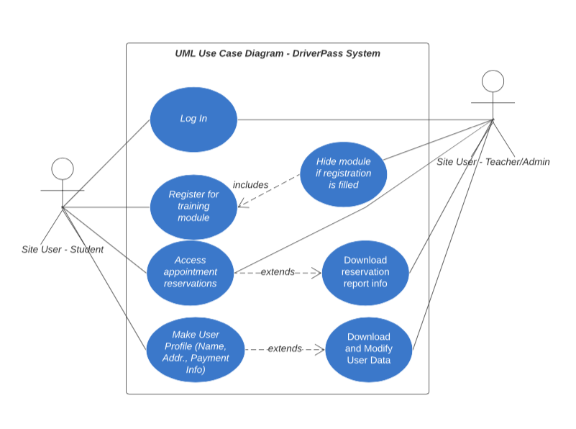

### UML Activity DiagramsActivity diagram.png

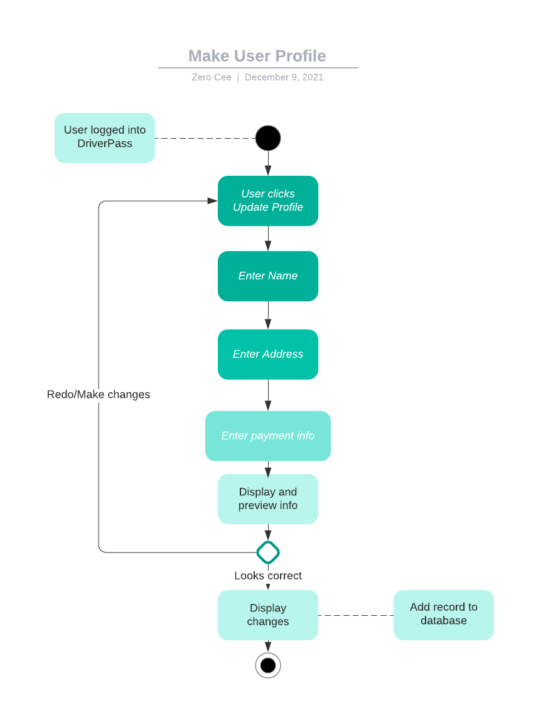

### UML Sequence DiagramSequence diagram.png

### UML Class Diagram

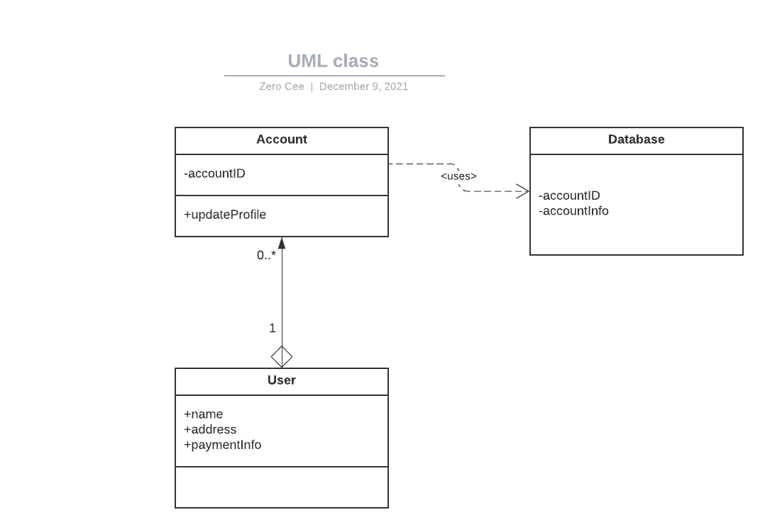

## Technical Requirements

*Initially, we won’t have too demanding of technical requirements. We will want to run on Windows or Mac platforms, as they are rather reliable. Our program will need to be web-based and we need cloud support for offline and remote working. The one thing we do need to consider is database storage. We are going to generate a bit of data by saving account info for users, as well as any history of courses and student grades. I believe we will want to start out with 1TB-5TB cloud storage, either operated by us or contracted out elsewhere.*