

# Adam Conger - CS 305 Project Two

**Practices for Secure Software Report**

Table of Contents

Document Revision History 3

Client 3

Instructions 3

Developer 4

1. Algorithm Cipher 4

2. Certificate Generation 4

3. Deploy Cipher 4

4. Secure Communications 4

5. Secondary Testing 4

6. Functional Testing 5

7. Summary 5

## Document Revision History

| **Version** | **Date** | **Author** | **Comments** |
| --- | --- | --- | --- |
| **1.0** | **April 16, 2022** | **Adam Conger** | **Secure Software Report draft 1** |

## Client



## Instructions

Deliver this completed Practices for Secure Software Report documenting your process for writing secure communications and refactoring code that complies with software security testing protocols.

Respond to the steps outlined below and replace the bracketed text with your findings in your own words. If you choose to include images or supporting materials, be sure to insert them throughout.

## Developer

Adam Conger

## 1. Algorithm Cipher

Determine an appropriate encryption algorithm cipher to deploy given the security vulnerabilities, justifying your reasoning. Be sure to address the following:

* Provide a brief, high-level overview of the encryption algorithm cipher.
* Discuss the hash functions and bit levels of the cipher.
* Explain the use of random numbers, symmetric vs non-symmetric keys, and so on.
* Describe the history and current state of encryption algorithms.

For this project we are going to use the SHA-256 algorithm cipher. This produces an output of data that is 256 bits long. The hash function is created through an encryption method, which cannot return to the original string without the hash key. SHA-256 avoids collisions, or when two pieces of text yield an identical hash; SHA-256 is about 1 in 10^8 odds for collision, or the number of known atoms in the universe. SHA-256, since it transmits data in 256 bit pieces, it a symmetric encryption. This is good for transmitting larger data. Although it is an older model, it will work for the time being until we can modernize and go to RSA encryption.

## 2. Certificate Generation

Generate appropriate self-signed certificates using the Java Keytool, which is used through the command line.

* To demonstrate that the keys were effectively generated, export your certificates (CER file) and submit a screenshot of the CER file below.

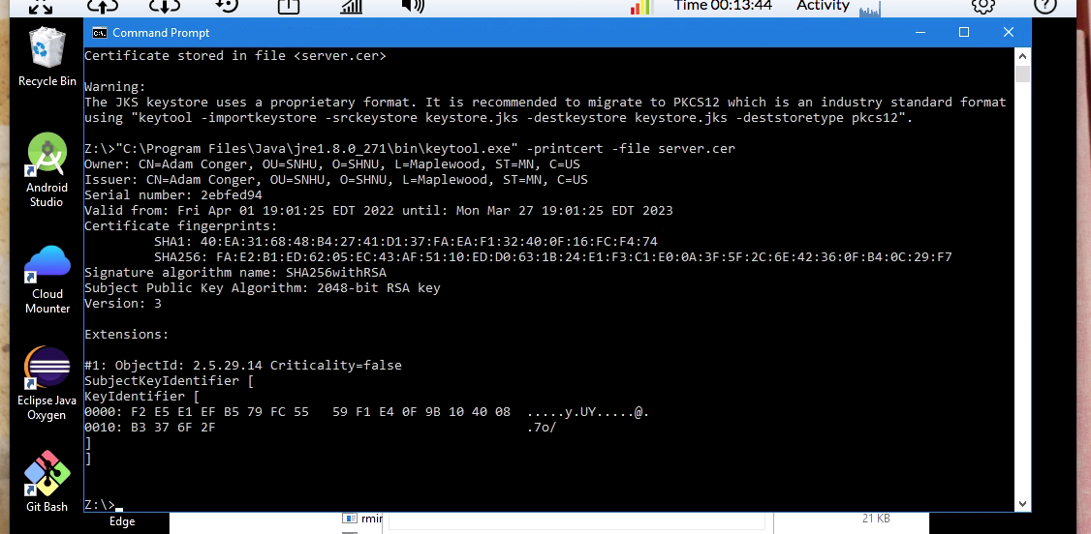

## 

## 3. Deploy Cipher

Refactor the code and use security libraries to deploy and implement the encryption algorithm cipher to the software application. Verify this additional functionality with a checksum.

* Insert a screenshot below of the checksum verification. The screenshot must show your name and a unique data string that has been created.

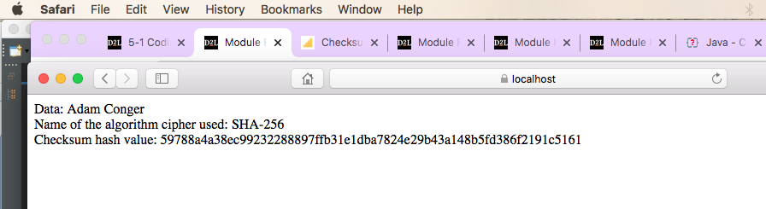

## 

## 4. Secure Communications

Refactor the code to convert HTTP to the HTTPS protocol. Compile and run the refactored code to verify secure communication by typing **https://localhost:8443/hash** in a new browser window to demonstrate that the secure communication works successfully.

* Insert a screenshot below of the web browser that shows a secure webpage.



## 5. Secondary Testing

Complete a secondary static testing of the refactored code using the dependency check tool to ensure code complies with software security enhancements. You only need to focus on the code you have added as part of the refactoring. Complete the dependency check and review the output to ensure you did not introduce additional security vulnerabilities.

* Include the following below:
  + A screenshot of the refactored code executed without errors
  + A screenshot of the dependency check report

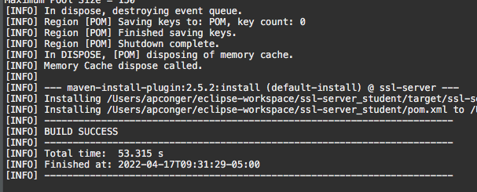

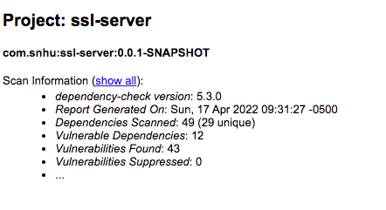

## 6. Functional Testing

Identify syntactical, logical, and security vulnerabilities for the software application by manually reviewing code.

* Complete this functional testing and include a screenshot below of the refactored code executed without errors.

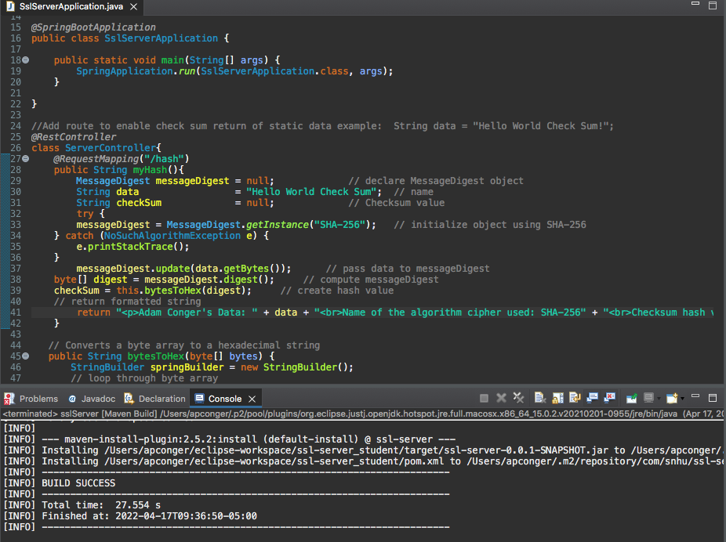

## 7. Summary

Discuss how the code has been refactored and how it complies with security testing protocols. Be sure to address the following:

* Refer to the Vulnerability Assessment Process Flow Diagram and highlight the areas of security that you addressed by refactoring the code.
* Discuss your process for adding layers of security to the software application and the value that security adds to the company’s overall wellbeing.
* Point out best practices for maintaining the current security of the software application to your customer.

In refactoring the code, we are focusing on the components of cryptography and code quality. By doing a thorough review with testing we are also making sure the overall API is secure, too. Overall, we will modernize long-term by transitioning our security to RSA. At the moment we have false positives suppressed with a successful build. This way we can ensure that we are keeping security as the number one priority for the customer. We will want to have well-documented code bases and identify the proper encryption methods for the size of data we’re working with as well as the speed that data needs to move, is it fast or slow or flexible?