QUESTION 36: LOAN INSTALMENT SCHEDULE

1. Problem Statement
A bank needs a simple schedule that splits a fixed monthly payment into interest and principal components.

Task
Read the principal, monthly interest rate percentage, number of months, and fixed monthly payment. For each month, calculate interest on the outstanding principal, subtract it from the fixed payment, and reduce the principal by the remaining payment amount. The fixed payment is supplied as input. If the payment does not cover the month’s interest, print PAYMENT TOO LOW.

Input Format
- Line 1: Principal.
- Line 2: Monthly interest rate percentage.
- Line 3: Number of months.
- Line 4: Fixed monthly payment.

Output Format
Print the month number, opening principal, interest, principal repaid, and closing principal for each month. If a payment does not cover the interest for a month, print PAYMENT TOO LOW.

Constraints
- 0 < principal ≤ 100,000,000
- 0 ≤ monthly interest rate ≤ 5
- 1 ≤ number of months ≤ 600
- Payment is non-negative and has two decimal places.

Sample Input
1000
1
2
510.00

Sample Output
Month 1: Opening 1000.00, Interest 10.00, Principal 500.00, Closing 500.00
Month 2: Opening 500.00, Interest 5.00, Principal 505.00, Closing 0.00

2. COBOL Solution
IDENTIFICATION DIVISION.
PROGRAM-ID. LOAN-SCHEDULE.

DATA DIVISION.
WORKING-STORAGE SECTION.
01 PRINCIPAL-AMT PIC 9(11)V99.
01 MONTHLY-RATE PIC 9V99.
01 TOTAL-MONTHS PIC 999.
01 PAYMENT-AMT PIC 9(11)V99.
01 OPENING-AMT PIC 9(11)V99.
01 INTEREST-AMT PIC 9(11)V99.
01 PRINCIPAL-REPAID PIC 9(11)V99.
01 CLOSING-AMT PIC 9(11)V99.
01 MONTH-NUM PIC 999.
01 DISPLAY-OPENING PIC Z(10)9.99.
01 DISPLAY-INTEREST PIC Z(10)9.99.
01 DISPLAY-REPAID PIC Z(10)9.99.
01 DISPLAY-CLOSING PIC Z(10)9.99.
01 DISPLAY-MONTH PIC ZZ9.

PROCEDURE DIVISION.
ACCEPT PRINCIPAL-AMT
ACCEPT MONTHLY-RATE
ACCEPT TOTAL-MONTHS
ACCEPT PAYMENT-AMT

PERFORM VARYING MONTH-NUM FROM 1 BY 1
UNTIL MONTH-NUM > TOTAL-MONTHS

MOVE PRINCIPAL-AMT TO OPENING-AMT

COMPUTE INTEREST-AMT ROUNDED =
OPENING-AMT * MONTHLY-RATE / 100

IF PAYMENT-AMT < INTEREST-AMT
DISPLAY "PAYMENT TOO LOW"
STOP RUN
END-IF

COMPUTE PRINCIPAL-REPAID =
PAYMENT-AMT - INTEREST-AMT

IF PRINCIPAL-REPAID > OPENING-AMT
MOVE OPENING-AMT TO PRINCIPAL-REPAID
END-IF

COMPUTE CLOSING-AMT =
OPENING-AMT - PRINCIPAL-REPAID

MOVE CLOSING-AMT TO PRINCIPAL-AMT

MOVE MONTH-NUM TO DISPLAY-MONTH
MOVE OPENING-AMT TO DISPLAY-OPENING
MOVE INTEREST-AMT TO DISPLAY-INTEREST
MOVE PRINCIPAL-REPAID TO DISPLAY-REPAID
MOVE CLOSING-AMT TO DISPLAY-CLOSING

DISPLAY "Month " FUNCTION TRIM(DISPLAY-MONTH)
": Opening " DISPLAY-OPENING
", Interest " DISPLAY-INTEREST
", Principal " DISPLAY-REPAID
", Closing " DISPLAY-CLOSING

IF PRINCIPAL-AMT = 0
STOP RUN
END-IF

END-PERFORM

STOP RUN.

3. Explanation of the Logic
- Read the inputs: Accept the original principal, monthly interest rate percentage, total number of months, and fixed payment.
- Save the opening balance: At the beginning of each month, copy the current outstanding principal into OPENING-AMT.
- Calculate monthly interest: Interest = opening principal × monthly rate ÷ 100. The ROUNDED option rounds the result to the field’s two decimal places.
- Check whether the payment covers interest: If the fixed payment is smaller than the calculated interest, display PAYMENT TOO LOW and stop.
- Calculate principal repaid: Principal repaid = fixed payment − interest. This is the part of the payment that reduces the loan balance.
- Avoid a negative balance: If the calculated principal repayment exceeds the opening balance, cap it at the opening balance. This handles the final payment.
- Calculate the closing balance: Closing principal = opening principal − principal repaid. Move the closing balance into PRINCIPAL-AMT for the next month.
- Display the schedule: Format the monetary values to show two decimal places and print the month’s figures.
- Stop when paid off: When the closing principal reaches zero, stop early rather than printing extra zero-balance months.

4. Input and output image:

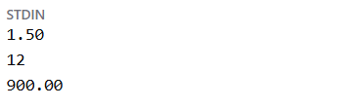
Input

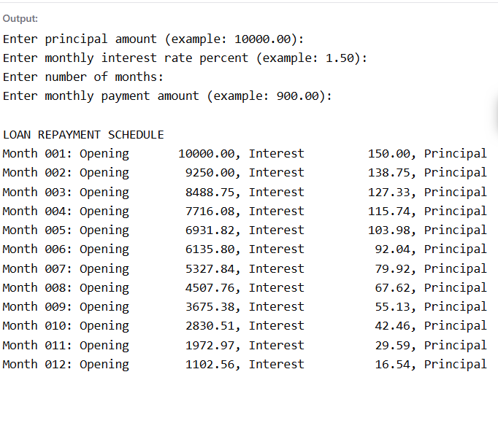
Output

