MINI PROJECT-II

(2020-2021)

**On**

**“Preparation for Exams”**

**REPORT**



**Institute of Engineering & Technology**

**Submitted by-**

Madan Mohan (181500354-H) Bhagat Singh (181500189-B)

Udit Aggarwal (181500765-H) Rajesh singh (181500548-H)

**Supervised By:-**

Ms. Harvinder Kaur

**Senior Technical Trainer**

**Department of Computer Engineering & Applications**

**CERTIFICATE**

This is to certify that Udit aggarwal, Rajesh Singh, Bhagat singh and Madan mohan students of B.Tech (CSE) 3rd year has successfully Completed the MINI PROJECT named PREP4EXAM on Android development under the Guidance of Ms. Harvinder kaur During 2020-21.

Signature: Ms. Harvindar kaur (Mentor)

Department Of Computer Engineering & Application i



**Mini-Project - II Synopsis**

**B. Tech 3rd year**

* **Project Group Members:**

1. Bhagat Singh (19/181500189-G)

2. Madan Mohan (16/181500354-D)

3. Rajesh singh (181500548-H)

4. Udit Aggarwal (35/181500765-D)

* **Project Supervisor**: Ms. Harvinder Kaur, Senior Technical Trainer

**Introduction:**

Various students fail in the exam due to lack of practice before the examination. They do not measure the time duration, for particular question in exam and waste a lot of time for single question so they get less mark as expectation. Maximum online exam are web based and require laptop or pc for taking exam and require strong internet connection. It also creates a problem for those students who haven’t pc. This situation have been experienced in GLA online exam where we cannot back after moving forward and many students left their exam due to entire situation.

**Motivation:**

The basic idea comes for ‘prep4exam’ from covid-19 because it opens new opportunity for various people and students. In the Pandemic situation, offline test and practice for exam is also difficult task. From here we get an idea, Why not we make an application that can perform this entire task? And move one step towards the growing technology of software development. We make this application for teachers that really want, students keep learning thing in also pandemic situation.

**Existing system:**

There are some problems in the existing system for example we went to the different platform for different type exams practice like ‘Myquizz.com’ keep practice only quizzes, but if we want make a poll for voting then we require different platform. So, entire redundancy makes disorder practice.

Table 1.1

|  |  |
| --- | --- |
| Existing system | Prep4Exam |
| It is web based application | It is android application |
| Choose different platform for different exam practice | Require single platform various exam practice |
| Require laptop or pc for better experience | Require android or ios cell phone |
| Easy to use but not portable. | Easy to use and portable. |

**Problem Definition:**

Various students fail in the exam due to lack of practice before the examination. They do not measure the time duration, for particular question in exam and waste a lot of time for single question so they get fewer marks. Maximum online exam are web based and require laptop or pc for taking exam and require strong internet connection. It also creates a problem for those students who haven’t pc. This situation have been experienced in GLA online exam where we cannot back after moving forward and many students left their exam due to entire situation.

**Objective:**

The problem discussed above is only reason to developing this kind of application. “Prep4Exam” gives better user experience for practice of exam.

1. Easy to use and portable.
2. Single platform for various practices.
3. See result instantly after just finishing the exam.
4. Having dashboard for updating the information.
5. The teacher can easily make records of students scoring and can save them at their server
6. The Students would be able to check their attempted quizzes so that they can know their mistakes done at the quiz time

**Methodology:**

It outlines how data will be collected and tools for collecting data. Model view controller (MVC) is software design for developing web applications. It consists three parts like

**1. Model** -The lowest level of the pattern which is responsible for maintaining data.

**2. View-**It is responsible for displaying all or a portion of the data to the user.

**3. Controller**-Software code that controls the interaction between model and view.

MVC isolates the application logic from the user interface layer and supports separation of concern. Here controller receives all requests for the application and then work with model to prepare any data needed by the view. The view then uses the data prepared by the controller to generate a final presentable response. It can be understood with the following diagram.

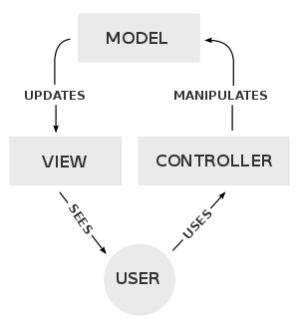

**Planning:**

This project is divided into four modules. Which are as follows?

* + 1. **Authentication:** In this module, teacher or student can make their account on our quiz platform. So that every activity (quiz) can be saved and directed to their account directly.
    2. **Quiz Dashboard:** From here authenticated user create or join the quiz.
    3. **Poll Dashboard:** It is polling dashboard from where polls is start.
    4. **Form Dashboard:** This dashboard is intensely added for taken the feedback of students.
    5. **Exam Dashboard:** From here user can take and create the exams.

**Hardware requirement:**

1. Pc with at least 8GB RAM
2. i5 processor or upgraded

**Software requirement:**

1. Vs code IDE
2. Git Repository
3. Android emulator
4. Flutter sdk, firebase Account, Google cloud storage

**Database:**

Fire Store (Nosql database)

**Programming language:** Dart

**References:**

1. Flutter <https://api.flutter.dev/flutter>
2. Official documentation of firebase <https://api.flutter.dev/firebase>
3. Dart <https://dart.dev/>

**Acknowledgement**

We would like to express grateful thanks to the people who have helped us throughout the project. We are grateful to our instructor Ms. Harvindar Kaur for nonstop support for the project. A special thank of mine goes to our colleagues who helped us out in completing the project, where they all exchanged their own interesting ideas, thoughts and made possible to complete the project with accurate information. We wish to thank our college teachers for their personal support who inspired us to go own way.

Finally, we also wish to express sincere thanks to the GLA UNIVERSITY for helping to develop this project.

Department Of Computer Engineering & Application iii

**Abstract**

Technology grows every day in the field of Engineering and industry revolution. Android is one of the technologies that increased so fast as compared to other technologies. It makes the task easy to perform at various field IOT based application, Medical application and automobiles industry. These entire fields require an easy operating system that can be possible only with help of android development application.

We are currently working on the Android Application with the help native technology of Flutter. Basically Flutter is software development kit for developing android application that uses own language Dart (object oriented). Flutter makes the development fast for any kind of application and provides attractive GUI that’s also main goal of application for users. Java also can be used for this project but it takes a lot of complex coding and dependencies.

We make an android application named ‘prep4exam’ for conducting the basic exam and preparation for student. In this application we develop various models for exam like it can hold quiz, forms and polls. It gives common platform for everyone where we can practice of exam with time duration. It simply requires one step registration for using this application. The main advantage of this application, that it is a cross platform app that can be used also ios.

Department Of Computer Engineering & Application iv

**Contents**

|  |  |
| --- | --- |
| **Certificate** | **i** |
| **Synopsis** | **ii** |
| **Acknowledgement** | **iii** |
| **Abstract** | **iv** |
| **1. Introduction** | **2** |
| 1.1 General introduction | 2 |
| 1.2 Motivation & Scope | 3 |
| 1.4 Hardware & Software Requirement | 4 |
| **2. Problem definition** | **5** |
| **3. Objective** | **6** |
| **4. System analysis & requirement** | **7** |
| **5.Software Design** | **9** |
| **6. Testing** | **11** |
| 6.1 Introduction | 11 |
| 6.3 Unit testing | 12 |
| **7.Database** | **16** |
| **8. Implementations details** | **20** |
| **Team Contribution** | **26** |
| **Conclusion** | **27** |
| **References** | **28** |

Department Of Computer Engineering & Application 1

1. **Introduction**

**1.1 General Introduction to Topic**

**Prep4Exam** refers to the services that conduct online examination, poll and quizzes. It will use for students progress evaluation using modern mobile technology. It replaced the paperwork and overcome the outcomes of traditional way of examinations using paper or pen.

It is android based application platform can be used by admin at any remote location. **Prep4Exam** is fully developed automated system is to efficiently evaluate the candidate progress that not only save the time of Examination Controller and also gives fast result. The administrator of the system has authority to propose tests or papers.

It is cost effective and time efficient method for exams. The candidate can login through proposed mobile with their email address matching the details to the student’s database, and then they can take the exam. Candidate can give their course’s examination in a specific duration and in specific number of questions.

It allows different types of practice like for quizzes and exam and also the form module for taking the response immediately.

Department Of Computer Engineering & Application 2

**1.2 Motivation**

The basic idea comes for ‘prep4exam’ from covid-19 because it opens new opportunity for various people and students. In the Pandemic situation, offline test and practice for exam is also difficult task. From here we get an idea, Why not we make an application that can perform this entire task? And move one step towards the growing technology of software development. We make this application for teachers that really want, students keep learning thing in also pandemic situation.

**1.3 Scope**

Technological advancements in this era of digitalization along with being a boon to the world have been advantageous to the educational sector too. The introduction of **Prep4Exam** software has replaced the conventional system of assessment. The various exam conducting agencies are now able to evaluate the test takers freely and cost-effective through computer based test.

This software allows users to take online tests and automatically generate result based on the answers marked by the user.

* It conducts exam effortless.
* Reduces anxiety in test takes.
* Conduct quizzes, polls.
* Safe and secure data transfer
* Reduce administrative burden.

**1.4 Hardware & Software requirements**

* **Hardware requirement:**

1. Pc with at least 8GB RAM
2. i5 processor or upgraded
3. Android Mobile or Emulator

Department Of Computer Engineering & Application 3

* **Software requirement:**

1. Vs code IDE
2. Git Repository
3. Android emulator
4. Flutter sdk

* **Database:**

Real Time Fire Store (Nosql database)

* **Programming language :** Dart

Department Of Computer Engineering & Application 4

**2. Problem Definition**

The aim of this project is to provide quick, immediate and easy way to appear in the exam. It can provide special advantages to the students/applicants. The online examination system can automatically add the marks allocate the marks in each question to determine the total marks of the questions. A time limit can be set for the questions. This app limits the number of times a student can attempt an exam.

Various students fail in the exam due to lack of practice before the examination. They do not measure the time duration, for particular question in exam and waste a lot of time for single question so they get fewer marks. Maximum online exam are web based and require laptop or pc for taking exam and require strong internet connection. It also creates a problem for those students who haven’t pc. This situation have been experienced in GLA online exam where we cannot back after moving forward and many students left their exam due to entire situation.

Department Of Computer Engineering & Application 5

**3. Objective**

The problem discussed above is only reason to developing this kind of application. “Prep4Exam” gives better user experience for practice of exam.

1. Easy to use and portable.
2. Single platform for various practices.
3. See the result instantly after just finishing the exam.
4. Having dashboard for updating the information.
5. The teacher can easily make records of students scoring and can save them at their server
6. The Students would be able to check their attempted quizzes so that they can know their mistakes done at the quiz time.

Department Of Computer Engineering & Application 6

**4. System Analysis & Requirement**

**4.1 INTRODUCTION**

The system objectives outlined during the feasibility study served as the basis from which the work of system design was initiated. Much of the activities involved at this stage were of technical nature requiring a certain degree of experience in designing systems sound knowledge of computer related technology and through understanding of computers available in the market and the various facilities provided by the vendors. Nevertheless, a system could not be designed in isolation without the active involvement of the user. The user had a vital role to play at this stage too.

Data collected during feasibility study was utilized systematically during the system design. Designing a system is a creative process which calls for logical as well as lateral thinking Logical approach involves systematic moves towards the end product keeping in mind the capabilities of the personnel and the equipment at each design making step.

**4.2 Feasibility study**

Here, I will carry out a study to gain an understanding of the User (Students and Teachers). Current system and problems experienced in this system through interviews, observations, and participations. I will use the obtained data to determine the viability of the system being proposed in terms of technical, economic and social feasibility.

**4.3 REQUIREMENTS ANALYSIS**

Requirement analysis involved defining user needs and objectives in the context of planned user use, environments and identified system characteristics to determine requirements for system functions.

**4.3.1 User Requirements**

It entailed user involvement and statements of facts and assumptions that define the expectations of the system in terms of mission objectives, environment, constraints and measures of effectiveness and suitability. Basically the users:

Department Of Computer Engineering & Application 7

1. User must be Mobile literate.
2. Each user has their authentication i.e. user need to register first before login.
3. User has their email address to register them.
4. User must know the code number of their exam before the commencement of exam.

**4.3.2 Functional Requirements**

This is a necessary task, action or activity that was accomplished. The proposed system is able to:

* 1. Allow teacher to edit the information of student if necessary.
  2. Teacher and student both are creating and join the quiz, poll, and Examination.

1. Provide the security in the system so that none can spread vulnerability in the system.
2. Work with slow internet connection also.

Department Of Computer Engineering & Application 8

**5. Software Design**

**Introduction:** It Describe the structure of application and how it is working in real time production.

1. Use Case Diagram:

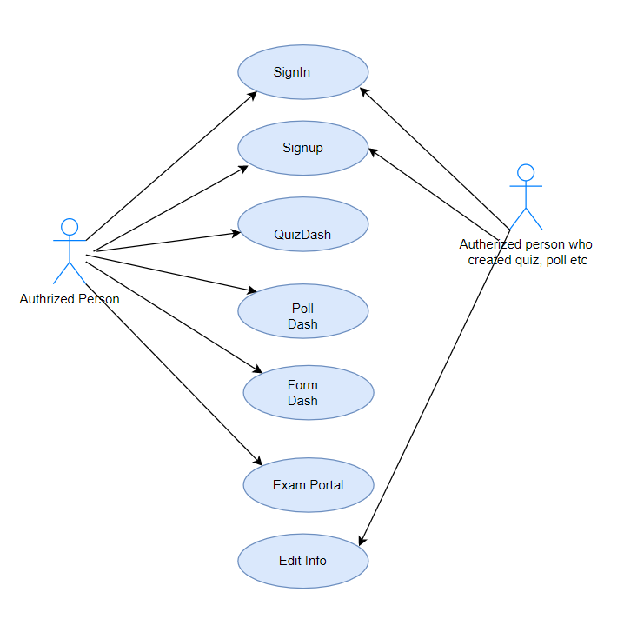

Department Of Computer Engineering & Application 9

1. **Flow Chart:**

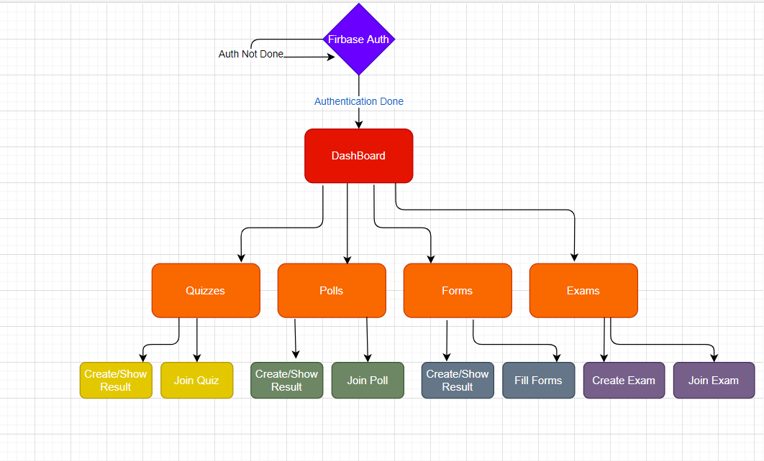

Department Of Computer Engineering & Application 10

**6. TESTING**

**6.1 Introduction:**

At this stage, I will ensure both individual and integrated whole are methodically verified to ensure they are error free and satisfy customer requirement. I will involve both unit testing of individual code module, system testing of the integrated product and acceptance testing conducted by or on behalf of customer. I will ensure bugs found are corrected before moving to the next stage. I will also prepare, review and publish product documentation at this stage.

**6.2 Maintenance:**

This stage occurs after installation. It involves modifications on the system to improve performance. Such changes are user initiated or as a result of bug being discovered which were initially not known. These modifications are recorded for documentation and system update.

**6.3 Unit Testing:**

It is a type of software testing where individual units or components of software are tested. The purpose is to validate that each unit of the software code performs as expected. Unit Testing is done during the development (coding phase) of an application by the developers. Unit Tests isolate a section of code and verify its correctness. A unit may be an individual function, method, procedure, module, or object.

## 6.3.1 Why Unit Testing?

**Unit Testing** is important because software developers sometimes try saving time doing minimal unit testing and this is myth because inappropriate unit testing leads to high cost Defect fixing during System Testing, Integration Testing and even Beta Testing after application is built. If proper unit testing is done in early development, then it saves time and money in the end.

Department Of Computer Engineering & Application 11

1. Unit tests help to fix bugs early in the development cycle and save costs.
2. It helps the developers to understand the code base and enables them to make changes quickly
3. Good unit tests serve as project documentation
4. Unit tests help with code re-use. Migrate both your code **and** your tests to your new project. Tweak the code until the tests run again.

## 6.3.2 Unit Testing Tools

There are several automated tools available to assist with unit testing. We will provide a few examples below:

1. [**Junit**](https://www.guru99.com/junit-tutorial.html): Junit is a free to use testing tool used for Java programming language.  It provides assertions to identify test method. This tool test data first and then inserted in the piece of code.
2. [**NUnit**](https://nunit.org/):  NUnit is widely used unit-testing framework use for all .net languages.  It is an open source tool which allows writing scripts manually. It supports data-driven tests which can run in parallel.
3. [**JMockit**](http://jmockit.github.io/index.html):  JMockit is open source Unit testing tool.  It is a code coverage tool with line and path metrics. It allows mocking API with recording and verification syntax. This tool offers Line coverage, Path Coverage, and Data Coverage.
4. [**EMMA**](http://emma.sourceforge.net/):  EMMA is an open-source toolkit for analyzing and reporting code written in Java language. Emma support coverage types like method, line, basic block. It is Java-based so it is without external library dependencies and can access the source code.
5. [**PHPUnit**](https://phpunit.de/): PHPUnit is a unit testing tool for PHP programmer. It takes small portions of code which is called units and tests each of them separately.  The tool also allows developers to use pre-define assertion methods to assert that a system behave in a certain manner.
6. Those are just a few of the available unit testing tools. There are lots more, especially for C languages and Java, but you are sure to find a unit testing tool for your programming needs regardless of the language you use.

Department Of Computer Engineering & Application 12

**6.3.3 How to do Unit Testing**

In order **to do unit testing**, developers write a section of code to test a specific function in software application. Developers can also isolate this function to test more rigorously which reveals unnecessary dependencies between function being tested and other units so the dependencies can be eliminated. Developers generally use unit test framework to develop automated test cases for unit testing.

Unit Testing is of two types

* Manual
* Automated

Unit testing is commonly automated but may still be performed manually. Software Engineering does not favor one over the other but automation is preferred. A manual approach to unit testing may employ a step-by-step instructional document.

**Test case 1:** Test case for authentication:

Table 6.1

|  |  |
| --- | --- |
| Test Procedure | Entering Email and Password. |
| Expected Result | Firebase authentication successful and redirect to home screen. |
| Actual Result: | Auth failed. |
| Comment | Need to check signing class. |
| Conditional Test | Again, run. |
| Expected Result | Firebase authentication successful and redirect to home screen. |
| Actual Result | Redirect to home screen. |

Department Of Computer Engineering & Application 13

**Case 2:** Test case for Create Quizzes.

Table 6.2

|  |  |
| --- | --- |
| Test Procedure | Fill quiz description and questions. |
| Expected Result | Created quiz shown on quiz portal |
| Actual Result: | Not showing on quiz portal |
| Conditional Test | Again, run. |
| Final Result | Successfully created. |

**Case 3:** Test case for Create poll.

Table 6.3

|  |  |
| --- | --- |
| Test Procedure | Enter poll question and upload to firebase |
| Expected Result | Poll created & shown on poll portal |
| Actual Result: | Not showing on poll portal |
| Conditional Test | Again, run. |
| Final Result | Successfully created. |

**Case 4:** Test case for Forms.

Table 6.4

|  |  |
| --- | --- |
| Test Procedure | Create Form and Share form id. |
| Expected Result | Shared form should be filled by filled by others authenticated users. |
| Actual Result: | Form is not shared. |
| Conditional Test | Check form class and firebase form collection |
| Final Result | Problem solved |

Department Of Computer Engineering & Application 14

**Case 5:** Complete testing

Table 6.5

|  |  |  |  |
| --- | --- | --- | --- |
| **Test case** | **Expected result** | **Actual Result** | **Status** |
| **Polls** | poll should be created | Poll created | Successful |
| **Quizs** | Quiz created & join | Successfully created & join. | Successful |
| **Exam create** | Exam created | Some details left | Unsuccessful |
| **Exam created** | Exam created | Exam created | Successful |
| **Join exam by Id** | Exam joined by Id | Okay | Successful |
| **Exam history** | Show expired exams | Not show expired Exams | Unsuccessful |
| **Exam history** | Show expired exams | Show expired exams | Successful |

Department Of Computer Engineering & Application 15

**7. Database**

1. **Exam Collection:** This Collection store the information of exams created.

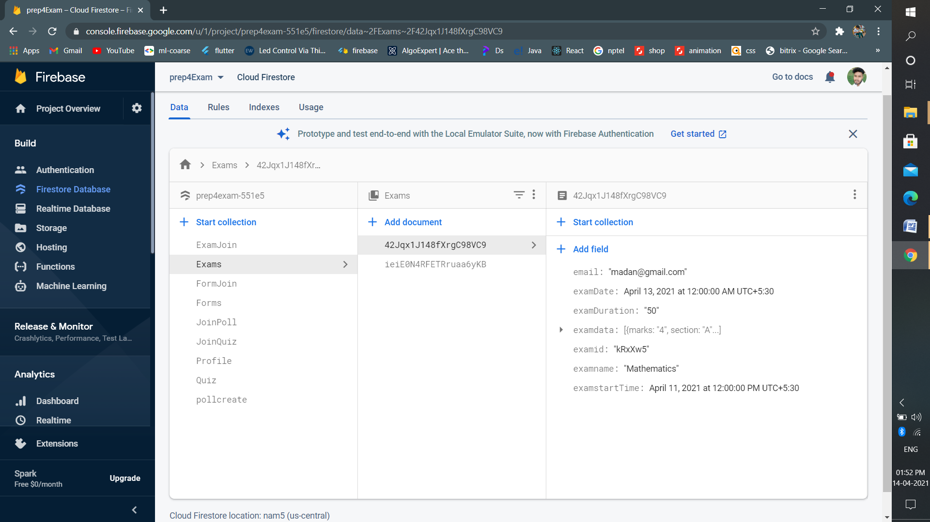

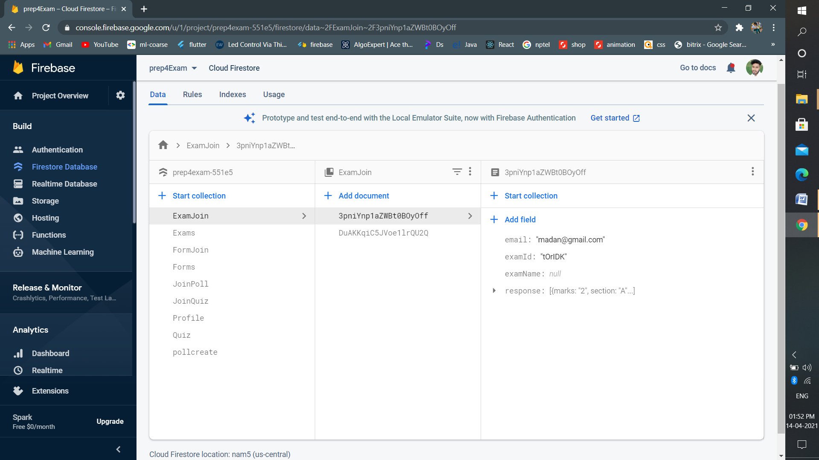

Department Of Computer Engineering & Application 16

1. **Quiz Collection:** Collection store the information of exams created.

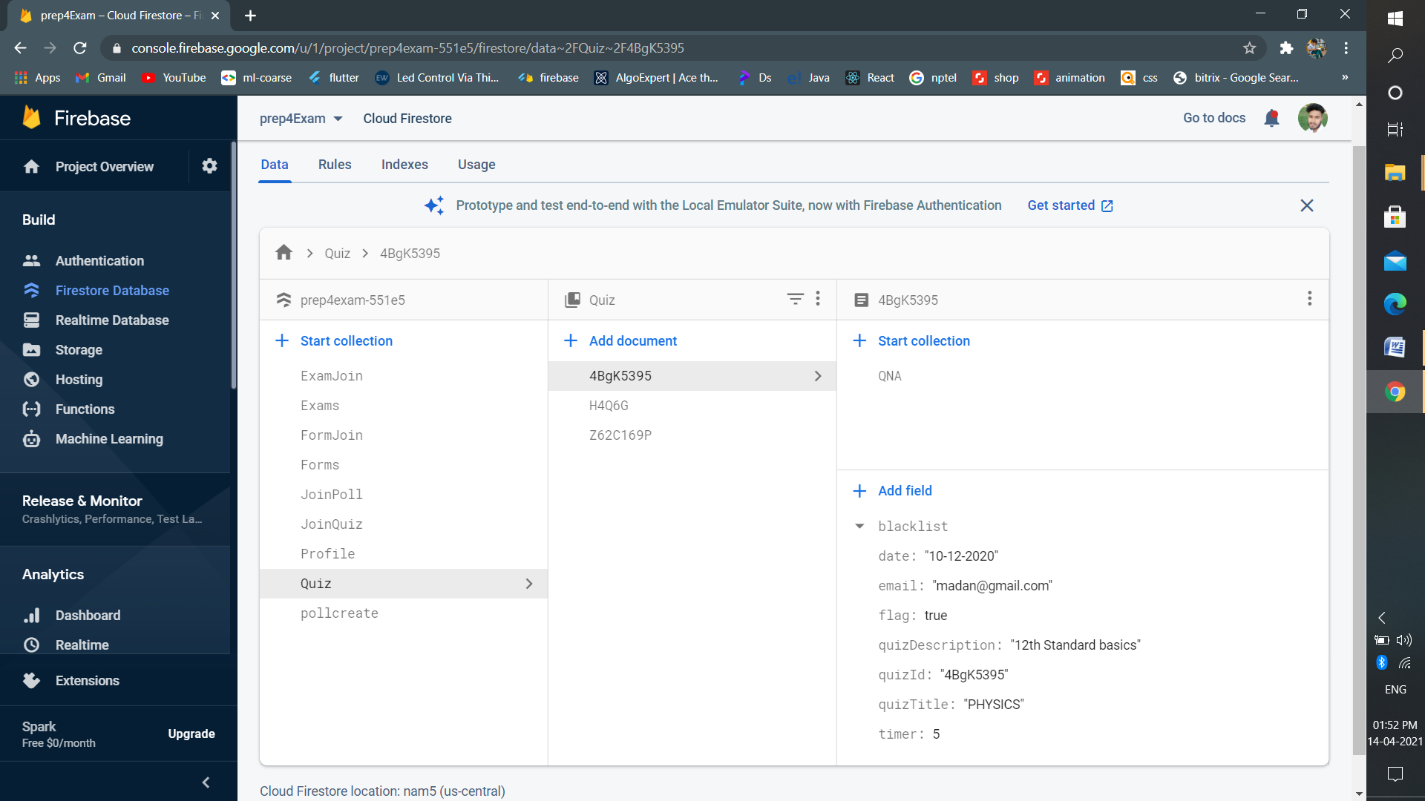

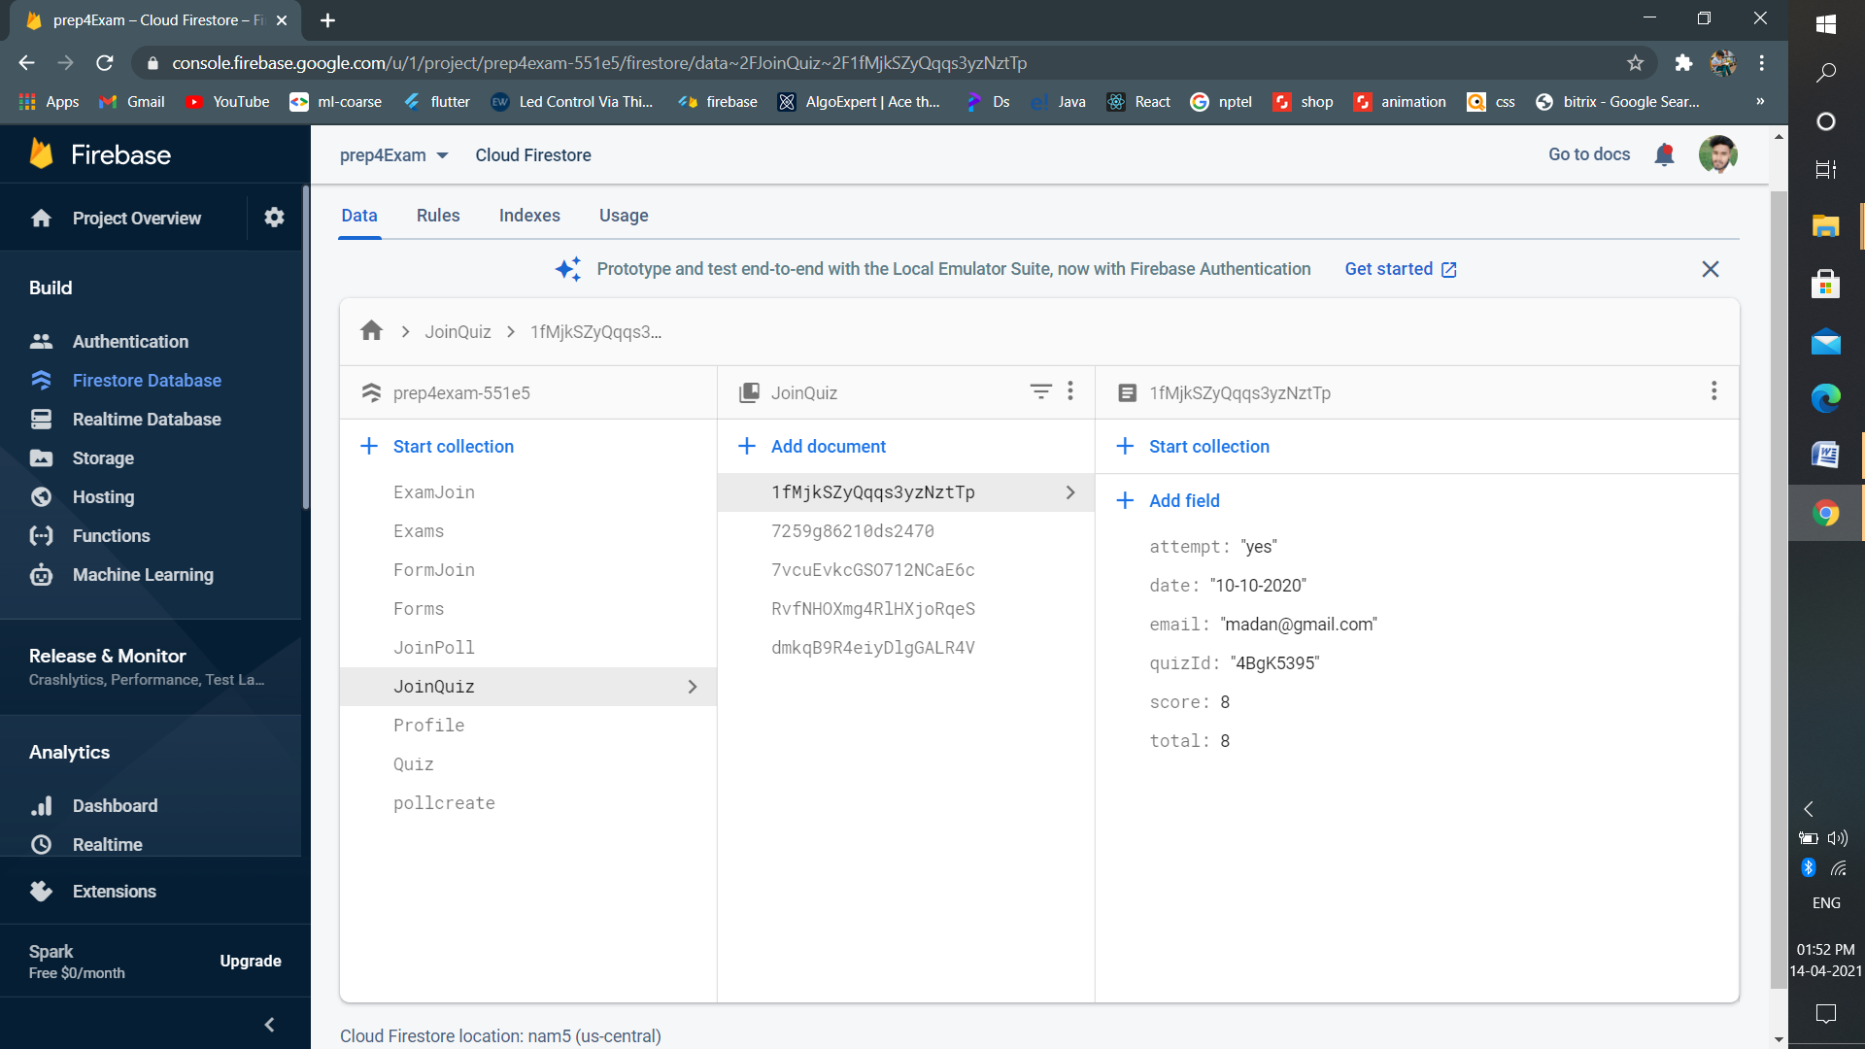

Department Of Computer Engineering & Application 17

1. **Profile Collection:** Store the user profile information.

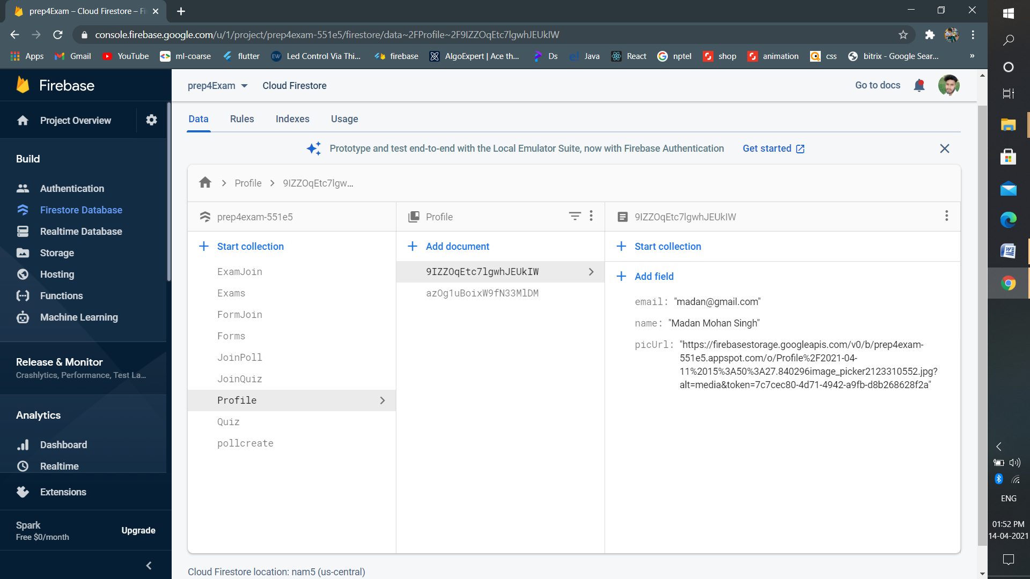

1. **Poll Collection:** Collection stores the information of Polls who joined polls.

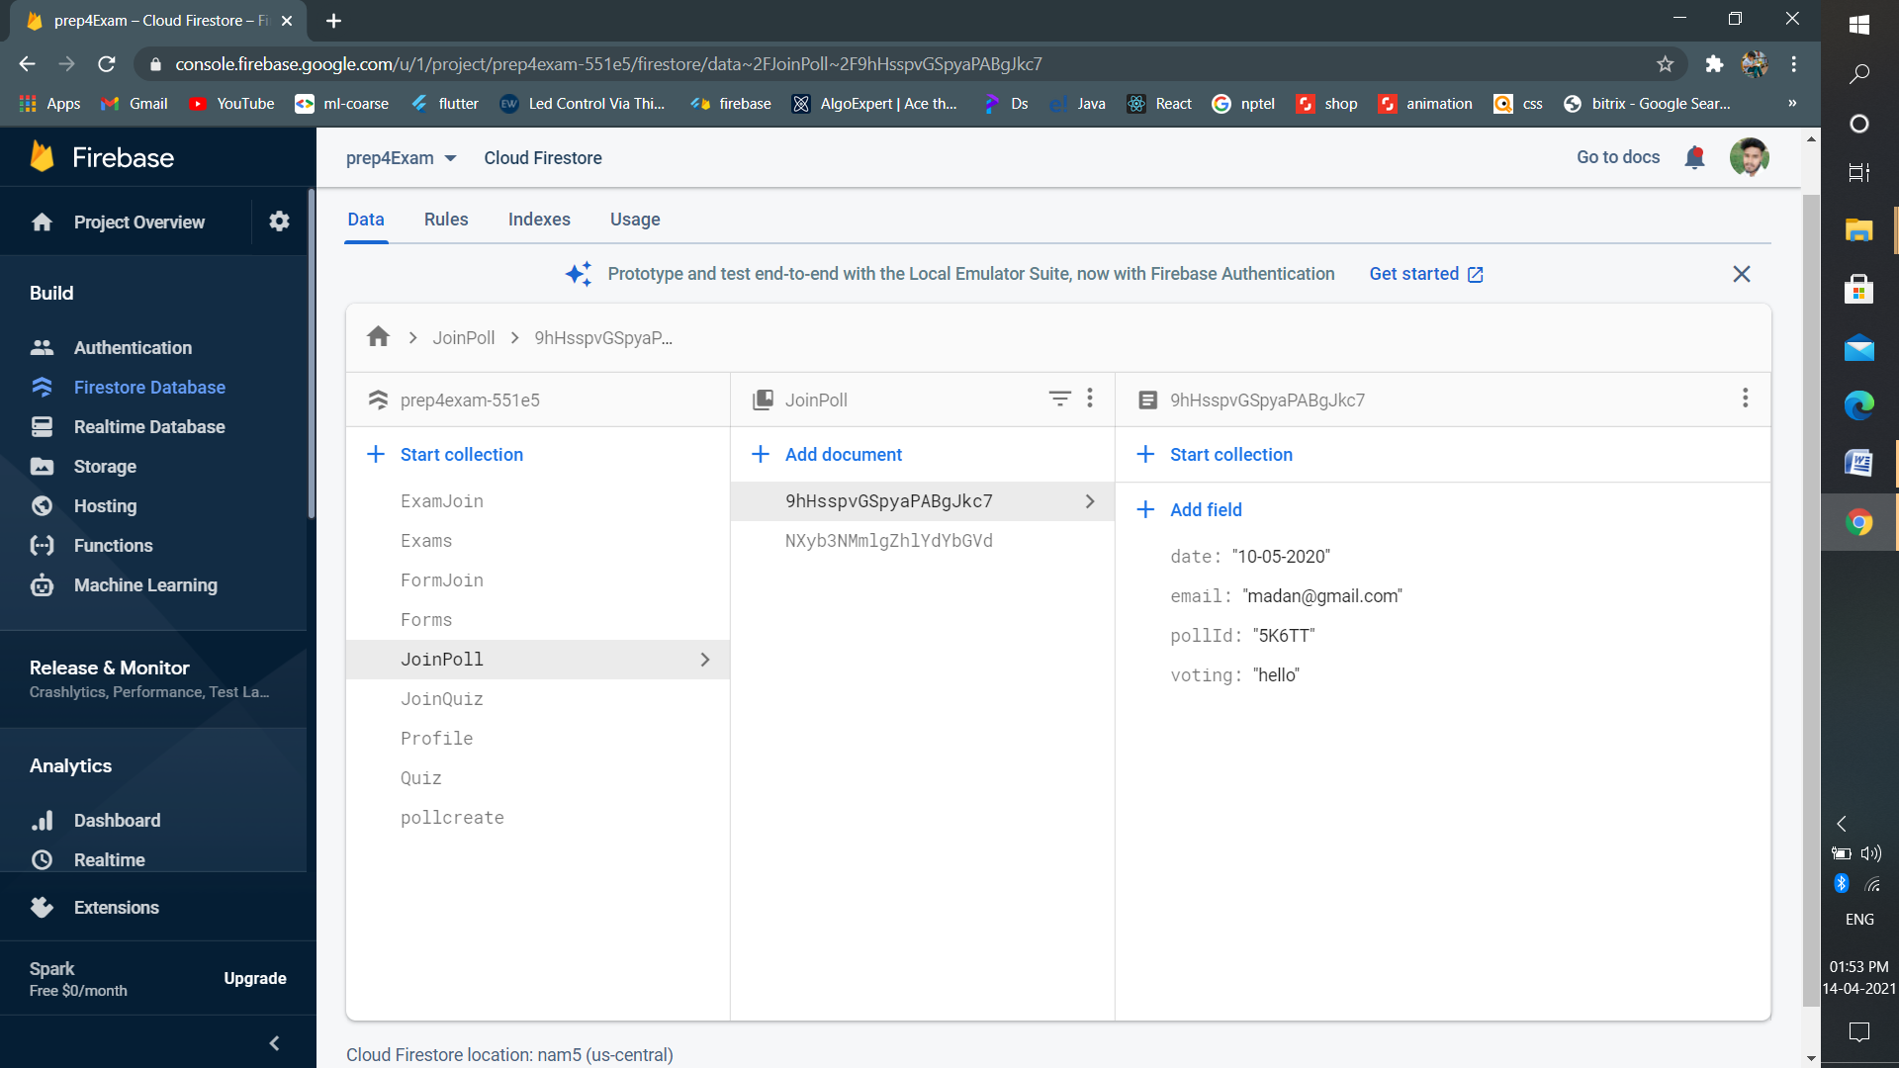

Department Of Computer Engineering & Application 18

1. **Forms Collection:** store the information of Forms that being created.

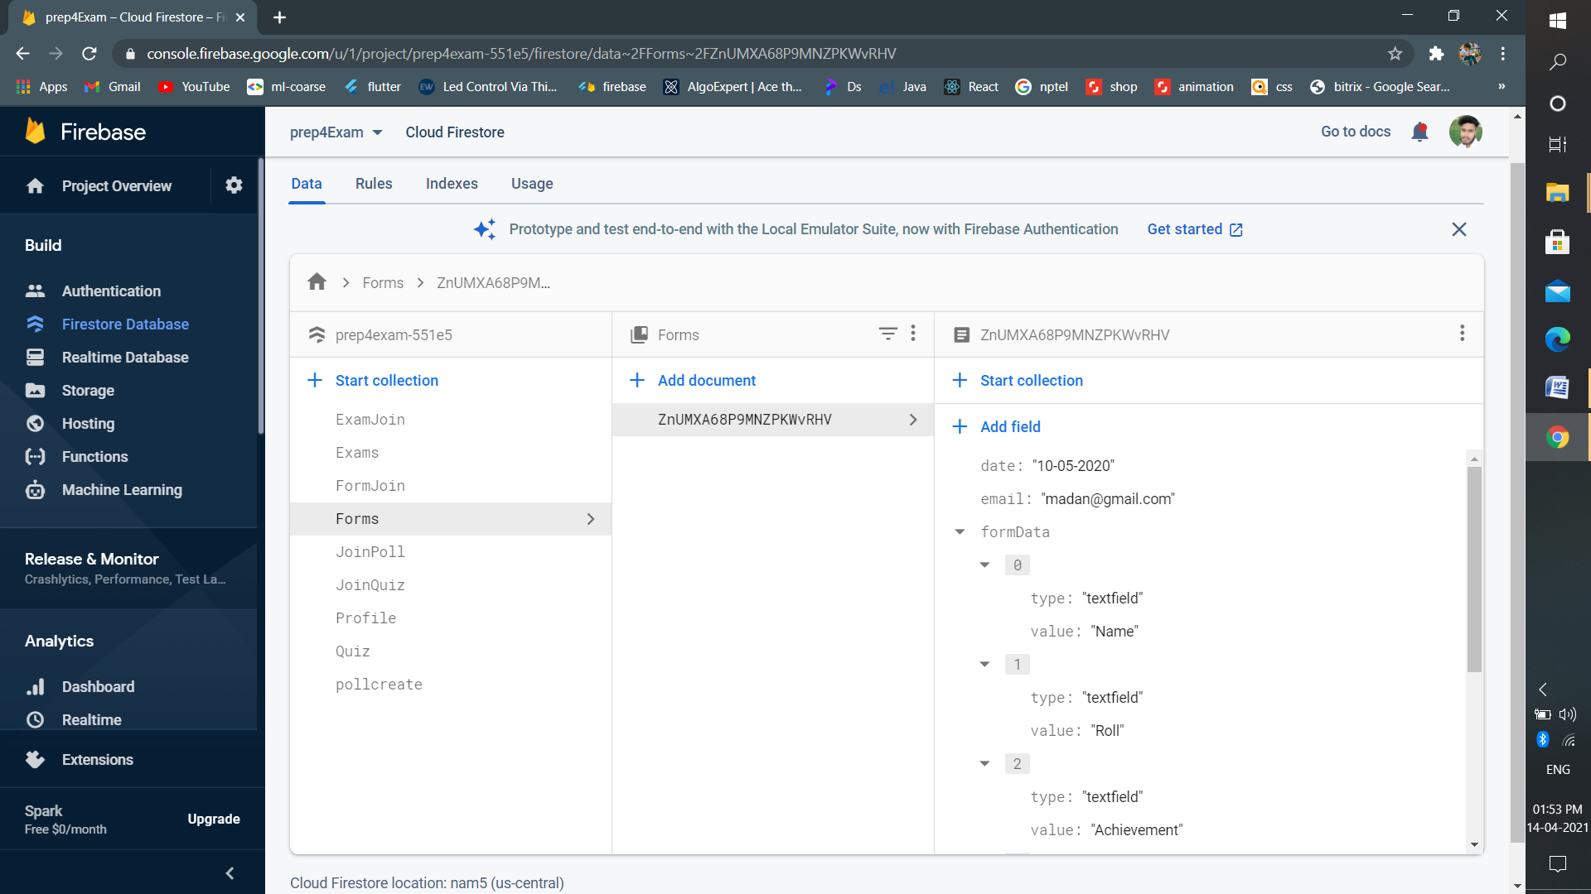

Department Of Computer Engineering & Application 19

**8. Implementation details**

This project divides into different modules such as Quiz, Poll, Forms and Exam portal. We will discuss each one by one.

**1. Authentication:** It is entry point of our project where every user must verify own identity with the system.

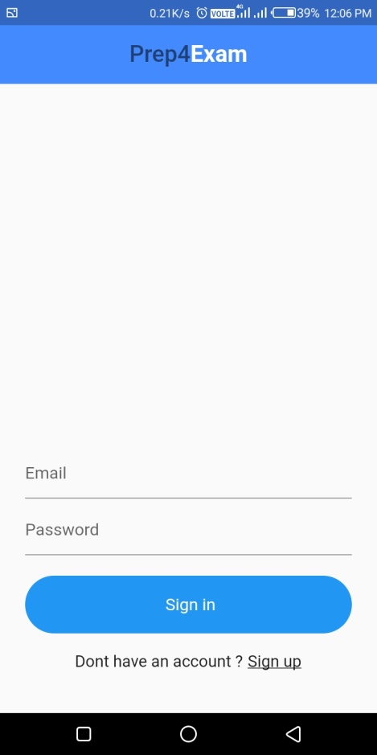

*Signing screen*

1. **Home:** After verification, it Show home dashboard which contains different modules like Quiz, poll and Form dashboard.

Department Of Computer Engineering & Application 20

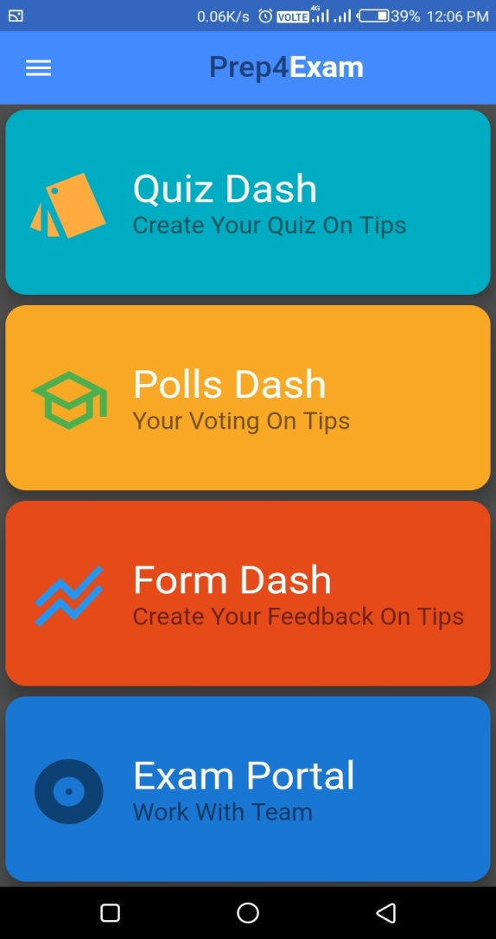

*Dashboard screen*

1. **Quiz Dash:** This Module provides the functionality of create and join quiz through the quiz id. Admin of quiz can control the quiz like remove participants, start quiz at fixed time.
2. From here admin create the quiz by filling the entire information and add question into the quiz.

Department Of Computer Engineering & Application 21

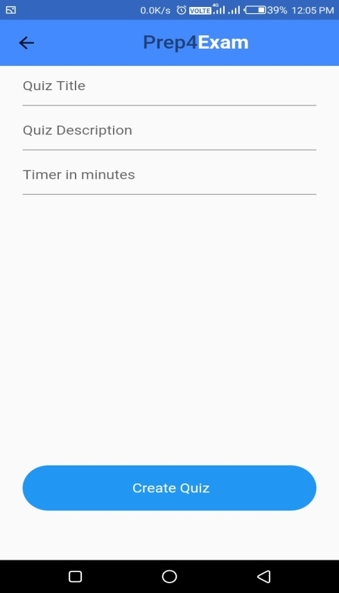

1. After creating the quiz anyone can join the quiz and participate into the quiz by quiz id given by admin.

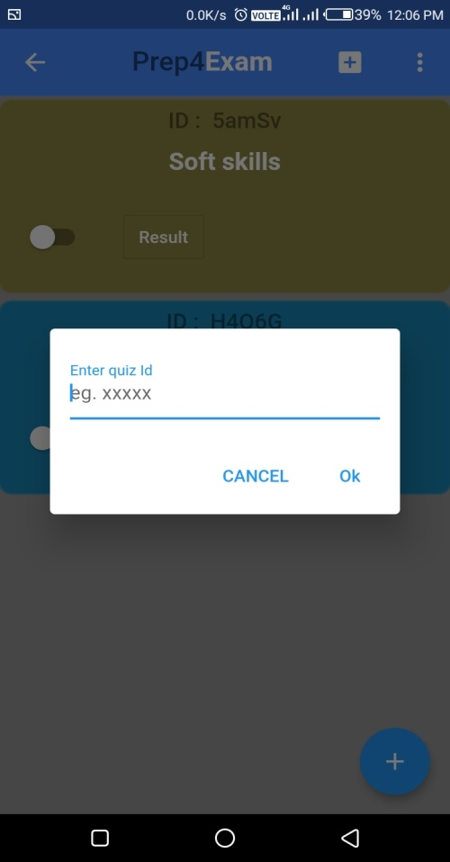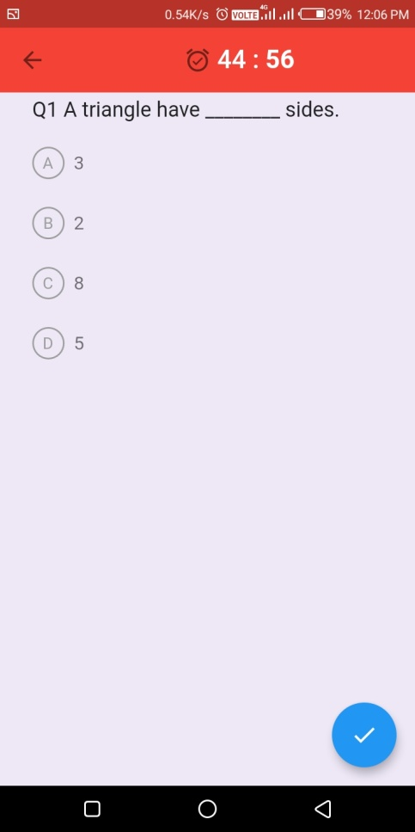

Department Of Computer Engineering & Application 22

**4. Poll Dash:** This is design for the creating the poll. Basically poll is creating for the instant feedback not wasting much more time to create forms. So admin create polls like quiz and distribute poll id to join the poll.

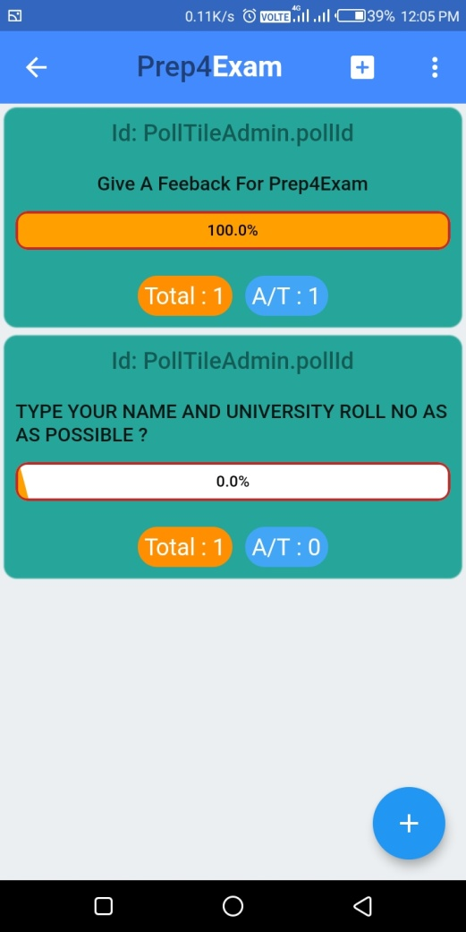 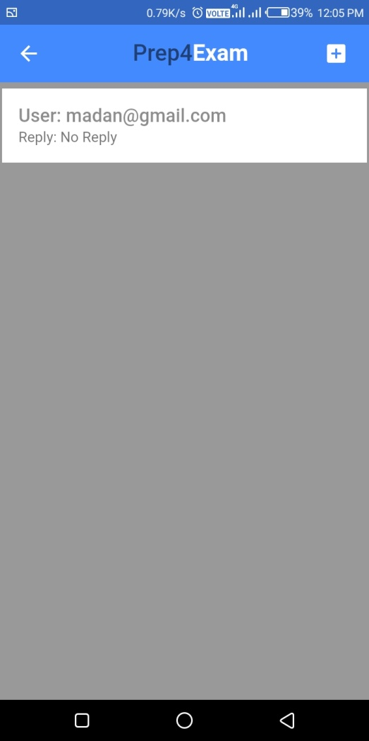

*Poll Dashboard: 1- Created polls 2- Response corresponding to each poll*

Department Of Computer Engineering & Application 23

1. **From dashboard:** Form dashboard allows the user to create the form and take out the result from the response that fills the particular form. It include in app because user not switch to other platform just for creating the forms.

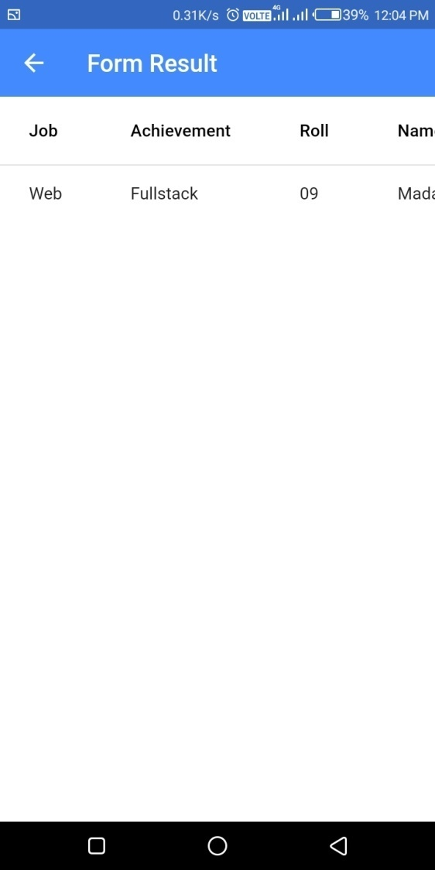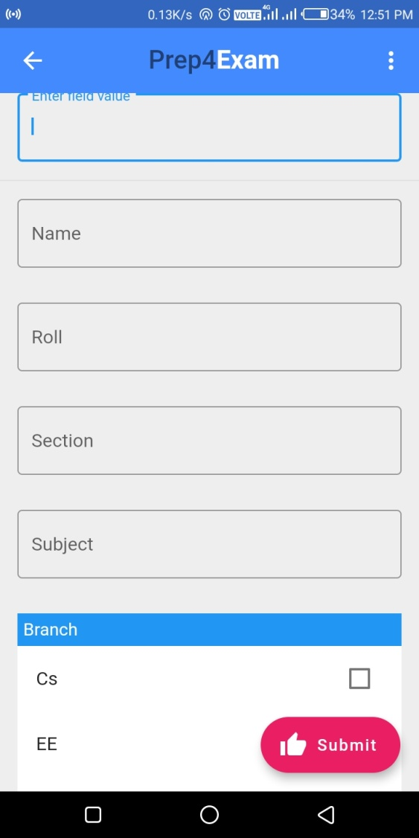

*Form Dashboard: 1-Result 2-Create form*

Department Of Computer Engineering & Application 24

1. **Exam Portal:** This includes the exam with creating different sections in the exam. It provides much functionality to user and admin on mobile.

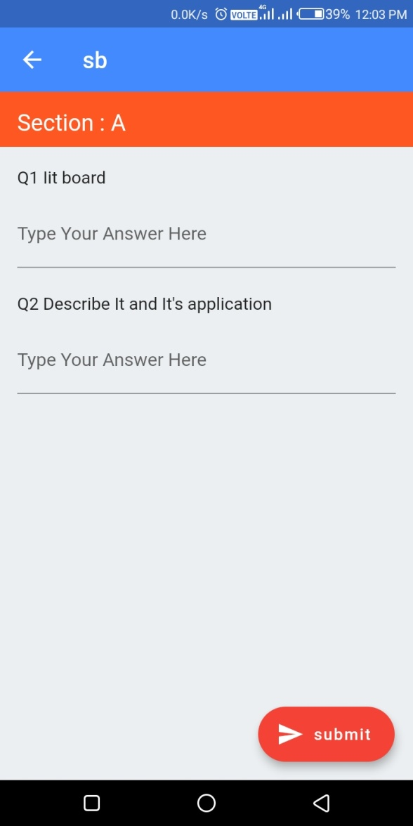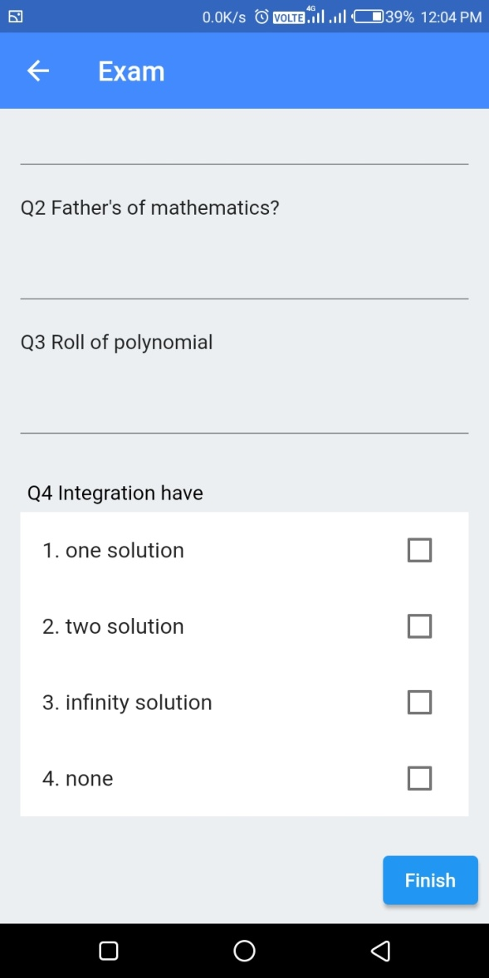

*Exam screen: 1- Preview exam on creating exam*

1. *Take exam when exam started*

Department Of Computer Engineering & Application 25

**Team Contribution**

The application is divided into five modules so that each team member takes equal opportunity to develop this application. This application consists designing of user interface and also backend part of application. In the backend part, we use fire store for storing the data, Google storage is used for storing the files like images and pdf files and Authentication is used for checking authentic user Each module describe below complete explanation.

* **Bhagat Singh:** The quiz dashboard of application is developed by me which includes front-end and also backend part. In this dashboard, user can create the quizzes and also join the quizzes through the quiz id given by admin. The fire store database is used to manage the details of quizzes so that quizzes can be managed in real time. There is facility of waiting room for those students who join the quiz without permission of admin. Admin enters them in waiting room so that he/she cannot join the quiz.
* **Madan Mohan:** There is need of authentication of user before access the application for removing the vulnerability in the application. Poll dashboard and authentication like sign in and signup managed by me. Here authentication is done through the Google firebase which is reliable authentication. Poll module is made intensely for taking instant feedback or query from any without wasting much more time in creating form. For graphical view of performance who replied for poll , there is used liquid progress indicator package.
* **Rajesh Singh:** One more thing is also need in the application that is exam portal so that user can create the exams for particular subject and check and depth of knowledge of students before taking exams. With creating exams, he/she can also check copies of students where marks can also be assigned. There are two collection made in fire store database for managing complete exam portal.
* **Udit Aggarwal:** Generally user require feedback from there participants or their employees. With the help of this app he can also create the form and distribute the form id so that everyone can give their response. In this module, user can make text field, radio box and checkbox according to requirements. There is ‘created form’ collection which managed all the created forms and another is ‘join form’ which check how many user join the form and give their responses.

**Conclusion**

Developing an android application gives us more knowledge about various technologies that are being used in this application like Google cloud storage, dart, flutter and Google messaging.

It was a wonderful learning experience for us while working on this project. This project took us through the various phases of project development and gave us real insight into the world of android development. The joy of working and the thrill involved while tackling the various problems and challenges gave us a feel of the developers’ industry. It was completely new experience for our team members to develop the project using the flutter and dart. But, now it gives vast knowledge of android and how to interact them with Google cloud and real time database.

We learned a lot through this project. This project has sharpened our concept of android development and the software-hardware interface. We learned a lot about different documentation. The piece of software we developed is intended to serve the colleges.

**6.1 The Achievements**

1. Now we know much more about android development.

2. How firebase work with flutter.

3. Develop technical skills.

4. Growing creative thinking and imagination capability.

**References**

<https://flutter.dev>

<https://firebase.flutter.dev/docs/firestore/usage/>

<https://firebase.flutter.dev/docs/auth/overview>

<https://firebase.flutter.dev/docs/storage/usage>