Lab 6: Code and Branch Coverage Analysis
Submission Document
Name | Madan P
SRN | PEES1UG24AM374
Application | cloud_storage_tier.py (Cloud Storage Tier)
Tools | Python 3.12, pytest, coverage.py

1. Objective
Measure the test coverage of the cloud_storage_tier module, identify untested lines and branches, and write test cases that reach at least 90% line coverage and 90% branch coverage.

2. Application Under Test
The module has two functions:
- process_storage_tenants(tenants, fixed_support_fee): validates input, then bills each active tenant by tier (hot 0.025, cool 0.015, archive 0.005 per GB). It applies a 10% discount above 500 GB, charges egress above 100 GB at 0.08 per GB, handles corrupted and invalid buckets, adds a backup vault fee, and returns BILLED, ZERO_USAGE or AUDIT_FLAGGED.
- monitor_replication_latency(cluster_matrix): returns NO_DATA, SYNC_LAG_ALERT (two or more consecutive readings above 200 ms on one node) or SYNCED.

3. Baseline (Starter Test Only)
The starter file has one test (test_single_active_hot_tenant). Baseline results:
Metric | Statements | Branches | Coverage
Line coverage | 57 (31 missed) | n/a | 46%
Branch coverage | 57 (31 missed) | 40 (10 partial) | 41%

4. Part 1: Code (Line) Coverage
File: CodeCoverageTest_cloud_storage_tier.py (13 tests). The tests were written so every line of the module runs at least once: invalid input, inactive account, cool tier with egress and backup vault, archive discount, archive corrupted break, hot corrupted bucket, unknown tier, zero-size bucket, audit flag, and the three outcomes of the latency monitor.

Commands
coverage run -m pytest CodeCoverageTest_cloud_storage_tier.py
coverage report -m

Terminal output (screenshot)
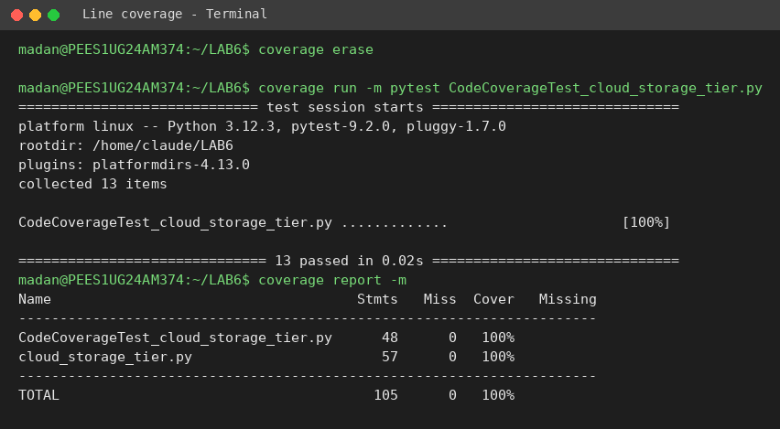
Result: 13 tests passed, 0 lines missed, 100% line coverage on cloud_storage_tier.py (target: at least 90%).

5. Part 2: Branch Coverage
File: BranchCoverageTest_cloud_storage_tier.py (39 tests). Line coverage can hide untested outcomes, so these tests make every decision evaluate to both True and False. They also cover loop skipped versus entered, default values from dict.get(), and boundary values 500 GB, 100 GB egress, 200 ms, 4 flagged buckets and a fee of 0.

Commands
coverage run --branch -m pytest BranchCoverageTest_cloud_storage_tier.py
coverage report -m

Terminal output (screenshot)
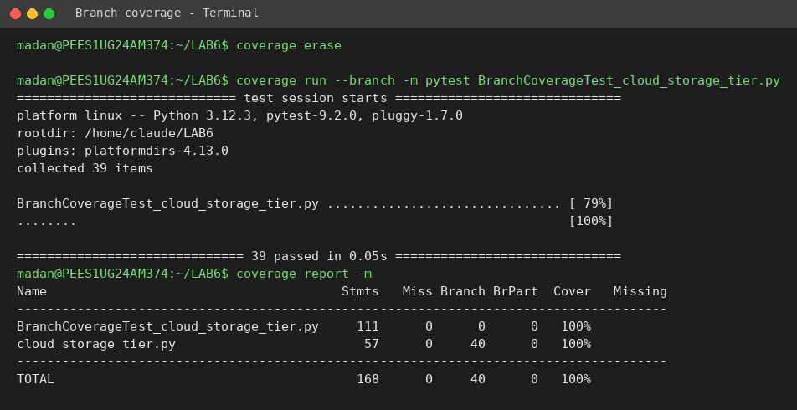
Result: 39 tests passed, 40 of 40 branches covered, 0 partial branches, 100% branch coverage on cloud_storage_tier.py (target: at least 90%).

6. Coverage Summary
Test suite | Tests | Line | Branch | Missing
Starter test | 1 | 46% | 41% | Many
CodeCoverageTest | 13 | 100% | 100%* | None
BranchCoverageTest | 39 | 100% | 100% | None
* The line-coverage suite happens to reach full branch coverage when run with --branch, because the module's branches are all exercised by the line-targeted scenarios. The separate branch suite adds boundary and default-value tests for stronger checking.

7. Key Branches and Boundaries Tested
Decision in code | Tests (True / False)
not isinstance(tenants, list) or fee < 0 | String/dict input and negative fee raise ValueError; empty list and fee 0 are valid
not account_active | Inactive and missing key skipped; active billed
tier hot / cool / archive / else | Each rate verified; unknown tier flagged; missing tier defaults to hot
size_gb <= 0 | 0, negative and missing size flagged; positive billed
is_corrupted and tier == archive | Archive: break and charge reset; hot: no break, continues
size_gb > 500 | 500 (no discount) versus 1000 (10% discount)
egress_gb > 100 | 100 (free) versus 150/200 (charged)
has_backup_vault | Fee added versus not added
flagged_buckets > 4 | 4 gives BILLED, 5 gives AUDIT_FLAGGED
total_billed == 0.0 | ZERO_USAGE versus BILLED
not cluster_matrix | [] and None give NO_DATA
latency > 200 and streak >= 2 | 200 (not lag), single spike, reset between spikes, two in a row, streak not carried across nodes

8. Git Commits
Run these in the cloned LAB6 repository (two commits, as required):
git add CodeCoverageTest_cloud_storage_tier.py code_coverage_screenshot.png
git commit -m "Add line coverage tests - 100% code coverage"
git add BranchCoverageTest_cloud_storage_tier.py branch_coverage_screenshot.png
git commit -m "Add branch coverage tests - 100% branch coverage"
git push origin main

9. Deliverables
- CodeCoverageTest_cloud_storage_tier.py
- BranchCoverageTest_cloud_storage_tier.py
- code_coverage_screenshot.png and branch_coverage_screenshot.png
- This submission document (Madan P, PEES1UG24AM374)

