NAME : Madhan Prasanth R

REG NO:22CSL06

1.Build a basic HTTP server that can handle different routes and HTTP methods (GET, POST, PUT, DELETE).

const http = require('http');

// Helper function to handle sending responses

function sendResponse(res, statusCode, message) {

res.writeHead(statusCode, { 'Content-Type': 'application/json' });

res.end(JSON.stringify({ message }));

}

// Create HTTP server

const server = http.createServer((req, res) => {

const { method, url } = req;

// Route: /

if (url === '/') {

if (method === 'GET') {

sendResponse(res, 200, 'Hello, World! This is the root route.');

} else {

sendResponse(res, 405, `Method ${method} not allowed on this route.`); }

}

// Route: /items

else if (url === '/items') {

if (method === 'GET') {

sendResponse(res, 200, 'Fetching all items...');

} else if (method === 'POST') {

sendResponse(res, 201, 'Creating a new item...');

} else {

sendResponse(res, 405, `Method ${method} not allowed on this route.`); }

}

// Route: /items/:id (using simple regex for demonstration)

else if (url.match(/^\/items\/\d+$/)) {

const id = url.split('/')[2];

if (method === 'GET') {

sendResponse(res, 200, `Fetching item with ID: ${id}`);

} else if (method === 'PUT') {

sendResponse(res, 200, `Updating item with ID: ${id}`);

} else if (method === 'DELETE') {

sendResponse(res, 200, `Deleting item with ID: ${id}`);

} else {

sendResponse(res, 405, `Method ${method} not allowed on this route.`); }

}

// Handle 404 - Not Found

else {

sendResponse(res, 404, 'Route not found.');

}

});

// Server listens on port 3000

server.listen(3000, () => {

console.log('Server is running on http://localhost:3000');

});

Output:

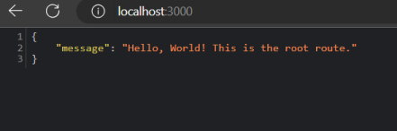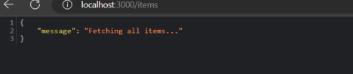

2.Create a server that allows users to upload files and save them to the server's filesystem.

const http = require('http');

const formidable = require('formidable');

const fs = require('fs');

const path = require('path');

const hostname = '127.0.0.1';

const port = 3000;

const server = http.createServer((req, res) => {

if (req.method.toLowerCase() === 'get') {

res.writeHead(200, { 'Content-Type': 'text/html' });

res.end(`

<form action="/upload" enctype="multipart/form-data" method="post"> <input type="file" name="fileupload"><br><br>

<input type="submit" value="Upload File">

</form>

`);

} else if (req.url === '/upload' && req.method.toLowerCase() === 'post') { const form = new formidable.IncomingForm();

form.parse(req, (err, fields, files) => {

if (err) {

console.error('Error parsing the form:', err);

res.writeHead(500, { 'Content-Type': 'text/plain' });

res.end('An error occurred during the file upload.');

return;

}

const uploadedFile = files.fileupload;

const oldPath = uploadedFile.filepath;

const newPath = path.join(__dirname, 'uploads', uploadedFile.originalFilename);

fs.rename(oldPath, newPath, (err) => {

if (err) {

console.error('Error saving the file:', err);

res.writeHead(500, { 'Content-Type': 'text/plain' });

res.end('File could not be saved.');

return;

}

res.writeHead(200, { 'Content-Type': 'text/plain' });

res.end('File uploaded and saved successfully!');

});

});

} else {

res.writeHead(404, { 'Content-Type': 'text/plain' });

res.end('Route not found.');

}

});

const uploadDir = path.join(__dirname, 'uploads');

if (!fs.existsSync(uploadDir)) {

fs.mkdirSync(uploadDir);

}

server.listen(port, hostname, () => {

console.log(`Server running at http://${hostname}:${port}/`); });

Output:

