Registration of 3D and 2D images
a report for the 2014 test assignment

Hennadii Madan
Department of General Physiology of Nervous System
Bogomoletz Institute of Physiology
Kiev Ukraine
madanh2014@gmail.com

Abstract—This is a report for the 2014 test assignment for junior researcher position candidates in the Laboratory of Imaging Technologies, Faculty of Electrical Engineering, University of Ljubljana. The assignment involves registration of a 3D CT data of a single vertebra to an X-ray image of a spine phantom through optimization of a similarity measure between a cone beam projection of the CT volume to the image plane and the X-ray image itself. A Report consist of the answers to the ten questions posed in the assignment.
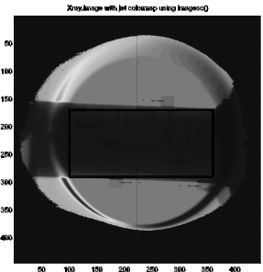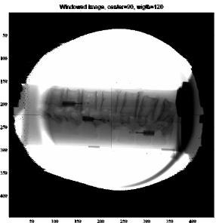
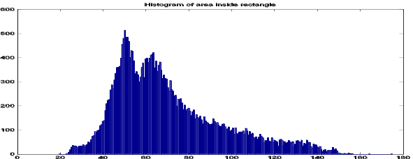
- Windowing of the initial X-ray image.

Keywords—3D-2D registration; CT 3d image;

Introduction
In the Laboratory of Imaging Technologies, Faculty of Electrical Engineering, University of Ljubljana each candidate for the junior researcher position is required to perform a test assignment to evaluate his fitness to this position.
Assignment requires the candidate to perform a 3D-2D registration of a CT scan of a vertebra to an X-ray image of a spine segment. It includes 10 tasks to prepare a report on. The assignment comes in a form of a .pdf file with task description supplemented by a .mat file containing the data to be processed. The .mat file contains two structures named *ct* and *Xray* representing a 3D CT image of lumbar vertebra L3 and a 2D X-ray image of the lumbar vertebrae L1–L5. The structures contain fields ct.TPos and Xray.TPos that are matrices of the geometric transformations of the coordinate systems of 3D and 2D images from the reference coordinate system to the first image element indexed by (1,1). Xray.SPos is the position of the X-ray source in the reference coordinate system. The spatial sampling of the 3D and 2D images is 1 milimeter isotropic..
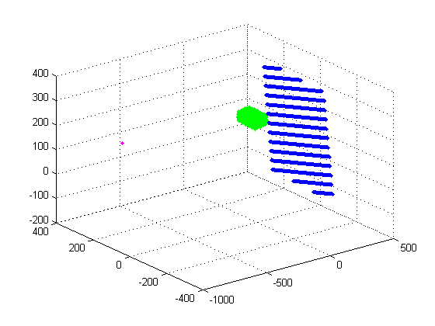
- Positions of CT volume, X-ray image and X-ray source in world coordinates.

Improving contrast of X-ray image
By looking at the scaled X-ray image one can see that vertebrae fit in a rectangular region with top-left corer at 100,170 width 260 and height 120 (Fig.1,A). Histogram of the image pixels that fall within the rectangle (Fig.1, B) suggests that all relevant structures have intensities within 20:160 range. A windowing with central intensity of 90 and width 140 is performed (Fig 1., C).

Verifying the geometric setup
Samplimg grids for Xray.image and ct.volume are created and stored in gridX, gridY and gridZ fields of both Xray and ct structures. These grids are then transformed using TPos field and saved as gx, gy and gz fields. Fig. 2 displays an image showing position of X-ray and CT volume and source for the projection in world coordinates.

Rigid transformation
Multiple conventions about the rotation sequence and whether those rotation are intrinsic or extrinsic are in use. Here a rotation around world z axis is first applied , then it is followed by rotation around world y axis and then around world x axis. These rotation are performed with respect to the center of the CT volume. That is before rotations are performed a translation that moves origin to the center of the CT volume is made and after rotations an inverse translation is carried out.
With these conventions parameters [0 0 0 90 0 0] would yield a right-angle rotation around z axis.
- Positions of CT volume after a trnasformation with parameters [0 0 0 90 0 0].

Results of rigid transformation of the CT grid with parameters [0 0 0 90 0 0] are shown in Fig. 3.

Cone beam projection
Digitally reconstructed radiographs (DRR) of CT 3D image may be used to perform 3D-2D registration. These are made using cone beam projection.
According to the assignment intensity of each voxel in the CT 3D image represents the atenuation coefficient µ(x) of the corresponding structure. A formula
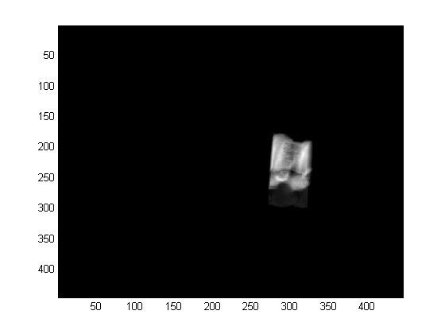
- A cone beam projection DRR of the given CT 3D image into the X-ray image plane with 1 mm beam sampling interval.

<EQ1>
is proposed for the cone beam projection. This formula is not entirely correct from the point of view of physics. A more correct (yet still neglecting different distance of Xray image pixels to the source) formula would be
<EQ2>,
where I0 is the intensity of the source. For given setup this should be set to 255.
Anyway a function drr.m that performs cone beam projection using formula <EQ1> has been written.
In this function beam sampling is done through interpolation of CT 3D image. Therefore it makes no sense to have beam sampling denser than CT 3D image grid. Decreasing beam sampling interval will lead to information loss. Therefore a reasonable beam sampling interval would be around 1 millimeter (Fig.4).
- Examples of beam projection DRR of the given CT 3D image transformed with parameters iPar = [0 20 0 0 0 0], iPar = [0 0 0 0 45 0], iPar = [0 0 0 0 0 90]

DRRs of rigid body transformed CT 3D image
Function *drr.m* has been extended to perform a projection of CT 3D volume after an arbitrary rigid body transformation. DRRs obtained with various transform parameters can be seen in Fig.5

Discarding anatomically irrelevant information
Using a histogram of the CT 3D image (Fig.6,A) one can see a peak at value 64 around 2 wide, that corresponds to the background. By thresholding this image at value 66 before performing the projection one effectively removes most if not all non-vertebra data from integration (see Fig.6,B).

Correlation coefficient
One of the similarity measures to be used is correlation coefficient given by equation.
<Eq3>
If we have images in the same modality, pixel values corresponding to the same structure would produce terms of the same sign in the nominator in <Equation 3> . Therefore correlation coefficient would have positive value. The better the pictures are aligned the closer it would be to 1. Conversely if we have different modalities so that the same structure would give pixel values above mean picture intensity in one image and below mean picture intensity in another one then we would have negative nominator. The better the structures would be aligned the smaller (more negative)the correlation coefficient would be. Theoretically it could reach -1 for a perfectly aligned negative of the very same picture. These pictures would be anti-correlated. In our case we have anti-correlated images and therefore we strive to minimize the correlation coefficient.
Values of correlation coefficient between given DRR of CT 3D image and X-ray when one of the rigid body parameter varies are shown in Fig. 7

Mutual information
Another similarity measure to be used in this assignment is mutual information given by equation
<Eq4>.
Regardless of modality the joint distribution histogram gives us the number of all states both pixels at given position can have. Obviously for perfectly aligned pictures the joint probability histogram would have the same amount of different states and same amount of pixels in each state as each individual picture. Therefore according to <Eq4> mutual information of perfectly aligned pictures would be equal to the entropy of an individual picture.
Any misalignment would increase the amount of states in the joint distribution and therefore increase joint entropy decreasing mutual information.
Values of mutual information for given DRR of CT 3D image and X-ray when one of the rigid body parameter varies are shown in Fig. 8

Similarity measure optimization

Selecting a Template (Heading 2)
First, confirm that you have the correct template for your paper size. This template has been tailored for output on the A4 paper size. If you are using US letter-sized paper, please close this file and download the file “MSW_USltr_format”.

Maintaining the Integrity of the Specifications
The template is used to format your paper and style the text. All margins, column widths, line spaces, and text fonts are prescribed; please do not alter them. You may note peculiarities. For example, the head margin in this template measures proportionately more than is customary. This measurement and others are deliberate, using specifications that anticipate your paper as one part of the entire proceedings, and not as an independent document. Please do not revise any of the current designations.

Prepare Your Paper Before Styling
- A- Histogram of CT 3D image. B - a DRR of thresholded CT 3D image..

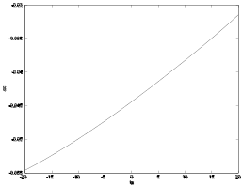 | 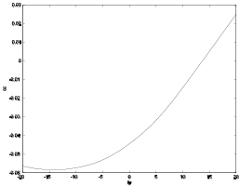
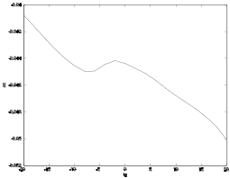 | 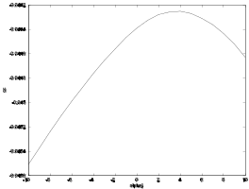
 | 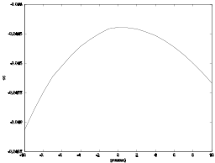

- Dependencies of correlation coefficient between given DRR of CT 3D and X-ray images depending on variation of rigid body transform parameters.

Before you begin to format your paper, first write and save the content as a separate text file. Keep your text and graphic files separate until after the text has been formatted and styled. Do not use hard tabs, and limit use of hard returns to only one return at the end of a paragraph. Do not add any kind of pagination anywhere in the paper. Do not number text heads-the template will do that for you.
Finally, complete content and organizational editing before formatting. Please take note of the following items when proofreading spelling and grammar:
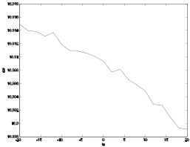 | 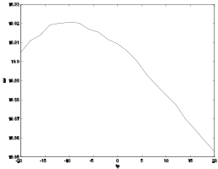
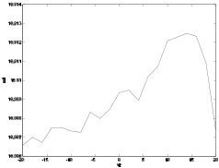 | 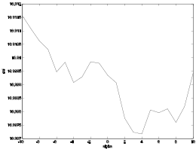
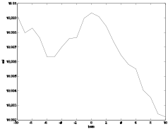

- Dependencies of correlation coefficient between given DRR of CT 3D and X-ray images depending on variation of rigid body transform parameters.

Abbreviations and Acronyms
Define abbreviations and acronyms the first time they are used in the text, even after they have been defined in the abstract. Abbreviations such as IEEE, SI, MKS, CGS, sc, dc, and rms do not have to be defined. Do not use abbreviations in the title or heads unless they are unavoidable.

Units
- Use either SI (MKS) or CGS as primary units. (SI units are encouraged.) English units may be used as secondary units (in parentheses). An exception would be the use of English units as identifiers in trade, such as “3.5-inch disk drive.”
- Avoid combining SI and CGS units, such as current in amperes and magnetic field in oersteds. This often leads to confusion because equations do not balance dimensionally. If you must use mixed units, clearly state the units for each quantity that you use in an equation.
- Do not mix complete spellings and abbreviations of units: “Wb/m2” or “webers per square meter,” not “webers/m2.” Spell units when they appear in text: “...a few henries,” not “...a few H.”
- Use a zero before decimal points: “0.25,” not “.25.” Use “cm3,” not “cc.” (bullet list)

Equations
The equations are an exception to the prescribed specifications of this template. You will need to determine whether or not your equation should be typed using either the Times New Roman or the Symbol font (please no other font). To create multileveled equations, it may be necessary to treat the equation as a graphic and insert it into the text after your paper is styled.
Number equations consecutively. Equation numbers, within parentheses, are to position flush right, as in (1), using a right tab stop. To make your equations more compact, you may use the solidus ( / ), the exp function, or appropriate exponents. Italicize Roman symbols for quantities and variables, but not Greek symbols. Use a long dash rather than a hyphen for a minus sign. Punctuate equations with commas or periods when they are part of a sentence, as in
a  b             
Note that the equation is centered using a center tab stop. Be sure that the symbols in your equation have been defined before or immediately following the equation. Use “(1),” not “Eq. (1)” or “equation (1),” except at the beginning of a sentence: “Equation (1) is ...”

Some Common Mistakes
- The word “data” is plural, not singular.
- The subscript for the permeability of vacuum μ₀, and other common scientific constants, is zero with subscript formatting, not a lowercase letter “o.”
- In American English, commas, semi-/colons, periods, question and exclamation marks are located within quotation marks only when a complete thought or name is cited, such as a title or full quotation. When quotation marks are used, instead of a bold or italic typeface, to highlight a word or phrase, punctuation should appear outside of the quotation marks. A parenthetical phrase or statement at the end of a sentence is punctuated outside of the closing parenthesis (like this). (A parenthetical sentence is punctuated within the parentheses.)
- A graph within a graph is an “inset,” not an “insert.” The word alternatively is preferred to the word “alternately” (unless you really mean something that alternates).
- Do not use the word “essentially” to mean “approximately” or “effectively.”
- In your paper title, if the words “that uses” can accurately replace the word using, capitalize the “u”; if not, keep using lower-cased.
- Be aware of the different meanings of the homophones “affect” and “effect,” “complement” and “compliment,” “discreet” and “discrete,” “principal” and “principle.”
- Do not confuse “imply” and “infer.”
- The prefix “non” is not a word; it should be joined to the word it modifies, usually without a hyphen.
- There is no period after the “et” in the Latin abbreviation “et al.”
- The abbreviation “i.e.” means “that is,” and the abbreviation “e.g.” means “for example.”
An excellent style manual for science writers is [7].

Using the Template
After the text edit has been completed, the paper is ready for the template. Duplicate the template file by using the Save As command, and use the naming convention prescribed by your conference for the name of your paper. In this newly created file, highlight all of the contents and import your prepared text file. You are now ready to style your paper; use the scroll down window on the left of the MS Word Formatting toolbar.

Authors and Affiliations
The template is designed so that author affiliations are not repeated each time for multiple authors of the same affiliation. Please keep your affiliations as succinct as possible (for example, do not differentiate among departments of the same organization). This template was designed for two affiliations.

For author/s of only one affiliation (Heading 3): To change the default, adjust the template as follows.

Selection (Heading 4): Highlight all author and affiliation lines.

Change number of columns: Select the Columns icon from the MS Word Standard toolbar and then select “1 Column” from the selection palette.

Deletion: Delete the author and affiliation lines for the second affiliation.

For author/s of more than two affiliations: To change the default, adjust the template as follows.

Selection: Highlight all author and affiliation lines.

Change number of columns: Select the “Columns” icon from the MS Word Standard toolbar and then select “1 Column” from the selection palette.

Highlight author and affiliation lines of affiliation 1 and copy this selection.

Formatting: Insert one hard return immediately after the last character of the last affiliation line. Then paste down the copy of affiliation 1. Repeat as necessary for each additional affiliation.

Reassign number of columns: Place your cursor to the right of the last character of the last affiliation line of an even numbered affiliation (e.g., if there are five affiliations, place your cursor at end of fourth affiliation). Drag the cursor up to highlight all of the above author and affiliation lines. Go to Column icon and select “2 Columns”. If you have an odd number of affiliations, the final affiliation will be centered on the page; all previous will be in two columns.

Identify the Headings
Headings, or heads, are organizational devices that guide the reader through your paper. There are two types: component heads and text heads.
Component heads identify the different components of your paper and are not topically subordinate to each other. Examples include ACKNOWLEDGMENTS and REFERENCES, and for these, the correct style to use is “Heading 5.” Use “figure caption” for your Figure captions, and “table head” for your table title. Run-in heads, such as “Abstract,” will require you to apply a style (in this case, italic) in addition to the style provided by the drop down menu to differentiate the head from the text.
Text heads organize the topics on a relational, hierarchical basis. For example, the paper title is the primary text head because all subsequent material relates and elaborates on this one topic. If there are two or more sub-topics, the next level head (uppercase Roman numerals) should be used and, conversely, if there are not at least two sub-topics, then no subheads should be introduced. Styles named “Heading 1,” “Heading 2,” “Heading 3,” and “Heading 4” are prescribed.

Figures and Tables

Positioning Figures and Tables: Place figures and tables at the top and bottom of columns. Avoid placing them in the middle of columns. Large figures and tables may span across both columns. Figure captions should be below the figures; table heads should appear above the tables. Insert figures and tables after they are cited in the text. Use the abbreviation “Fig. 1,” even at the beginning of a sentence.
- Table Styles
Table Head | Table Column Head
Table Head | Table column subhead | Subhead | Subhead
copy | More table copyª
- Sample of a Table footnote. (Table footnote)

- Example of a figure caption. (figure caption)
Figure Labels: Use 8 point Times New Roman for Figure labels. Use words rather than symbols or abbreviations when writing Figure axis labels to avoid confusing the reader. As an example, write the quantity “Magnetization,” or “Magnetization, M,” not just “M.” If including units in the label, present them within parentheses. Do not label axes only with units. In the example, write “Magnetization (A/m)” or “Magnetization (A ( m(1),” not just “A/m.” Do not label axes with a ratio of quantities and units. For example, write “Temperature (K),” not “Temperature/K.”

Acknowledgment (Heading 5)
The preferred spelling of the word “acknowledgment” in America is without an “e” after the “g.” Avoid the stilted expression “one of us (R. B. G.) thanks ...”. Instead, try “R. B. G. thanks...”. Put sponsor acknowledgments in the unnumbered footnote on the first page.

References
The template will number citations consecutively within brackets [1]. The sentence punctuation follows the bracket [2]. Refer simply to the reference number, as in [3]—do not use “Ref. [3]” or “reference [3]” except at the beginning of a sentence: “Reference [3] was the first ...”
Number footnotes separately in superscripts. Place the actual footnote at the bottom of the column in which it was cited. Do not put footnotes in the reference list. Use letters for table footnotes.
Unless there are six authors or more give all authors’ names; do not use “et al.”. Papers that have not been published, even if they have been submitted for publication, should be cited as “unpublished” [4]. Papers that have been accepted for publication should be cited as “in press” [5]. Capitalize only the first word in a paper title, except for proper nouns and element symbols.
For papers published in translation journals, please give the English citation first, followed by the original foreign-language citation [6].

- G. Eason, B. Noble, and I.N. Sneddon, “On certain integrals of Lipschitz-Hankel type involving products of Bessel functions,” Phil. Trans. Roy. Soc. London, vol. A247, pp. 529-551, April 1955. (references)
We suggest that you use a text box to insert a graphic (which is ideally a 300 dpi resolution TIFF or EPS file with all fonts embedded) because this method is somewhat more stable than directly inserting a picture.
To have non-visible rules on your frame, use the MSWord “Format” pull-down menu, select Text Box > Digitally reconstructed radiographs (DRR) of CT 3D image may be used to perform 3D-2D registration. These are made using cone beam projection.
According to the assignment intensity of each voxel in the CT 3D image represents the
atenuation coefficient µ(x) of the corresponding structure. A formula
<EQ1>
is proposed for the cone beam projection. This formula is not entirely correct from the point of view of physics. A more correct (yet still neglecting different distance of Xray pixels to the source) formula would be
<EQ2>,
where I0 is the intensity of the source. For given setup this should be set to 255.
Anyway a function *drr.m* that performs cone beam projection using formula <EQ1> has been written.
In this function beam sampling is done through interpolation of CT 3D image. Therefore it makes no sense to have beam sampling denser than CT 3D image grid. Decreasing beam sampling interval will lead to information loss. Therefore a reasonable beam sampling interval would be around 1 millimeter (Fig.4).Colors and Lines to choose No Fill and No Line.
- J. Clerk Maxwell, A Treatise on Electricity and Magnetism, 3rd ed., vol. 2. Oxford: Clarendon, 1892, pp.68-73.
- I.S. Jacobs and C.P. Bean, “Fine particles, thin films and exchange anisotropy,” in Magnetism, vol. III, G.T. Rado and H. Suhl, Eds. New York: Academic, 1963, pp. 271-350.
- K. Elissa, “Title of paper if known,” unpublished.
- R. Nicole, “Title of paper with only first word capitalized,” J. Name Stand. Abbrev., in press.
- Y. Yorozu, M. Hirano, K. Oka, and Y. Tagawa, “Electron spectroscopy studies on magneto-optical media and plastic substrate interface,” IEEE Transl. J. Magn. Japan, vol. 2, pp. 740-741, August 1987 [Digests 9th Annual Conf. Magnetics Japan, p. 301, 1982].
- M. Young, The Technical Writer’s Handbook. Mill Valley, CA: University Science, 1989.

