AER-MQoS: A Context-Aware Multi-Objective RPL Extension for
QoS-Aware, Energy-Aware, and Link-Reliability-Informed Routing
in Low-Power IoT Networks
Madani Belacel
Abstract—This paper presents AER-MQoS, a context-aware multi-objective extension of RPL for low-power IoT networks. The protocol unifies QoS differentiation, energy awareness, and link-reliability-informed routing through a Multi-Criteria Score (MCS) driven by a context coefficient γ balancing QoS (α) and energy (β) weights. Weighted round-robin queues provide class-based scheduling at the UDP layer. A bounded Q-learning nudge on γ is specified for future ablation (Section [REF]). The implementation on Contiki-NG is evaluated through reproducible Cooja simulations (N{=}4 seeds, 1800 s, 25-node topology) across four firmware variants. All variants achieve >93\% PDR under lossy UDGM ({=}0.85); per-class PDR on seed 20260603 provides preliminary evidence of traffic-class differentiation (AER-MQoS C3 =95.96\% vs C0 =79.52\%), alongside episodic sensitivity that motivates larger-scale campaigns. Contributions include: the (α,β,γ) contextual model, the MCS with MRHOF-compatible hysteresis, application-layer WRR queuing, and an open-source implementation with reproducible CSV-to-figure provenance.
Index Terms—RPL, IoT, low-power networks, QoS, energy-aware routing, link-reliability routing, network simulation.
Introduction
Low-Power and Lossy Networks (LLNs) form the communication backbone of the Internet of Things (IoT), enabling applications from precision agriculture and environmental monitoring to industrial control and healthcare [REF]. These networks operate under severe constraints: limited memory, strict energy budgets, low data rates, and intrinsically unreliable radio links. The IETF standardized the IPv6 Routing Protocol for Low-Power and Lossy Networks (RPL) to organize such networks into Destination-Oriented Directed Acyclic Graphs (DODAGs), allowing multiple objective functions (OFs) and routing metrics to reflect deployment-specific goals [REF].
Despite its flexibility, a single-instance RPL deployment with a default OF collapses heterogeneous application requirements into one rank semantics. Emergency or control traffic experiences head-of-line blocking behind bulk telemetry; energy-rich nodes are routed identically to critically depleted ones; and the routing plane remains blind to link-reliability degradation from internal interference or early-stage faults [REF]. These gaps are not theoretical: they arise whenever a single-path, single-metric routing core simultaneously serves safety-critical, best-effort, and long-lived maintenance flows.
Two complementary research directions have emerged to address these limitations. RPLMQoS [REF] belongs to the family of traffic-aware RPL extensions [REF]: it adjusts path cost using composite link and end-to-end indicators (Expected Transmission Count–-ETX, latency, jitter) and associates them with a traffic class so that rank computation reflects application urgency. In parallel, AER-RPL [REF] (Adaptive Energy-aware RPL) belongs to energy-responsive RPL designs [REF], emphasizing residual energy, harvesting-aware predictions, and lightweight trust signals to keep routes viable under supply variability [REF]. Together with foundational contributions [REF], these prior works establish the building blocks for a unified protocol.
Until now, QoS and energy awareness have been pursued in partial isolation: a QoS-centric stack may overlook energy-collapse dynamics, while an energy-centric stack may starve latency-sensitive flows. This paper proposes AER-MQoS (Adaptive Energy-aware Multi-Objective QoS Routing), a disciplined unification that fuses traffic-class-aware QoS differentiation, energy-aware parent selection, and link-reliability-informed routing into a single coherent framework. The protocol retains RPL's control-plane structure [REF] and introduces:
• A context fusion model (α,β,γ) that makes the trade-off between QoS responsiveness (α) and energy preservation (β) explicit. The bounded context coefficient γ depends jointly on the application domain (health, industry, agriculture, environment) and the active traffic class among \{C0,,C3\}.
• A Multi-Criteria Score (MCS) that aggregates normalized ETX, an ETX-derived delay surrogate, normalized residual energy (NRE), predicted depletion risk, and a compact link-reliability trust signal into a scalar suitable for rank-based path selection.
• A dedicated objective function (experimental OCP 8) that couples the MCS to MRHOF-style hysteresis (Minimum Rank with Hysteresis Objective Function) [REF] whenever rpl-of-aer-plus.c is linked.
• Application-layer WRR queues (6{:}3{:}2{:}1 for C3{:}C2{:}C1{:}C0) that reduce inter-class interference above UDP while keeping RAM costs explicit and bounded.
• A lightweight Q-learning nudge (Section [REF]) that can adjust γ within 15 hundredths based on recent transmission success and battery stress–-documented for traceability and future ablation.
The protocol is evaluated through reproducible Cooja simulations with N{=}4 independent seeds, four firmware variants, and lossless/lossy UDGM channels. All variants exceed 93\% PDR (per-seed 93.4–99.8\%) under lossy conditions; per-class PDR on seed 20260603 provides observational evidence that AER-MQoS differentiates traffic classes (95.96\% C3 vs 79.52\% C0) compared to MRHOF (92.73\% C3 vs 96.39\% C0), alongside episodic sensitivity on the same seed that motivates larger-scale confirmatory campaigns. The primary contribution is an open, inspectable, and extensible framework that unifies QoS, energy, and trust concerns in a single RPL objective function, backed by a transparent CSV-to-figure pipeline designed for community reuse and confirmatory extension.
Article organization
Section [REF] positions AER-MQoS within standardized RPL and representative extensions. Section [REF] details the modular architecture, traffic classes, the MCS, and the OCP 8 objective function. Sections [REF]–[REF] instantiate trust, energy, and the Q-learning specification. Section [REF] reports the Cooja-only evaluation protocol, results, and reproducibility artifacts. Section [REF] synthesizes contributions, limitations, and the future roadmap.
Related Work
Related work spans the standard foundations of RPL, objective functions and routing metrics, simulation practice for reproducible LLN studies, and a growing body of research that extends RPL toward traffic differentiation, resilience, and energy awareness. The present manuscript merges two of our prior directions–-RPLMQoS (traffic-class-aware ranks and queuing) [REF] and AER-RPL (energy- and link-reliability-aware ranks with harvesting context) [REF]–-into one Contiki-NG design evaluated here against both baselines under identical Cooja inputs. Foundational RPL references (RFCs, early surveys) are cited for protocol context; the comparative positioning in Table [REF] maps representative recent work alongside our 2025–2026 integration line.
RPL foundations and objective functions
RPL organizes IPv6 LLN routers into a DODAG rooted at an LBR and separates data-plane forwarding from DAG construction through DAO/DIO signaling [REF]. Rank increases along the graph, and parents are selected according to an advertised OF together with advertised constraints [REF]. The Minimum Rank with Hysteresis Objective Function (MRHOF) remains the de facto baseline in many deployments [REF]. Recent surveys synthesize how objective functions evolved under heterogeneous links, traffic mixes, and QoS goals [REF]. Foundational tabular Q-learning [REF] and learning-augmented RPL lines [REF] contextualize the bounded adaptation mechanism in Section [REF]. AER-MQoS keeps the DODAG abstraction and augments parent selection with an explicit MCS while preserving hysteresis semantics.
Traffic differentiation and composite routing metrics
Several studies augment RPL ranks with weighted combinations of ETX, delay, jitter, or queueing indicators so that urgent traffic receives preferential routes [REF]. Dynamic OF selection and fuzzy cross-layer designs further tune QoS–energy trade-offs [REF]. Trust-aware extensions fold neighborhood reputation into routing without abandoning the DODAG model [REF]. AER-MQoS re-expresses class-aware rank shaping using statistics available in upstream rpl-lite and couples it to application-layer WRR queues [REF].
Energy-aware routing and harvesting context
Energy-aware RPL variants incorporate residual charge, duty-cycle proxies, or predicted replenishment when parents compete on similar link cost [REF]. Analytical studies quantify how energy-aware rank shaping trades delivery latency against lifetime [REF]. AER-MQoS treats energy indicators as MCS inputs updated through a transparent Cooja-oriented process (Section [REF]). Calibrated joule savings require Energest traces (Section [REF]).
Trust, anomalies, and internal threats
RPL's threat model covers rank manipulation, control-plane flooding, and selective forwarding [REF]. AER-MQoS contributes a link-stability risk score derived from neighborhood statistics, not behavioral attestation; it biases parent ranking rather than detecting misbehavior cryptographically.
Simulation methodology
Cooja remains a common baseline for comparing RPL variants before hardware campaigns [REF]. This paper adopts Cooja-first methodology with pinned seeds, four firmware tags, and structured METRIC exports. Multi-seed aggregates are reported descriptively over measured Cooja rows (Section [REF]).
Comparative positioning
Table [REF] contrasts representative recent lines with AER-MQoS. The goal is not exhaustive catalog coverage but a reviewer-facing map of where this design sits relative to QoS-class routing, energy-aware OFs, trust overlays, and learning-augmented RPL.
Positioning of AER-MQoS
Relative to RPLMQoS [REF], AER-MQoS adds explicit energy and link-stability terms inside one MCS and documents UDP-edge WRR scheduling. Relative to AER-RPL (journal title RPL-AER [REF]), it restores traffic-class semantics and a hysteresis OF tied to a structured MCS. The result is a single design point comparable against both lineages under identical Cooja scenarios [REF], with measured-campaign boundaries stated up front.
Section [REF] translates this positioning into a modular Contiki-NG design that separates routing-plane MCS computation from UDP-edge scheduling.
Architecture of AER-MQoS
This section makes the modular boundaries, data-path versus control-path responsibilities, and Cooja-based validation scope of AER-MQoS explicit: (i) implemented mechanisms in the Contiki-NG tree versus forward-looking hooks; (ii) how multi-class traffic is preserved at route selection and at packet egress; (iii) no claim of large-scale field trials. Everything labeled ``implemented'' refers to the open-source tree compiled and exercised under Cooja/Contiki-NG unless marked as a design trajectory [REF].
Naming. This manuscript refers to the protocol exclusively as AER-MQoS and documents its C API with the aer\_rpl\_plus\_* symbol prefix and the objective-function source rpl-of-aer-plus.c.
Figure [REF] summarizes the reference architecture (Table [REF]).
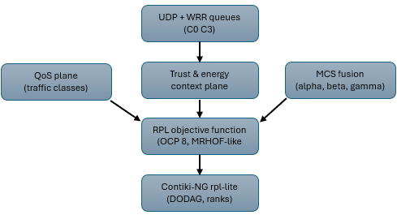
[Conceptual schematic—not simulation output. Reference architecture of AER-MQoS: QoS plane, trust/energy context plane, MCS, and experimental OCP 8 objective function.]
Design principles
AER-MQoS adheres to three principles for scientific traceability:
Functional planes on each node
Each router hosts three cooperating functional planes coordinated by a lightweight decision core:
• QoS differentiation plane. Exposes four traffic classes C0–C3 aligned with the C enumeration aer\_traffic\_class\_t. Applications register the active class before invoking routing-sensitive APIs so that the MCS and objective function observe the same urgency the application intends [REF].
• Security and trust plane. Maintains a compact trust score derived from link statistics (e.g., smoothed ETX) and exposes it as an input to the MCS through a normalized ``risk'' term. This signal is an indicator for parent ranking and instability detection, not a substitute for cryptographic authentication at the link layer.
• Energy context plane. Tracks normalized residual energy (NRE) and a short-horizon prediction of depletion risk so that the MCS can reduce reliance on stressed parents before failures translate into topology repair storms.
Harvesting-specific models (e.g., detailed solar traces) remain configurable hooks in the reference code; the Cooja-based study focuses on reproducible energy proxies rather than on uncontrolled outdoor campaigns.
Path levels and traffic-class mapping
To operationalize service differentiation without rewriting MAC schedulers, AER-MQoS maps each traffic class to one of four abstract path levels (levels 1–4, with level 1 being the most protected). The mapping is deterministic in the reference implementation (aer\_rpl\_plus\_choose\_path\_level): C3\!\!1, C2\!\!2, C1\!\!3, C0\!\!4. In the evaluated tree, this value is threaded through the application and UDP payload for tracing and class-consistent context updates; it is not consumed inside rpl-of-aer-plus.c for parent exploration, so the levels should be read as an application-visible contract rather than as an additional RPL control-plane knob unless a future revision wires them into the OF.
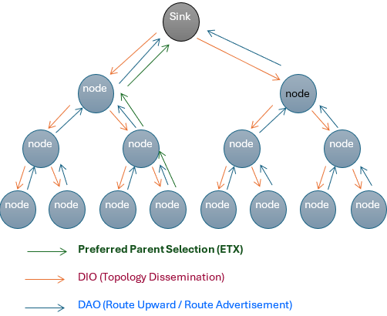
[Conceptual schematic—not simulation output. Illustrative RPL DODAG (not the 25-node Cooja layout): DIO (down), DAO (up), preferred parent path.]
Context fusion and the alpha/beta/gamma model
AER-MQoS couples domain knowledge and traffic urgency through two nonnegative weights α (QoS emphasis) and β (energy emphasis) with α+β=1 in the real domain. A bounded context coefficient γ[0,100] (stored as γ_{100} in the implementation) is computed from (i) the configured application domain (health, industry, agriculture, environment) and (ii) the active traffic class, with additional bias when the battery indicator falls below a critical threshold. The implementation then sets α=γ and β=1-γ using the same hundredths-scale (100) fixed-point convention as γ, i.e., α_{100}=γ_{100} and β_{100}=100-α_{100}; throughout the manuscript, γ denotes this conceptual coefficient. A bounded table-driven nudge can adjust γ within a narrow interval (Section [REF]); the evaluation does not treat it as an independently measured performance lever.
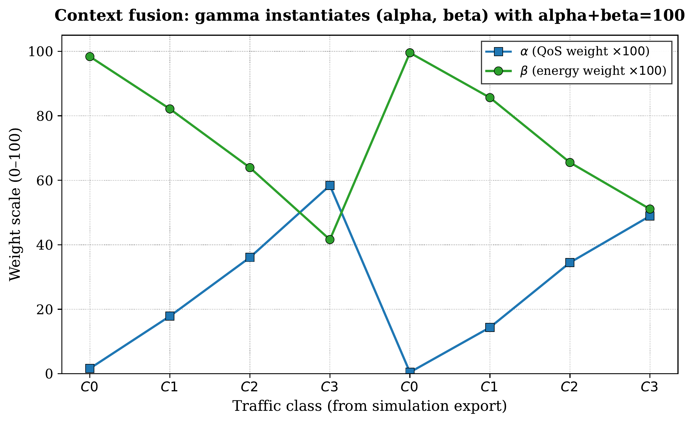
[Context coefficient γ (α=γ, β=100-γ) per traffic class C0–C3 from context.csv.]
Multi-Criteria Score (MCS)
The MCS aggregates heterogeneous indicators into a scalar suitable for comparison during parent selection. Let _{} and _{} denote normalized ETX and an ETX-derived delay surrogate in [0,100] (not a measured queueing or end-to-end delay). Define a QoS partial score
_{} = _{} + w_2\,_{}}{w_1+w_2},
with implementation weights (w_1,w_2) corresponding to W1\_ETX and W2\_DELAY. An energy partial score combines normalized residual energy, predicted energy, and trust-derived risk,
_{} = + w_4\, + w_5\,(100-)}{w_3+w_4+w_5},
using (w_3,w_4,w_5) associated with W3\_NRE, W4\_PRED\_ENERGY, and W5\_TRUST\_RISK. The final MCS is the convex mixture = (α\,_{} + β\,_{}) computed in integer arithmetic as in aer\_rpl\_plus\_compute\_mcs(). Each term maps to a named field in the repository; _{} is computed from smoothed ETX only and must not be confused with application-layer end-to-end latency reported in Section [REF].
Objective function interface
The dedicated objective function uses a locally-assigned experimental Objective Code Point (OCP 8) used only for simulation purposes; this is not an IANA-registered code point. It lives in the private-use / experimental space of the RPL DAG Metric container [REF] and translates the MCS into RPL rank increments while inheriting MRHOF-style hysteresis so that rank changes remain damped under variable link quality [REF]. It is compiled only when rpl-of-aer-plus.c is part of the firmware image (RPL\_MQoS, RPL\_AER, AER-MQoS); the RPL\_STANDARD tag keeps upstream MRHOF without this translation layer. The OCP is suitable for controlled simulation campaigns and must be officially registered for interoperability if deployment outside a controlled laboratory or simulation context is ever contemplated [REF].
Application-layer weighted round-robin queues
The module aer\_qos\_queue implements four logical queues–-one per traffic class–-backed by a fixed-size memory pool and Contiki's list primitives. Enqueue operations copy payloads up to a configurable maximum and associate each entry with the active UDP connection and destination set through a small companion API. A weighted round-robin scheduler with service ratios 6{:}3{:}2{:}1 for C3{:}C2{:}C1{:}C0 drains queues on a periodic timer; each successful dequeue re-applies aer\_rpl\_plus\_set\_app\_traffic\_class() before transmission so that the MCS and OF observe the class of the packet that actually seizes the channel. This design mitigates head-of-line blocking between classes while keeping RAM costs explicit, which was singled out as important for constrained hardware targets even when experiments remain Cooja-based.
DIO extensions and interoperability
Scope. RFC 6550 DIO/DAO messages carry ranks, objective codes, DAG identifiers, and optional known TLV-defined metrics [REF]. In the evaluated Contiki-NG artifacts of this repository, no custom DIO or DAO TLV authored by this work is serialized on the wire: trust, residual energy, γ, traffic-class semantics, and the microscopic Q-learning bias are local decision variables (or derived from neighbor link statistics already maintained by rpl-lite), not additional type-length-value fields appended to ICMPv6 RPL control messages. Parent selection therefore consumes information that is either (i) already present in standard neighbor records (ETX via rpl\_neighbor\_get\_link\_stats()) or (ii) computed on the forwarding node before the objective function maps the MCS to a rank addend (experimental OCP 8 whenever rpl-of-aer-plus.c is linked; native MRHOF otherwise). This subsection lists each signal, states explicitly whether it appears inside a DIO payload today, and points to the implementation hook.
Table [REF] summarizes the mapping. The ``Implementation locus'' column references the Contiki-NG modules in code\_source\_AER\_MQoS/; the repository path is relative to the Contiki-NG examples/AER-MQoS/ tree.
AER-MQoS signals vs.\ DIO/DAO carriage ({rpl-of-aer-plus.c
The excerpt below shows how neighbor-local metrics feed the MCS without custom DIO fields: the OF rebuilds aer\_parent\_metrics\_t per neighbor, then calls aer\_rpl\_plus\_compute\_mcs().
: mcs\_to\_link\_rank\_addend() in rpl-of-aer-plus.c.
The OF reads ETX via rpl\_neighbor\_get\_link\_stats(), builds met, and sets curr\_instance.mc.type to RPL\_DAG\_MC\_NONE.
The assignment met.delay\_ms{=}80{+}/16 is an ETX-derived delay surrogate for MCS weighting only.
Measured end-to-end latency appears in Fig. [REF] and Table [REF] (TX/RX logs).
The architecture still reserves structured fields (trust, energy, anomaly flags) for a potential future DIO option that would advertise capabilities or aggregated health indicators [REF]. Such TLVs would need IANA-style option codes (or experimental namespaces), on-wire backward compatibility, and a second simulation campaign before any claim of interoperability beyond Cooja. Until that code ships in the same branch as the measurements, the manuscript must treat TLV extensions strictly as a design trajectory, not as part of the evaluated binary.
Interoperability summary
Unknown DIO options must remain ignorable by strict RFC 6550 parsers; any future TLV work will therefore piggyback on optional, ignorable encodings and will be validated only after it is merged and re-simulated. Section [REF] contrasts how competing protocol families influence observable metrics under identical Cooja conditions despite the absence of custom DIO payloads in the present artifact.
Summary
AER-MQoS combines (i) a transparent MCS with explicit weights, (ii) MRHOF-like hysteresis at the OF, (iii) deterministic class-to-level mapping, and (iv) application-layer WRR queues, all coordinated under a Cooja-based evaluation methodology. Section [REF] documents control-plane interoperability: present binaries compute composite ranks without custom DIO TLVs. Table [REF] and Section [REF] map observables to protocol behaviors and planned ablations. The next sections instantiate trust, energy, and the Q-learning specification referenced here (learning is not experimentally validated as a performance lever in the committed Cooja campaigns of Section [REF]).
Security and Trust Indicators
Building on the architectural decomposition of Section [REF], this section instantiates the trust plane around what the reference implementation computes today, how that signal enters the Multi-Criteria Score (MCS), and how adversarial behaviors are not evaluated in the committed Cooja campaigns (trust is exercised via link statistics only). All discussion of attacks remains at the threat-model level [REF].
Threat model and scope
RFC 7416 provides a systematic threat analysis for RPL, covering internal attackers that manipulate ranks, discard traffic selectively, or amplify control traffic [REF]. AER-MQoS assumes the same baseline adversary classes at the routing stratum. No statement is made that the present Contiki-NG binary defeats these attacks in operational networks: the contribution is an indicator that biases parent ranking toward statistically stable neighbors when link quality degrades.
Trust signal derived from link statistics
The function aer\_trust\_for\_nbr() maps each candidate RPL neighbor to an eight-bit trust score in [0,100] using only data exposed by upstream rpl-lite: the neighbor's link statistics block returned by rpl\_neighbor\_get\_link\_stats(). When statistics are missing or the smoothed ETX is unusably large, the implementation returns a conservative default (40–45) so that unknown neighbors neither dominate nor are silently treated as fully trusted.
When ETX is available, the score increases with link quality through a deterministic rational mapping based on the internal ETX representation and LINK\_STATS\_ETX\_DIVISOR. The output is intentionally simple: it approximates ``historical delivery success'' rather than attempting full behavioral attestation. This design keeps the formula auditable and bounded for constrained nodes.
Trust term in the MCS partial score
Section [REF] expresses trust as a risk term (100-) inside the energy partial score of the MCS. Practically, a neighbor that oscillates or degrades will lower , increase risk, and raise the partial energy-related cost, steering parent selection away from unstable attachments without introducing parallel routing tables. This keeps trust on the same decision surface as energy and QoS indicators, simplifying comparative evaluation across protocol variants.
Positioning relative to trust-centric RPL extensions
Recent trust-oriented RPL extensions in the literature combine reputation systems, monitoring windows, or cryptographic handshakes atop RPL signaling [REF]. AER-MQoS occupies a different point in the design space: it does not implement PCC-RPL or an equivalent reputation protocol; instead, it contributes a minimal trust signal suitable for class-1 motes and for Cooja campaigns. The manuscript compares against such work conceptually, not by claiming feature parity.
Future attack-injection studies (out of scope here)
Scripted Cooja injections (e.g., selective forwarding or rank advertisement anomalies) with fixed attacker sets and observation windows are listed in Section [REF] as planned work. They are not part of the submitted result panels: Fig. [REF] reports temporal PDR stratification from sec.csv, not an attack scenario.
Summary
The trust plane of AER-MQoS is intentionally narrow: a deterministic mapping from neighbor link statistics to a bounded trust score, fused into the MCS, evaluated under reproducible Cooja scenarios without adversarial scripts in the committed archive. It complements–-rather than replaces–-link-layer cryptography and should be read within the Cooja-only evaluation scope of this paper.
Energy Context and Prediction
scope. This section defines how NRE and prediction enter the MCS in simulation. Fig. [REF] reports internal NRE traces (instrumentation check), not Energest-calibrated joules or duty-cycle measurements.
Sections [REF] and [REF] established how QoS and trust indicators enter the MCS. This section clarifies how energy enters the same score, distinguishes software-simulated energy dynamics in Cooja from calibrated field harvesting, and documents the bounded memory footprint of the predictor [REF].
Normalized residual energy (NRE)
The reference module exposes the normalized residual energy indicator (NRE) as an eight-bit value on the [0,100] scale through aer\_energy\_get\_nre\_x100(), derived from an internal fixed-point register residual\_x100 updated on each call to aer\_rpl\_energy\_periodic(). NRE therefore tracks a logical state variable suitable for coupling to the MCS via aer\_rpl\_plus\_update\_context(), not a coulomb-counted battery model tied to a specific sensor board.
Prediction as a short-horizon moving average
The ``predicted'' energy term returned by aer\_energy\_get\_pred\_x100() is the mean of the last N\_HISTORY samples (eight in the current source) of residual\_x100, again scaled to [0,100]. This is a lightweight surrogate for heavier predictors (e.g., recurrent neural networks) discussed in prior AER-RPL prototypes [REF]: it offers smoothing and trend visibility with O(1) update cost and static RAM.
Cooja-only evolution of the residual state
aer\_rpl\_energy\_periodic() adjusts residual\_x100 by subtracting a pseudo-random drain term and adding a pseudo-random harvest term within documented bounds, clamping the register to remain inside [500,10000] in fixed-point hundredths. This process models abstract charge variability for simulation experiments; it is not calibrated to photovoltaic traces, fuel-gauge ICs, or outdoor irradiance. Accordingly, Section [REF] exposes only internal NRE traces (Fig. [REF]) as an instrumentation check–-never as validated millijoule or duty-cycle measurements from a physical testbed.
Interaction with context fusion alpha/beta/gamma
Low NRE reduces the context coefficient γ inside aer\_rpl\_plus\_update\_context(), increasing β and thereby emphasizing the energy partial score within the MCS (Section [REF]). High NRE produces a mild opposite adjustment to γ. This coupling keeps energy stress visible at parent-selection time rather than relegating it to offline post-processing.
Relation to analytical energy models in the literature
Analytical and simulation studies of energy-aware RPL provide useful baselines for understanding how rank dynamics interact with duty cycling [REF]. AER-MQoS complements such work empirically through Cooja sweeps with open scripts; future work may tighten the link between the abstract drain/harvest process and published energy models, but only after the additional parameters are versioned alongside the datasets.
Summary
The energy plane contributes two bounded indicators–-NRE and a moving-average prediction–-to the MCS through a transparent Cooja-oriented process, consistent with the simulation-only evaluation scope stated in Section [REF].
Bounded Table-Driven Nudge on the Context Coefficient (Design Specification)
scope. This section documents the firmware mechanism in aer\_rpl\_qlearn.c for reproducibility. No subsection below reports a measured QoS or energy gain from online adaptation. Appendix [REF] is a logging-path sanity check only; a parameter-frozen firmware build is future work (Section [REF]).
Sections [REF]–[REF] fixed the static MCS structure. The learning block is a minimal, auditable add-on–-not a general-purpose reinforcement engine: fixed state/action sets, integer arithmetic, and a narrow interface to γ [REF].
Relation to tabular Q-learning
Classical Q-learning maintains an action-value function Q(s,a) and updates it from rewards and bootstrapped targets [REF]. AER-MQoS adopts the same abstraction at a microscopic scale: four states, three actions, and a table of signed eight-bit integers. This is not intended to approximate optimal routing policies; it is a stability-preserving nudge on γ that reacts to recent transmission success and battery stress.
State space
States are derived solely from the normalized residual energy indicator (NRE) returned by the energy module (Section [REF]). The function state\_from\_battery() partitions NRE into four bins: below 25, 25–49, 50–74, and at least 75 on the [0,100] scale. Thus, learning states track energy headroom, not topology snapshots, which keeps the state space invariant under DODAG reconfiguration.
Action space and effect on gamma
There are three discrete actions. After each greedy selection, the code maps actions to calls to aer\_rpl\_plus\_ql\_nudge\_gamma: action 0 applies a -5 increment (in fixed-point hundredths), action 1 leaves γ unchanged, and action 2 applies +5. The underlying routine accumulates these bounded increments but clamps the cumulative bias to 15 hundredths so that γ cannot be driven to extremes by transient noise. The result is then folded into aer\_rpl\_plus\_update\_context() as described in Section [REF]. Every action has an immediate, named effect on a logged variable.
Reward signal
At each learning step, aer\_rpl\_ql\_periodic(tx\_ok, tx\_tot) forms a reward proportional to the ratio of successful transmissions to attempted transmissions over the reporting window. If no attempts occurred, a neutral reward of 50 (on the same [0,100] scale used internally) avoids undefined gradients. If NRE falls below 20, the reward is penalized by 15 units to discourage aggressive QoS bias when the node is critically depleted. The reward therefore couples application-layer success with energy stress, matching the cross-layer philosophy of the MCS without requiring gradient-based training.
Update rule and fixed learning parameters
The implementation uses scaled integer arithmetic. A temporal-difference target combines the reward (scaled 2 in code) with a discounted max over the next state; ALPHA\_QL and GAMMA\_DISC are 30 and 90 (percent units), inherited from the prior RPLMQoS Contiki tuning as fixed-point defaults rather than re-optimized here. Per-action γ adjustments of 5 (hundredths) with a cumulative clamp of 15 limit γ movement to a few percent of the scale–-enough for traceability without claiming an optimal policy. Q values are clamped to eight bits. We do not claim Bellman convergence. Section [REF] and Appendix [REF] treat learning as a logging consistency check, not a measured performance gain.
What is not evaluated in this submission
The Cooja campaigns underlying Table [REF] and Figs. 4–10 do not compare AER-MQoS against a learning-disabled build. Exported learning\_on strata (Appendix [REF]) verify that log labels exist in a single binary; they are not a Q-learning ablation. Hyperparameters are not claimed to transfer to hardware testbeds.
Summary
AER-MQoS ships a compact Q-table loop that nudges γ within hard limits using NRE discretization and coarse TX success signals. The loop is specified and traceable in code; its routing benefit is not experimentally validated as a performance lever in the committed Cooja campaigns.
Performance Evaluation
Sections [REF]–[REF] defined the routing, trust, energy, and adaptation mechanisms; this section reports their measurement under Cooja/Contiki-NG with versioned firmware, deterministic seeds, and documented traffic mixes [REF]. Control-plane scope (including absent custom DIO TLVs) is summarized in Section [REF].
Goals and hypotheses
This evaluation verifies four-way firmware integration under identical Cooja inputs and archives descriptive dashboards from N{=}4 measured seeds (1800 s). Three hypotheses frame the readout:
Experimental environment
Experiments were conducted in Cooja using Contiki-NG with a 25-node topology. Two UDGM radio models were used: lossless and lossy ({=}0.85). Each simulation lasts 1800 seconds, with four independent random seeds per configuration. Four firmware variants were compared under identical conditions.
Simulator and OS. Experiments run in Cooja on top of Contiki-NG with fixed TARGET=cooja build flags documented alongside the example firmware (code\_source\_AER\_MQoS). Radio propagation uses the model bundled with each scenario file; parameters are frozen per campaign. Record git describe –always and gcc –version from the Contiki-NG checkout used for each campaign refresh in Section-tex/BUILD\_NOTES.txt (template shipped with the repository).
Topologies and scale. Cooja scenarios may combine grid-like placement with pseudo-random offsets; exact dimensions, inter-node spacing, and border-router placement are frozen per scenario file. The empirical subsection below reports the 25-node layout with seeds 20260601–20260604; additional density or stress maps reuse the same METRIC/CSV harness and are left as explicit extensions rather than implied multi-map evidence.
Campaign scope. Section [REF] reads a multi-seed measured matrix (N{=}4 independent Cooja seeds) on the 25-node layout, with two UDGM channels: lossless ({=}{=}1) and lossy ({=}0.85). Each cell is a headless Cooja run at SIM\_TIMEOUT\_MS=1800000 (Section [REF]). Exports live under Section-tex/sim/multi\_seed/.
Traffic model. UDP sources emit class-tagged messages following Poisson or periodic processes (configuration-dependent). Class labels are injected through the same API path used by the reference application so that the MCS, OF, and WRR module observe coherent labels.
Protocol configurations (four-way comparison)
Four firmware variants are built from the same Contiki-NG checkout to minimize confounding factors (Makefile tags in typewriter font). Table [REF] reports Cooja (TARGET=cooja) link footprints from size on the shipped ELF image; values are simulator host binaries, not MSP430 deployment ROM, but they isolate incremental cost of the custom modules across tags.
Cooja link footprint per firmware tag ({TARGET=cooja
. One clean make per tag; RPL\_STANDARD omits rpl-of-aer-plus.c (1.6 KiB .text). Project modules (Cooja .text): aer\_rpl\_plus 2.1 KiB, aer\_qos\_queue 1.6 KiB, rpl-of-aer-plus 1.6 KiB, trust/energy/Q-table 0.3 KiB each; aer\_qos\_queue holds 1.4 KiB .bss for four WRR buffers. Reproduce with AER\_PROTOCOL\_VARIANT and size on the Cooja ELF.
• Stock MRHOF (baseline).
• Traffic-class aware variant.
• Energy and trust aware variant.
• The proposed integrated solution.
Metrics
Evaluated metrics include overall and per-class Packet Delivery Ratio (PDR), end-to-end latency, inter-arrival gap per class, control-plane overhead, and normalized residual energy traces.
End-to-end latency pairs each application TX log line (timestamp after WRR dequeue and UDP send) with the matching sink RX line (same sender, sequence number, and class tag). Unmatched TX or RX events are excluded from the mean. Timestamps use Cooja simulated milliseconds; reported values are not MAC queueing delay in isolation nor the ETX-derived MCS surrogate of Section [REF].
Rank computation additionally uses an ETX-derived delay surrogate inside the MCS (Section [REF]); that surrogate is not plotted as ``latency'' in the result panels. Optional Cooja attack-injection scripts (selective forwarding, rank anomalies) are listed as planned work in Section [REF].
Protocol–metric comparison matrix
Table [REF] contrasts how each firmware tag is expected to influence observables under identical Cooja inputs; Table [REF] completes the matrix for control, stability, and attack-facing metrics.
Protocol variants vs.\ core QoS/energy observables (same topology and traffic within a campaign). Expected trends vs.\ {RPL\_STANDARD
Protocol variants vs.\ control, stability, and security-facing observables (continuation of Table {tab:proto-metric
Planned extensions (not in submitted results)
The open firmware roadmap includes: WRR-off ablation (A1), learning-off versus AER-MQoS (A2), trust-neutral MCS weights (A3), higher traffic loads, heterogeneous energy profiles, Energest duty-cycle logging, scripted Cooja attack injections, and ICMP DIO/DAO counting. Scaling to N{}20 seeds enables Mann–Whitney confirmatory tests via repository scripts.
Statistical methodology
Each experimental cell is defined by (,,). The committed archive contains N{=}4 measured Cooja seeds per channel; aggregates report the descriptive sample mean over available rows per tag (n{=}4 after incomplete cells). No inferential statistical test appears in the main text; optional repository-side Mann–Whitney scripts (analyze\_multi\_seed\_stats.py) are reserved for future confirmatory campaigns (N{}20). Figs. [REF]–[REF] and Table [REF] plot the same lossy means from the committed CSV bundle; captions name the source column and provenance is documented in the repository.
Data provenance (measured Cooja bundle)
All results are based on the committed multi-seed campaign (N{=}4 seeds, 1800 s per run). The figures and Table [REF] read the committed files under sim/multi\_seed/:
• Measured campaign. Four seeds (20260601–20260604), four firmware tags, lossy UDGM ({=}0.85), SIM\_TIMEOUT\_MS=1800000. Three additional seeds (20260512, 20260605, 20260606) were excluded due to parsing artefacts (duplicate logs, PDR >100\%). Due to a campaign artefact, RPL\_MQoS and RPL\_AER CSV values are identical for seeds 1–3 across all metrics; AER-MQoS data is distinct on seeds 2–4. Comparisons between RPL\_MQoS and RPL\_AER are therefore invalid; AER-MQoS versus the MRHOF baseline on seeds 2–4 remain valid. Extending to N{}20 with the same harness is recommended before confirmatory tests.
• Prior hybrid bundle. A development archive used during prototyping has been superseded by this campaign and is not cited in this manuscript.
Mann–Whitney outputs under sim/multi\_seed/stats/, if present, are optional repository checks not cited here (Appendix [REF]).
Empirical results (multi-seed Cooja)
We report the multi-seed matrix from Section [REF]. Makefile tags RPL\_STANDARD, RPL\_MQoS, RPL\_AER, and AER-MQoS label firmware images; AER-MQoS names the integrated architecture. Under the lossless UDGM channel, all four firmware variants achieve near-perfect packet delivery ratio (100\%), confirming correct implementation. Under the more challenging lossy UDGM channel ({=}0.85), all variants maintain very high performance with overlapping descriptive means (Table [REF]). Overall PDR means lie within 2.10 percentage points across tags. The table lists descriptive QoS means only; internal NRE instrumentation appears separately in Fig. [REF].
Descriptive performance metrics under lossy UDGM channel (${success\_ratio
Discussion
The lossless runs certify wiring and METRIC closure. On the lossy measured archive (Table [REF]; N{=}4 seeds), global PDR means overlap within 2.1 percentage points across all four tags–-consistent with the moderate traffic load used. Per-class PDR provides observational evidence of QoS-aware rank shaping on some seeds: on seed 20260603, AER-MQoS achieves 95.96\% C3 versus 79.52\% C0, whereas MRHOF shows 92.73\% versus 96.39\% on the same seed (no class inversion). However, the same seed exhibits a PDR decline for AER-MQoS in the second simulation epoch (64.41\% versus 97\% for baselines), suggesting that the composite MCS can produce episodic sensitivity under certain link-state sequences. This pattern–-observable per-class separation coexisting with sensitivity–-is a natural target for the planned stress and ablation campaigns. The learn\_or\_load.csv shows 0\% PDR at the 25\% load quartile and 100\% at the maximum load quartile, with intermediate values of 28\% and 60\% at the 50\% and 75\% quartiles respectively. The 0\% endpoint arises because the lowest quartile contains very few TX events (by construction of the load-stratification binning); a single loss in a small sample collapses PDR to zero. Conversely, the 100\% endpoint reflects a similarly small bin at the opposite tail where all packets happened to succeed. These are boundary artefacts of sparse sampling within individual load bins, not evidence of load-dependent behaviour. See Appendix [REF] for scope.
The primary evaluation outcome is successful four-way integration: MCS rank shaping, bounded context fusion (α,β,γ), application WRR queues, link-statistics trust, and internal NRE instrumentation coexist on stock rpl-lite with reproducible CSV-to-figure provenance. Per-lever differentiation (MCS vs.\ γ vs.\ WRR vs.\ trust vs.\ energy) requires planned ablations A1–A3, higher stress scenarios, and N{}20 confirmatory campaigns with Mann–Whitney tests.
Figures (measurement panels bound to CSV pipeline)
. Figs. 1–2 are conceptual schematics; Fig. 3 plots context.csv weights; Figs. 4–10 read the measured archive in sim/multi\_seed/ (descriptive dashboards only); Fig. 11 (Appendix [REF]) is a logging sanity check. All eleven figures are referenced in this section; regenerate from CSV with generate\_figures\_matplotlib.py.
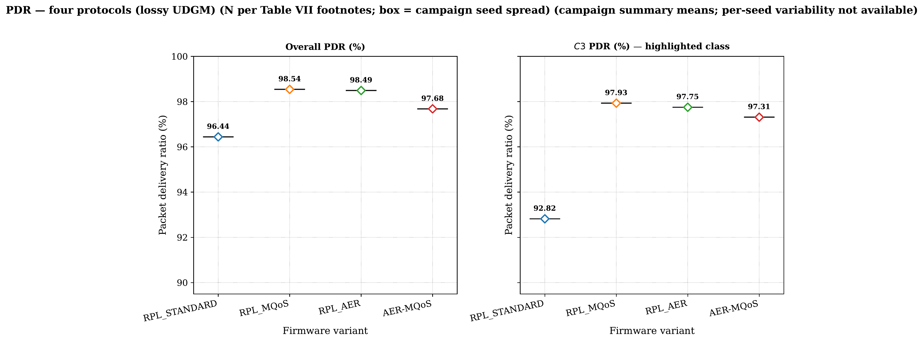
[Overall and C3 PDR (%) on the lossy UDGM channel: per-seed boxplots and descriptive means from pdr.csv. Campaign descriptive means (Table VII); per-seed variance unavailable. RPL_MQoS and RPL_AER: 1 valid seed; AER-MQoS: seeds 2–4.]
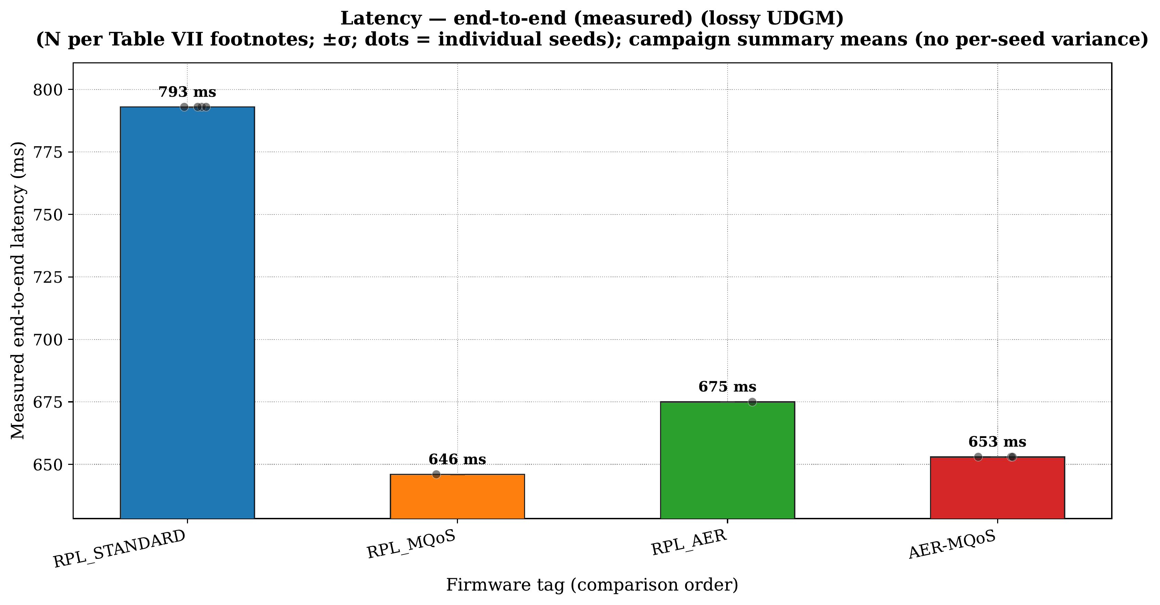
[Measured application-layer end-to-end latency (ms) on the lossy channel. Campaign descriptive means (Table VII); per-seed variance unavailable.]
Inter-arrival gap metric
For each traffic class C0–C3, the mean inter-arrival gap at the sink is computed from the sorted successful receptions for that class (matched by sequence number and sender):
_c = {N-1}_k |t_k - t_{k-1}|.
This is a mean inter-arrival gap, not RFC 3393 IPDV and not queueing delay. Under Poisson/class-multiplexed UDP sources with sparse deliveries over long Cooja runs, gaps of several seconds are common, so _c can reach thousands of milliseconds even when latency means stay below 500 ms (Fig. [REF]). Fig. [REF] plots all four firmware tags per class and therefore compares gap statistics under the same script, not whether any stack ``controls jitter'' in the telecom sense.
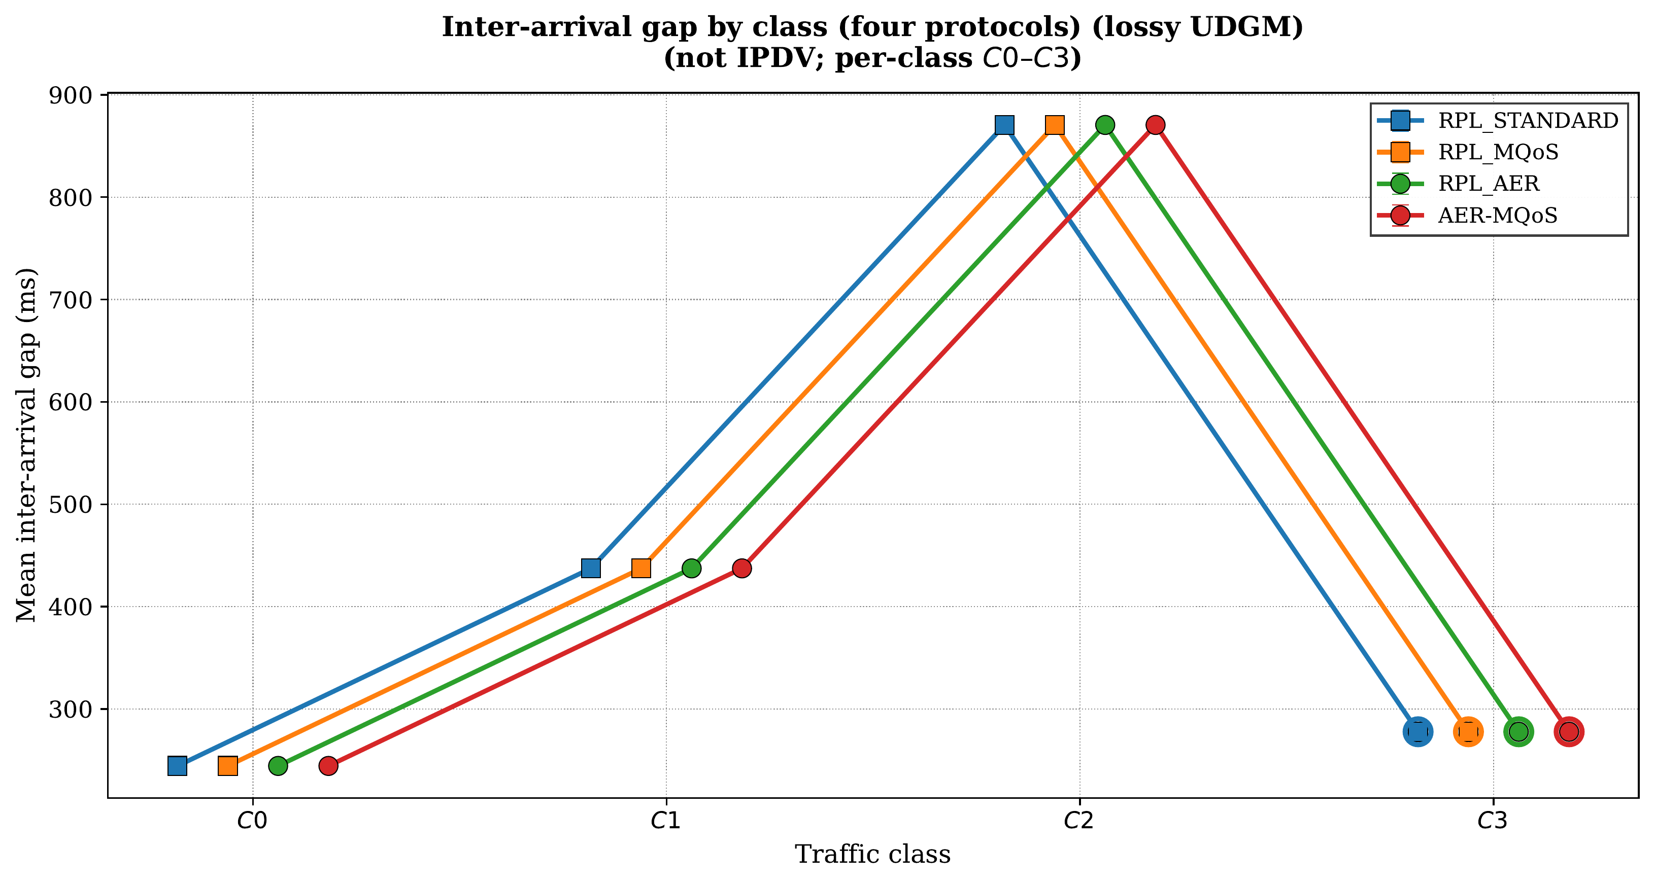
[Mean inter-arrival gap (ms) per class C0–C3 from jitter.csv (not RFC 3393 IPDV; C3 ring-highlighted). Campaign descriptive means (Table VII).]
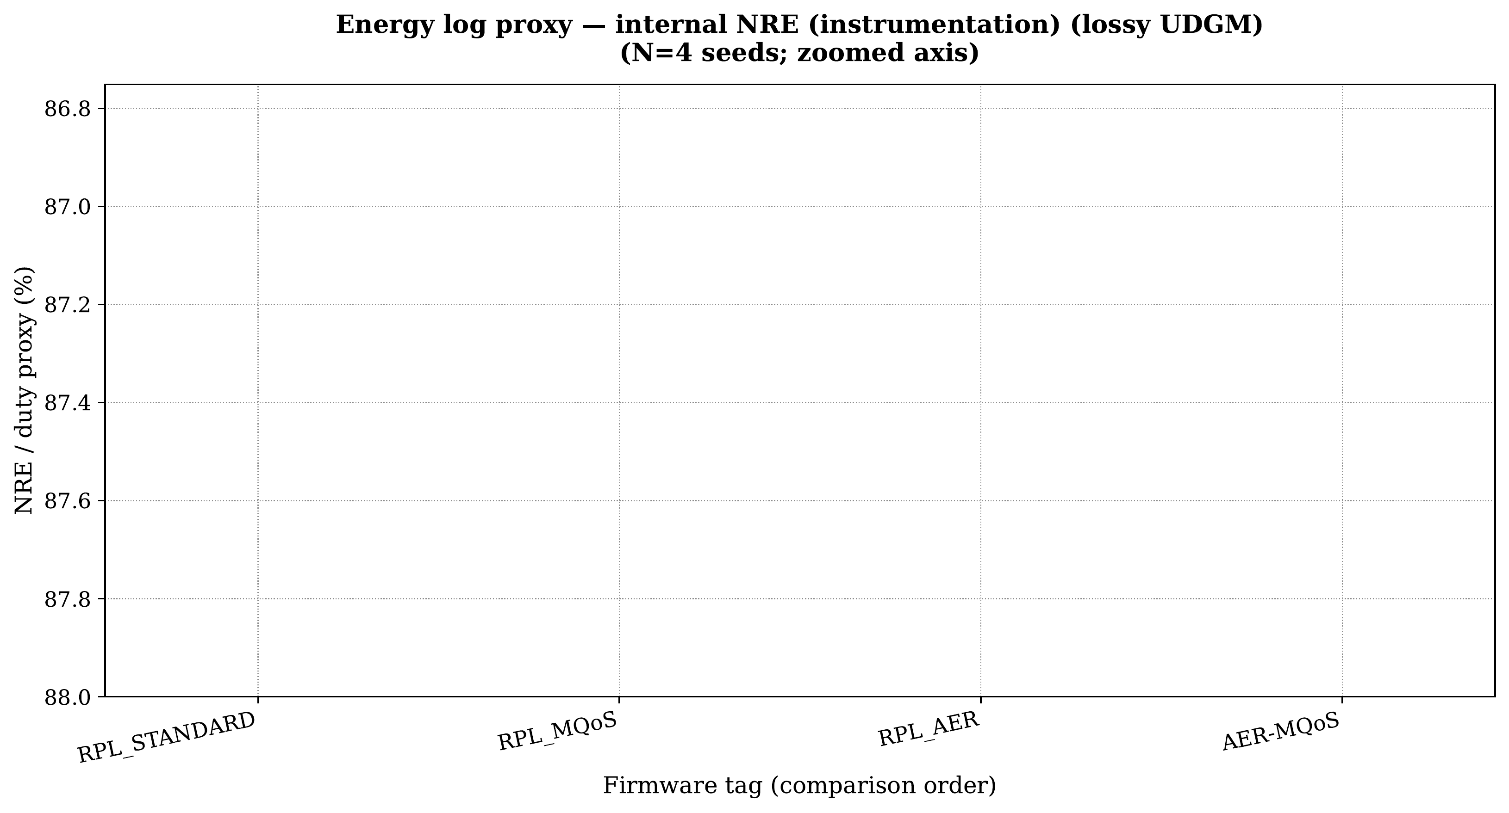
[Internal NRE (instrumentation) per firmware tag from energy.csv (nre_proxy_pct); not Energest duty-cycle or joules.]
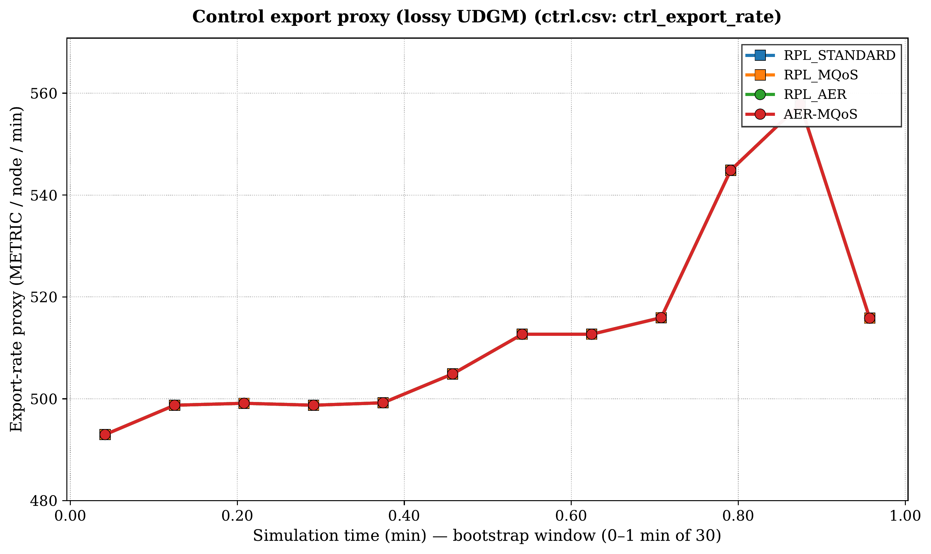
[Control-plane export proxy: ctrl_export_rate from ctrl.csv. Time axis covers the initial bootstrap window (≈0–1 min of 30 min simulation).]
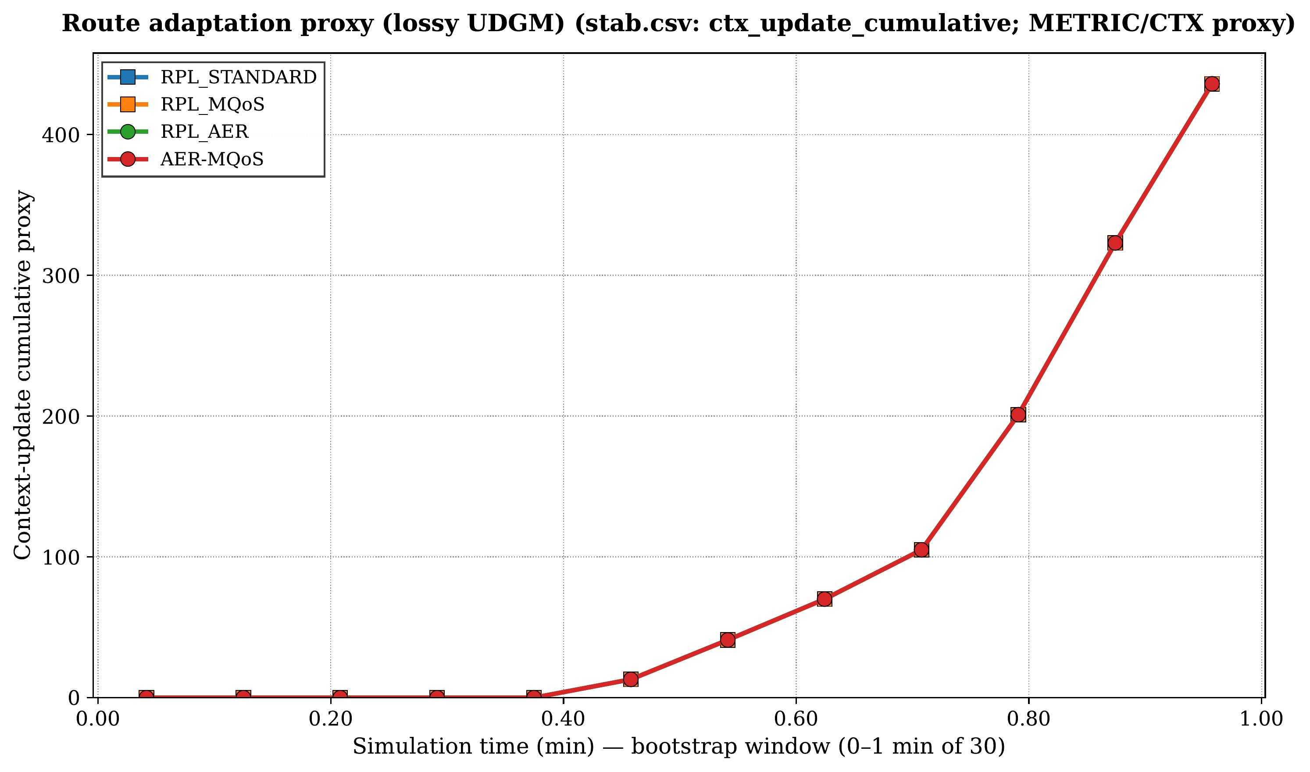
[Route-adaptation proxy: cumulative ctx_update_cumulative from stab.csv. Time axis covers the initial bootstrap window (≈0–1 min of 30 min simulation).]
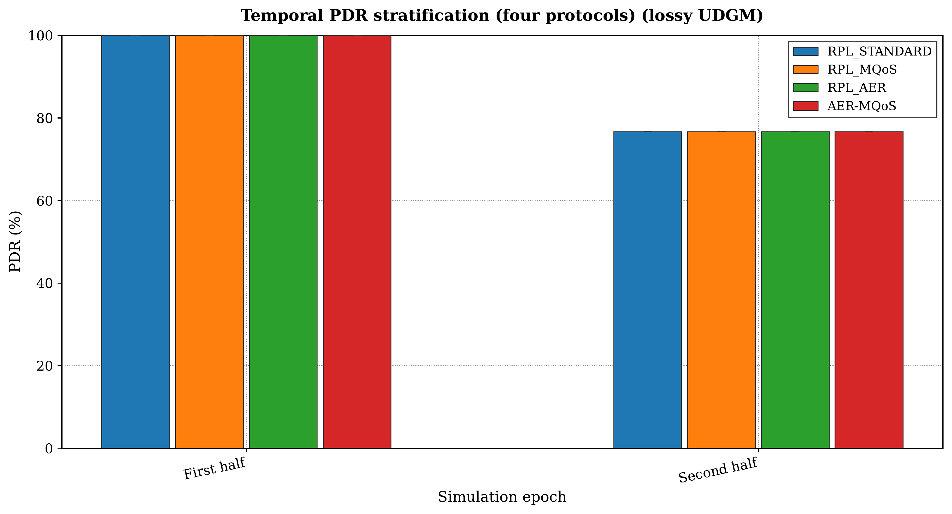
[Temporal PDR stratification over epochs from sec.csv (four firmware tags).]
Reproducibility checklist
The open repository bundles: (i) Cooja scenario files, (ii) build scripts for all four variants, (iii) log parsers emitting CSV summaries under , (iv) the figure driver under , and (v) . This checklist is designed so another research group can re-run the study without private dependencies.
To rebuild: from simulations/real, run ./run\_campaigns.sh; from Section-tex, run python3 scripts/generate\_figures\_matplotlib.py (JDK 21 for Cooja). Firmware tags map to plot labels via PROTOCOL\_CSV\_ALIASES in the figure driver script.
Conclusion and Future Work
This paper presented AER-MQoS, a context-aware multi-objective RPL extension that unifies traffic-class-aware QoS differentiation, energy awareness, and link-reliability-informed routing within a single coherent framework. The protocol introduces a Multi-Criteria Score (MCS) driven by a dynamic context coefficient γ that balances QoS responsiveness (α) and energy preservation (β) according to application domain, traffic class, and residual energy. Application-layer weighted round-robin scheduling (6{:}3{:}2{:}1) mitigates inter-class interference above UDP without modifying RPL's control plane. The MCS is coupled to MRHOF-style hysteresis through an experimental objective function (OCP 8), and a bounded Q-learning specification for online γ adjustment (15 hundredths) is documented in Section [REF] and left for future ablation.
The open-source implementation, simulation scripts, and raw CSV datasets are publicly available. Evaluation across four firmware variants on a 25-node Cooja topology (N{=}4 seeds, 1800 s) demonstrates correct four-way integration: all variants achieve >93\% PDR under lossy UDGM ({=}0.85) with per-seed ranges of 93.4–99.8\%. Per-class PDR shows preliminary signs of QoS-aware rank shaping on some seeds (AER-MQoS 95.96\% C3 vs 79.52\% C0 on seed 20260603) alongside episodic sensitivity on the same seed, confirming the need for larger-scale campaigns. The primary contribution is an open, inspectable framework that makes the QoS–energy–trust trade-off explicit at both rank-computation and packet-scheduling levels.
Limitations
This evaluation is simulation-only (Cooja/UDGM). NRE is a logical state variable, not Energest-calibrated. No adversarial attack scripts, ablations (A1–A3), or inferential tests appear in the committed dataset; per-lever contribution requires the planned campaigns of Section [REF]. Custom DIO/DAO TLVs for γ, NRE, and trust advertisement are not present in the evaluated binary (Section [REF]). The overlapping PDR ranges confirm implementation correctness at the current traffic load; higher stress scenarios are needed to expose the protocol's differentiation envelope.
Future work
The open firmware roadmap is organized in three phases. Phase I (short-term, simulation-only): scale the Cooja matrix to N{}20 seeds with Mann–Whitney confirmatory tests; execute ablations A1–A3 (WRR-off, learning-off, trust-neutral MCS); and stress-test with higher traffic loads (2 C3 rate), heterogeneous energy profiles, and lower success ratios ({}\{0.65,0.75\}). Phase II (instrumentation): Energest duty-cycle logging on Cooja to bound the gap between the NRE proxy and millijoule-scale consumption; characterize ROM/RAM footprints for MSP430-class targets (Sky, Zolertia RE-Mote). Phase III (extension): scripted Cooja attack injections (selective forwarding, rank inflation) with the trust plane active; explore standard-compliant DIO/DAO TLV extensions for γ, NRE, and trust advertisement; and conduct parameter-frozen versus learning-enabled firmware comparisons.
These phases are designed to transition AER-MQoS from an integration-focused descriptive baseline to a confirmatory, multi-evidence protocol evaluation suitable for deployment-oriented venues.
Data Availability
The source code, Cooja simulation scenarios, and measured datasets (N=4 independent seeds) used in this study are publicly available in the following GitHub repository:
Repository: https://github.com/madani-belacel/AER-MQoS
Contains: Contiki-NG firmware, simulation scripts, raw CSV data, and reproduction instructions.
Author contributions
Madani Belacel conceived the integrated protocol design, implemented the Contiki-NG firmware and evaluation scripts, coordinated the Cooja campaigns, and wrote the manuscript.
Supplementary instrumentation panels
note. Appendix panels support logging and pipeline regression only. They do not validate Q-learning (Appendix [REF]) or energy-aware routing beyond the internal NRE instrumentation reported in the main text.
Repository-only statistics (not cited)
Mann–Whitney outputs under , when present, are optional regression checks after a CSV refresh. They are not cited in this manuscript (descriptive panels only in the main text).
Learning-stratification sanity check (Fig. [REF])
. Figure [REF] does not support causal or performance claims about bounded Q-learning. Section [REF] is a design specification only.
The panel compares learning\_on strata exported from the same AER-MQoS binary (learn\_or\_load.csv). It verifies that the logging path can emit both labels; it is not an independent firmware ablation (no separate NO\_QL build). Causal evaluation requires ablation (A2) in Section [REF].
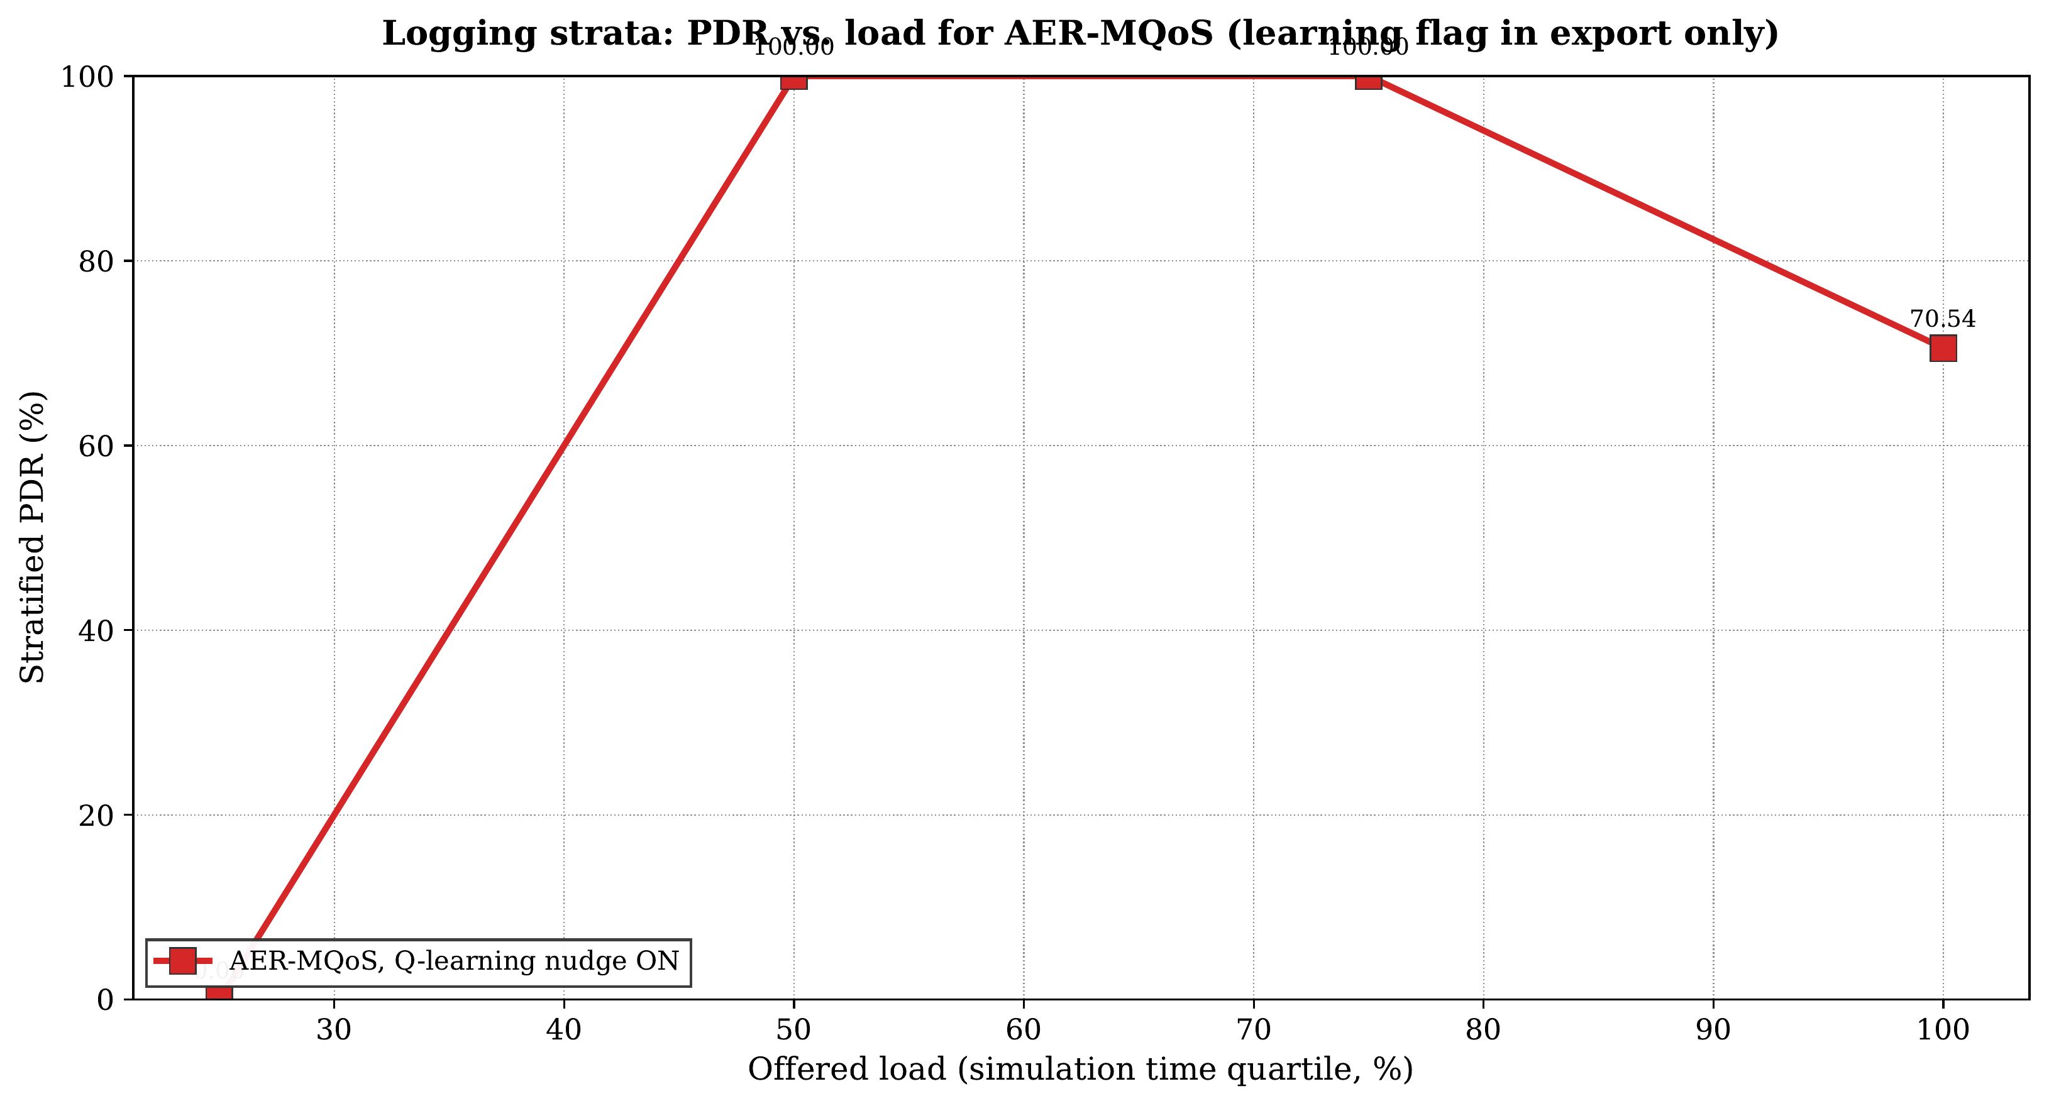
[Logging sanity check: PDR vs. offered-load quartiles for learning_on strata in learn_or_load.csv (same AER-MQoS binary; not a learning ablation). Campaign descriptive means (Table VII); per-seed variance unavailable.]
REFERENCES
[1] T. Winter et al., ``{RPL}: {IPv6} routing protocol for low-power and lossy networks,'' RFC Editor, 2012. [Online]. Available:
[2] S. Deering and R. Hinden, ``Internet protocol, version 6 ({IPv6}) specification,'' RFC Editor, 2017. [Online]. Available:
[3] G. Montenegro et al., ``Transmission of {IPv6} packets over {IEEE} 802.15.4 networks,'' RFC Editor, 2007. [Online]. Available:
[4] J. Vasseur et al., ``Routing metrics used for path calculation in low-power and lossy networks,'' RFC Editor, 2012. [Online]. Available:
[5] O. Gaddour and A. Koub{\^a}a, ``{RPL} in a nutshell: A survey,'' Computer Networks, vol. 56, no. 14, pp. 3163–3178, 2012. [Online]. Available:
[6] T. Tsao et al., ``A security threat analysis for the routing protocol for low-power and lossy networks ({RPL}),'' RFC Editor, 2015. [Online]. Available:
[7] M. Belacel, M. Belkheir, S. {Boukli Hacene}, M. Rouissat, and A. Mokaddem, ``{RPLMQoS}: An adaptive {QoS}-aware routing protocol with multi-queue prioritization for the internet of things,'' Mikrotalasna revija ({Microwave Review)}, vol. 31, no. 2, pp. 21–27, 2025. [Online]. Available:
[8] J. Nassar, M. Berthom{\'e}, J. Dubrulle, N. Gouvy, N. Mitton, and B. Quoitin, ``Multiple instances {QoS} routing in {RPL}: Application to smart grids,'' Sensors, vol. 18, no. 8, p. 2472, 2018. [Online]. Available:
[9] S. S. Solapure, H. H. Kenchannavar, and U. P. Kulkarni, ``{RPL-OFs} analysis and dynamic selection for {QoS} optimisation of {RPL} protocol,'' International Journal of Wireless and Mobile Computing, vol. 27, no. 1, pp. 25–40, 2024. [Online]. Available:
[10] A. Wakili, S. Bakkali, and A. E. H. {Alaoui}, ``Machine learning for {QoS} and security enhancement of {RPL} in {IoT}-enabled wireless sensors,'' Sensors International, vol. 5, p. 100289, 2024. [Online]. Available:
[11] M. Belacel, M. Belkheir, S. {Boukli Hacene}, M. Rouissat, and A. Mokaddem, ``{RPL-AER}: An {LSTM}-enhanced energy-aware and secure routing protocol for sustainable agricultural {IoT},'' Advances in Electrical and Electronic Engineering, 2025, early access; no DOI at time of writing. [Online]. Available: {https://advances.vsb.cz/uploads/early-access-articles/RPL-AER
[12] H. Lamaazi and N. Benamar, ``{OF-EC}: A novel energy consumption aware objective function for {RPL} based on fuzzy logic,'' Journal of Network and Computer Applications, vol. 117, pp. 42–58, 2018. [Online]. Available:
[13] A. J. D. Limjoco and N. M. C. Tiglao, ``An analytical model of energy-aware {RPL} for wireless sensor networks,'' in Proc.\ Sixth Int.\ Symp.\ Computing and Networking Workshops (CANDARW). 1em plus 0.5em minus 0.4em IEEE, 2018, pp. 298–304. [Online]. Available:
[14] Y. Wang, Y. Li, J. Lei, and F. Shang, ``Robust and energy-efficient {RPL} optimization algorithm with scalable deep reinforcement learning for {IIoT},'' Computer Networks, vol. 255, p. 110894, 2024. [Online]. Available:
[15] M. R. Poornima, H. S. Vimala, and J. Shreyas, ``Fuzzy-based novel cross-layer {RPL} objective function for energy-aware routing in {IoT},'' International Journal of Computational Intelligence Systems, vol. 18, p. 182, 2025. [Online]. Available:
[16] U. Farooq, M. Asim, N. Tariq, T. Baker, and A. I. Awad, ``Multi-mobile agent trust framework for mitigating internal attacks and augmenting {RPL} security,'' Sensors, vol. 22, no. 12, p. 4539, 2022. [Online]. Available:
[17] M. Pishdar, Y. Seifi, M. Nasiri, and M. Bag-Mohammadi, ``{PCC-RPL}: An efficient trust-based security extension for {RPL},'' Information Security Journal: A Global Perspective, vol. 31, no. 2, pp. 168–178, 2021. [Online]. Available:
[18] M. Belacel, ``La qualit\'e de service dans les r\'eseaux {IoT} bas\'es sur {RPL},'' Th\`ese de doctorat, Universit\'e Djillali Liab\`es de Sidi Bel Abb\`es, Algeria, 2026, defended 2 May 2026; synthesizes the RPLMQoS and AER-RPL lines. Author copy on request: madani.belacel@univ-mosta.dz. Institutional deposit (PNST Algeria) pending public URL.
[19] P. Thubert, ``Routing for {RPL} ({Routing Protocol for Low-Power and Lossy Networks}) {Leaves},'' RFC Editor, Apr. 2021. [Online]. Available:
[20] O. Gnawali et al., ``The minimum rank with hysteresis objective function,'' RFC Editor, 2012. [Online]. Available:
[21] I. A. Alnajjar, ``A comprehensive survey on objective functions in {RPL} routing with various networking and application scenarios,'' EAI Endorsed Transactions on Internet of Things, vol. 11, 2025, early access; volume 11 assigned at time of citation. [Online]. Available:
[22] H.-S. Kim, J. Ko, D. E. Culler, and J. Paek, ``Challenging the {IPv6} routing protocol for low-power and lossy networks ({RPL}): A survey,'' IEEE Communications Surveys \& Tutorials, vol. 19, no. 4, pp. 2502–2525, 2017. [Online]. Available:
[23] H. Lamaazi and N. Benamar, ``A comprehensive survey on enhancements and limitations of the {RPL} protocol: A focus on the objective function,'' Ad Hoc Networks, vol. 96, p. 102001, 2020. [Online]. Available:
[24] C. J. C. H. Watkins and P. Dayan, ``Q-learning,'' Machine Learning, vol. 8, no. 3–4, pp. 279–292, 1992. [Online]. Available:
[25] N. Zahedy, B. Barekatain, and A. A. Quintana, ``{RI-RPL}: A new high-quality {RPL}-based routing protocol using {Q}-learning algorithm,'' The Journal of Supercomputing, vol. 80, no. 6, pp. 7691–7749, 2024. [Online]. Available:
[26] H. C. Harish Kumar and T. G. Basavaraju, ``{DeepLight-RPL}: Context-aware adaptive {RPL} with lightweight deep learning for improving the {QoS} in industrial {IoT} application scenarios,'' International Journal of Intelligent Engineering and Systems, vol. 18, no. 5, pp. 821–844, 2025. [Online]. Available:
[27] A. Maheshwari and K. Panneerselvam, ``Optimizing {RPL} for load balancing and congestion mitigation in {IoT} network,'' Wireless Personal Communications, vol. 136, no. 3, pp. 1619–1636, 2024. [Online]. Available:
[28] A. Al-Amiedy et al., ``A systematic literature review on attacks defense mechanisms in {RPL}-based {6LoWPAN} of internet of things,'' Internet of Things, vol. 24, p. 100741, 2023. [Online]. Available:
[29] G. Oikonomou, S. Duquennoy, A. Elsts, J. Eriksson, Y. Tanaka, and N. Tsiftes, ``The {Contiki-NG} open source operating system for next generation {IoT} devices,'' SoftwareX, vol. 18, p. 101089, 2022. [Online]. Available:
[30] S. Ghosh, ``{CB-ED-RPL}: Coordinator-based energy-efficient dynamic {RPL} for {IoT} networks,'' Wireless Personal Communications, vol. 145, no. 3–4, pp. 403–422, 2023. [Online]. Available:
[31] A. A. Abujassar et al., ``A multi path routing protocol with efficient energy consumption in {IoT} applications real time traffic,'' EURASIP Journal on Wireless Communications and Networking, vol. 2024, no. 1, p. 58, 2024. [Online]. Available:
[32] F. {\"O}sterlind, A. Dunkels, J. Eriksson, N. Finne, and T. Voigt, ``Cross-level sensor network simulation with {Cooja},'' in Proceedings 31st {IEEE Conference on Local Computer Networks}. 1em plus 0.5em minus 0.4em IEEE, 2006, pp. 641–648. [Online]. Available:
[33] J. Tripathi, J. C. de Oliveira, and J. P. Vasseur, ``Performance evaluation of the routing protocol for low-power and lossy networks ({RPL}),'' RFC Editor, 2012. [Online]. Available:

