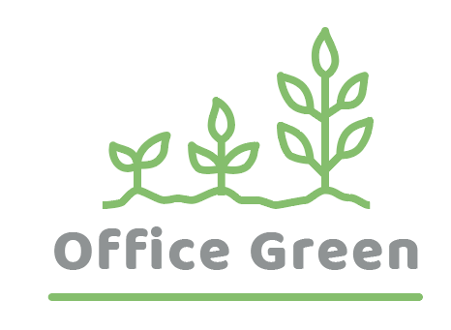
Project Plant Pals
Operations & Training Plan
August 2021

Document Status: Draft | In Review | Approved

Executive Summary:
Our plan is to offer plants that can be used inside office premises. The service is cost effective, offers low-maintenance and easy to be upgraded.

Project Goal
SMART: Specific, Measurable, Attainable, Relevant, and Time-bound
- Increase the customer base by 80% by the EOY by providing the service that meets customers’ expectations.

Deliverables
- Send free plants to every corporate organization and public sector companies to increase brand awareness.
- Send 1000 plants to 100 customers.

Business Case / Background
Why are we doing this?
- Increasing the customer base will result in the revenue by 10% EOY.

Benefits, Costs, and Budget
Benefits:
- Support new service leading to 5% revenue increase, reduce late shipments and related costs, increase customer satisfaction
- Additional benefits (optional):

Costs:
- Price of software, installation fees, time spent on hiring and training
- Additional cost areas (optional):

Budget needed:
- $75,000

Scope and Exclusion
In-Scope:
- Customer service standards, delivery processes, training protocols
- Other in-scope items (optional):

Out-of-Scope:
- Product development, vendor contracts
- Other out-of-scope items (optional):

Project Team
Project Sponsor: Director of Operations

Project Lead: Project Manager (You!)

Project Team: Fulfillment Director, Quality Assurance Tester, Inventory Manager, Financial Analyst, Human Resources Specialist, Training Manager

Additional Stakeholders: VP of Customer Success, Account Manager, Receptionist, Sales Director, Sales Team, Marketing Director, Investors

Measuring Success
What is acceptable:
- Have onboarded 100 new customers.
- Have increased sales to existing customers by 10%.

