AI-103
- AI-103: Develop generative AI apps in Azure
- Plan and prepare to develop AI solutions on Azure
https://learn.microsoft.com/en-us/training/modules/tour-azure-portal/
generative AI in particular means that developers are increasingly required to create comprehensive AI solutions. These solutions need to combine machine learning models, AI services, prompt engineering solutions, and custom code.
What is AI?:
The term "Artificial Intelligence" (AI) covers a wide range of software capabilities that enable applications to exhibit human-like behavior. AI has been around for many years, and its definition has varied as the technology and use cases associated with it have evolved.
AI solutions are built on machine learning models that encapsulate semantic relationships found in huge quantities of data; enabling applications to appear to interpret input in various formats, reason over the input data, and generate appropriate responses and predictions.

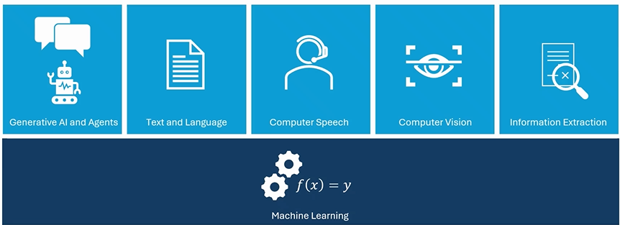
Microsoft Foundry
Microsoft Foundry is a platform for AI development on Microsoft Azure.
Microsoft Foundry provides the Microsoft Foundry portal, a web-based visual interface for working with AI projects. It also provides the Microsoft Foundry SDK, which you can use to build AI solutions programmatically.
Microsoft Foundry projects
In Microsoft Foundry, you manage the resource connections, data, code, and other elements of the AI solution in a project. Each project belongs to a single Microsoft Foundry resource in Azure, which provides compute, data storage, AI tools, and other services.
A Foundry resource can support one or more child projects, with one of them being designated the default project.
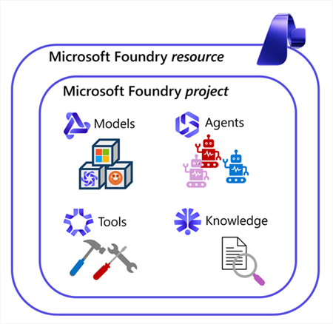
Models: Large language model (LLM) deployments based on models available in Foundry Models. You can connect to and interact with these models through the project endpoint (using Foundry-specific APIs and SDKs) and the Azure OpenAI endpoint (using OpenAI APIs and SDKs).
Agents: Named AI configurations that encapsulate an LLM, instructions, and tools to define an autonomous AI entity that can automate tasks and collaborate with users and other agents. Agents in Foundry are developed and consumed using the Microsoft Foundry Agent service through the project endpoint.
Tools: The tools used by agents can be based on built-in functionality, such as web search or a code interpreter, or connections to custom and third-party tools through Model Context Protocol (MCP) connections. Additionally, Microsoft Foundry Tools includes a suite of AI services for common tasks such as text analysis, speech recognition and synthesis, translation, and content understanding that you can use in your Foundry-based AI solutions.
The Microsoft Foundry portal
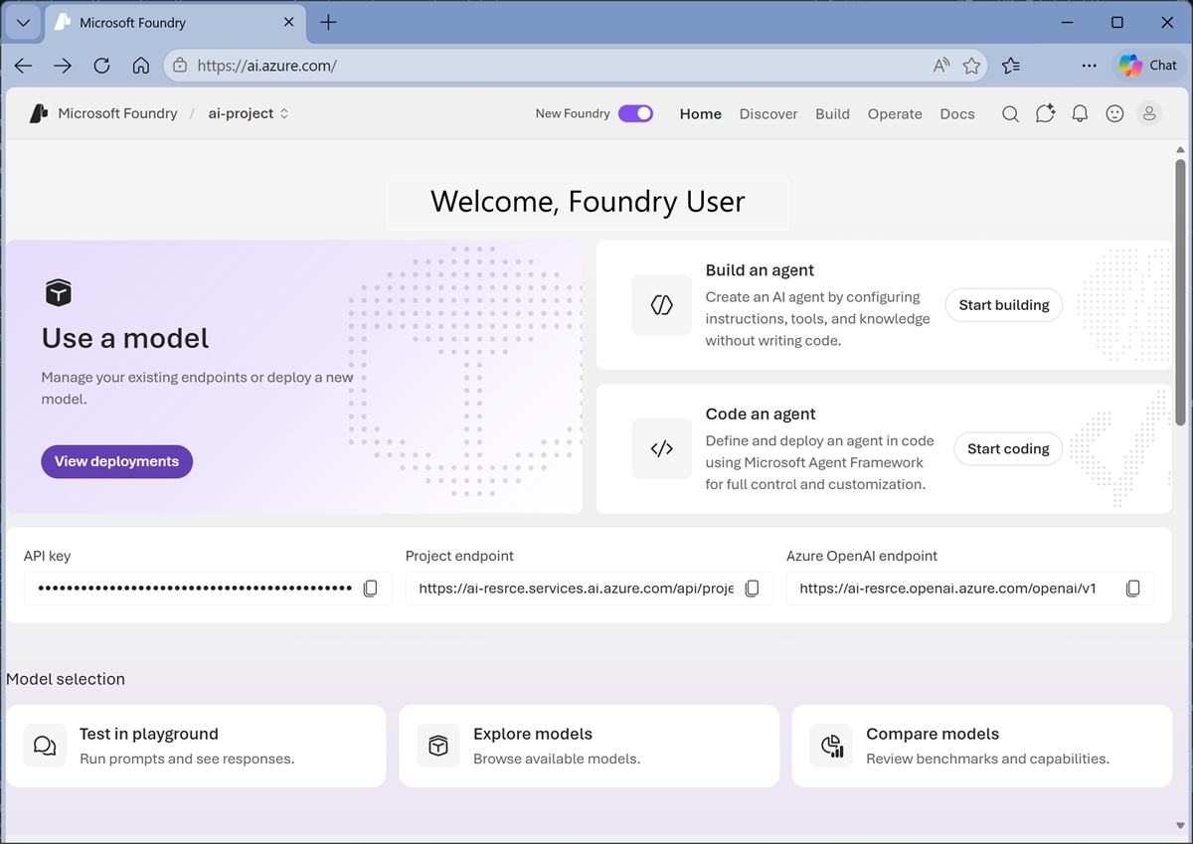
Most AI solution development projects begin in the Foundry project, where you can:
- Find, compare, deploy, and test models.
- Create and test agents.
- Create MCP connections to tools and Foundry IQ knowledge sources.
- Explore and test Microsoft Foundry tools.
- Manage resource configuration and user access.
- Find the endpoints and keys you need to access assets from client applications.

- Select, deploy, and evaluate Microsoft Foundry models
- Develop a generative AI chat app with Microsoft Foundry
- Develop generative AI apps that use tools
- Optimize generative AI model performance with Microsoft Foundry
- Implement a responsible generative AI solution in Microsoft Foundry

- Develop AI agents on Azure
- Develop natural language solutions in Azure
- Extract insights from visual data on Azure

