AZ-104
- AZ-104: Prerequisites for Azure administrators
- Manage services with the Azure portal:
https://learn.microsoft.com/en-us/training/modules/tour-azure-portal/
Azure is a cloud platform that provides the compute, storage, and networking resources needed to build cloud-hosted applications. As a new user, the Azure portal is likely to be the primary way you interact with Azure. The Azure portal lets you create and manage all your Azure resources.
Tools that are commonly used for day-to-day management and interaction include:
- Azure portal for interacting with Azure via a Graphical User Interface (GUI)
- Azure PowerShell and Azure Command-Line Interface (CLI) for command-line and automation-based interactions with Azure
- Azure Cloud Shell for a web-based command-line interface
- Azure mobile app for monitoring and managing your resources from your mobile device
Azure PowerShell:
Azure account using the command Connect-AzAccount
For example, Azure PowerShell provides the New-AzVM command that creates a virtual machine for you inside your Azure subscription.
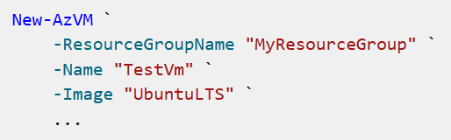
Azure CLI:
sign in to Azure using the command az login
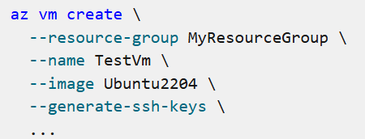
- Introduction to Azure Cloud Shell
https://learn.microsoft.com/en-us/training/modules/intro-to-azure-cloud-shell/
What is Azure Cloud Shell?
Azure Cloud Shell is a command-line environment you can access through your web browser. You can use this environment to manage Azure resources, including VMs, storage, and networking. Just like you do when using the Azure CLI or Azure PowerShell.
You can use Azure Cloud Shell to:
- Open a secure command-line session from any browser-based device.
- Interact with Azure resources without the need to install plug-ins or add-ons to your device.
- Persist files between sessions for later use.
- Use either Bash or PowerShell, whichever you prefer, to manage Azure resources.
- Edit files (such as scripts) via the Cloud Shell editor.
- Introduction to Bash
https://learn.microsoft.com/en-us/training/modules/bash-introduction/

- Introduction to PowerShell
- Deploy Azure infrastructure by using JSON ARM templates

- Manage identities and governance in Azure
- Configure and manage virtual networks for Azure administrators
- Implement and manage storage in Azure
- Deploy and manage Azure compute resources
- Monitor and back up Azure resources

