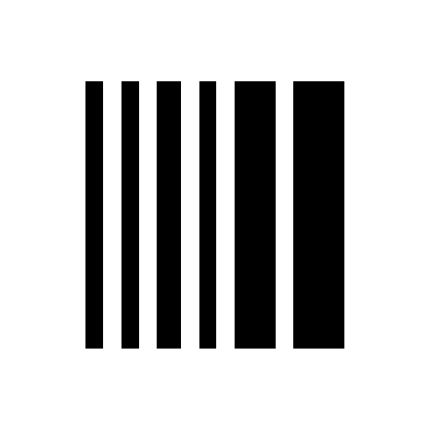
STACKBOX
WMS Core — SAP Loading Plan API
Example Payloads & Response Structures
Version 1.0 · 2026-06-29 · Audience: SAP integration team

How to call
All examples use this endpoint and headers. Every response is wrapped in a top-level “message” object; check message.ok for the business result.
POST https://wms-core.stackbox.xyz/api/method/sbx_wmslite.sap_api.receive_loading_plan
Content-Type: application/json
X-WMSLite-Key: <API_KEY>

1. Successful operations

1.1 Create a new plan
New shipment. action=upsert, resend blank.
REQUEST (body)
{
"sap_plan_id": "0080448913",
"truck_number": "WB19AA1124",
"action": "upsert",
"resend": "",
"source_plant": "1300",
"delivery_date": "2026-06-27",
"transport_description": "Lorry",
"coils": [
{"coil_barcode": "J1909A522", "weight": 564.0, "item_description": ""},
{"coil_barcode": "J1909A601", "weight": 255.0},
{"coil_barcode": "J1909A701", "weight": 480.0}
]
}
RESPONSE
HTTP 200
{ "message": {
"ok": true,
"plan": "LP-00021",
"status": "Open",
"total_coils": 3,
"summary": "3 added",
"added": ["J1909A522", "J1909A601", "J1909A701"],
"removed": [], "protected": [], "loaded_changed": [], "warnings": []
} }

1.2 Update / re-send an existing plan
Correction of an existing shipment. resend="X" is required. Coils absent from the payload that are still pending are removed; coils present are added/updated.
REQUEST (body)
{
"sap_plan_id": "0080448913",
"truck_number": "WB19AA1124",
"action": "upsert",
"resend": "X",
"coils": [
{"coil_barcode": "J1909A522", "weight": 570.0},
{"coil_barcode": "J1909A900", "weight": 410.0}
]
}
RESPONSE
HTTP 200
{ "message": {
"ok": true,
"plan": "LP-00021",
"status": "Open",
"total_coils": 2,
"summary": "1 added, 2 removed",
"added": ["J1909A900"],
"removed": ["J1909A601", "J1909A701"],
"protected": [], "loaded_changed": [], "warnings": []
} }

1.3 Cancel a plan
action=cancel. No coils needed.
REQUEST (body)
{
"sap_plan_id": "0080448913",
"truck_number": "WB19AA1124",
"action": "cancel"
}
RESPONSE
HTTP 200
{ "message": {
"ok": true,
"plan": "LP-00021",
"status": "Cancelled"
} }

2. Business responses

2.1 Duplicate shipment
An existing shipment re-sent WITHOUT resend="X". Nothing is changed.
REQUEST (body)
{
"sap_plan_id": "0080448913",
"truck_number": "WB19AA1124",
"action": "upsert",
"coils": [ {"coil_barcode": "J1909A522", "weight": 564.0} ]
}
RESPONSE
HTTP 200
{ "message": {
"ok": false,
"duplicate": true,
"error": "Duplicate shipment",
"plan": "LP-00021"
} }

2.2 Loaded-coil conflict (“Coil Already Loaded”)
Coil J1909A522 was already physically loaded; the re-send drops/changes it. The loaded coil is protected (kept unchanged) and reported; other coils are still processed.
REQUEST (body)
{
"sap_plan_id": "0080448913",
"truck_number": "WB19AA1124",
"action": "upsert",
"resend": "X",
"coils": [ {"coil_barcode": "J1909A601", "weight": 255.0} ]
}
RESPONSE
HTTP 200
{ "message": {
"ok": true,
"plan": "LP-00021",
"status": "In Progress",
"total_coils": 2,
"summary": "J1909A522 (Coil Already Loaded)",
"added": [], "removed": [],
"protected": ["J1909A522"],
"loaded_changed": [],
"warnings": ["J1909A522 (Coil Already Loaded)"]
} }

2.3 Re-send to a terminal plan (rejected)
The plan is already Completed / Completed (Short) / Cancelled. Re-sends are rejected.
REQUEST (body)
{
"sap_plan_id": "0080448913",
"truck_number": "WB19AA1124",
"action": "upsert",
"resend": "X",
"coils": [ {"coil_barcode": "J1909A522", "weight": 564.0} ]
}
RESPONSE
HTTP 200
{ "message": {
"ok": false,
"error": "Plan is Completed",
"plan": "LP-00021"
} }

3. Error responses

3.1 Invalid or missing API key
Request sent with a wrong or absent X-WMSLite-Key header.
REQUEST (body)
X-WMSLite-Key: <wrong-or-missing>
{ "sap_plan_id": "0080448913", "truck_number": "WB19AA1124", "coils": [ ... ] }
RESPONSE
HTTP 401
{ "message": {
"ok": false,
"error": "Invalid or missing X-WMSLite-Key"
} }

3.2 SAP intake disabled
Correct key, but SAP intake is switched off on the WMS Core side.
REQUEST (body)
{ "sap_plan_id": "0080448913", "truck_number": "WB19AA1124", "coils": [ ... ] }
RESPONSE
HTTP 401
{ "message": {
"ok": false,
"error": "SAP intake is disabled"
} }

3.3 Missing identifiers
Neither sap_plan_id nor truck_number supplied.
REQUEST (body)
{
"action": "upsert",
"coils": [ {"coil_barcode": "J1909A522"} ]
}
RESPONSE
HTTP 422
{ "message": {
"ok": false,
"error": "sap_plan_id or truck_number required"
} }

3.4 Malformed JSON
The request body is not valid JSON.
REQUEST (body)
{ "sap_plan_id": "0080448913", "truck_number": "WB19AA1124", "coils": [ <-- truncated / invalid
RESPONSE
HTTP 400
{ "message": {
"ok": false,
"error": "Malformed JSON body"
} }

3.5 Cancel with no matching plan
action=cancel but no plan matches the id/truck.
REQUEST (body)
{
"sap_plan_id": "UNKNOWN-999",
"truck_number": "WB00XX0000",
"action": "cancel"
}
RESPONSE
HTTP 404
{ "message": {
"ok": false,
"error": "No matching plan to cancel"
} }

