
STACKBOX
SBX WMSLite
User Training Manual
Truck Loading for Steel-Coil Dispatch

Version 1.0 · 2026-06-24
Operator (handheld) + Supervisor (console) edition

1. Introduction
SBX WMSLite is a lightweight Warehouse Management application for loading steel coils onto trucks for dispatch. It keeps the physical loading on the floor in step with SAP, so the right coils go on the right truck and stock is issued accurately.

How it works
The end-to-end flow has four stages:
- SAP sends a loading plan — the truck number and the list of coils that should go on it.
- An operator at the bay opens the truck on a handheld, scans each coil's QR, and confirms it loaded.
- When the truck is full (or completed short, with supervisor approval), the plan is marked complete.
- WMSLite posts a goods-issue confirmation back to SAP so stock is issued for the loaded coils.

Two apps, two roles
- Loading Operator — uses the handheld app (/wms-loading) to find a truck and scan/confirm coils.
- Loading Supervisor — uses the back-office console (/wms-console) to monitor progress, approve exceptions, import plans, and watch the SAP integration.

2. Getting started

Devices
- Operators use a Zebra / DataWedge handheld scanner. Scanning a barcode types the value into the focused field and submits it automatically — loading is hands-free.
- You can also use any phone or tablet browser: tap a field, type the value, and press the keyboard's Go / Done key.
- Supervisors use the console in any desktop browser.

Logging in
Open the app link and sign in with your StackBox account. Operators are taken to the loading Home screen; supervisors can open the console.
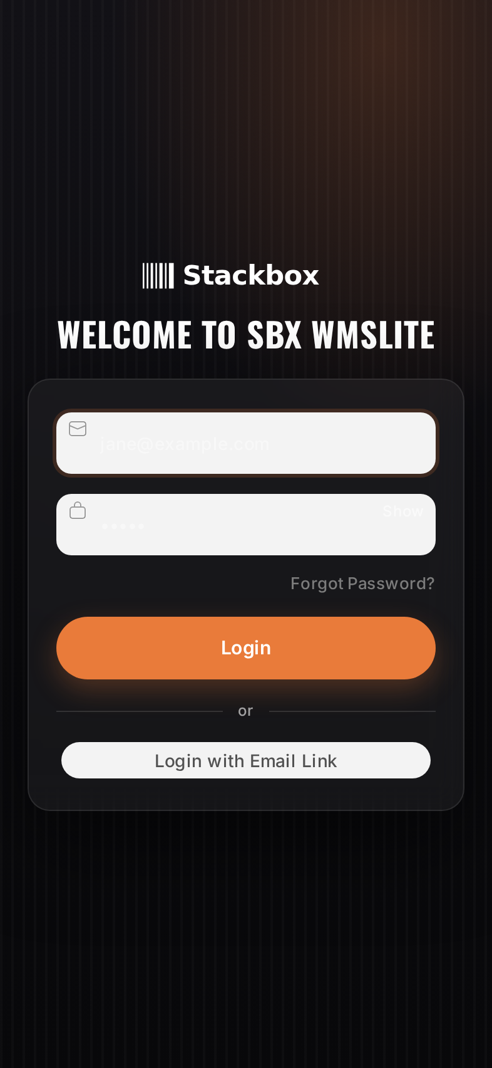
Figure 1 — Sign-in screen.

3. Operator Guide — Handheld (/wms-loading)

3.1 The Home screen
Home is your starting point. It shows, at a glance:
- Stats strip — trucks pending, trucks loaded today, and coils loaded today.
- Scan box — scan or type a truck number to jump straight in.
- To Load — trucks waiting to be loaded, oldest first. Each card shows progress and an 'in use' badge if another operator already has it.
- Loaded Today — trucks completed today (tap to review).
- Refresh (top of To Load) reloads the lists.
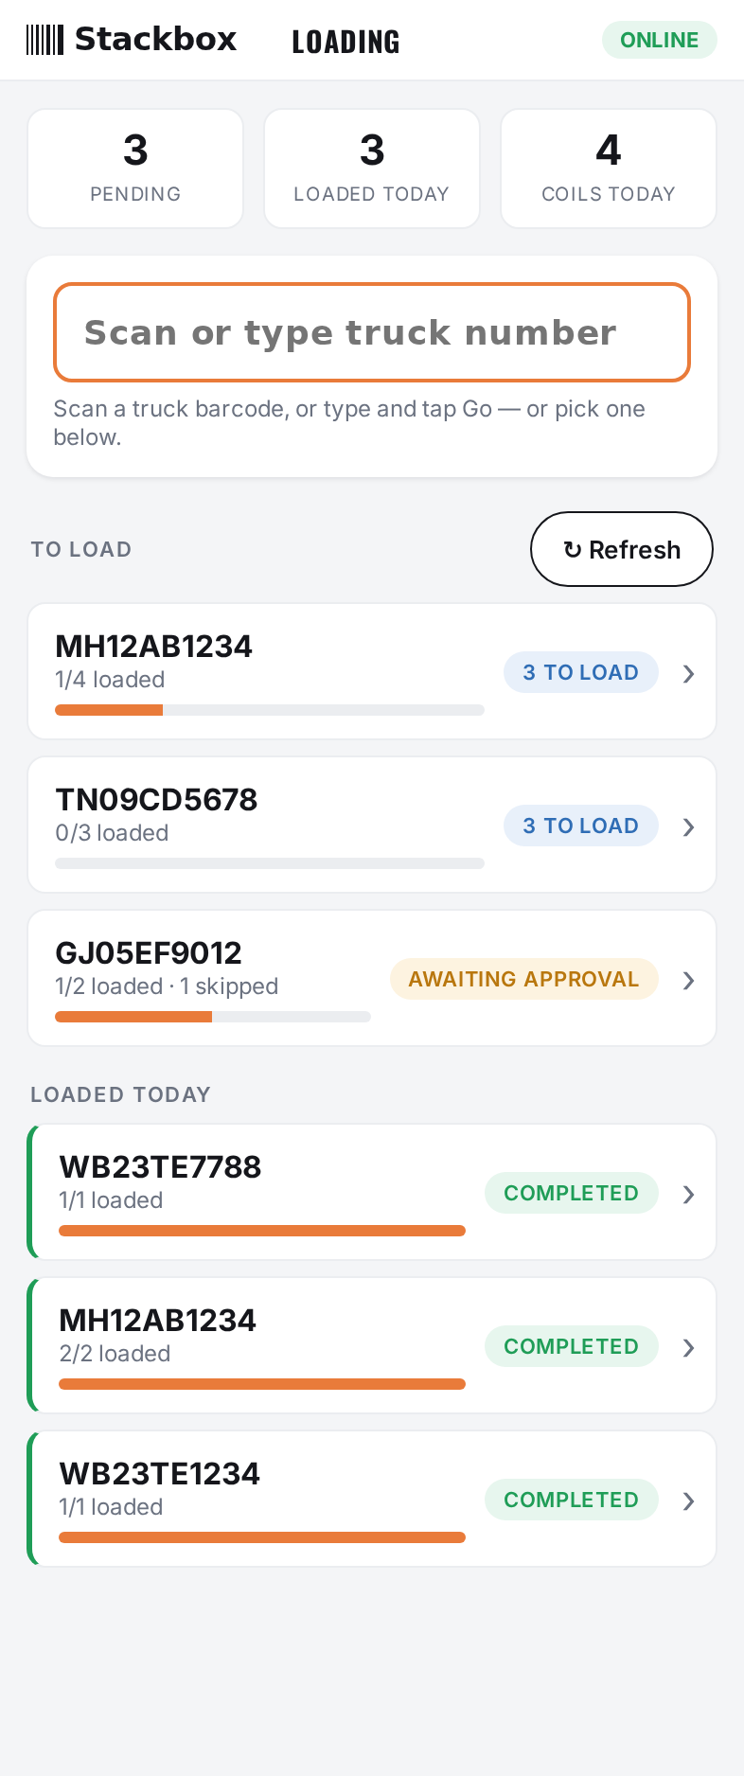
Figure 2 — Operator Home: stats, scan box, To Load and Loaded Today lists.

3.2 Selecting a truck
Two ways to start loading a truck:
- Scan the truck barcode (or type the number and press Go) in the scan box.
- Tap a truck card in the To Load list.
When you open a truck it becomes 'claimed by you' so colleagues know it is being worked. If a truck shows 'in use', another operator has it; you can take it over if needed (this is logged).

3.3 The loading screen
The loading screen shows the truck, a live count of Loaded / Pending / Skipped / Total with a progress bar, the coil scan box, and the list of coils with their status.
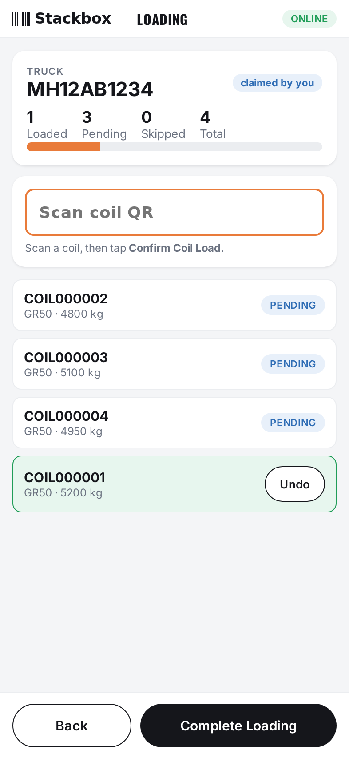
Figure 3 — Loading screen: progress, scan box, and coil list.

3.4 Loading a coil
- Scan the coil's QR (or type its code and press Go).
- A 'READY TO LOAD' panel appears with the coil's details.
- Tap Confirm Coil Load. The coil turns green (Loaded) and the counts update.
- Repeat for the next coil. The scan box stays focused.
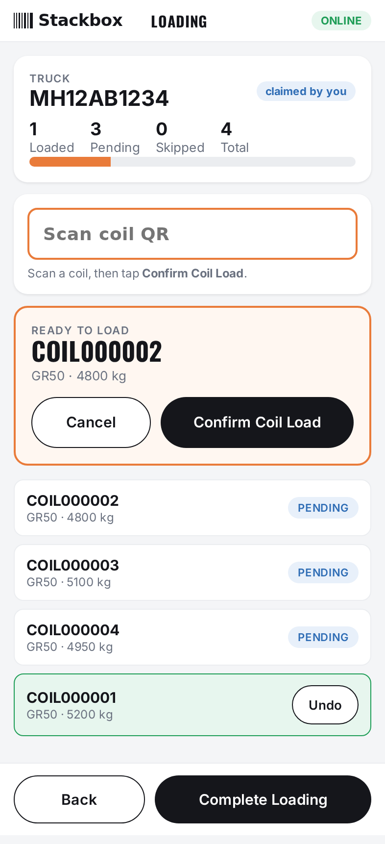
Figure 4 — After scanning, tap 'Confirm Coil Load' to load the coil.
Made a mistake? Tap Undo on a loaded coil (within a short window) to put it back to Pending.

3.5 Exceptions while scanning
- Coil not on this truck — a red banner appears; the coil is not loaded.
- Already loaded — a red banner tells you the coil is already done.
- Over-scan (coil not in the SAP plan) — if your site allows it, an amber 'Add & Load' panel lets you load it anyway; it is recorded as an unplanned load for the supervisor to see.

3.6 Completing the truck
When every coil is loaded, tap Complete Loading — the truck moves to Loaded Today and you return Home.
If some coils could not be loaded, tapping Complete Loading opens the Short-load screen: pick a reason for each missing coil (Damaged, Not Available, Quality Hold, Truck Full, Other). A supervisor then enters their PIN to approve completion. This requires a connection.
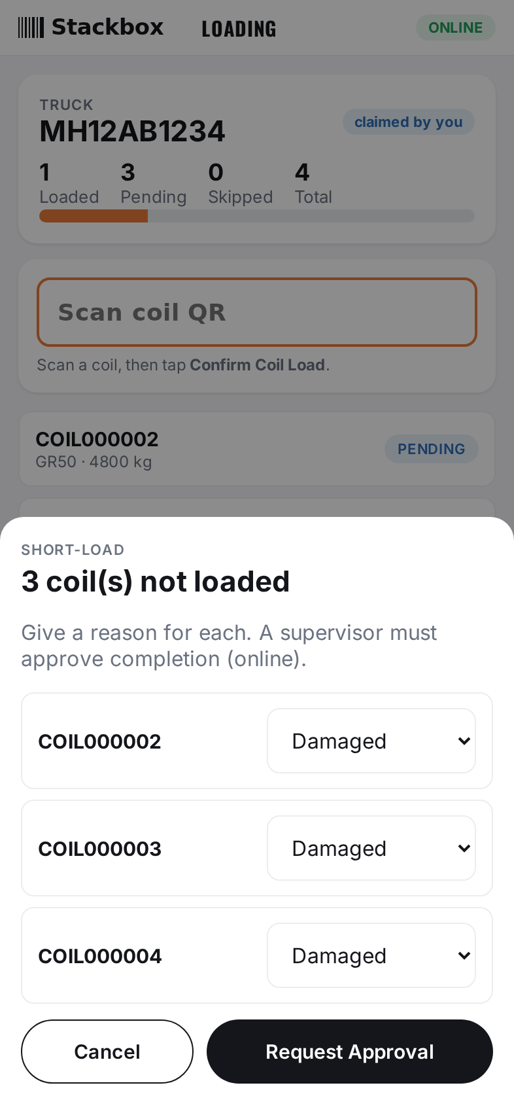
Figure 5 — Short-load: give a reason for each coil not loaded; a supervisor approves.

3.7 Reviewing a loaded truck
From Home, tap any truck under Loaded Today to see a read-only summary — which coils were loaded, who loaded them, any skipped coils, and the SAP goods-issue status.
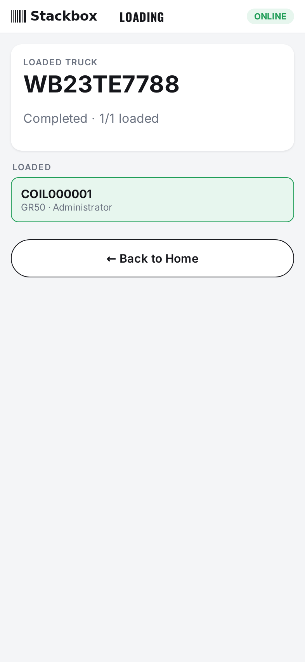
Figure 6 — Read-only summary of a completed truck.

3.8 Working offline
The handheld keeps working without signal. Your scans are saved on the device and a badge shows how many are queued; they sync automatically when the connection returns. Note: short-load approval needs a connection (the supervisor PIN is checked online).

4. Supervisor Guide — Console (/wms-console)

4.1 Dashboard
The dashboard separates two kinds of numbers:
- NOW tiles (Open/Active, Awaiting Approval, GI Awaiting Release, GI Failed) always show the current situation, regardless of the date range.
- THROUGHPUT tiles (Completed, Coils Loaded, Rejects) and the progress bar follow the From/To date range (default: last 7 days).
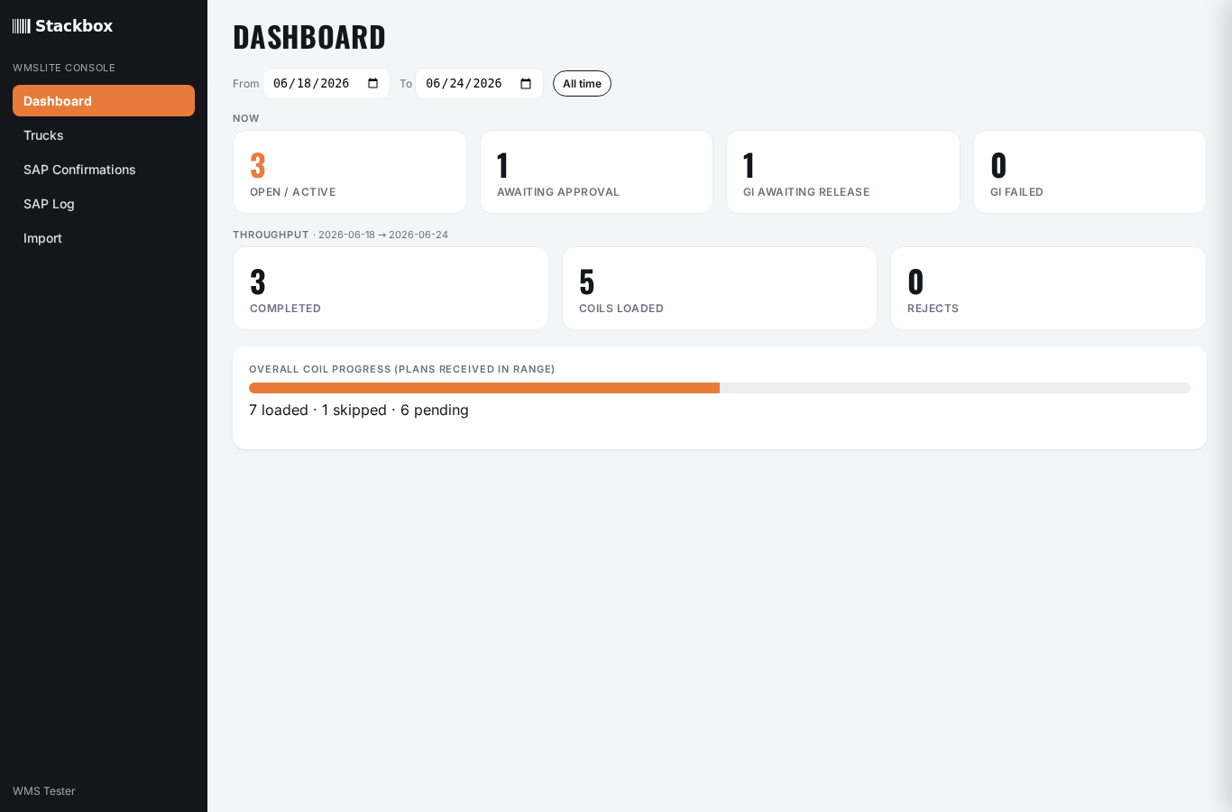
Figure 7 — Console dashboard with date range, live and throughput tiles.

4.2 Trucks & drill-down
The Trucks page lists every loading plan with status, GI status and progress; filter by status, search, or date range. Click a truck to open its drawer — coils with who/when, the full event history, and Cancel / Reopen actions.
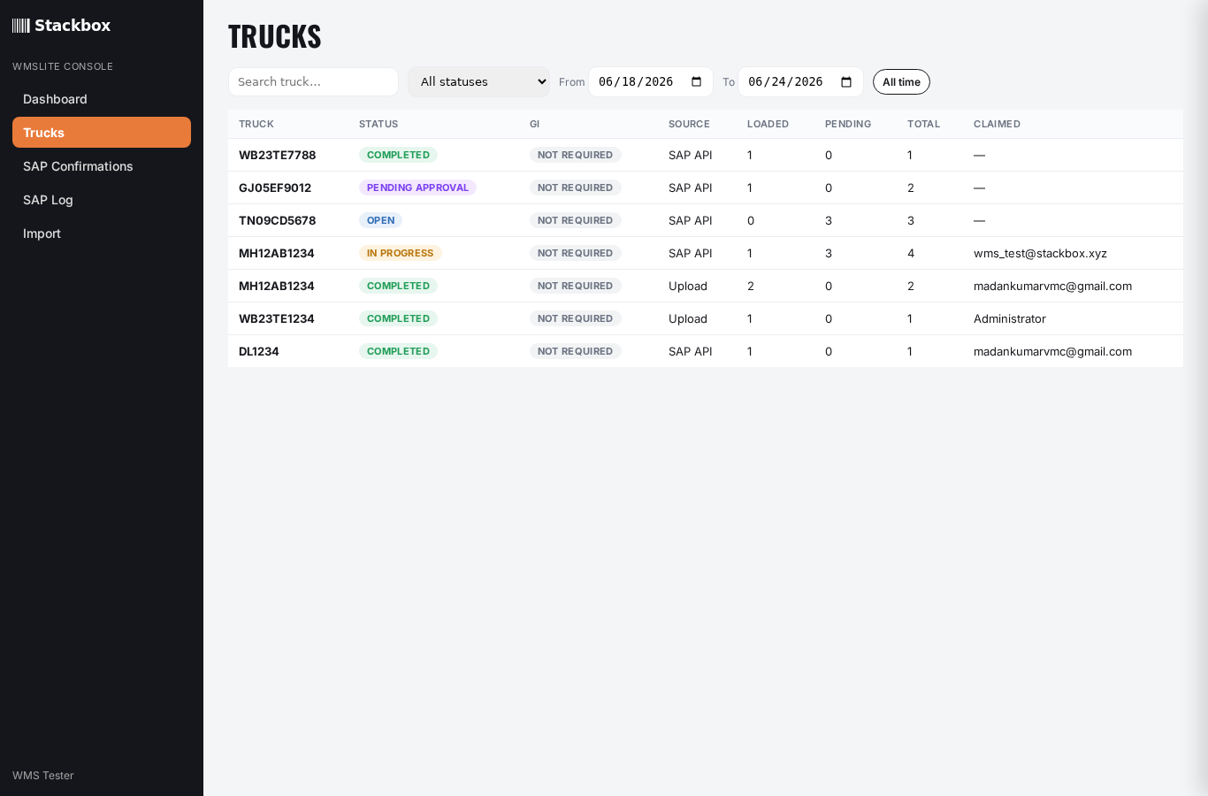
Figure 8 — Trucks list with status, GI and progress columns.
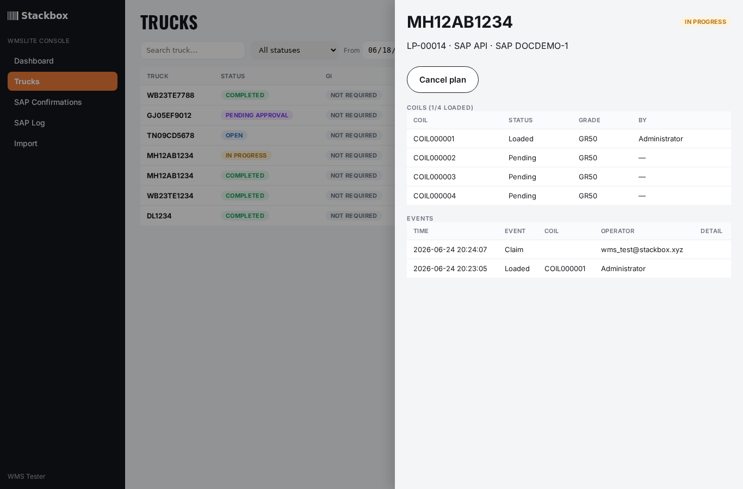
Figure 9 — Truck drill-down: coils and the event audit trail.

4.3 SAP Confirmations (goods issue)
Each completed truck raises a goods-issue confirmation to SAP. This view shows its status and lets you act:
- Release — send a short-load confirmation that was held for review.
- Retry — resend a confirmation that failed (e.g. SAP was down). Transient failures also retry automatically.
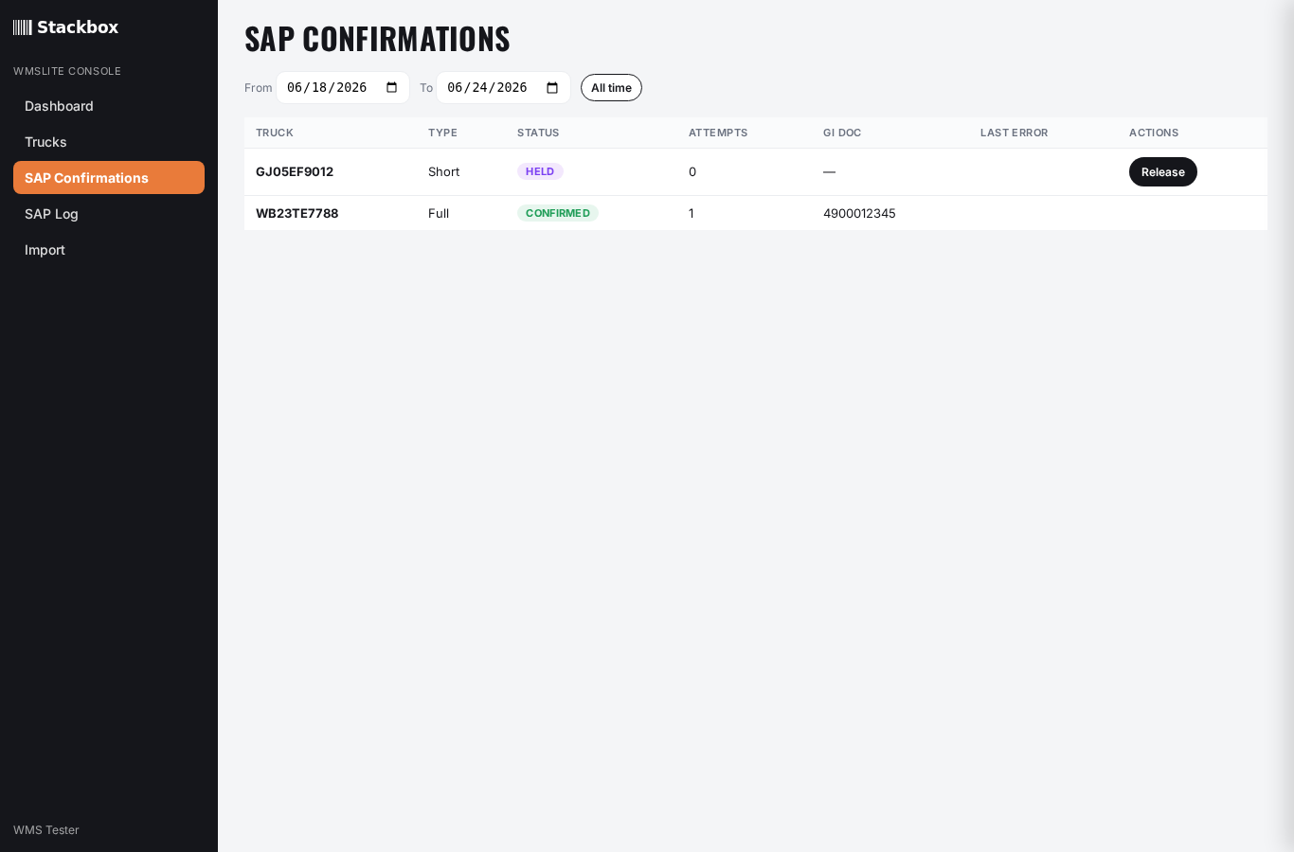
Figure 10 — SAP Confirmations with Release / Retry actions.

4.4 SAP Log
A complete record of every SAP message — inbound loading plans and outbound goods-issue calls — with result and detail. Filter by direction and date to investigate the integration.
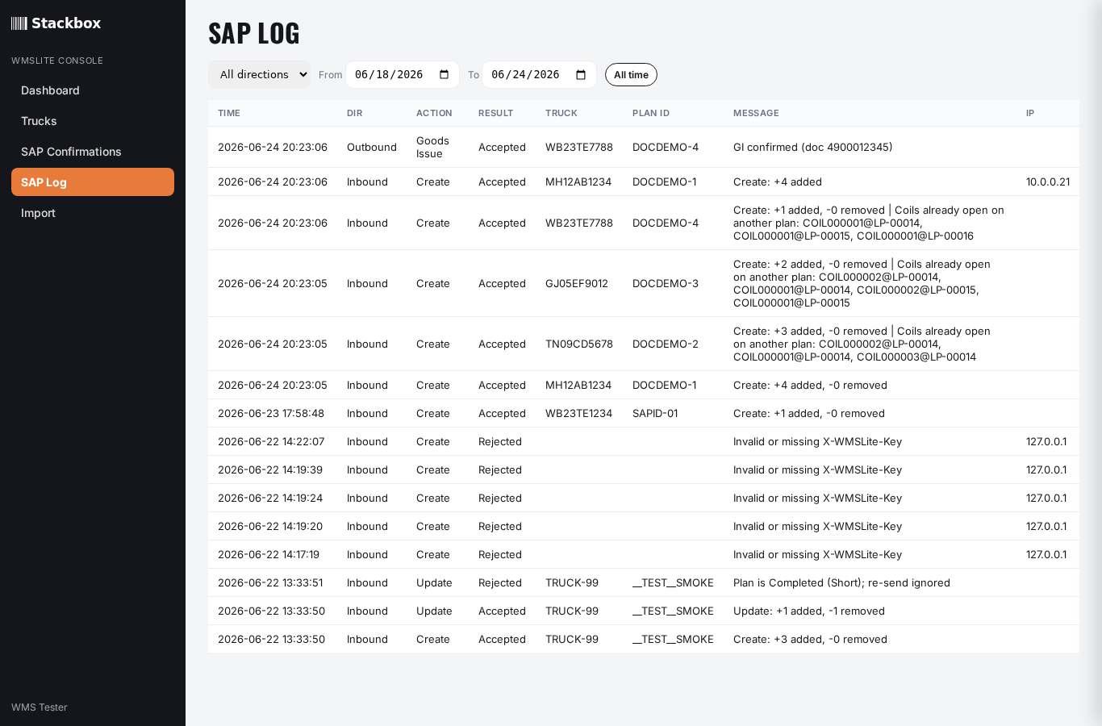
Figure 11 — SAP Log (inbound + outbound).

4.5 Importing loading plans (upload fallback)
If SAP is not pushing plans yet, you can upload them. Click Download template for a CSV with the correct columns (truck_number and coil_barcode are required; sap_plan_id, material_grade, weight are optional — one row per coil). Fill it in, upload, map the columns, preview, and commit.
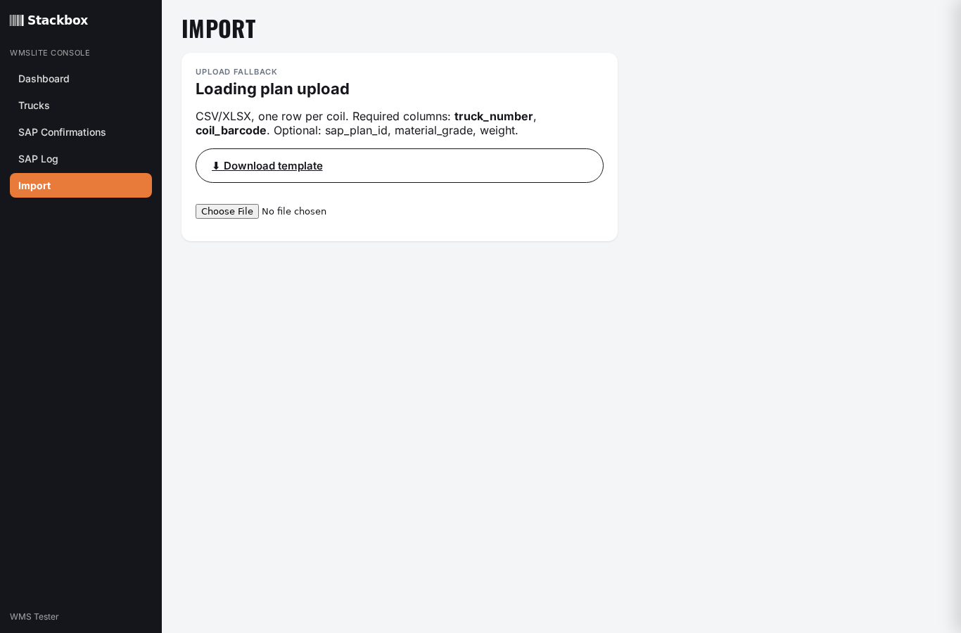
Figure 12 — Import: download the template, then upload a loading plan.

4.6 Settings overview
WMSLite Settings (admin) controls the integration and floor rules: the SAP push API key, the coil QR decode rule, whether over-scan is allowed, the undo window, the supervisor approval PIN, and the outbound goods-issue connection (OAuth credentials + endpoint).

5. Troubleshooting & FAQ
I scanned a coil but nothing happened on my phone.
Make sure the coil scan box is focused (tap it), then press the keyboard's Go/Done key after typing, or use the handheld scanner which submits automatically.
The coil says 'not on this truck'.
It belongs to a different truck's plan, or the code was misread — re-scan. If it genuinely must go on this truck and over-scan is enabled, use Add & Load.
A truck shows 'in use'.
Another operator has claimed it. Coordinate with them, or take it over (this is logged).
I can't complete the truck — coils are still pending.
Either load them, or use Complete Loading to start a short-load: give a reason per missing coil and have a supervisor approve with their PIN (needs a connection).
A goods issue shows Failed in the console.
If it's a transient error it retries automatically; otherwise click Retry. A 'Business' failure usually means SAP rejected the data — check the message and the coils.
I lost signal mid-load.
Keep scanning — work is saved on the device and syncs when you reconnect. The queued badge shows pending items.

6. Glossary
Loading Plan — A truck and the coils that should be loaded on it, from SAP or an upload.
Coil — A steel coil identified by a barcode/QR; the unit that gets loaded.
Claim — Marking a truck as being worked by you, so others don't load it at the same time.
Short-load — Completing a truck with some coils not loaded, each with a reason; needs supervisor approval.
Over-scan / Unplanned — Loading a coil that wasn't in the SAP plan; recorded for review.
Goods Issue (GI) — The SAP confirmation that stock has left the warehouse for the loaded coils.
Held — A goods-issue confirmation waiting for a supervisor to release it.
Reject — A scan that was refused (wrong truck / already loaded / unknown coil), recorded for audit.

