Index

|  |  |  |
| --- | --- | --- |
| **Chapter Nos.** | **Chapter Name** | **Page Nos.** |
| 01 | Introduction   * Software Introduction * Introduction to SQL Server * Existing System * Problem in Existing System * Needs for Computerizations |  |
| 02. | Proposed System   * Proposed System * Hardware and Software Specifications * Feasibility Study * Fact Finding Techniques |  |
| 03. | Analysis   * Nomenclature( ERD, DFD symbols) * Entity Relationship Diagram * Data Flow Diagram |  |
| 04. | System Design   * Data Element Dictionary * Table Design * Program Specification * Menu Design * Input Screen Design |  |
| 05. | Testing Procedures |  |
| 06. | Output Screen |  |
| 07. | Implementation Procedure |  |
| 08. | User Manual |  |
| 09. | Scope for Future Enhancement |  |
| 10. | Conclusions |  |
| 11. | Bibliography |  |

***Introduction***

***To***

***System***

**Introduction**

The “**Bus Management System”** project was designed for Karad Bus Depot, to provide an Application developed in JAVA to automate the management procedures in Karad Bus Depot. The main aim of the project is to provide an effective working platform to computerize the whole Karad Bus Depot. This project has been designed in such a way that it suits to all other cities Bus Depot. It assists the gas depots in recording the name, address and other information of regular customers in any type of gas depot.

It will help to adding, modifying and viewing records. It will help the use to check booking records, Customer information without referring various manual pages. This system will act as a service oriented system. Cost effective and readily available system that provides dynamic and wide Varity of business logic is needed.

It will provide various management information reports. The system mainly proves beneficial to manager as it is analysis friendly. In other words user can generate various reports and analyze the figure related with total Customer, stock,billing details, etc.

The main aim of developing this Bus Management System

based application is to manage the HP gas agency companies. The main advantage is to provide better solution to the customers who wants gas immediately and reduces the man power and cost. Here users can ask and book gas through this Vb project and all users information can be stored at the back end MS access server, here admin has all rights to view, open and give access to all customers. This Project was done in three months under the guidance of our college computer science professors.

***Existing***

***System***

**Existing system**

***The Existing System is –***

* The existing system is manual system. Needs to be converted into automated system.
* In the existing system all the documents are not contain any paper work which is handled there is no chance of getting documents corrupted.
* There are many drawbacks of the existing system such as requirement of large number of human resource and papers along with higher chance of losing data and tearing books.
* Less Security.
* It is not reliable.
* Existing system is a time consuming.
* Accuracy not guaranteed.

***drawbackis –***

* As the system totally manually it is difficult to receive a Customer ,bookingrecords,billing record that’s why it was consume his lot of time.
* A computerized management system is required.
* All records stores in pages while spend out of time and human power.
* It is difficult to get a quick reference in registers

***The Solution of these Problem -***

The development of the new system contains the following activities, which try to automate the entire process keeping in view of the database integration approach.

* User friendliness is provided in the application with various controls.
* The system makes the overall project management much easier and flexible.
* There is no risk of data mismanagement at any level while the project development is under process.
* It provides high level of security with different level of authentication.
* Users from any part of the world can make use of the system.
* New system will process accurate results.
* New system will be much better in performance as compared to existing one.

***Proposed***

***System***

**Proposed System**

The front-end development tool was JAVA which allows visualization to build the Bus Management System. The back-end code was done with fully object-oriented. The JAVA is easy-to-use and efficient.

The back-end database development tool used was MySQL Server. It is able to handle large amounts of data while maintaining data integrity and provides a number of senior management and data distribution functions. These two development tools are powerful, and a good interface for development.

***Features of The System –***

The Features & easy to manage for this project are:**-**

* The System is user friendly.
* Cost effective,Back up support,Secured Data.
* The coding language is JAVA which is easy to understand which follows the C/C++ language syntax .
* The forms are designed in MDI form Computerized System.

***Objectives of The System –***

The Objectives for this project are:**-**

* Maintains various master information related to depot such as Employee Information, Route Information, Bus Information, Ticket Charges Information etc.
* It allows booking your ticket, maintaining bus schedules, Driver duties, Employee Salary etc.
* Provide all reports which contain Employee Details, Booking details, Bus details and also daily updates to the admin.

***scope of The System –***

* The provided system cannot be used to calculate profit loss report as there are many other things have to be considered in calculating the profit loss report.
* The target user for this system is the only Admin of the Gas management system.
* The system helps to overcome data redundancy and it also saves time.

***System***

***Analysis***

**Fact Finding Techniques**

A key part of feasibility is gathering information about the present system. The analyst knows what information to gather to make of it.

***questionnaries :-***

It allows analyst to collect information from a group of individuals who may or may not be using the system thus resulting some times in irrelevant data & data redundancy.

***interviews :-***

Analysts use interview to collect information from individuals who they consider should be the sources, who are current users of the existing system. The analyst should have a face conversation with the users & administrator of the system & fixed set of questions is prepared.

***Record review :-***

Consisting of analyzing the previous operations in the company & forecasting the new future schemes .Record include table name, date& time creation, user login etc.

***Observation :-***

If information is not collected from the other fact-finding method, then observation method is used. In this method analyst observes flow of documents, way the process is carried out steps followed person involved etc.

**Feasibility Study**

The main objective of feasibility study is to test the technical, social and economic of developing a system. This is done by investigation the existing system in the area under investigation and generation idea about the new system. Prior to the system developed a thorough study of the system is carried out involves…….

* Identification of user requirement.
* Identification how different tasks are carried out.
* Identification whether proposed system can meet the user requirement.
* Providing technical, economical, operational feasibility of the proposed system.

The details of the feasibility study are given below:-

***TECHNICAL FEASIBILITY :-***

* The system is developed by using Visual Studio 2010 which has already installed on the computer system. The machine configuration also supports the system.
* The system being user friendly, data entre & reports generation is made easy.
* Easy retrieval and access of data is provided.

***OPERATIONAL FEASIBILITY :-***

* Cost of implementation of the system as well as the installation that to consider in the operational feasibility. After implementation of the system there is need to arrange training program for users of the system.
* Expenditure for this system is also a part of this of his study.

***ECONOMIC FEASIBILITY :-***

Economical feasibility is basically a cost benefit analysis. The cost concerned is….

* The cost for system development.
* The cost of hardware, software for the system is presented economical.
* The benefit can be seen in form cost cutting due to fast working.
* The user training is also included in cost of making the software, so it is beneficial deal.

**System Requirements**

For implementing this project, NetBeans IDE and MySQL Server database used as a s/w platform.

***Software Requirement :-***

* **Operating System :** Windows 7/8/10
* **Front End ( IDE & Tool)** : NetBeans IDE and JDK 1.8
* **Back End :** MySQL Server

***Hardware Requirement :-***

* **Processor :** Pentium IV (and above)
* **RAM :**  Min 2GB RAM
* **Hard Disk :** 256 GB (or more)
* **Other Equipment :** Printer, KeyBorad, Mouse ,etc.

**Introduction**

**to**

**JAVA & MySQL Server**

**Introduction to Software**

**Front End :**

* **Introduction to visual Basic .NET**

Visual Basic .NET is multi Paradigm, high level programing language, implemented on the .NET framework. Microsoft launched VB. NET in 2002 as the successor to its original visual basic language. It is an object oriented computer programming language. It has full acess to all the libraries in the .NET Framework. It also possible to run VB.NET programs on Mono, The open source alternative to .NET, not only under windows, but even Linux or Mac OSX.

Microsoft integrated Development (IDE) for developing in Visual Basic .NET languages is Visual Studio. Most of Visual Studio editions are commercial; the only exceptions are Visual studio expresses and Visual Studio community which are freeware. In edition, .Net framework SDK includes a freeware command –line complier vbc.exe. Mono also includes a command-line VB.Net compiler.

Features of VB.NET

* Boolean condition
* Standard Library
* Automatic garbage collect
* Assembly versioning
* Properties and events
* Delegates and Event Management
* Easy to Use Generics
* Conditional compilation
* Indexs
* Simple Multithreading

**Back End :**

* **Introduction to SQL Server**

SQL Server introduces “Studio” to help you with development and Management task: SQL server Management Studio and Businesses intelligence development studio. In Management Studio, you develop and manage SQL Server database Engine and notification solutions, Manage deployed analysis services solutions, Manage and run integration services packages, and manage report server and reporting services report and report model. In BI development studio, businesses Intelligence solution using analysis services. Projects develop cubes, dimensions and mining structures; The report model project to define models for reports; and integration services project to create packages.

Both of these studios are closely integrated with Microsoft Visual Studio And the Microsoft Office system. SQL Server 2005 provides the graphical tools you need to design, develop, deploy & administrator relational databases, analytic objects, data transformation packages, replication topologies, reporting servers & reports, and notification. Additional, SQL server includes command prompt utilities to perform administrative tasks from the command prompt.

***System Design***

**Entity Relationship Diagram(ERD)**

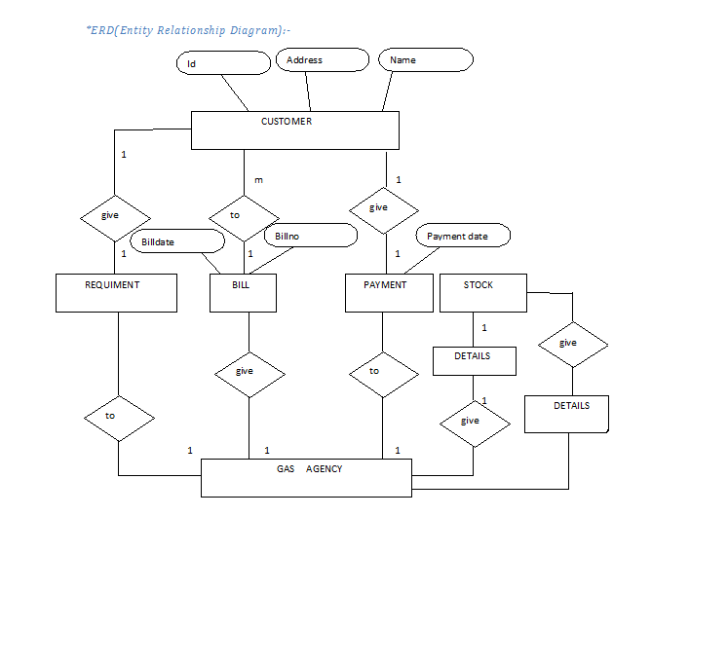

**Data Flow Diagram(DFD)**

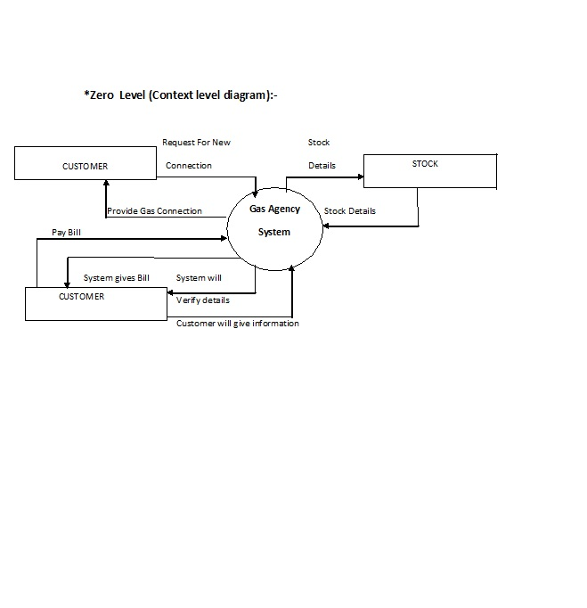

**Context Level Diagram(Zero Level)**

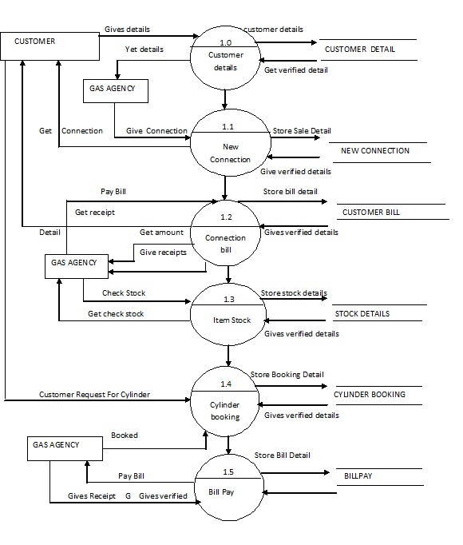

***Data Dictionary***

**Data Dictionary**

* **Bill Table:**

|  |  |  |
| --- | --- | --- |
| **ColumnName** | **DataType** | **Description** |
| BillNo | INT | To Store BillNo.(PK) |
| BillDate | DATE | To Store BillDate |
| CustNo | INT | To Store CustNo |
| Shipping | VARCHAR (200) | To Store Shipping |
| BillTotal | NUMERIC (10, 2) | To Store BillTotal |
| Disc | DECIMAL (4, 2) | To Store Disc |
| NetAmt | DECIMAL (10, 2) | To Store NetAmt |

* **Billitem Table:**

|  |  |  |
| --- | --- | --- |
| **ColumnName** | **DataType** | **Description** |
| BillNo | INT | To Store BillNo.(PK) |
| ItemNo | INT | To Store ItemNo |
| Rate | DECIMAL (10, 2) | To Store Rate |
| Qty | INT | To Store Qty |
| Disc | DECIMAL (4, 2) | To Store Disc |
| Total | DECIMAL (10, 2) | To Store Total |

* Change Table:

|  |  |  |
| --- | --- | --- |
| **ColumnName** | **DataType** | **Description** |
| UserName | VARCHAR (50) | To Store UserName.(PK) |
| OldPassword | VARCHAR (50) | To Store OldPassword. |
| NewPassword | VARCHAR (50) | To Store NewPassword. |
| ConfirmPassword | VARCHAR (50) | To Store ConfirmPassword. |

**Book Table:**

|  |  |  |
| --- | --- | --- |
| **ColumnName** | **DataType** | **Description** |
| BookingNo | INT | To Store BookingNo.(PK) |
| BookingDate | DATE | To Store BookingDate. |
| ConsumerNo | INT | To Store ConsumerNo. |
| CustomerName | VARCHAR (50) | To Store Customer Name. |
| Address | VARCHAR (50) | To Store Address. |
| PhoneNo | VARCHAR (50) | To Store PhoneNo. |
| ConnectionType | VARCHAR (50) | To Store ConnectionType. |

* **ConnectionBill Table:**

|  |  |  |
| --- | --- | --- |
| **ColumnName** | **DataType** | **Description** |
| BillNo | INT | To Store BillNo.(PK) |
| BillDate | DATE | To Store BillDate |
| ConsumerNo | INT | To Store ConsumerNo. |
| CustomerName | VARCHAR (50) | To Store Customer Name. |
| TotalAmount | INT | To Store TotalAmount. |

* **ConnectionBillList Table**

|  |  |  |
| --- | --- | --- |
| **ColumnName** | **DataType** | **Description** |
| BillNo | INT | To Store BillNo.(PK) |
| BillDate | DATE | To Store BillDate |
| ConsumerNo | INT | To Store ConsumerNo. |
| CustomerName | VARCHAR (50) | To Store Customer Name. |
| TotalAmount | INT | To Store TotalAmount. |

* **ConnectionList Table:**

|  |  |  |
| --- | --- | --- |
| **ColumnName** | **DataType** | **Description** |
| ConsumerNo | INT | To Store ConsumerNo(PK). |
| CustomerName | VARCHAR (50) | To Store CustomerName. |
| Address | VARCHAR (50) | To Store Address |
| Mobile | VARCHAR (50) | To Store Mobile |
| NoOfCylinder | INT | To Store NoOfCylinder |

* **Customer Table:**

|  |  |  |
| --- | --- | --- |
| **ColumnName** | **DataType** | **Description** |
| CustNo | INT | To Store CustNo(PK). |
| Name | VARCHAR (50) | To Store Name. |
| Address | VARCHAR (50) | To Store Address |
| Mobile | VARCHAR (50) | To Store Mobile |
| AccBalance | DECIMAL (10, 2) | To Store AccBalance |

* **CylinderBooking Table:**

|  |  |  |
| --- | --- | --- |
| **ColumnName** | **DataType** | **Description** |
| BookingNo | INT | To Store BookingNo.(PK) |
| BookingDate | DATE | To Store BookingDate. |
| SelectConsumerNo | INT | To Store SelectConsumerNo. |
| CustomerName | VARCHAR (50) | To Store CustomerName. |
| Address | VARCHAR (50) | To Store Address. |
| PhoneNo | VARCHAR (50) | To Store PhoneNo. |
| ConnectionType | VARCHAR (50) | To Store ConnectionType. |
| Status | VARCHAR (50) | To Store Status. |

* **CylinderDelivery Table:**

|  |  |  |
| --- | --- | --- |
| **ColumnName** | **DataType** | **Description** |
| BookingNo | INT | To Store BookingNo.(PK) |
| DateOfBooking | DATE | To Store DateOfBooking . |
| DateOfDelivery | DATE | To Store DateOfDelivery . |
| ConsumerNo | INT | To Store ConsumerNo . |
| CustomerName | VARCHAR (50) | To Store CustomerName . |
| Address | VARCHAR (50) | To Store Address. |
| PhoneNo | VARCHAR (50) | To Store PhoneNo. |
| ConnectionType | VARCHAR (50) | To Store ConnectionType . |
| Status | VARCHAR (50) | To Store Status . |
| Charge | INT | To Store Charge . |

* **Item Table:**

|  |  |  |
| --- | --- | --- |
| **ColumnName** | **DataType** | **Description** |
| ItemNo | INT | To Store ItemNo.(PK) |
| ItemName | VARCHAR (30) | To Store ItemName. |
| ItemRate | DECIMAL (10, 2) | To Store ItemRate. |
| Qty | INT | To Store Qty. |

* **Login Table:**

|  |  |  |
| --- | --- | --- |
| **ColumnName** | **DataType** | **Description** |
| UserName | VARCHAR (30) | To Store UserName.(PK) |
| Password | VARCHAR (30) | To Store Password. |

* **PKS Table:**

|  |  |  |
| --- | --- | --- |
| **ColumnName** | **DataType** | **Description** |
| CSNo | INT | To Store CsNo.(PK) |

|  |  |  |
| --- | --- | --- |
| **ColumnName** | **DataType** | **Description** |
| Commercial | VARCHAR (50) | To Store Commercial .(PK) |
| Domestic | VARCHAR (50) | To Store Domestic. |

* **SetPrice Table:**
* **Stock Table:**

|  |  |  |
| --- | --- | --- |
| **ColumnName** | **DataType** | **Description** |
| Commercial | VARCHAR (50) | To Store Commercial .(PK) |
| Domestic | VARCHAR (50) | To Store Domestic. |

* **Change Table:**

|  |  |  |
| --- | --- | --- |
| **ColumnName** | **DataType** | **Description** |
| UserName | VARCHAR (30) | To Store UserName.(PK) |
| Password | VARCHAR (30) | To Store Password. |

* **Terminate Table:**

|  |  |  |
| --- | --- | --- |
| **ColumnName** | **DataType** | **Description** |
| TerminateNo | INT | To Store TerminateNo .(PK) |
| TerminateDate | DATE | To Store TerminateNoDate |
| SelectConsumerNo | INT | To Store SelectConsumerNo |
| CustomerName | VARCHAR (50) | To Store CustomerName |
| ConnectionType | VARCHAR (50) | To Store ConnectionType |
| NoOfCylinder | INT | To Store NoOfCylinder |
| RefundableDeposit | VARCHAR (50) | To Store RefundableDeposit |

* **Transfer Table:**

|  |  |  |
| --- | --- | --- |
| **ColumnName** | **DataType** | **Description** |
| TransferNo | INT | To Store TerminateNo .(PK) |
| TransferDate | DATE | To Store TerminateNoDate |
| TransferTo |  |  |
| SelectConsumerNo | INT | To Store SelectConsumerNo |
| CustomerName | VARCHAR (50) | To Store CustomerName |
| ConnectionType | VARCHAR (50) | To Store ConnectionType |
| Declaration | VARCHAR (50) | To Store NoOfCylinder |
| Reason | VARCHAR (50) | To Store RefundableDeposit |

* **newconnection Table:**

|  |  |  |
| --- | --- | --- |
| **ColumnName** | **DataType** | **Description** |
| CustomerNo | INT | To Store CustomerNo .(PK) |
| Name | VARCHAR (50) | To Store Name. |
| Mobile | VARCHAR (50) | To Store Mobile. |
| DateOfBirth | DATE | To Store DateOfBirth. |
| FamilySize | VARCHAR (50) | To Store FamilySize . |
| CustomerType | VARCHAR (50) | To Store CustomerType . |
| Address | VARCHAR (50) | To Store Address. |
| NameOfBank | VARCHAR (50) | To Store NameOfBank. |
| Branch | VARCHAR (50) | To Store Branch. |
| AccountNo | INT | To Store AccountNo. |
| Document | VARCHAR (50) | To Store Document . |
| RationCardNo | INT | To Store RationCardNo. |
| AdharCardNo | VARCHAR (50) | To Store AdharCardNo. |
| NumberOfCylinder | INT | To Store NumberOfCylinder. |
| RegulatorNo | INT | To Store RegulatorNo . |
| CsNo | INT | To Store CsNoRegulatorNo . |
| Deposite | INT | To Store Deposite. |
| ConnectionDate | DATE | To Store ConnectionDate. |
| Photo | IMAGE | To Store Photo. |

|  |  |  |
| --- | --- | --- |
| **ColumnName** | **DataType** | **Description** |
| BillNo | INT | To Store BillNo.(PK) |
| ConsumerNo | INT | To Store ConsumerNo . |
| BillDate | DATE | To Store BillDate . |
| Name | VARCHAR (50) | To Store Name . |
| NoOfCylinder | INT | To Store NoOfCylinder . |
| CylinderDeposit | INT | To Store CylinderDeposit . |
| Depreciation | VARCHAR (50) | To Store Depreciation . |
| HotePlate | VARCHAR (50) | To Store HotePlate. |
| WithoutHotePlate | VARCHAR (50) | To Store WithoutHotePlate . |
| Installation | VARCHAR (50) | To Store Installation . |
| PassBook | VARCHAR (50) | To Store PassBook . |
| CylinderCharges | INT | To Store CylinderCharges . |
| lighter | INT | To Store lighter . |
| Tube | INT | To Store Tube . |
| ADMCharge | INT | To Store ADMCharge. |
| LPG | INT | To Store LPGConsumerNo . |
| CommertialLPG | INT | To Store CommertialLPG . |
| Stamp | VARCHAR (50) | To Store Stamp . |
| TotalAmount | INT | To Store TotalAmount . |
| PaidAmount | INT | To Store PaidAmount. |

* **NewConnectionCharge Table:**
* **NewConnectionBill:**

|  |  |  |
| --- | --- | --- |
| **ColumnName** | **DataType** | **Description** |
| CylinderDeposit | INT | To Store CylinderDeposit . |
| Depreciation | VARCHAR (50) | To Store Depreciation . |
| HotePlate | VARCHAR (50) | To Store HotePlate. |
| WithoutHotePlate | VARCHAR (50) | To Store WithoutHotePlate . |
| Installation | VARCHAR (50) | To Store Installation . |
| PassBook | VARCHAR (50) | To Store PassBook . |
| lighter | INT | To Store lighter . |
| Tube | INT | To Store Tube . |
| ADMCharge | INT | To Store ADMCharge. |
| LPG | INT | To Store LPGConsumerNo . |
| CommertialLPG | INT | To Store CommertialLPG . |
| Stamp | VARCHAR (50) | To Store Stamp . |

***Input & output screen***

**Splash Form:**



**Login Form:**

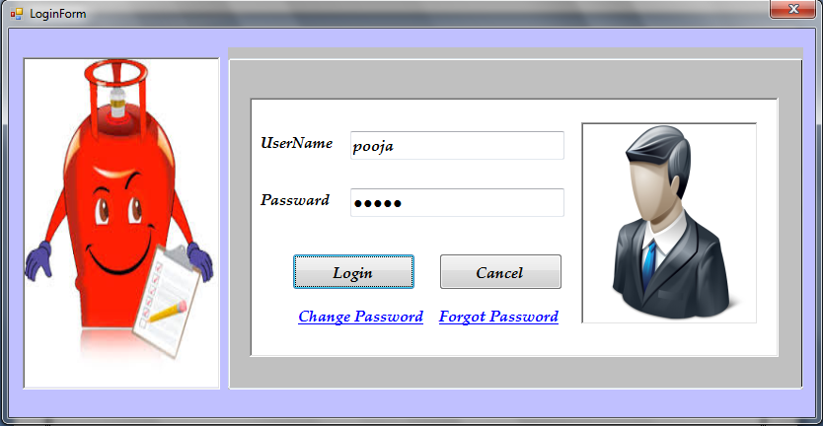

**Main Form:**

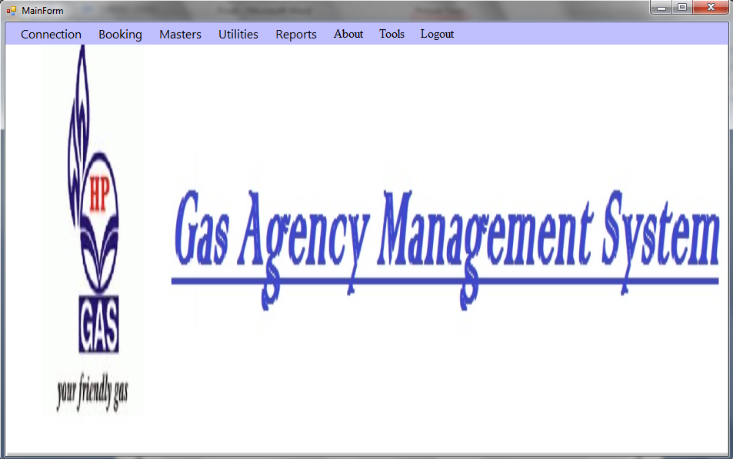

New Connection Form :

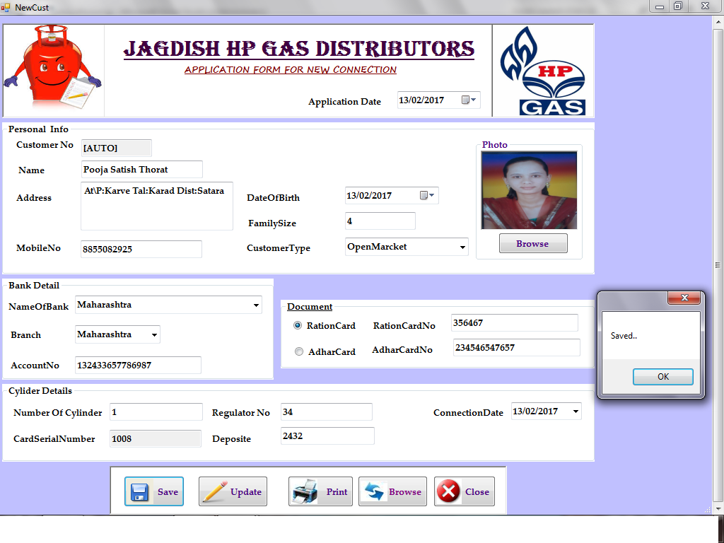

New Connection Form :

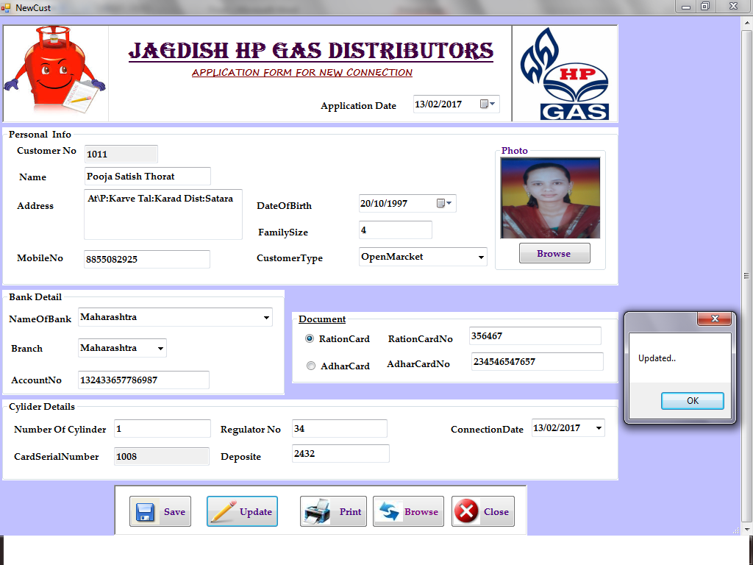

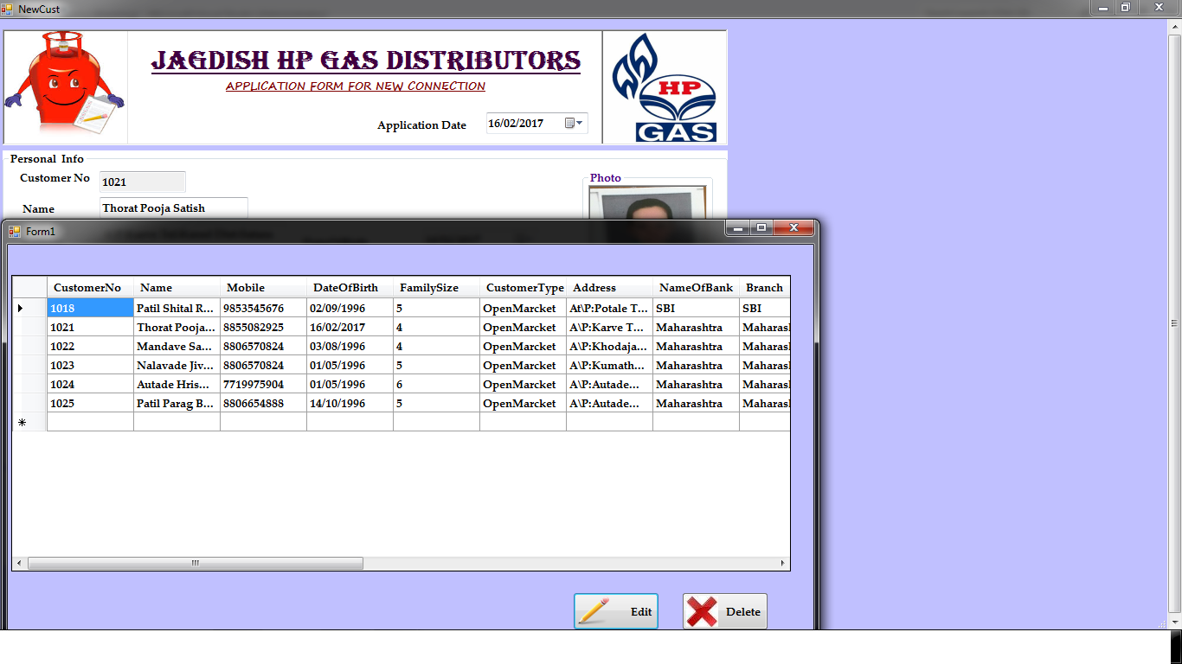New Connection Charge Form :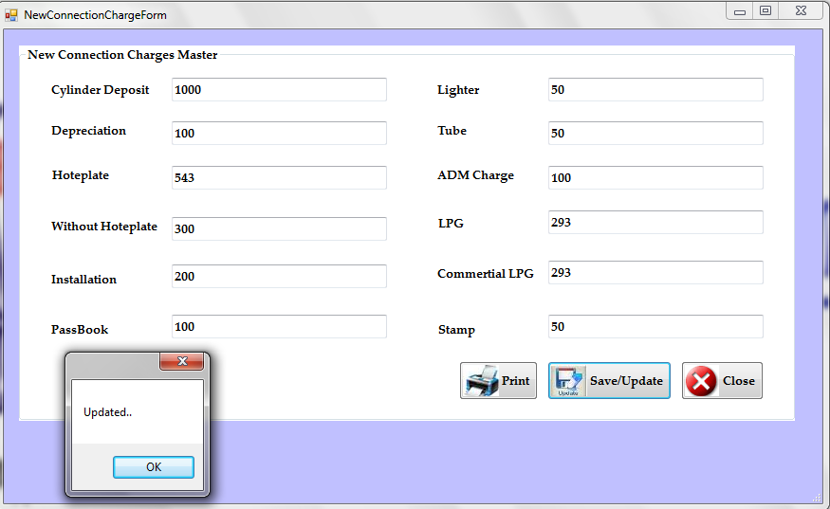

New Connection List Form:

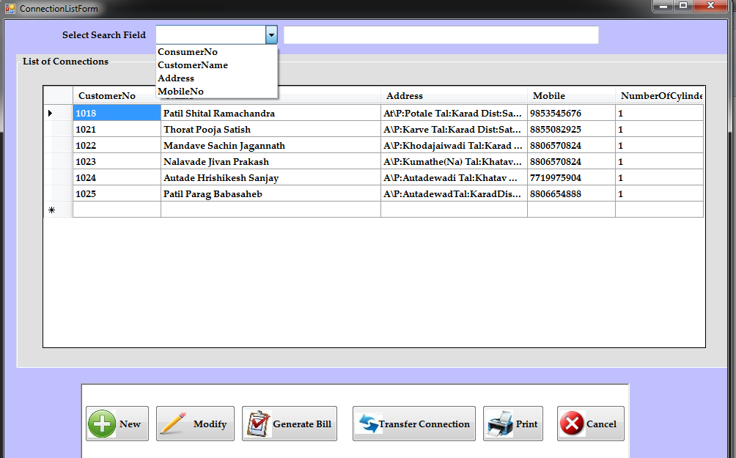

New Connection Bill Form:

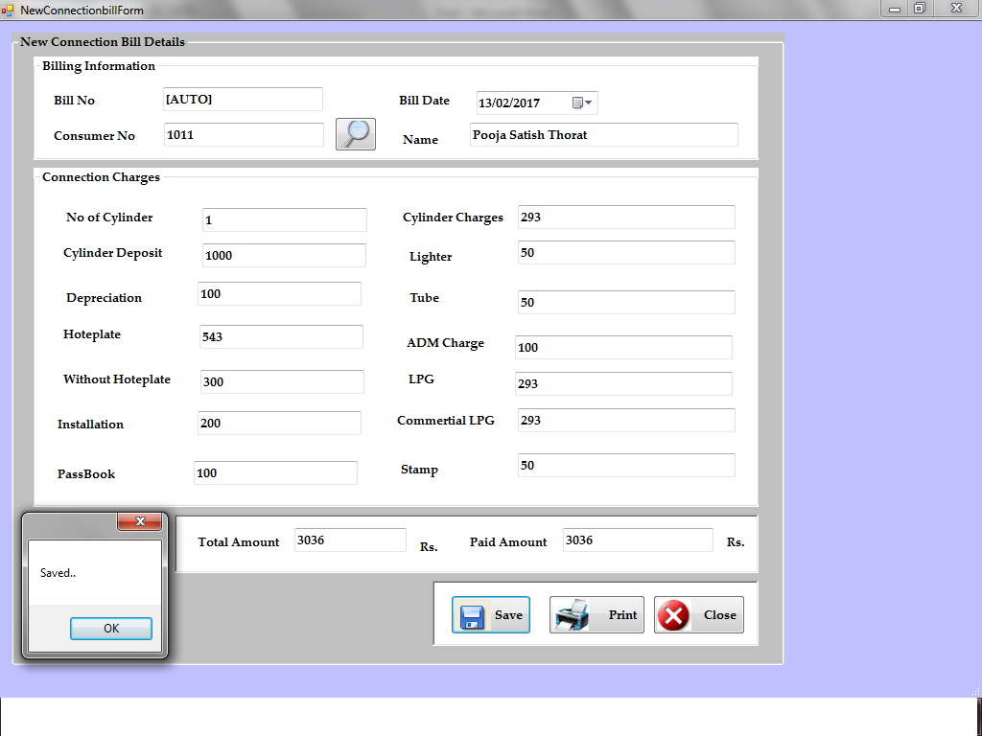

Connection Bill List Form:

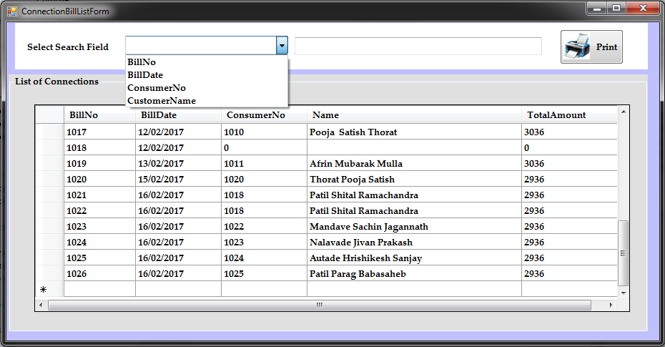

Terminate Connection Form:

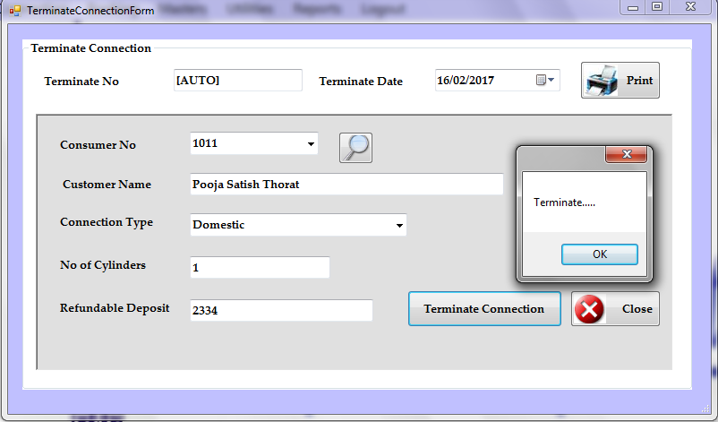**Transfer Connection Form:**

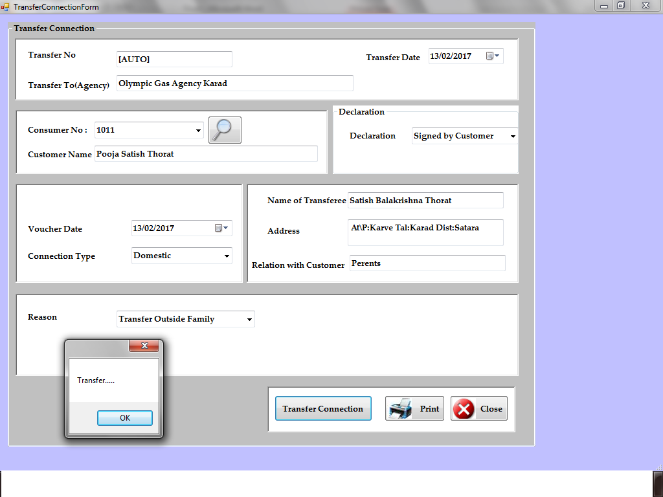

**Cylinder Booking Form:**

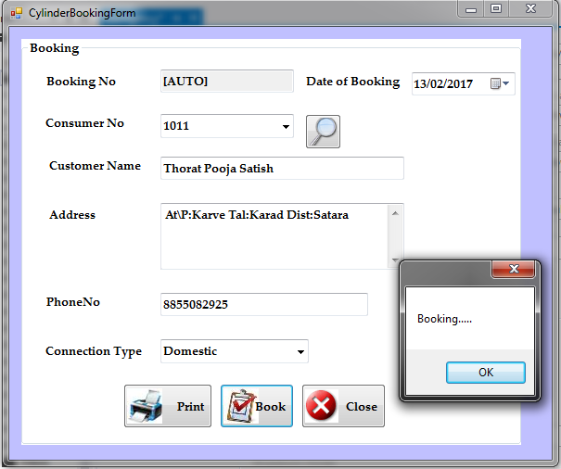

**New BillForm:**

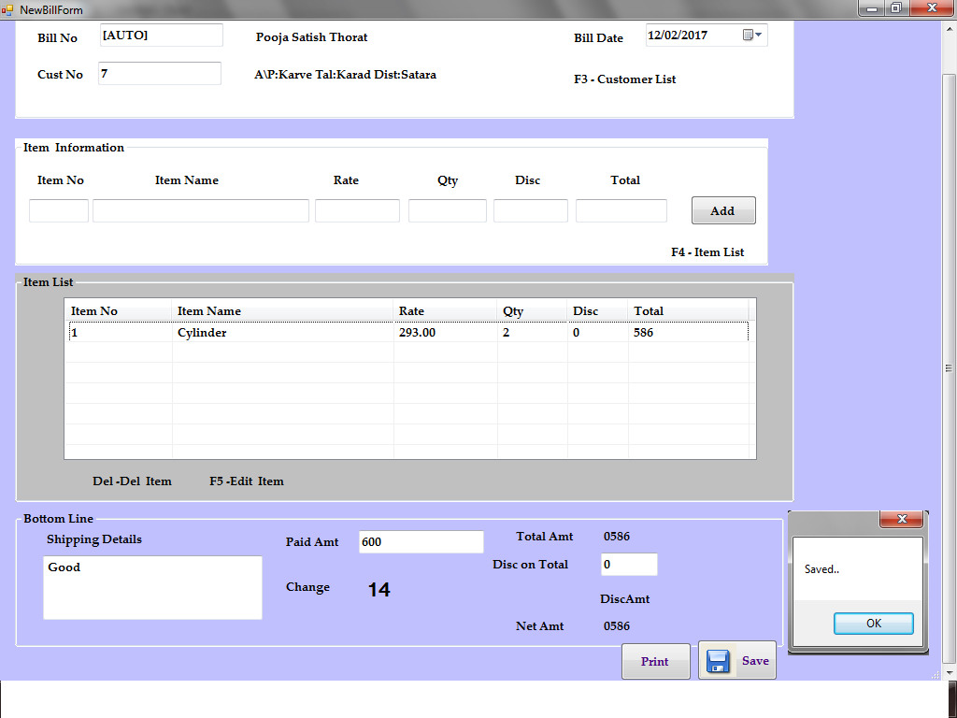

**Bill List Form:**

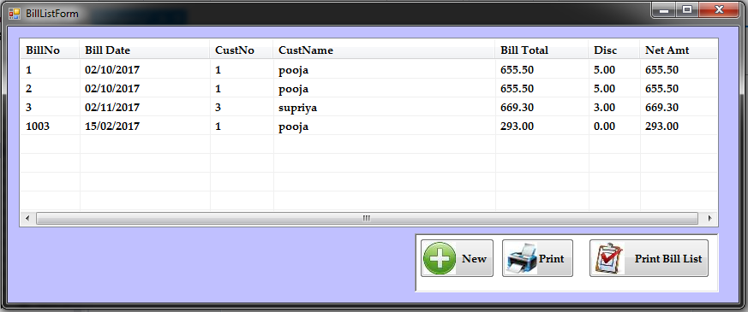

**Set Get Stock Of Cylinder Form:**

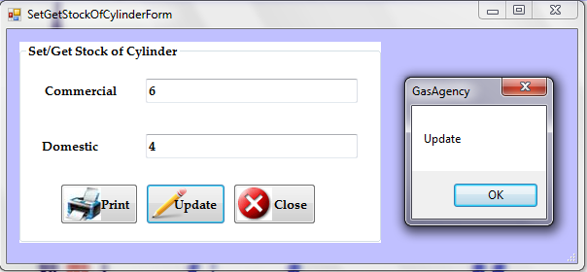

**Set Price Form:**

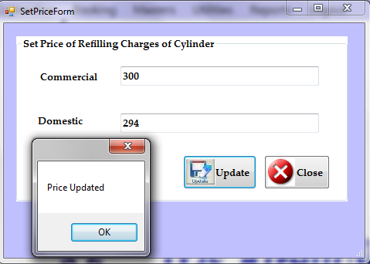

**Change Password Form:**

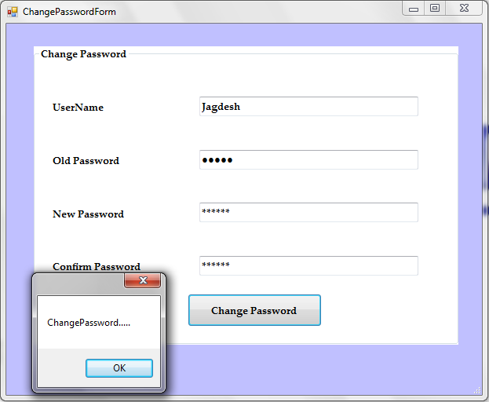

**Item Form:**

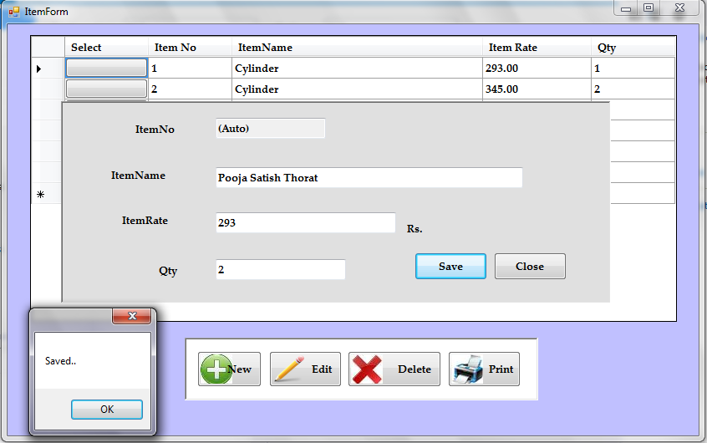

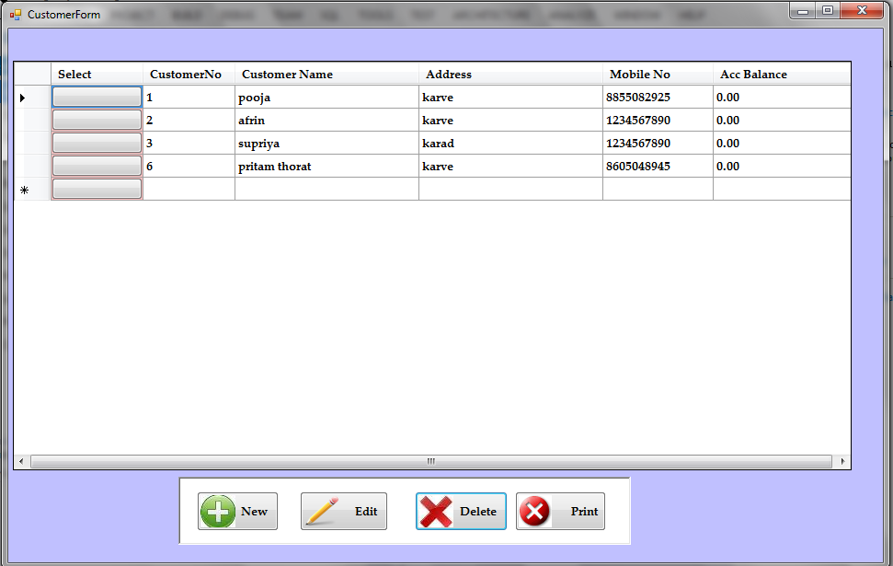

**Customer Form:**

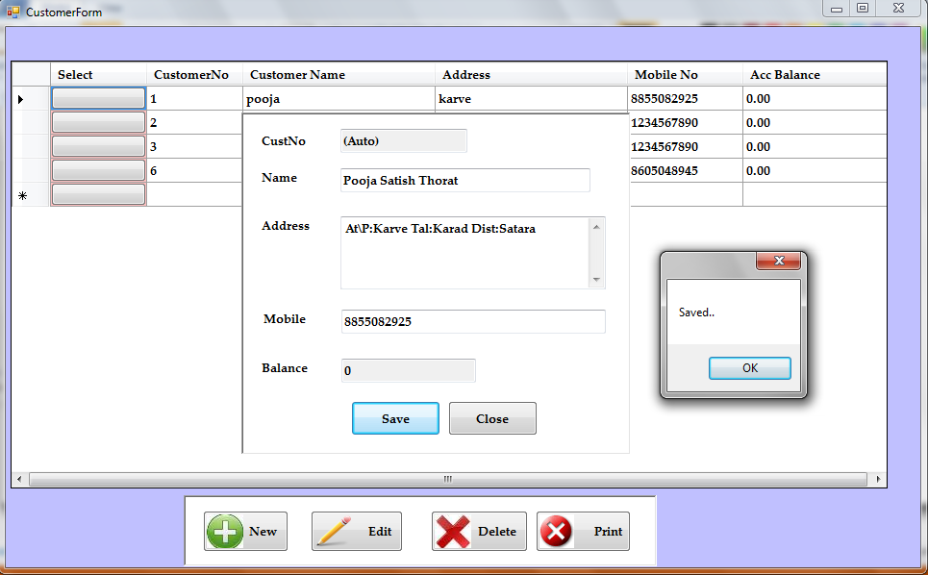

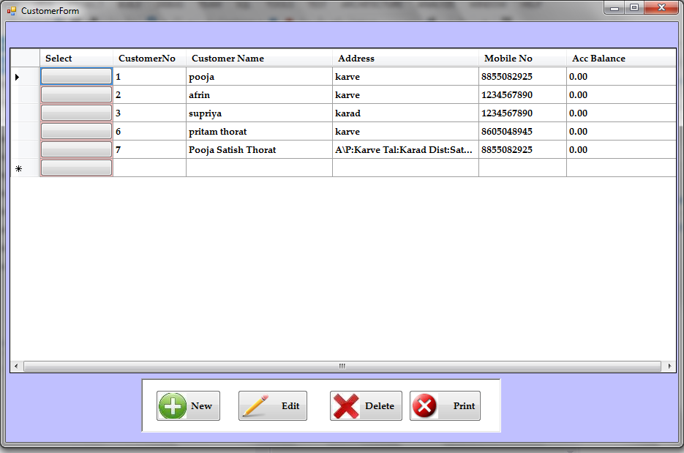

**Booking List Form:**

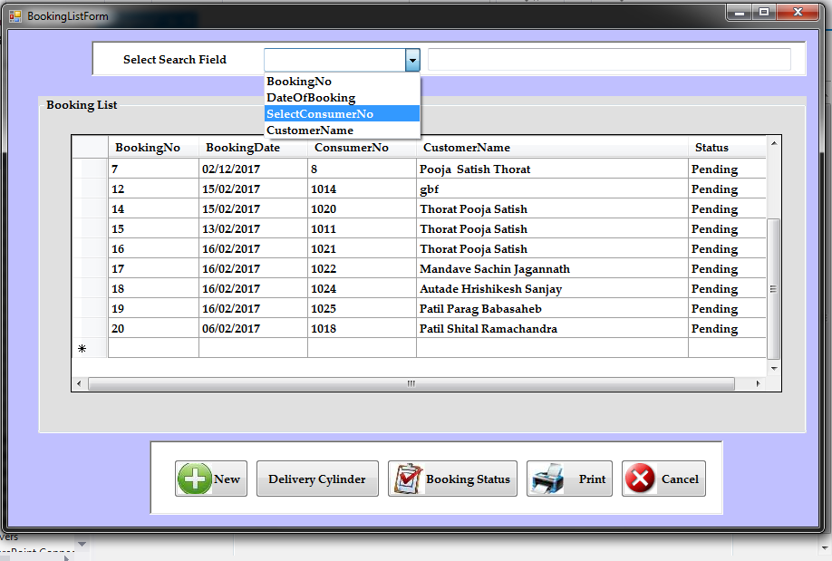

**Cylinder Booking Form:**

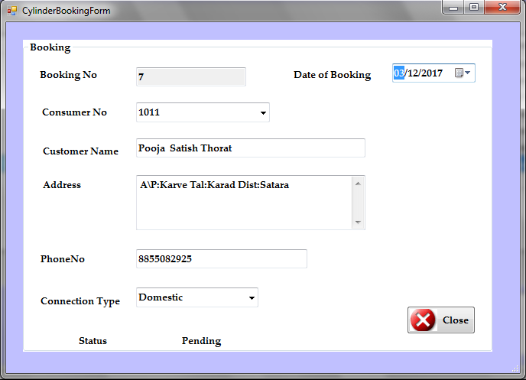

**Cylinder Delivery Form:**

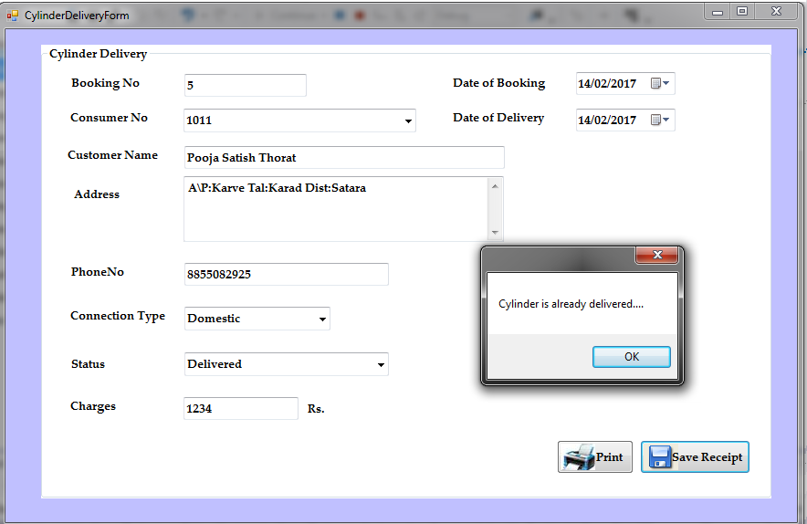

***Report***

**New Connection Report:**

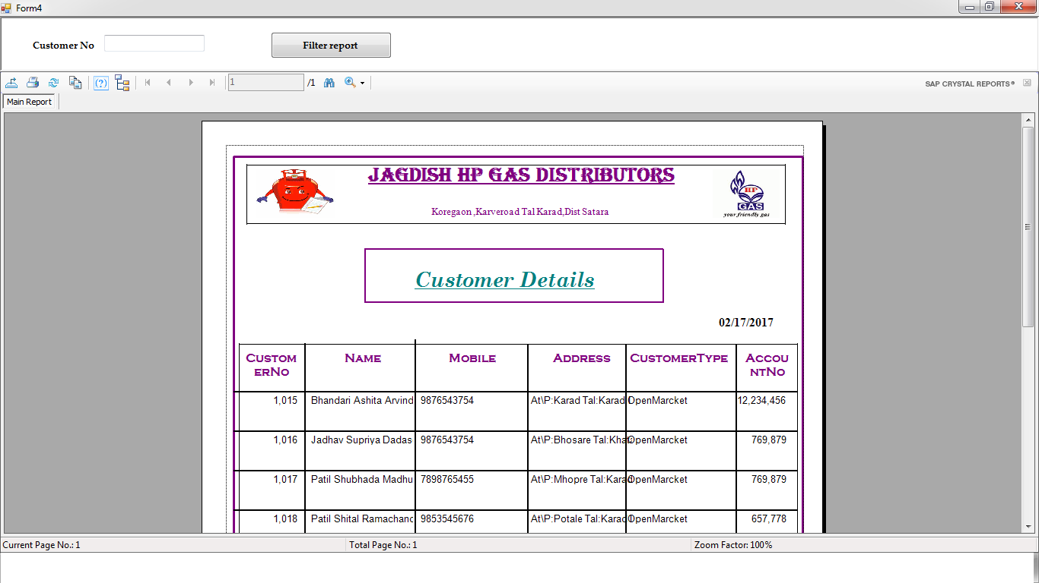

**Customer Report:**

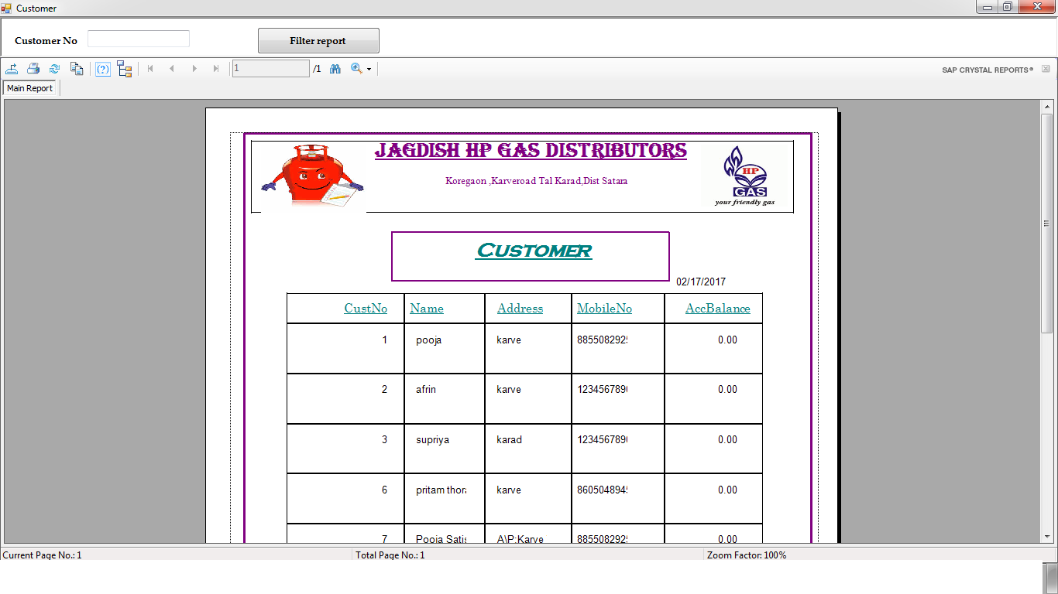

**Item Report:**

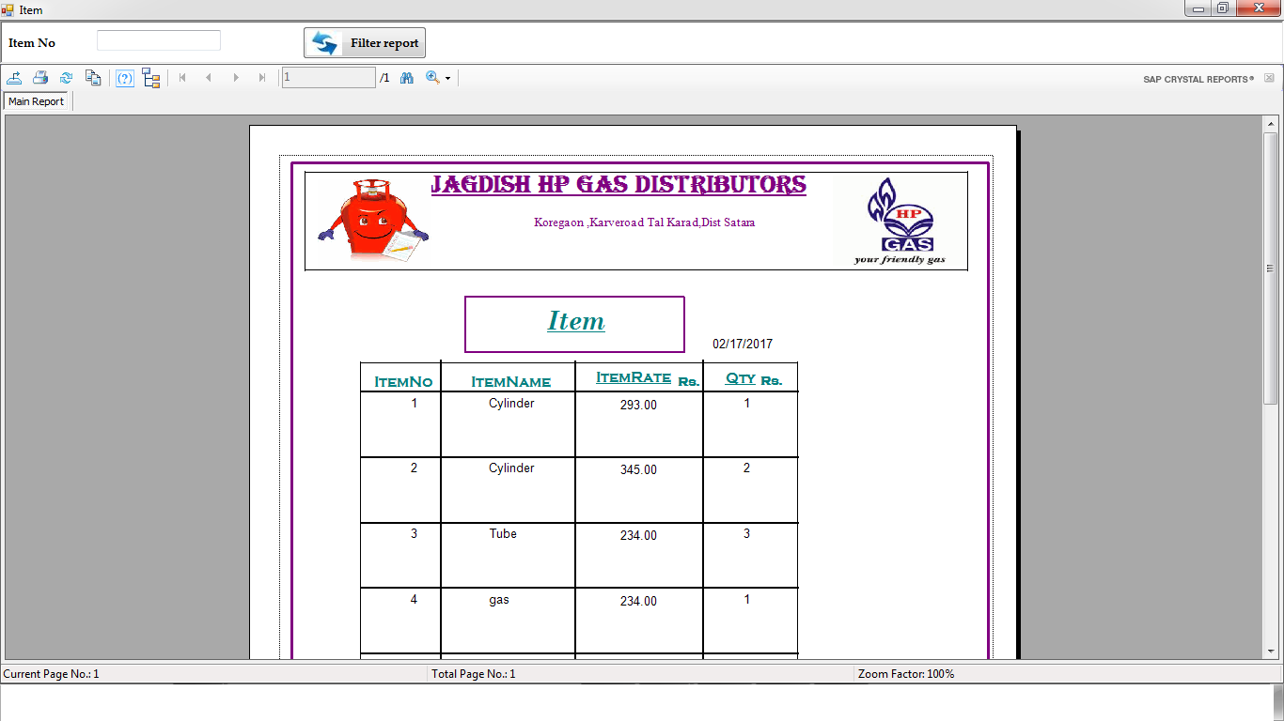

**New Bill Report**

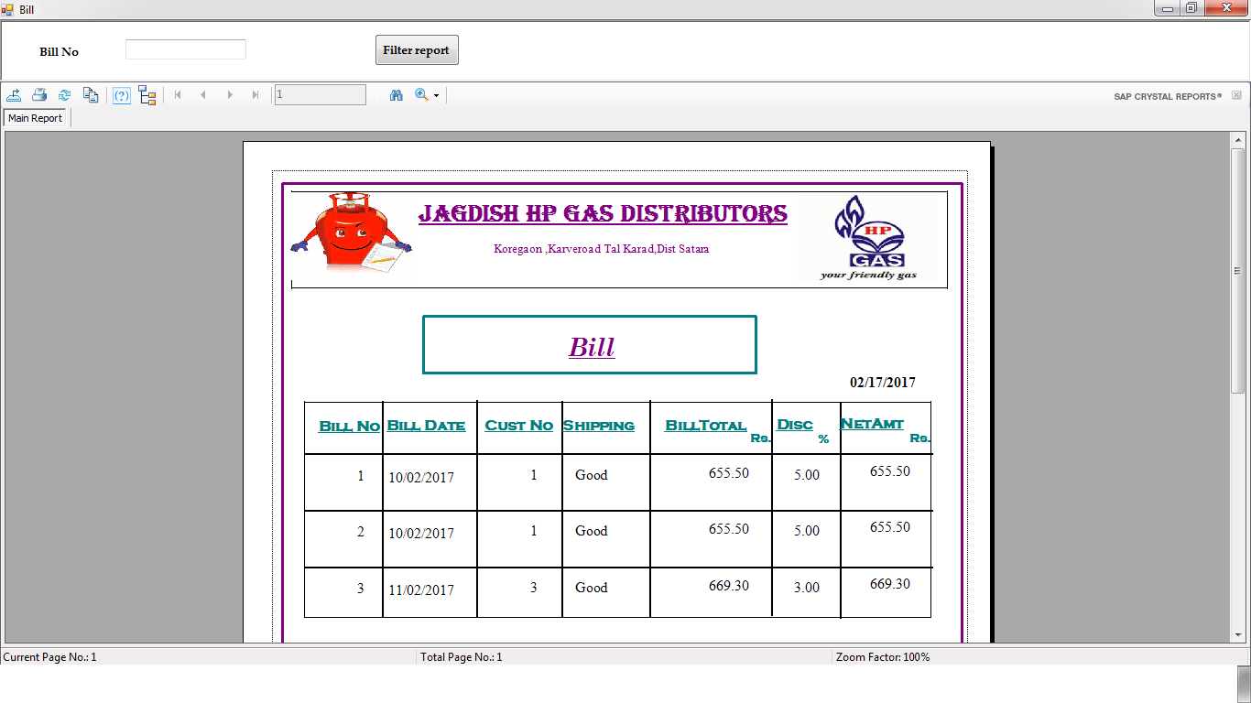

**Cylinder Book Report**

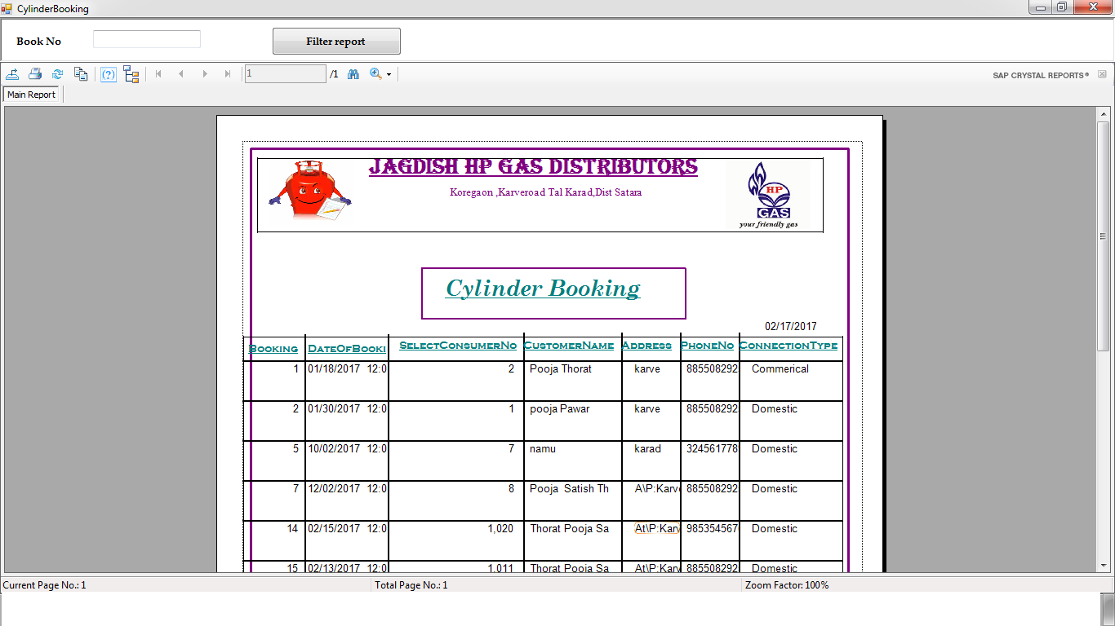

*User manual*

**USER MANUAL**

**User Manual:-**

Firstly When user visit To a Software You will find following menus.

* ***Splash Form***
* ***Login***
* ***Main Form***
* ***Home page***

This is the First page of Software

* ***Login***

In This Form we Show all Detail about User Login

After Login You will find following menus.

* ***Main Form***
* ***New Connection Form***
* ***New Connection Charges Form***
* ***New Connection Billing***
* ***Transfer Connection Form***
* ***Terminate Connection Form***
* ***Cylinder Booking Form***
* ***Cylinder Delivery Form***
* ***Change Password***
* ***Set Get Stock***
* ***Set Price***
* ***Main Form***

In this Form We will Show all form.

* ***New Connection Form***

In This form user can fill yourself info.

* ***New Connection Charge Form***

In this form pay your new connection bill

* ***New Connection Billing***

In this form pay your new connection bill

* ***Transfer Connection Form***

This is transfer connection in another city

* ***Cylinder Booking Form***

This is the Cylinder Booking form

* ***Cylinder Delivery Form***

This is the Cylinder Delivery form

* ***Change Password***

This is change password in a system

* ***Set Get Stock***
* ***Set Price***

Set Price of cylinder

***System Testing***

*System Testing*

*System testing*

Testing is the major control measure used during software development. Its basic function is to detect errors in the software. Thus the goal of testing is to uncover the requirements, design and coding errors in the programs.

Main activities performed in this phase are:

* Black box Testing
* White Box Testing
* Unit Testing

***WHITE BOX TESTING :-***

For doing this testing process the person have to access to the source code of the product to be tested. So it is essential that the person doing this white box testing have some knowledge of the program being tested.

***BLACK BOX TESTING :-***

This is otherwise called as functional testing. In contrary to white box testing here the person who is doing the black box testing need not have the programming knowledge .This is because the person doing the black box testing would access the output and would perform thorough functionality testing to check whether the developed module or products.

***UNIT TESTING :-***

In this testing procedure ,individual program will be tested with respect output from the system. After complition of program some test data as per specification will be used for testing of the program to see if it work as specified.

*FUTURE ENHANCEMENT*

*Future Enhancement*

* The Gas Management system could reduce the manual work and physical entities of the system.
* The system can be further enchanced by proposing an advance Management system.
* The system can be further enchanced by proposing an advance Facilities.
* In future due to increase in records of database file, data redundancy occurs.
* More modules can be included to keep track of occurance.
* Generation of financial reports financial hierarchical detailed information about profit.

*Conclusion*

*Conclusion*

Finally, we can conclude that the system we had developed will eliminate the existing system’s drawbacks and limitations to maximum extent. And provide the user with a product of high quality, standard sand excellence. Hence ,it will be very profitable to the and satisfaction will also be achieved because the delay an din convenience caused due to existing system will be eliminated.

During the project ,there a importance for following all principles of System Analysis and Designed a wnedonme.We want through all the stages of Software Development Life Cycle i.e. starting with Requirement Analysis till Final Implementation of the Software.

*BIBLOGRAPHY*

* **Book:**

1. **Visual Basic .NET Black Book:-Steven Holzner**
2. **Visual Basic.NET-Gary J. Bronsoln**
3. **SQL Server:-Rob Vieira**
4. **SQL Server:-Rick Sawtell**

* **Reference:**

[**www.VBnetInformation.com**](http://www.VBnetInformation.com)

[**www.vbsourcecode.com**](http://www.vbsourcecode.com)

[**www.HPgas.com**](http://www.HPgas.com)

[**www.Bharatgas.com**](http://www.Bharatgas.com)

[**www.Reliancegas.com**](http://www.Reliancegas.com)