Swinburne University of Technology

Programming Concepts OnCampus Sem1 2019

Doubtfire Submission

**Task 2.15C**

*Submitted By:*

Sanduni Amanda Galhenage *Tutor:*

101337547 Somkiat Kitjongthawonku

2019/05/21 11:11

May 21, 2019



Produced by Doubtfire

Programming Concepts

Week 2 **CREDIT** Submission Tasks Template

Student ID: _101337547____________________

Student Name: __Sanduni Amanda ____________________________

Pass Task 15 HTML code page

Paste the HTML code of the web page here.

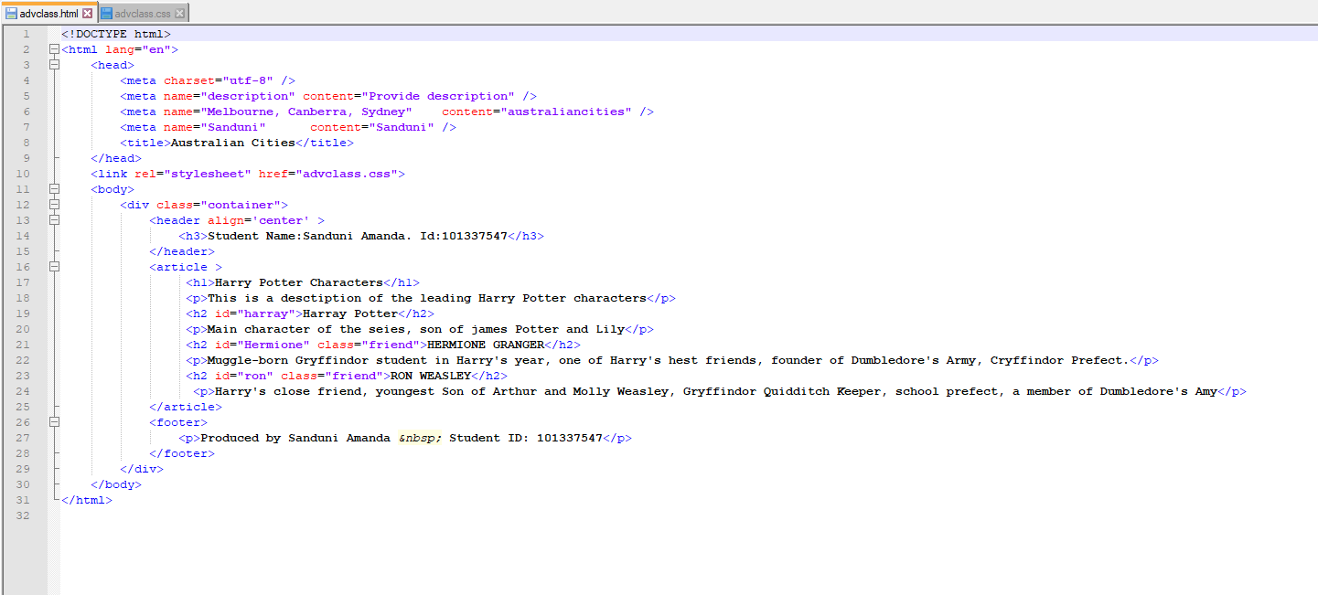

Pass Task 8 Css code

Paste the JavaScript code of the same page here.

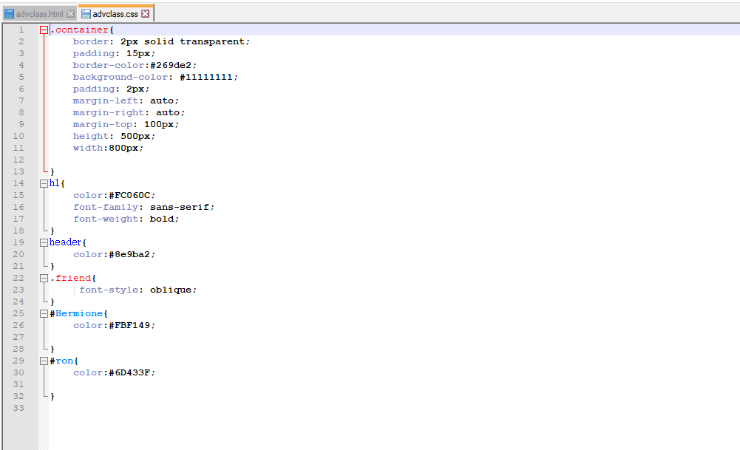

Pass Task 15 web page testing

Paste the screen captures of your testing web page here.

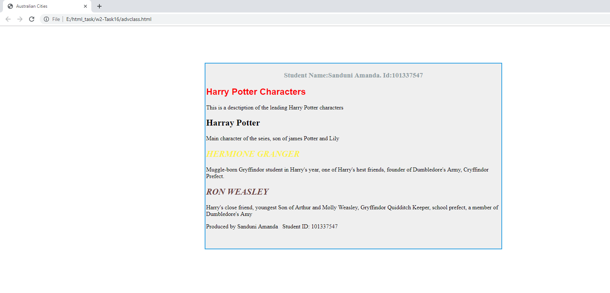

Content advclass.html

<!DOCTYPE html>

<html lang="en">

<head>

<meta charset="utf-8" />

<meta name="description" content="Provide description" />

<meta name="Melbourne, Canberra, Sydney" content="australiancities" />

<meta name="Sanduni" content="Sanduni" />

<title>Australian Cities</title>

</head>

<link rel="stylesheet" href="advclass.css">

<body>

<div class="container">

<header align='center' >

<h3>Student Name:Sanduni Amanda. Id:101337547</h3>

</header>

<article >

<h1>Harry Potter Characters</h1>

<p>This is a desctiption of the leading Harry Potter characters</p>

<h2 id="harray">Harray Potter</h2>

<p>Main character of the seies, son of james Potter and Lily</p>

<h2 id="Hermione" class="friend">HERMIONE GRANGER</h2>

<p>Muggle-born Gryffindor student in Harry's year, one of Harry's hest friends, founder of Dumbledore's Army, Cryffindor Prefect.</p>

<h2 id="ron" class="friend">RON WEASLEY</h2>

<p>Harry's close friend, youngest Son of Arthur and Molly Weasley, Gryffindor Quidditch Keeper, school prefect, a member of Dumbledore's Amy</p>

</article>

<footer>

<p>Produced by Sanduni Amanda &nbsp; Student ID: 101337547</p>

</footer>

</div>

</body>

</html>

Content advclass.css

.container{

border: 2px solid transparent;

padding: 15px;

border-color:#269de2;

background-color: #11111111;

padding: 2px;

margin-left: auto;

margin-right: auto;

margin-top: 100px;

height: 500px;

width:800px;

}

h1{

color:#FC060C;

font-family: sans-serif;

font-weight: bold;

}

header{

color:#8e9ba2;

}

.friend{

font-style: oblique;

}

#Hermione{

color:#FBF149;

}

#ron{

color:#6D433F;

}