Swinburne University of Technology

Programming Concepts OnCampus Sem1 2019

Doubtfire Submission

**Task 2.7P**

*Submitted By:*

Sanduni Amanda Galhenage *Tutor:*

101337547 Somkiat Kitjongthawonkul

2019/05/21 11:11

May 21, 2019



Produced by Doubtfire

Programming Concepts

Week 2 **PASS** Submission Tasks Template

Student ID: _101337547____________________

Student Name: __Sanduni Amanda ____________________________

Pass Task 7 HTML code page

Paste the HTML code of the web page here.

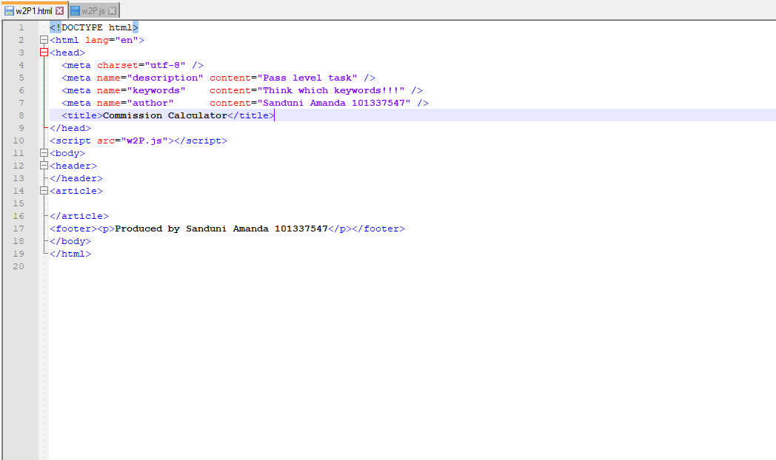

Pass Task 7 JavaScript code

Paste the JavaScript code of the same page here.

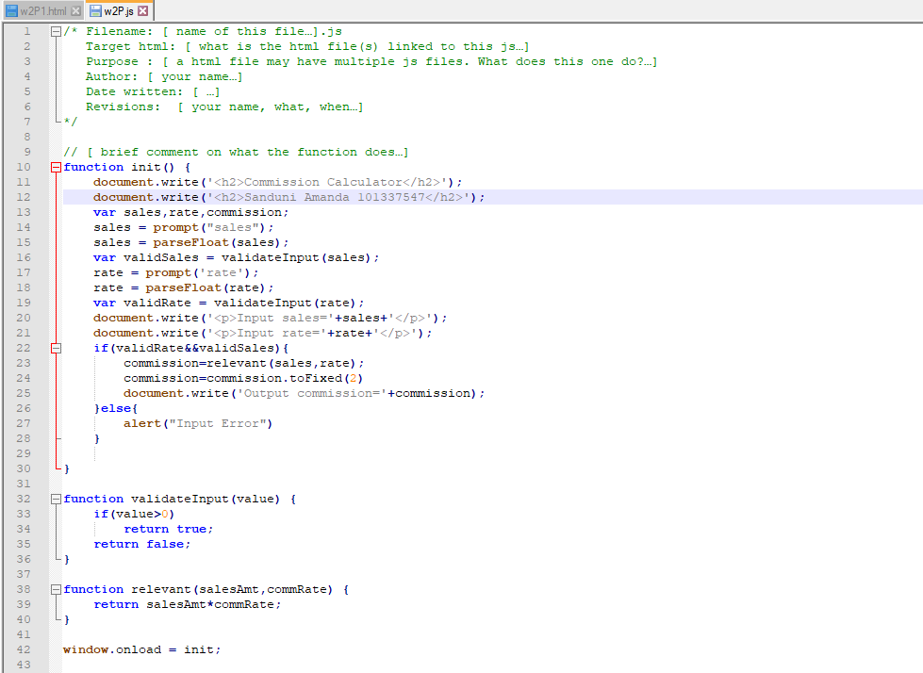

Pass Task 7 web page testing (All inputs are valid)

Paste the screen captures of your testing web page here.

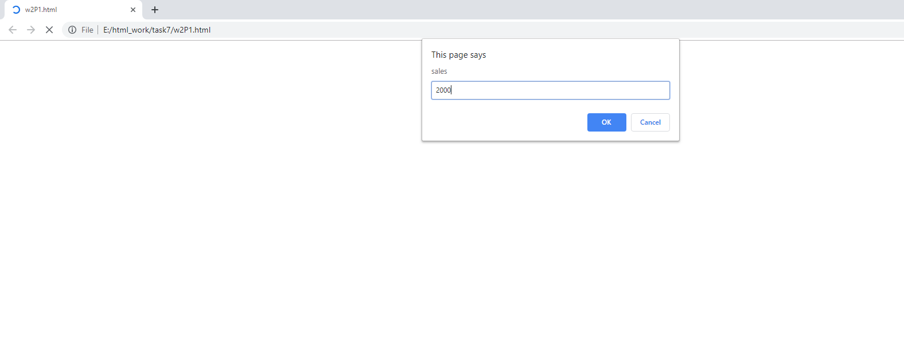

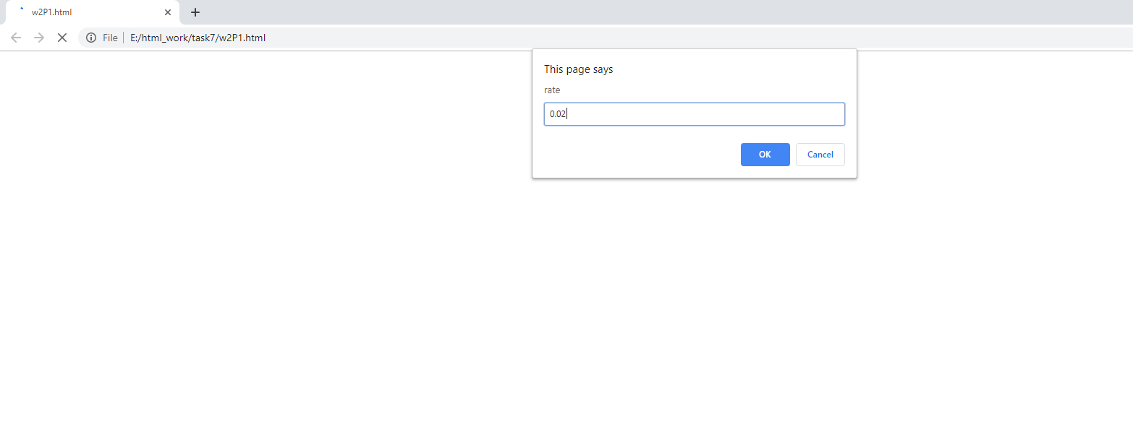

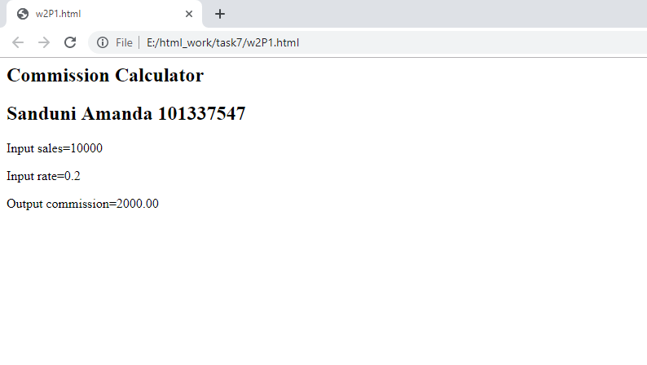

Pass Task 7 web page testing (Valid sales, valid rate)

Paste the screen captures of your testing web page here.

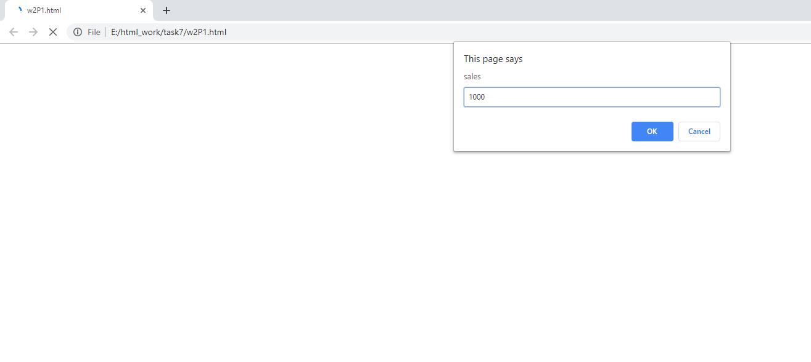

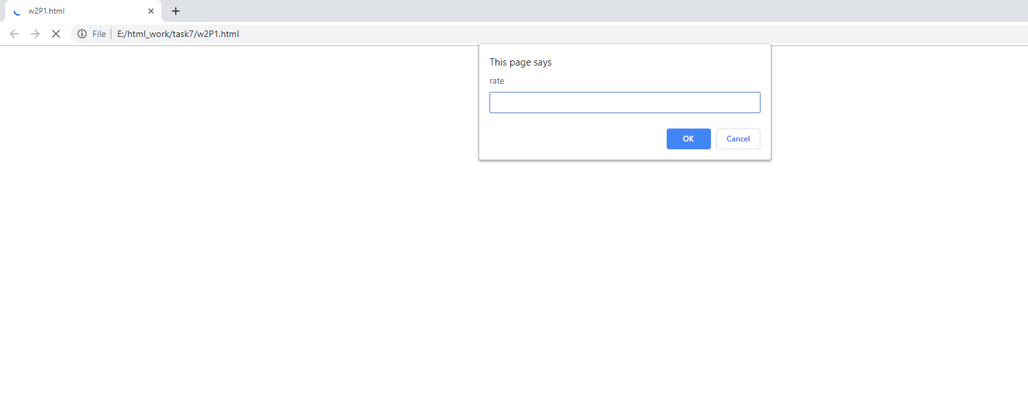

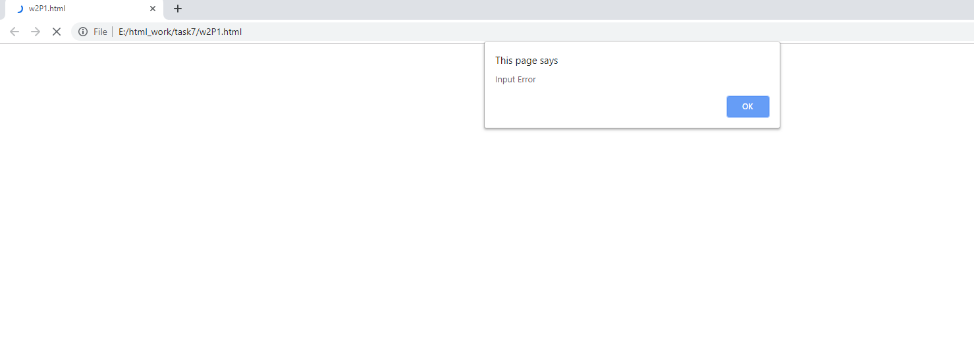

Pass Task 7 web page testing (Invalid sales, Invalid rate)

Paste the screen captures of your testing web page here.

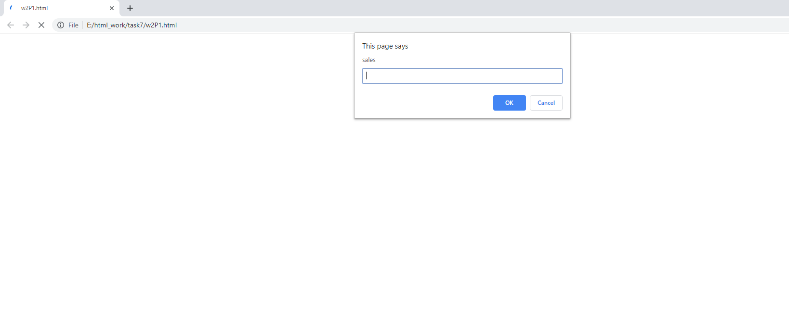



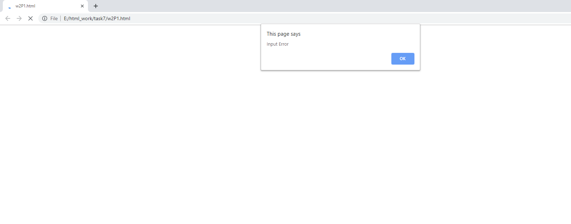

Pass Task 7 web page testing (Both sales rate are invalid)

Paste the screen captures of your testing web page here.



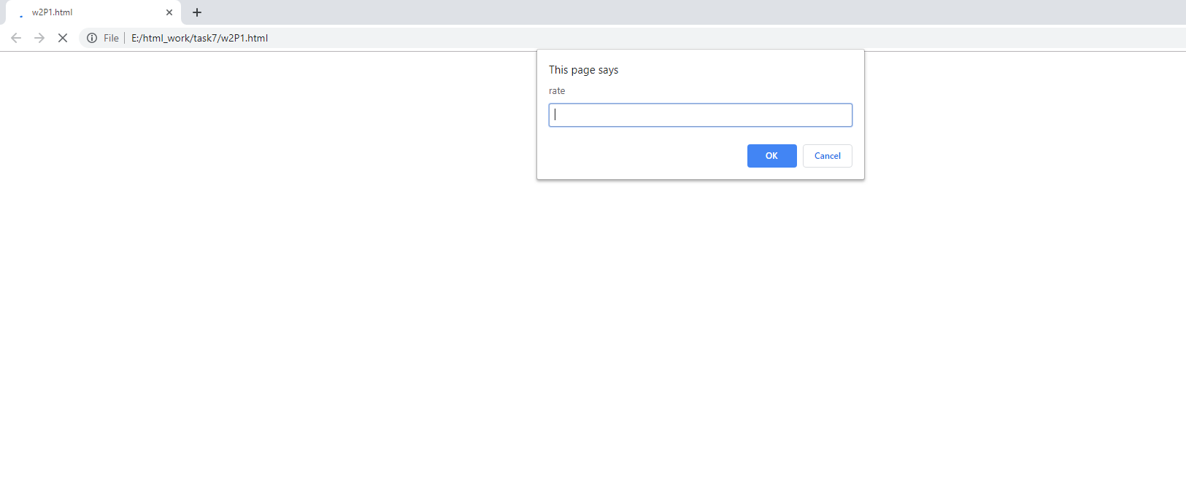



Content W2P1.html

<!DOCTYPE html>

<html lang="en">

<head>

<meta charset="utf-8" />

<meta name="description" content="Pass level task" />

<meta name="keywords" content="Think which keywords!!!" />

<meta name="author" content="Sanduni Amanda 101337547" />

<title>Commission Calculator</title>

</head>

<script src="w2P.js"></script>

<body>

<header>

</header>

<article>

</article>

<footer><p>Produced by Sanduni Amanda 101337547</p></footer>

</body>

</html>

Content W2P.js

function init() {

document.write('<h2>Commission Calculator</h2>');

document.write('<h2>Sanduni Amanda 101337547</h2>');

var sales,rate,commission;

sales = prompt("sales");

sales = parseFloat(sales);

var validSales = validateInput(sales);

rate = prompt('rate');

rate = parseFloat(rate);

var validRate = validateInput(rate);

document.write('<p>Input sales='+sales+'</p>');

document.write('<p>Input rate='+rate+'</p>');

if(validRate&&validSales){

commission=relevant(sales,rate);

commission=commission.toFixed(2)

document.write('Output commission='+commission);

}else{

alert("Input Error")

}

}

function validateInput(value) {

if(value>0)

return true;

return false;

}

function relevant(salesAmt,commRate) {

return salesAmt*commRate;

}

window.onload = init;