Swinburne University of Technology

Programming Concepts OnCampus Sem1 2019

Doubtfire Submission

**Task 2.8C**

*Submitted By:*

Sanduni Amanda Galhenage *Tutor:*

101337547 Somkiat Kitjongthawonku

2019/05/21 11:11

May 21, 2019



Produced by Doubtfire

Programming Concepts

Week 2 **CREDIT** Submission Tasks Template

Student ID: _101337547____________________

Student Name: __Sanduni Amanda ____________________________

Pass Task 8 HTML code page

Paste the HTML code of the web page here.

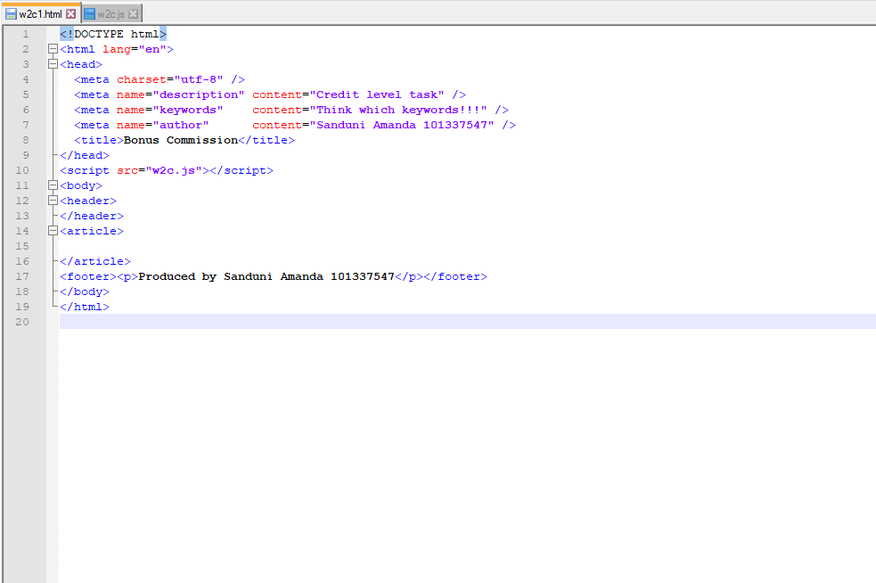

Pass Task 8 JavaScript code

Paste the JavaScript code of the same page here.

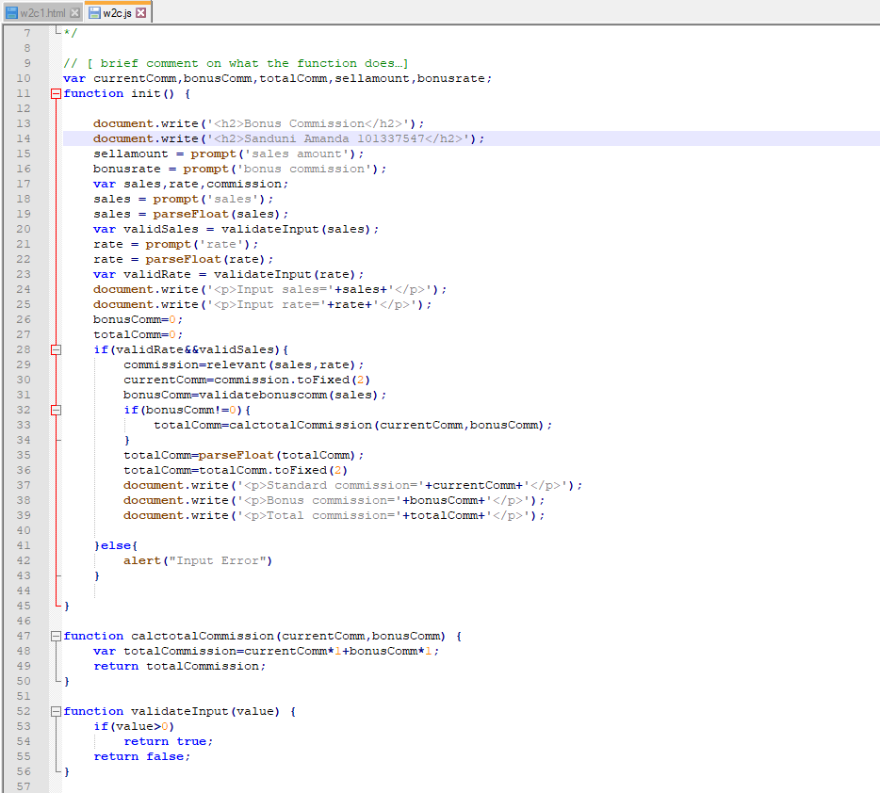

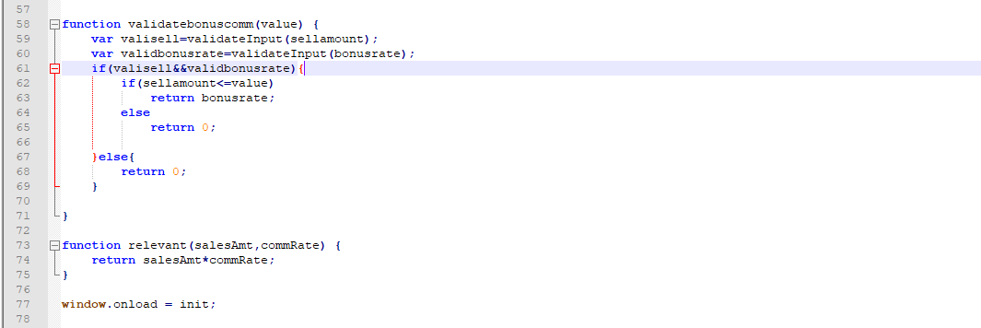

Pass Task 8 web page testing (Valid sales, invalid commission rate)

Paste the screen captures of your testing web page here.

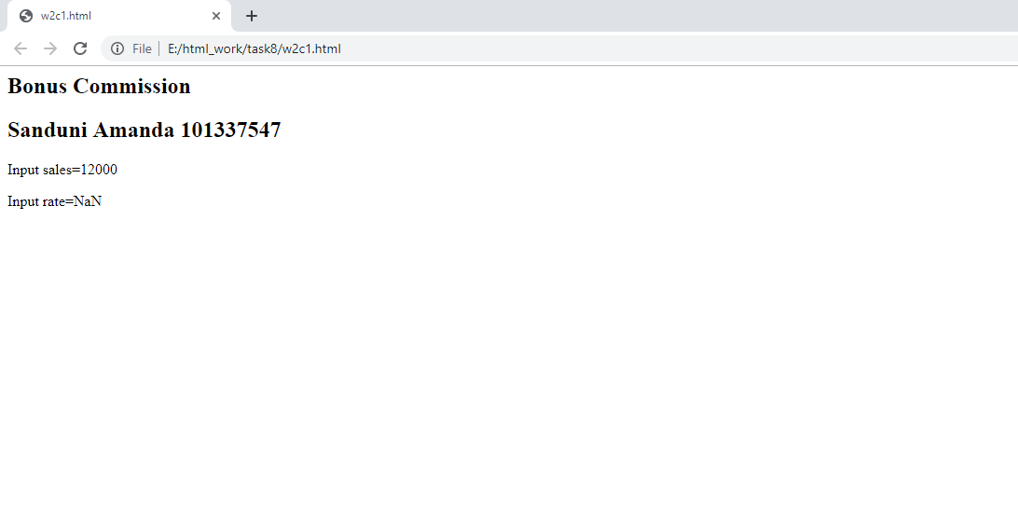

Pass Task 8 web page testing (Invalid sales, valid commission rate)

Paste the screen captures of your testing web page here.

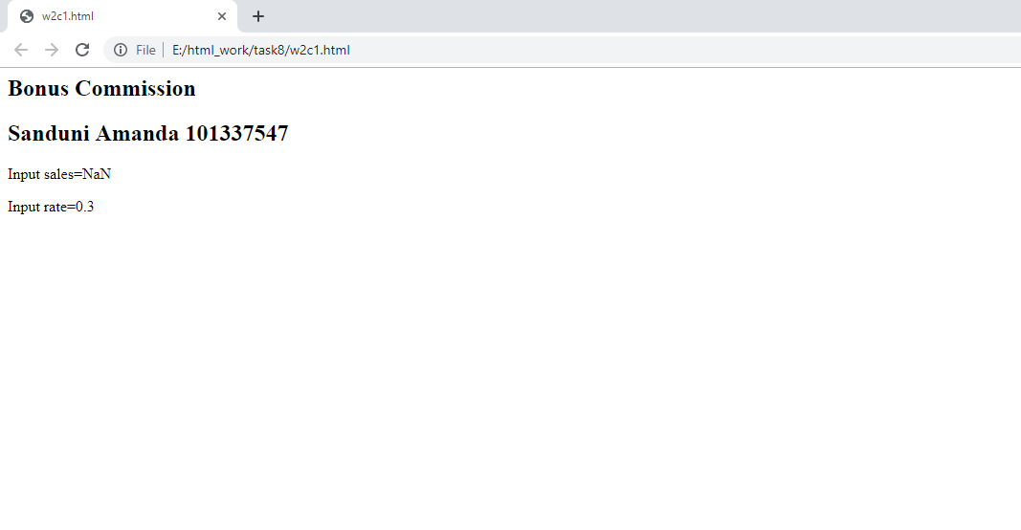

Pass Task 8 web page testing (All inputs are valid resulting in 0 bonus commission)

Paste the screen captures of your testing web page here.

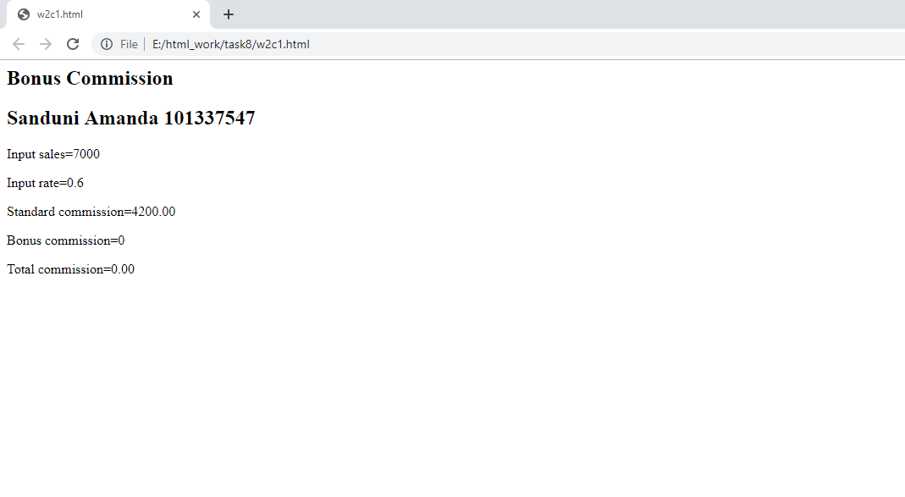

Pass Task 8 web page testing (All inputs are valid resulting in bonus commission)

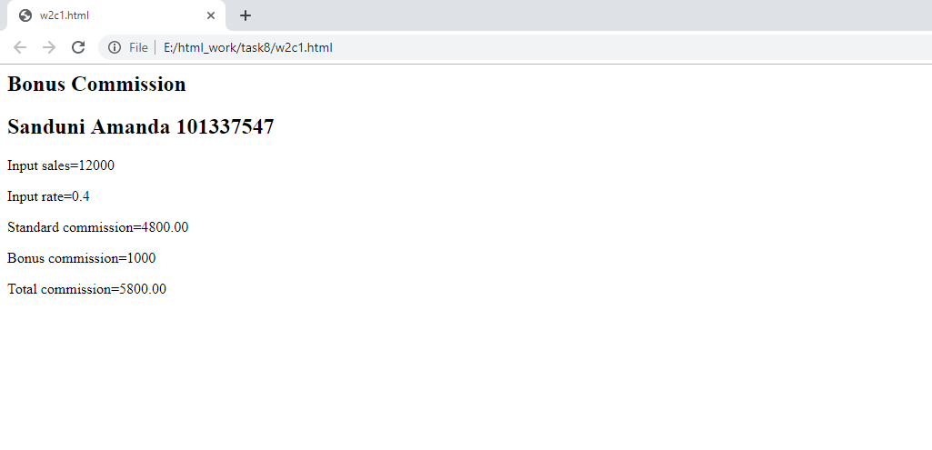

Pass Task 8 web page testing (Invalid sales, invalid commission rate)

Paste the screen captures of your testing web page here.

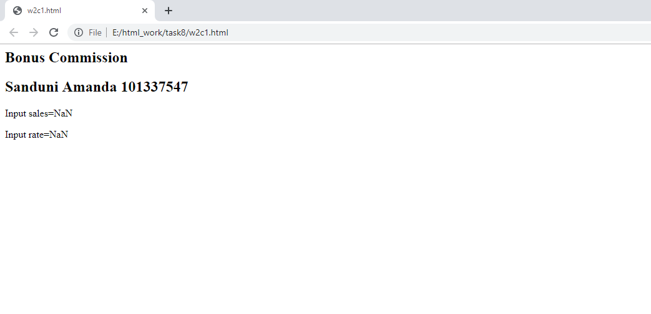

Content w2c1.html

<!DOCTYPE html>

<html lang="en">

<head>

<meta charset="utf-8" />

<meta name="description" content="Credit level task" />

<meta name="keywords" content="Think which keywords!!!" />

<meta name="author" content="Sanduni Amanda 101337547" />

<title>Bonus Commission</title>

</head>

<script src="w2c.js"></script>

<body>

<header>

</header>

<article>

</article>

<footer><p>Produced by Sanduni Amanda 101337547</p></footer>

</body>

</html>

Content w2c.js

// [ brief comment on what the function does…]

var currentComm,bonusComm,totalComm,sellamount,bonusrate;

function init() {

document.write('<h2>Bonus Commission</h2>');

document.write('<h2>Sanduni Amanda 101337547</h2>');

sellamount = prompt('sales amount');

bonusrate = prompt('bonus commission');

var sales,rate,commission;

sales = prompt('sales');

sales = parseFloat(sales);

var validSales = validateInput(sales);

rate = prompt('rate');

rate = parseFloat(rate);

var validRate = validateInput(rate);

document.write('<p>Input sales='+sales+'</p>');

document.write('<p>Input rate='+rate+'</p>');

bonusComm=0;

totalComm=0;

if(validRate&&validSales){

commission=relevant(sales,rate);

currentComm=commission.toFixed(2)

bonusComm=validatebonuscomm(sales);

if(bonusComm!=0){

totalComm=calctotalCommission(currentComm,bonusComm);

}

totalComm=parseFloat(totalComm);

totalComm=totalComm.toFixed(2)

document.write('<p>Standard commission='+currentComm+'</p>');

document.write('<p>Bonus commission='+bonusComm+'</p>');

document.write('<p>Total commission='+totalComm+'</p>');

}else{

alert("Input Error")

}

}

function calctotalCommission(currentComm,bonusComm) {

var totalCommission=currentComm*1+bonusComm*1;

return totalCommission;

}

function validateInput(value) {

if(value>0)

return true;

return false;

}

function validatebonuscomm(value) {

var valisell=validateInput(sellamount);

var validbonusrate=validateInput(bonusrate);

if(valisell&&validbonusrate){

if(sellamount<=value)

return bonusrate;

else

return 0;

}else{

return 0;

}

}

function relevant(salesAmt,commRate) {

return salesAmt*commRate;

}

window.onload = init;