Swinburne University of Technology

Programming Concepts OnCampus Sem1 2019

Doubtfire Submission

**Task 3.4P**

*Submitted By:*

Sanduni Amanda Galhenage *Tutor:*

101337547 Somkiat Kitjongthawonkul

2019/05/21 11:11

May 21, 2019



Produced by Doubtfire

Programming Concepts

Week 3 **PASS** Submission Tasks Template

Student ID: _101337547____________________

Student Name: __Sanduni Amanda ____________________________

Pass Task 4 HTML code page

Paste the HTML code of the web page here.

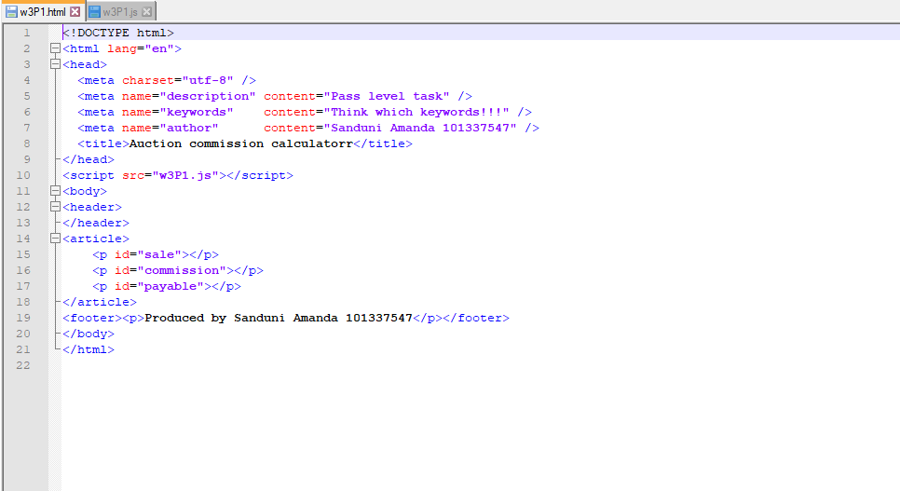

Pass Task 4 JavaScript code

Paste the JavaScript code of the same page here.

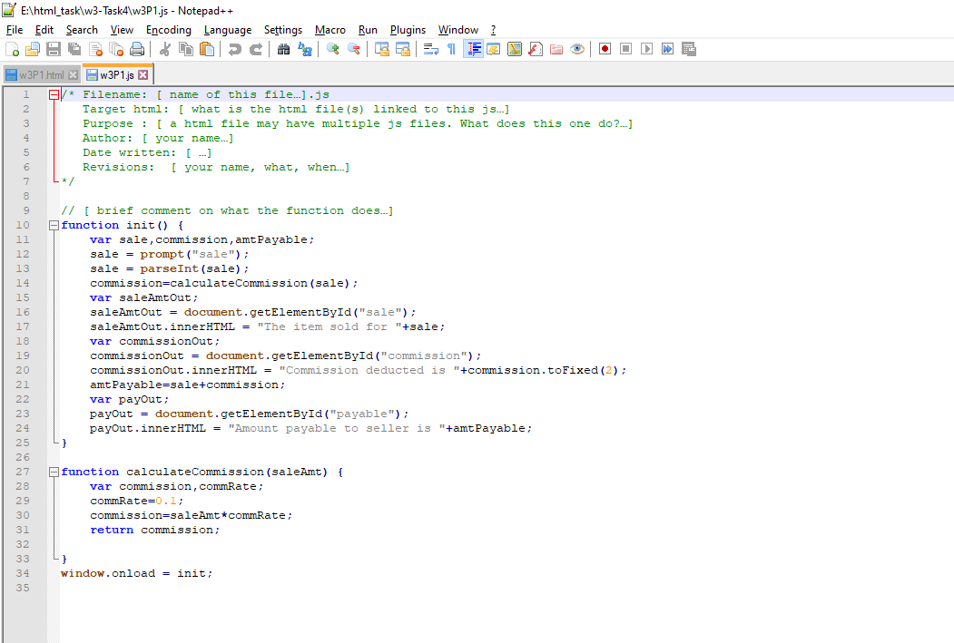

Pass Task 4 web page testing (Before clicking OK)

Paste the screen captures of your testing web page here.

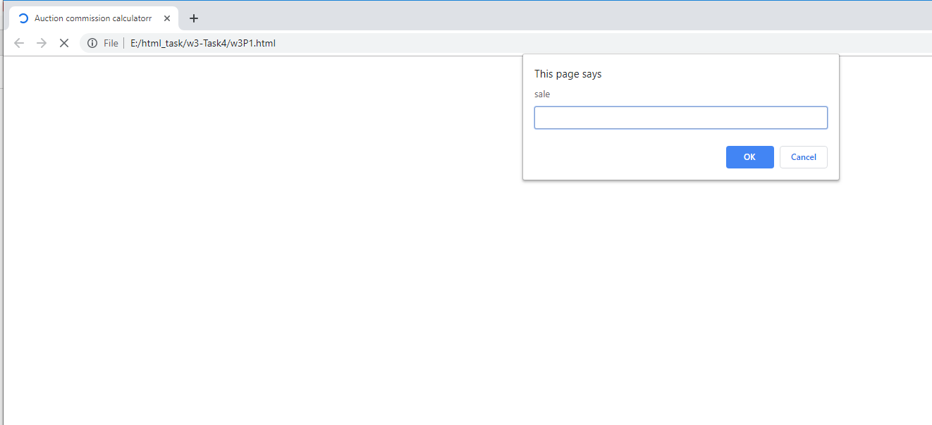

Pass Task 4 web page testing (After clicking OK on the prompt window)

Paste the screen captures of your testing web page here.

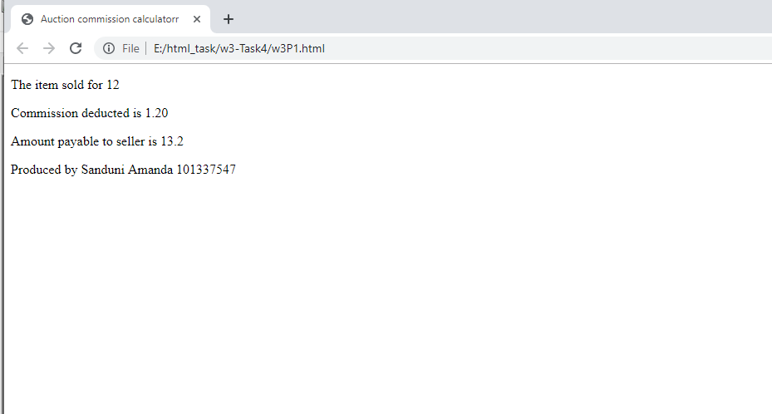

Content W3P1.html

<!DOCTYPE html>

<html lang="en">

<head>

<meta charset="utf-8" />

<meta name="description" content="Pass level task" />

<meta name="keywords" content="Think which keywords!!!" />

<meta name="author" content="Sanduni Amanda 101337547" />

<title>Auction commission calculatorr</title>

</head>

<script src="w3P1.js"></script>

<body>

<header>

</header>

<article>

<p id="sale"></p>

<p id="commission"></p>

<p id="payable"></p>

</article>

<footer><p>Produced by Sanduni Amanda 101337547</p></footer>

</body>

</html>

Content W3P1.js

/* Filename: [ name of this file…].js

Target html: [ what is the html file(s) linked to this js…]

Purpose : [ a html file may have multiple js files. What does this one do?…]

Author: [ your name…]

Date written: [ …]

Revisions: [ your name, what, when…]

*/

// [ brief comment on what the function does…]

function init() {

var sale,commission,amtPayable;

sale = prompt("sale");

sale = parseInt(sale);

commission=calculateCommission(sale);

var saleAmtOut;

saleAmtOut = document.getElementById("sale");

saleAmtOut.innerHTML = "The item sold for "+sale;

var commissionOut;

commissionOut = document.getElementById("commission");

commissionOut.innerHTML = "Commission deducted is "+commission.toFixed(2);

amtPayable=sale+commission;

var payOut;

payOut = document.getElementById("payable");

payOut.innerHTML = "Amount payable to seller is "+amtPayable;

}

function calculateCommission(saleAmt) {

var commission,commRate;

commRate=0.1;

commission=saleAmt*commRate;

return commission;

}

window.onload = init;