Swinburne University of Technology

Programming Concepts OnCampus Sem1 2019

Doubtfire Submission

**Task 3.7P**

*Submitted By:*

Sanduni Amanda Galhenage *Tutor:*

101337547 Somkiat Kitjongthawonkul

2019/05/21 11:11

May 21, 2019



Produced by Doubtfire

Programming Concepts

Week 3 **PASS** Submission Tasks Template

Student ID: _101337547____________________

Student Name: __Sanduni Amanda ____________________________

Pass Task 7 HTML code page

Paste the HTML code of the web page here.

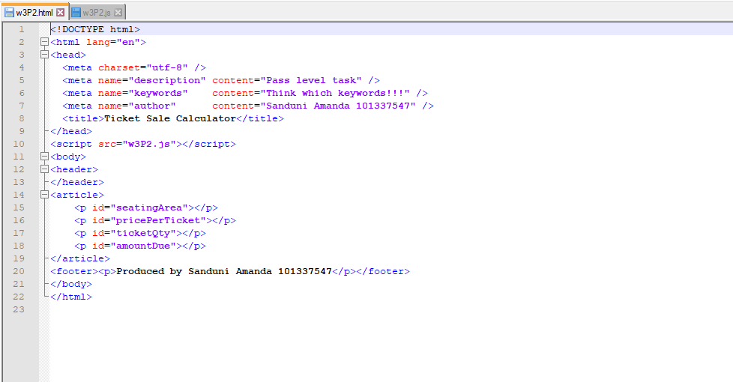

Pass Task 7 JavaScript code

Paste the JavaScript code of the same page here.

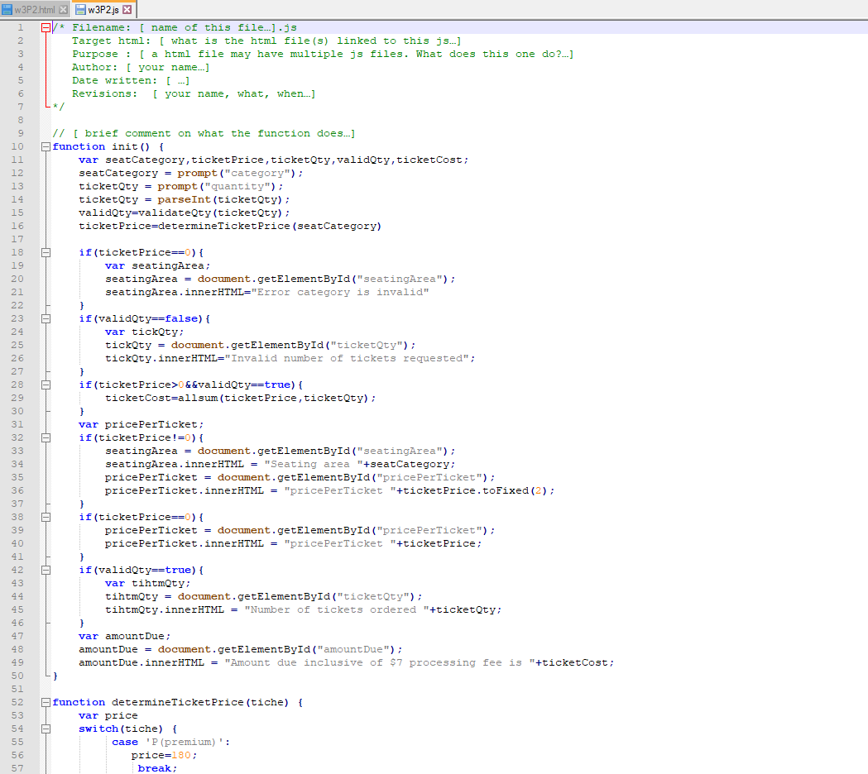

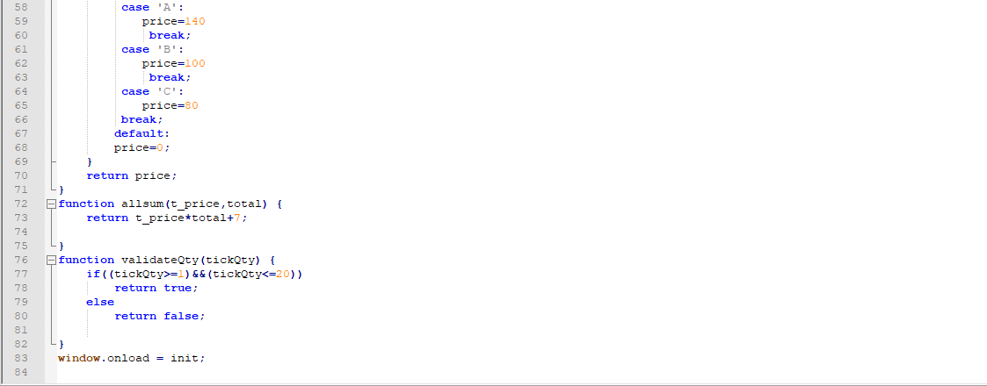

Pass Task 7 web page testing (**Valid seating category, invalid quantity** )

Paste the screen captures of your testing web page here.

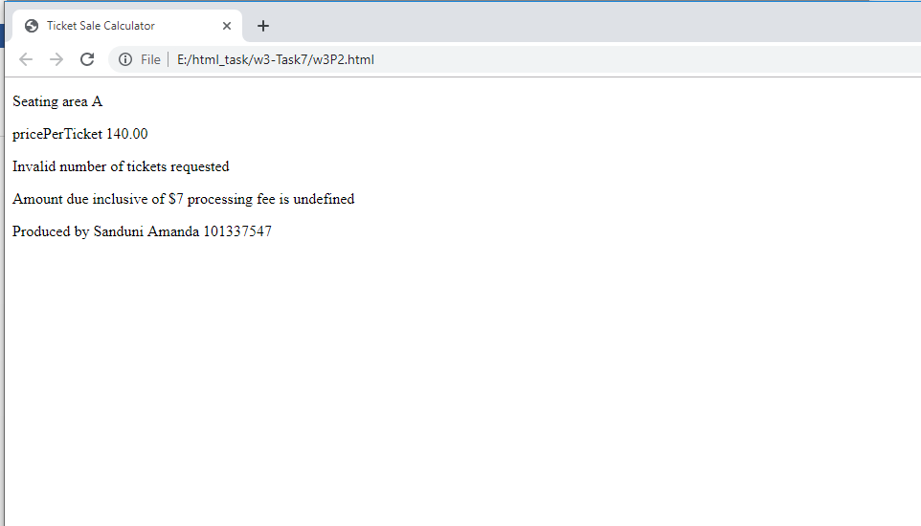

Pass Task 7 web page testing (**Invalid seating category, valid quantity**)

Paste the screen captures of your testing web page here.

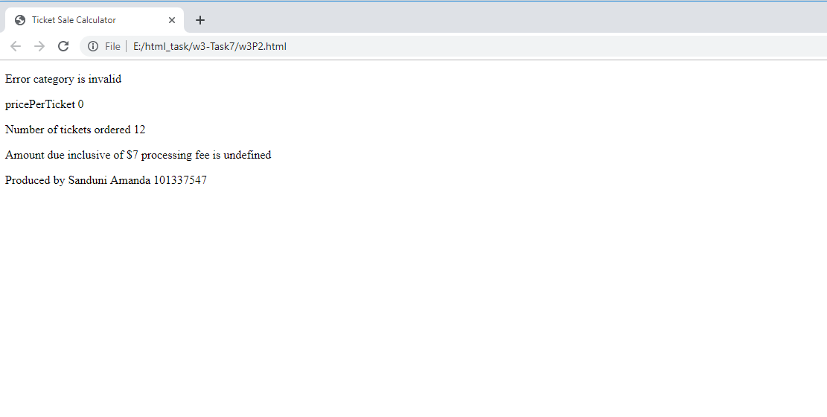

Pass Task 7 web page testing (**Both seating category and quantity are invalid** )

Paste the screen captures of your testing web page here.

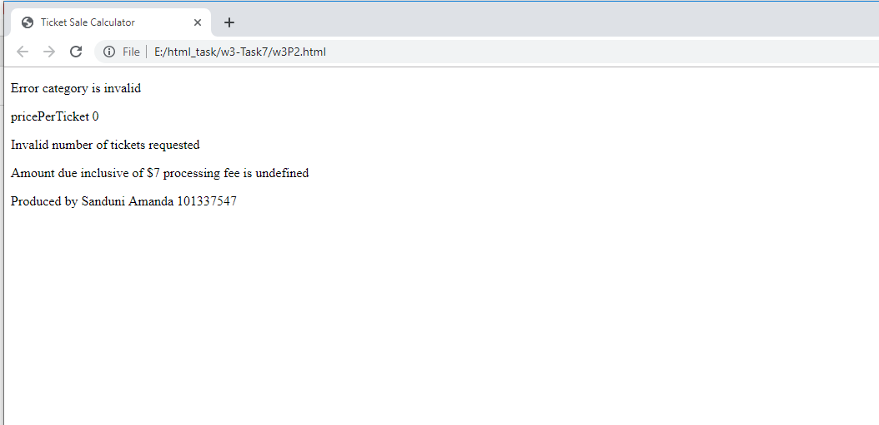

Pass Task 7 web page testing (**All inputs are valid with EVERY seating category tested (at least 4 screenshots, mix of uppercase and lowercase entries)**

)

Paste the screen captures of your testing web page here.

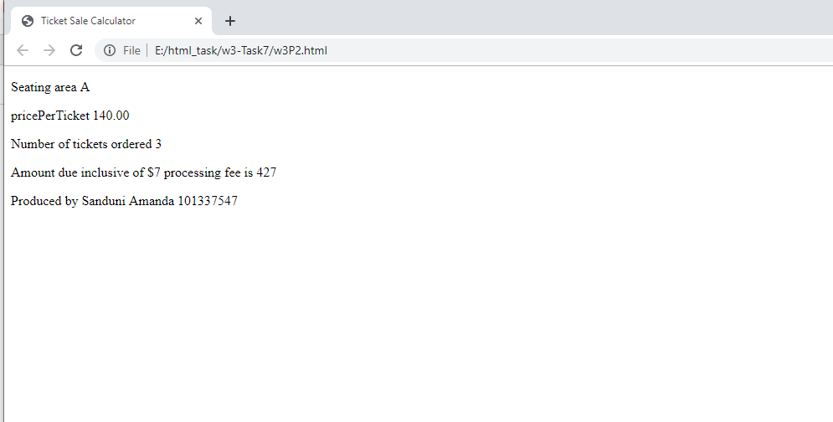

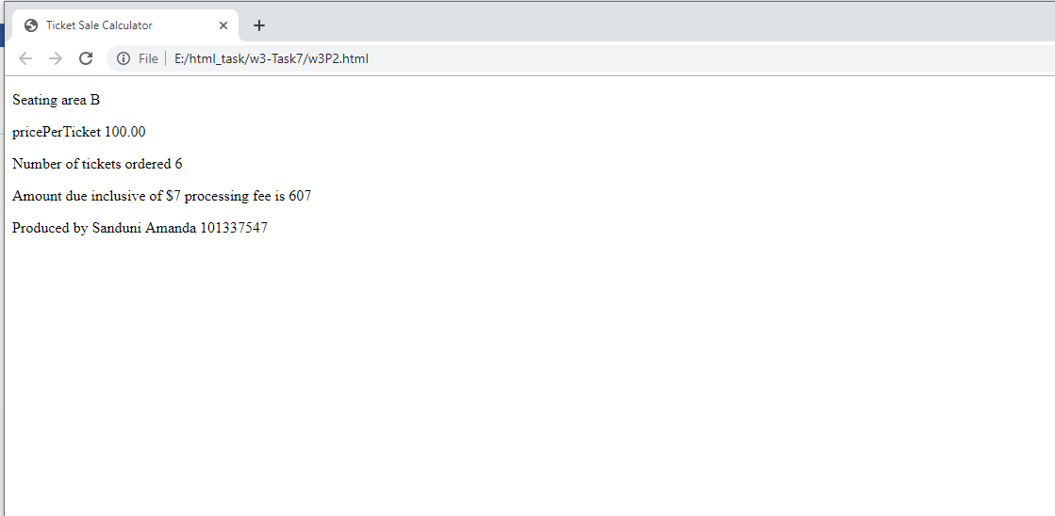

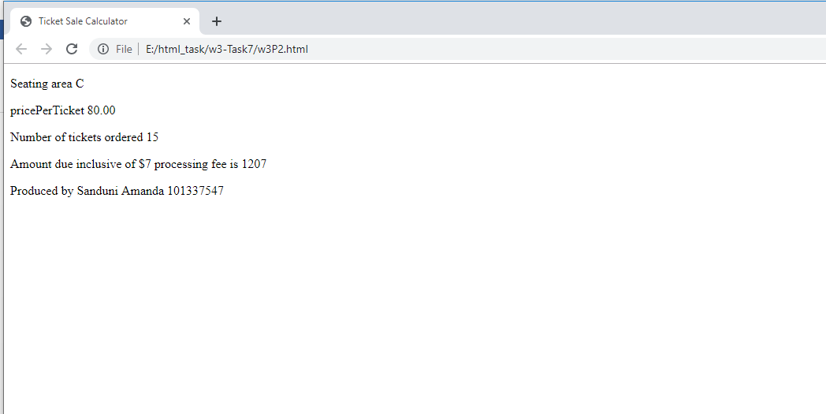

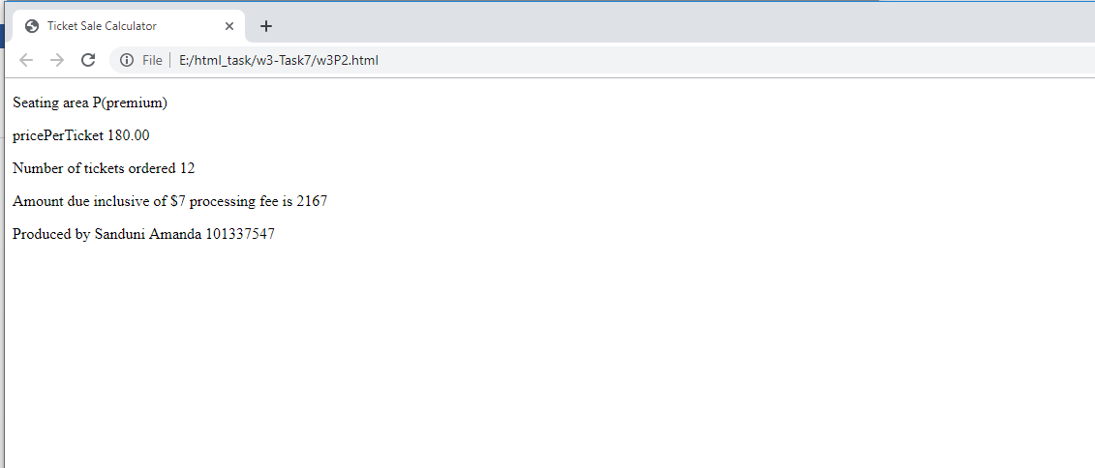

Content W3P2.html

<!DOCTYPE html>

<html lang="en">

<head>

<meta charset="utf-8" />

<meta name="description" content="Pass level task" />

<meta name="keywords" content="Think which keywords!!!" />

<meta name="author" content="Sanduni Amanda 101337547" />

<title>Ticket Sale Calculator</title>

</head>

<script src="w3P2.js"></script>

<body>

<header>

</header>

<article>

<p id="seatingArea"></p>

<p id="pricePerTicket"></p>

<p id="ticketQty"></p>

<p id="amountDue"></p>

</article>

<footer><p>Produced by Sanduni Amanda 101337547</p></footer>

</body>

</html>

Content W3P2.js

/* Filename: [ name of this file…].js

Target html: [ what is the html file(s) linked to this js…]

Purpose : [ a html file may have multiple js files. What does this one do?…]

Author: [ your name…]

Date written: [ …]

Revisions: [ your name, what, when…]

*/

// [ brief comment on what the function does…]

function init() {

var seatCategory,ticketPrice,ticketQty,validQty,ticketCost;

seatCategory = prompt("category");

ticketQty = prompt("quantity");

ticketQty = parseInt(ticketQty);

validQty=validateQty(ticketQty);

ticketPrice=determineTicketPrice(seatCategory)

if(ticketPrice==0){

var seatingArea;

seatingArea = document.getElementById("seatingArea");

seatingArea.innerHTML="Error category is invalid"

}

if(validQty==false){

var tickQty;

tickQty = document.getElementById("ticketQty");

tickQty.innerHTML="Invalid number of tickets requested";

}

if(ticketPrice>0&&validQty==true){

ticketCost=allsum(ticketPrice,ticketQty);

}

var pricePerTicket;

if(ticketPrice!=0){

seatingArea = document.getElementById("seatingArea");

seatingArea.innerHTML = "Seating area "+seatCategory;

pricePerTicket = document.getElementById("pricePerTicket");

pricePerTicket.innerHTML = "pricePerTicket "+ticketPrice.toFixed(2);

}

if(ticketPrice==0){

pricePerTicket = document.getElementById("pricePerTicket");

pricePerTicket.innerHTML = "pricePerTicket "+ticketPrice;

}

if(validQty==true){

var tihtmQty;

tihtmQty = document.getElementById("ticketQty");

tihtmQty.innerHTML = "Number of tickets ordered "+ticketQty;

}

var amountDue;

amountDue = document.getElementById("amountDue");

amountDue.innerHTML = "Amount due inclusive of $7 processing fee is "+ticketCost;

}

function determineTicketPrice(tiche) {

var price

switch(tiche) {

case 'P(premium)':

price=180;

break;

case 'A':

price=140

break;

case 'B':

price=100

break;

case 'C':

price=80

break;

default:

price=0;

}

return price;

}

function allsum(t_price,total) {

return t_price*total+7;

}

function validateQty(tickQty) {

if((tickQty>=1)&&(tickQty<=20))

return true;

else

return false;

}

window.onload = init;