Swinburne University of Technology

Programming Concepts OnCampus Sem1 2019

Doubtfire Submission

**Task 4.4P**

*Submitted By:*

Sanduni Amanda Galhenage *Tutor:*

101337547 Somkiat Kitjongthawonkul

2019/05/21 11:11

May 21, 2019



Produced by Doubtfire

Programming Concepts

Week 4 **Pass** Submission Tasks Template

Student ID: _101337547____________________

Student Name: __Sanduni Amanda ____________________________

Pass Task 4HTML code page

Paste the HTML code of the web page here.

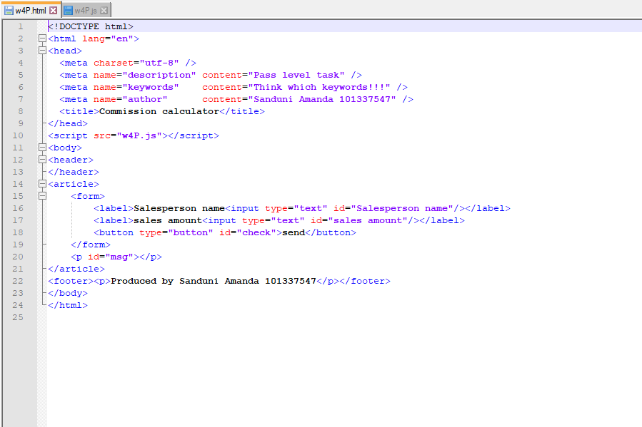

Pass Task 7 JavaScript code

Paste the JavaScript code of the same page here.

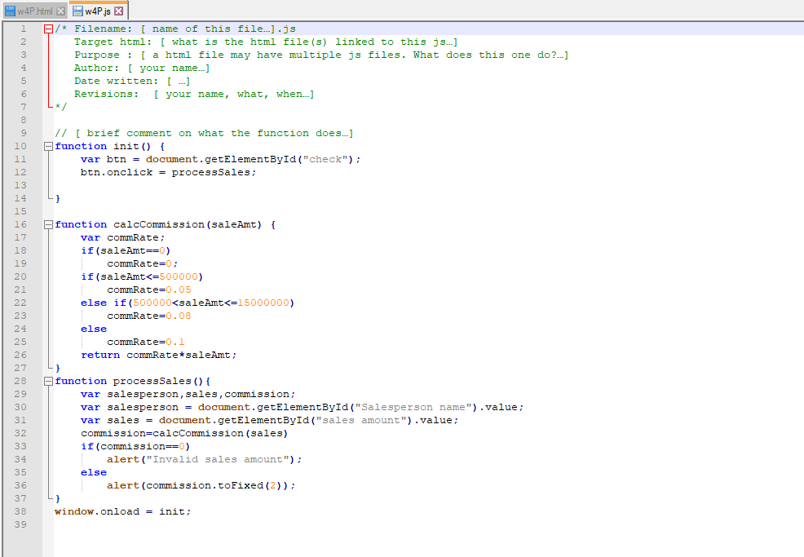

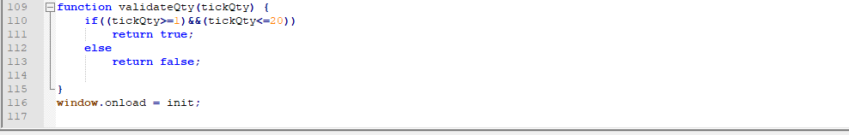

Pass Task 4 web page testing

Paste the screen captures of your testing web page here.

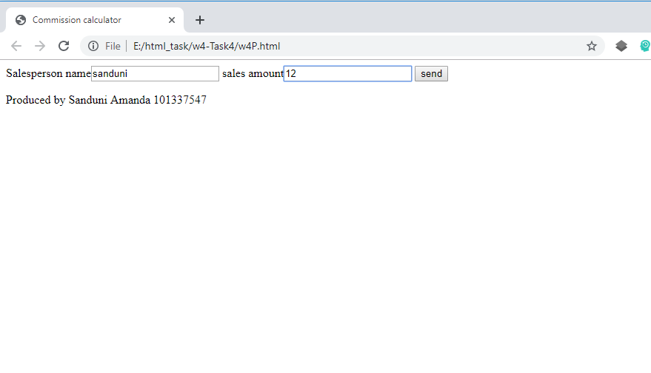

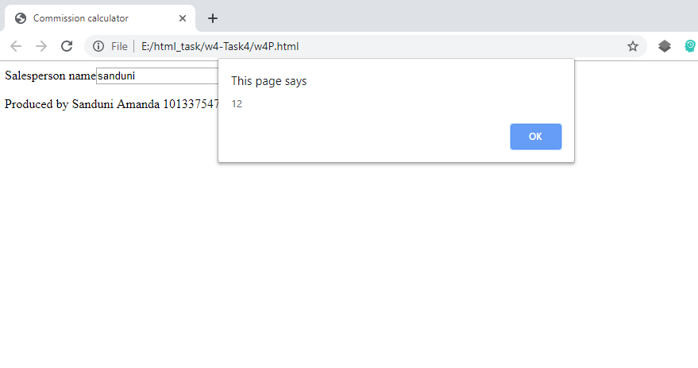

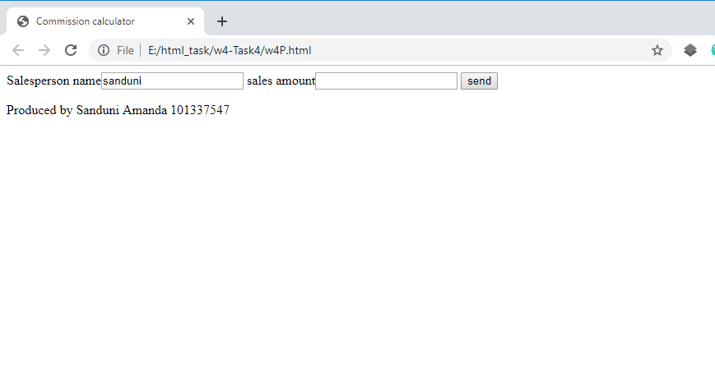

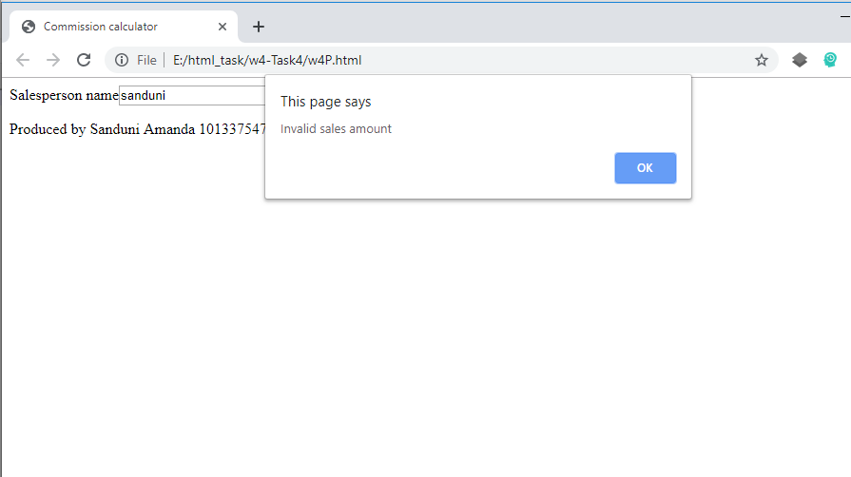

Content W4P.html

<!DOCTYPE html>

<html lang="en">

<head>

<meta charset="utf-8" />

<meta name="description" content="Pass level task" />

<meta name="keywords" content="Think which keywords!!!" />

<meta name="author" content="Sanduni Amanda 101337547" />

<title>Commission calculator</title>

</head>

<script src="w4P.js"></script>

<body>

<header>

</header>

<article>

<form>

<label>Salesperson name<input type="text" id="Salesperson name"/></label>

<label>sales amount<input type="text" id="sales amount"/></label>

<button type="button" id="check">send</button>

</form>

<p id="msg"></p>

</article>

<footer><p>Produced by Sanduni Amanda 101337547</p></footer>

</body>

</html>

Content w4P.js

/* Filename: [ name of this file…].js

Target html: [ what is the html file(s) linked to this js…]

Purpose : [ a html file may have multiple js files. What does this one do?…]

Author: [ your name…]

Date written: [ …]

Revisions: [ your name, what, when…]

*/

// [ brief comment on what the function does…]

function init() {

var btn = document.getElementById("check");

btn.onclick = processSales;

}

function calcCommission(saleAmt) {

var commRate;

if(saleAmt==0)

commRate=0;

if(saleAmt<=500000)

commRate=0.05

else if(500000<saleAmt<=15000000)

commRate=0.08

else

commRate=0.1

return commRate*saleAmt;

}

function processSales(){

var salesperson,sales,commission;

var salesperson = document.getElementById("Salesperson name").value;

var sales = document.getElementById("sales amount").value;

commission=calcCommission(sales)

if(commission==0)

alert("Invalid sales amount");

else

alert(commission.toFixed(2));

}

window.onload = init;