Swinburne University of Technology

Programming Concepts OnCampus Sem1 2019

Doubtfire Submission

**Task 4.5C**

*Submitted By:*

Sanduni Amanda Galhenage *Tutor:*

101337547 Somkiat Kitjongthawonkul

2019/05/21 11:11

May 21, 2019



Produced by Doubtfire

Programming Concepts

Week 5 CREDITSubmission Tasks Template

Student ID: _101337547____________________

Student Name: __Sanduni Amanda ____________________________

Pass Task 5HTML code page

Paste the HTML code of the web page here.

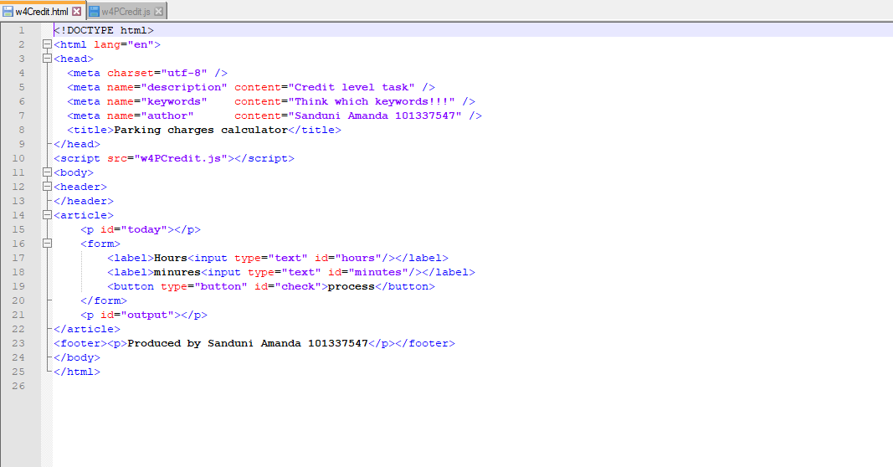

Pass Task 7 JavaScript code

Paste the JavaScript code of the same page here.

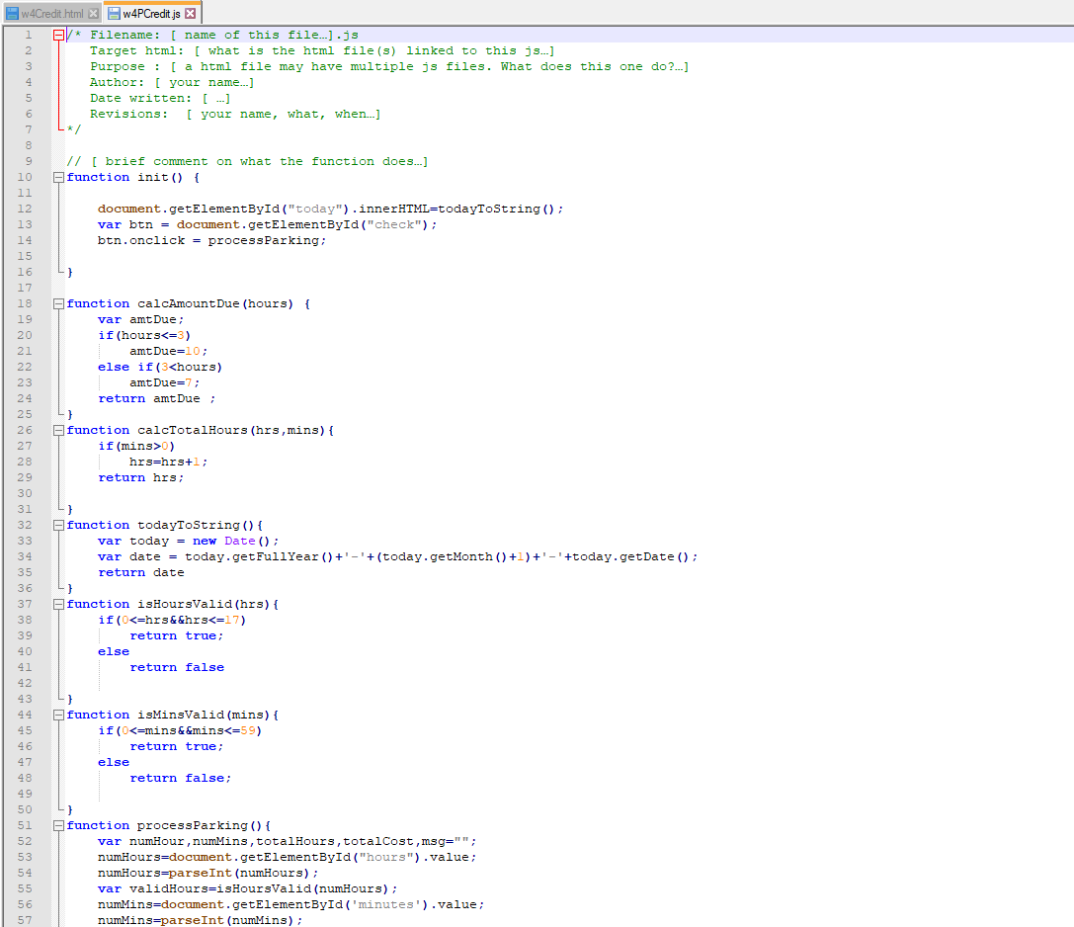

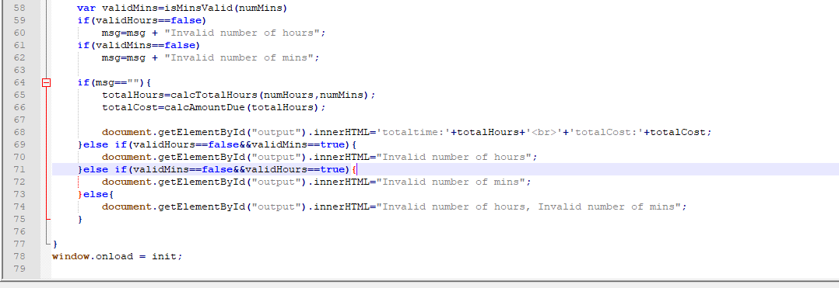

Pass Task 4 web page testing(**Valid hours, invalid minutes**)

Paste the screen captures of your testing web page here.

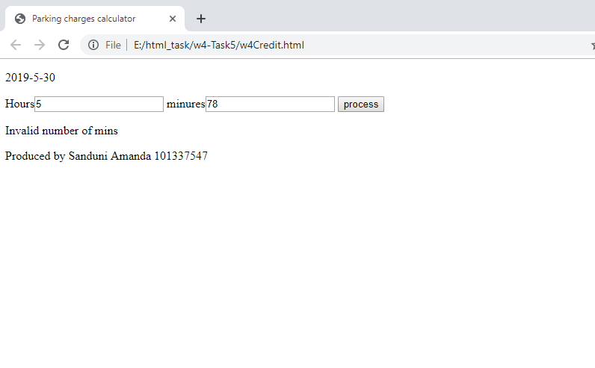

Pass Task 4 web page testing(**Invalid hours, valid minutes** )

Paste the screen captures of your testing web page here.

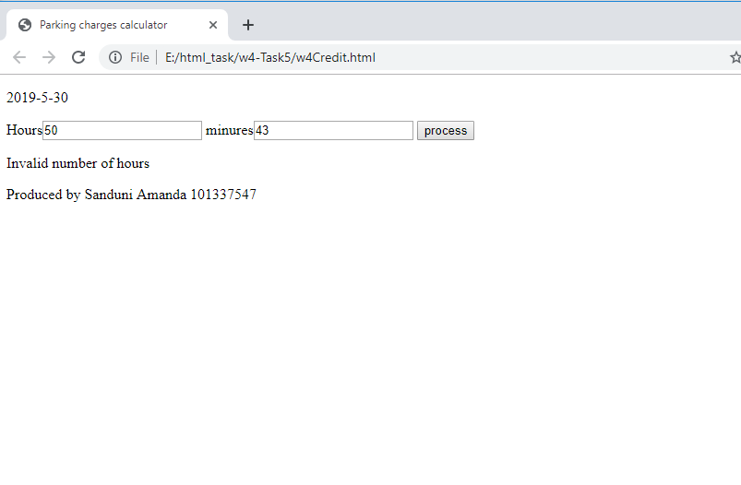

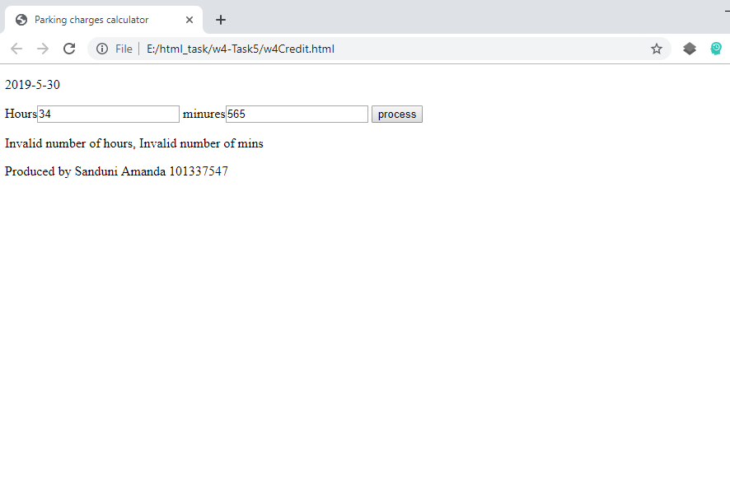

Content W4PCredit.html

<!DOCTYPE html>

<html lang="en">

<head>

<meta charset="utf-8" />

<meta name="description" content="Credit level task" />

<meta name="keywords" content="Think which keywords!!!" />

<meta name="author" content="Sanduni Amanda 101337547" />

<title>Parking charges calculator</title>

</head>

<script src="w4PCredit.js"></script>

<body>

<header>

</header>

<article>

<p id="today"></p>

<form>

<label>Hours<input type="text" id="hours"/></label>

<label>minures<input type="text" id="minutes"/></label>

<button type="button" id="check">process</button>

</form>

<p id="output"></p>

</article>

<footer><p>Produced by Sanduni Amanda 101337547</p></footer>

</body>

</html>

Content w4PCredit.js

/* Filename: [ name of this file…].js

Target html: [ what is the html file(s) linked to this js…]

Purpose : [ a html file may have multiple js files. What does this one do?…]

Author: [ your name…]

Date written: [ …]

Revisions: [ your name, what, when…]

*/

// [ brief comment on what the function does…]

function init() {

document.getElementById("today").innerHTML=todayToString();

var btn = document.getElementById("check");

btn.onclick = processParking;

}

function calcAmountDue(hours) {

var amtDue;

if(hours<=3)

amtDue=10;

else if(3<hours)

amtDue=7;

return amtDue ;

}

function calcTotalHours(hrs,mins){

if(mins>0)

hrs=hrs+1;

return hrs;

}

function todayToString(){

var today = new Date();

var date = today.getFullYear()+'-'+(today.getMonth()+1)+'-'+today.getDate();

return date

}

function isHoursValid(hrs){

if(0<=hrs&&hrs<=17)

return true;

else

return false

}

function isMinsValid(mins){

if(0<=mins&&mins<=59)

return true;

else

return false;

}

function processParking(){

var numHour,numMins,totalHours,totalCost,msg="";

numHours=document.getElementById("hours").value;

numHours=parseInt(numHours);

var validHours=isHoursValid(numHours);

numMins=document.getElementById('minutes').value;

numMins=parseInt(numMins);

var validMins=isMinsValid(numMins)

if(validHours==false)

msg=msg + "Invalid number of hours";

if(validMins==false)

msg=msg + "Invalid number of mins";

if(msg==""){

totalHours=calcTotalHours(numHours,numMins);

totalCost=calcAmountDue(totalHours);

document.getElementById("output").innerHTML='totaltime:'+totalHours+'<br>'+'totalCost:'+totalCost;

}else if(validHours==false&&validMins==true){

document.getElementById("output").innerHTML="Invalid number of hours";

}else if(validMins==false&&validHours==true){

document.getElementById("output").innerHTML="Invalid number of mins";

}else{

document.getElementById("output").innerHTML="Invalid number of hours, Invalid number of mins";

}

}

window.onload = init;