Swinburne University of Technology

Programming Concepts OnCampus Sem1 2019

Doubtfire Submission

**Task 5.14C**

*Submitted By:*

Sanduni Amanda Galhenage *Tutor:*

101337547 Somkiat Kitjongthawonkul

2019/05/21 11:11

May 21, 2019



Produced by Doubtfire

W5P2.html

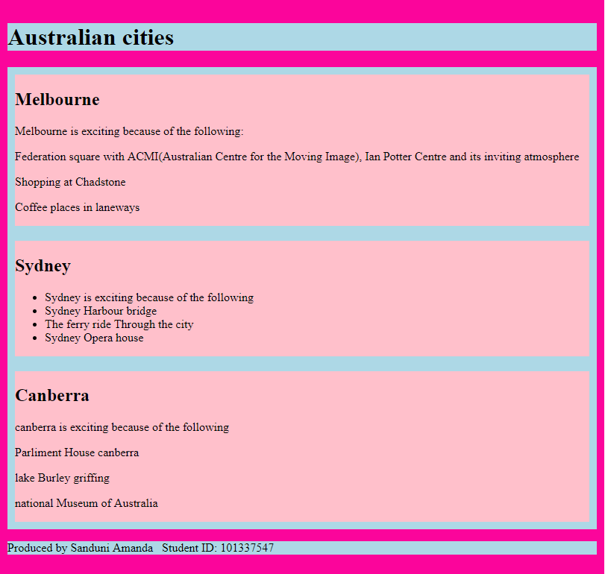

Content of W5P2.html

<!DOCTYPE html>

<html lang="en">

<head>

<meta charset="utf-8" />

<meta name="description" content="Provide description" />

<meta name="Melbourne, Canberra, Sydney" content="australiancities" />

<meta name="Sanduni" content="Sanduni" />

<title>Australian Cities</title>

</head>

<link rel="stylesheet" href="w5p2.css">

<body>

<div class="container">

<header>

<h1>Australian cities</h1>

</header>

<article>

<article class="flex-container">

<section class="flex-item">

<h2>Melbourne</h2>

<p>Melbourne is exciting because of the following:</p>

<p>Federation square with ACMI(Australian Centre for the Moving Image), Ian Potter Centre and its inviting atmosphere</p>

<p>Shopping at Chadstone</p>

<p>Coffee places in laneways</p>

</section>

<section class="flex-item">

<h2>Sydney</h2>

<ul>

<li>Sydney is exciting because of the following</li>

<li>Sydney Harbour bridge</li>

<li>The ferry ride Through the city</li>

<li>Sydney Opera house</li>

</ul>

</section>

<section class="flex-item">

<h2>Canberra</h2>

<p>canberra is exciting because of the following</p>

<p>Parliment House canberra</p>

<p>lake Burley griffing</p>

<p>national Museum of Australia</p>

</section>

</article>

</article>

<footer>

<p>Produced by Sanduni Amanda &nbsp; Student ID: 101337547</p>

</footer>

</div>

</body>

</html>

=============================================================

Content of w5p2.css

.container{

background-color: #fb059b;

padding: 10px;

margin-left: auto;

margin-right: auto;

margin-top: 30px;

}

@media screen and (min-width: 790px) {

.container{

width: 790px;

}

}

.flex-container {

display: flex;

background-color: lightblue;

flex-direction: column;

}

.flex-item {

background-color: pink;

margin: 10px;

}

header{

background-color: lightblue;

}

footer{

background-color: lightblue;

}

===============================================