Swinburne University of Technology

Programming Concepts OnCampus Sem1 2019

Doubtfire Submission

**Task 5.4C**

*Submitted By:*

Sanduni Amanda Galhenage *Tutor:*

101337547 Somkiat Kitjongthawonkul

2019/05/21 11:11

May 21, 2019



Produced by Doubtfire

Programming Concepts

Week 5 **CREDIT** Submission Tasks Template

Student ID: _101337547____________________

Student Name: __Sanduni Amanda ____________________________

Pass Task 4 HTML code page

Paste the HTML code of the web page here.

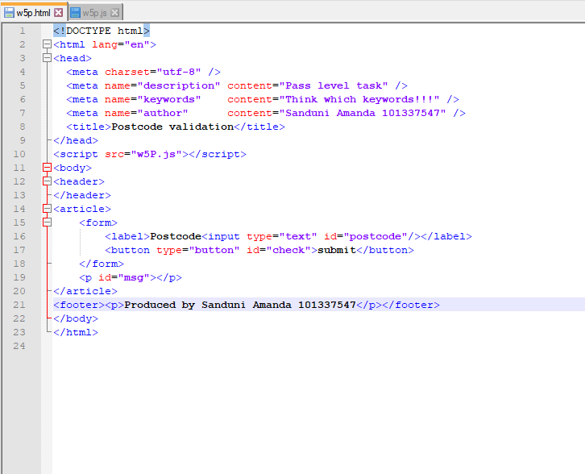

Pass Task 4 JavaScript code

Paste the JavaScript code of the same page here.

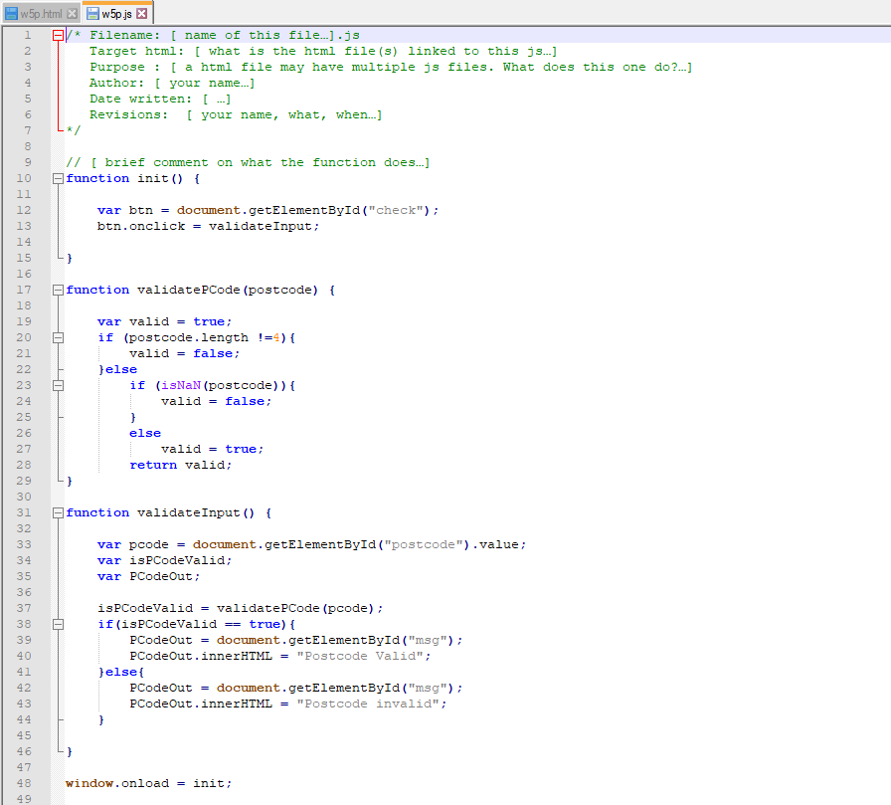

Pass Task 4 web page testing (all digits but less than 4 characters)

Paste the screen captures of your testing web page here.

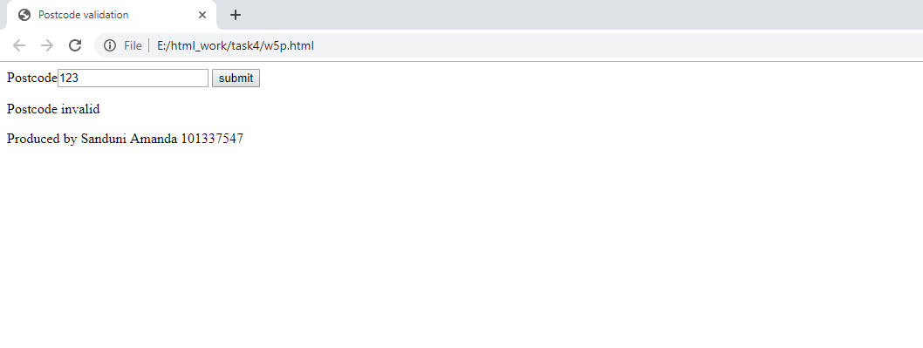

Pass Task 4 web page testing (exactly 4 characters but not only digits)

Paste the screen captures of your testing web page here.

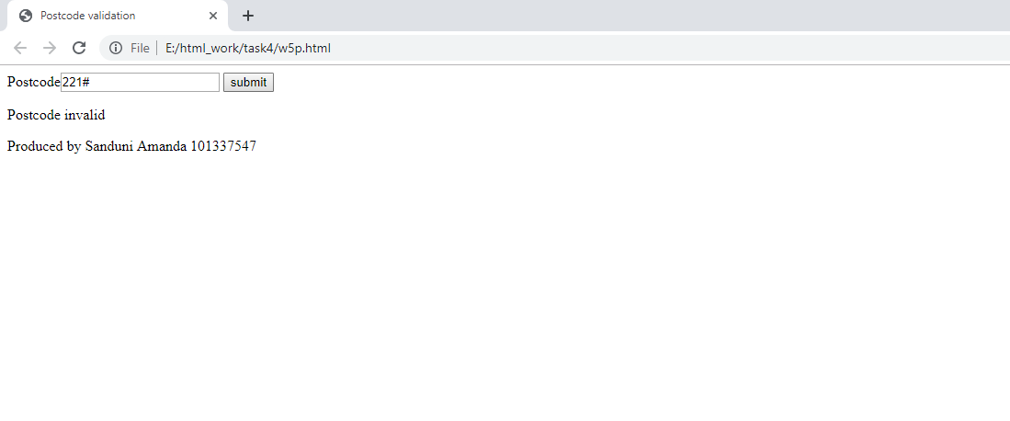

Pass Task 4 web page testing (all digits and exactly 4 characters)

Paste the screen captures of your testing web page here.

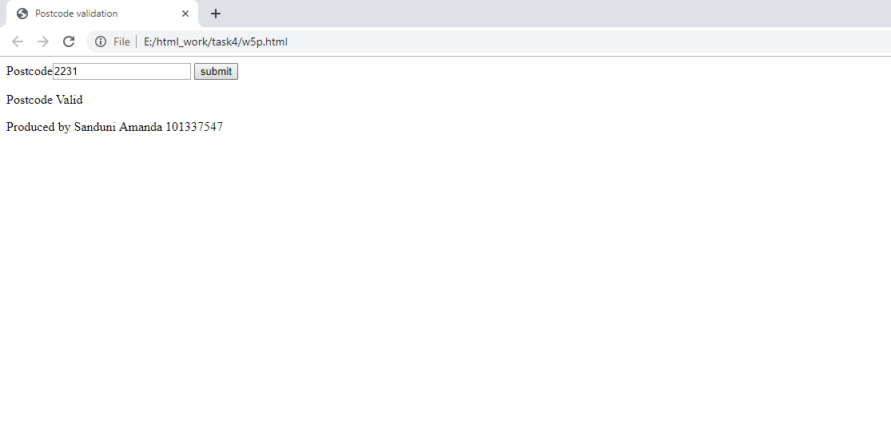

Content w5p.html

<!DOCTYPE html>

<html lang="en">

<head>

<meta charset="utf-8" />

<meta name="description" content="Pass level task" />

<meta name="keywords" content="Think which keywords!!!" />

<meta name="author" content="Sanduni Amanda 101337547" />

<title>Postcode validation</title>

</head>

<script src="w5P.js"></script>

<body>

<header>

</header>

<article>

<form>

<label>Postcode<input type="text" id="postcode"/></label>

<button type="button" id="check">submit</button>

</form>

<p id="msg"></p>

</article>

<footer><p>Produced by Sanduni Amanda 101337547</p></footer>

</body>

</html>

Content w5p.js

function init() {

var btn = document.getElementById("check");

btn.onclick = validateInput;

}

function validatePCode(postcode) {

var valid = true;

if (postcode.length !=4){

valid = false;

}else

if (isNaN(postcode)){

valid = false;

}

else

valid = true;

return valid;

}

function validateInput() {

var pcode = document.getElementById("postcode").value;

var isPCodeValid;

var PCodeOut;

isPCodeValid = validatePCode(pcode);

if(isPCodeValid == true){

PCodeOut = document.getElementById("msg");

PCodeOut.innerHTML = "Postcode Valid";

}else{

PCodeOut = document.getElementById("msg");

PCodeOut.innerHTML = "Postcode invalid";

}

}

window.onload = init;