Swinburne University of Technology

Programming Concepts OnCampus Sem1 2019

Doubtfire Submission

**Task 5.5P**

*Submitted By:*

Sanduni Amanda Galhenage *Tutor:*

101337547 Somkiat Kitjongthawonkul

2019/05/21 11:11

May 21, 2019



Produced by Doubtfire

Programming Concepts

Week 5 **Pass** Submission Tasks Template

Student ID: _101337547____________________

Student Name: __Sanduni Amanda ____________________________

Pass Task 5 HTML code page

Paste the HTML code of the web page here.

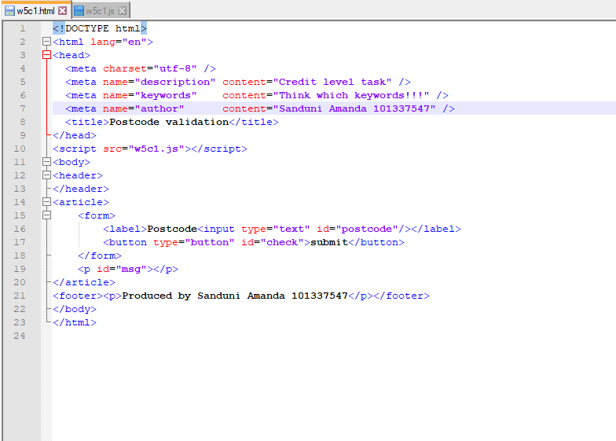

Pass Task 5 JavaScript code

Paste the JavaScript code of the same page here.

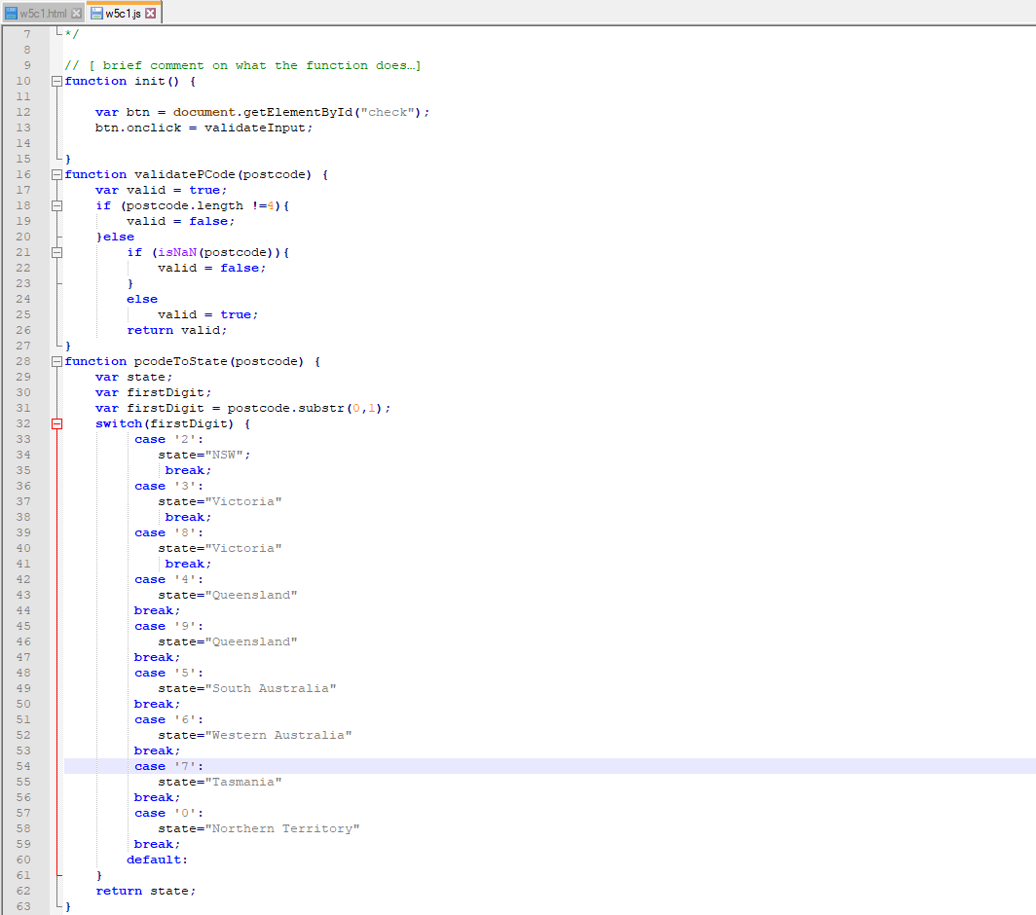

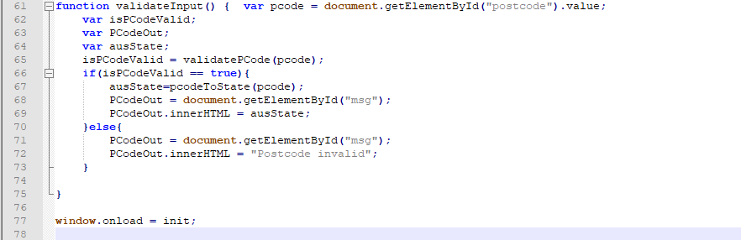

Pass Task 5 web page testing (At least one value resulting in the error message)

Paste the screen captures of your testing web page here.

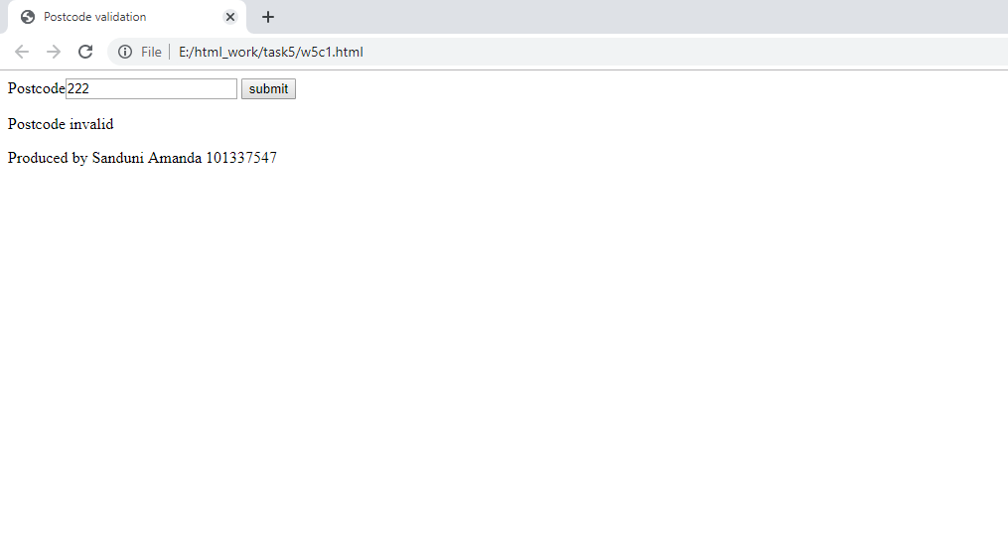

Pass Task 5 web page testing (

Every first digit option resulting in every state or territory (total 9 screenshots of valid inputs)

)

Paste the screen captures of your testing web page here.

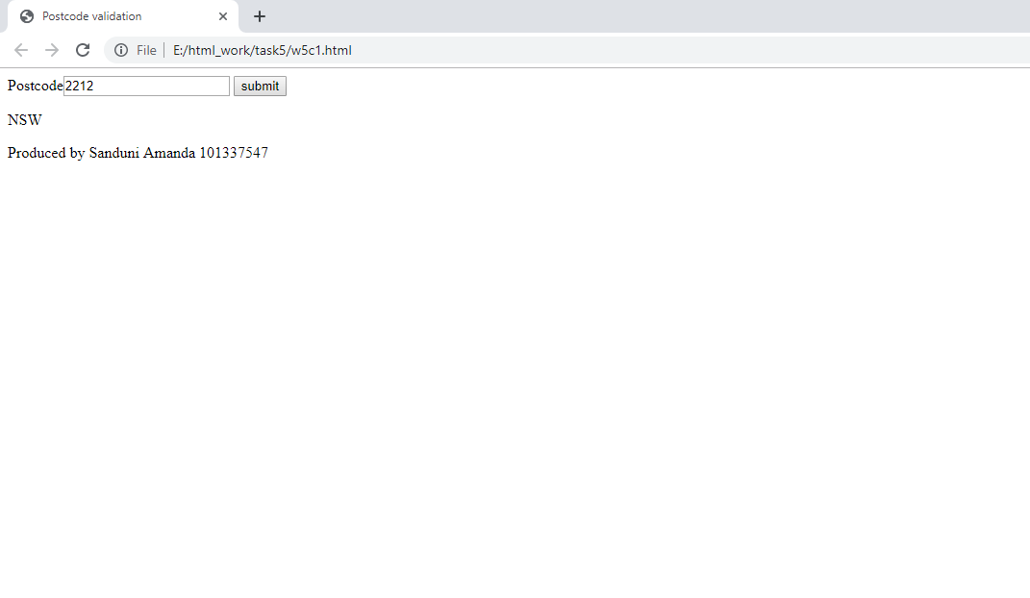

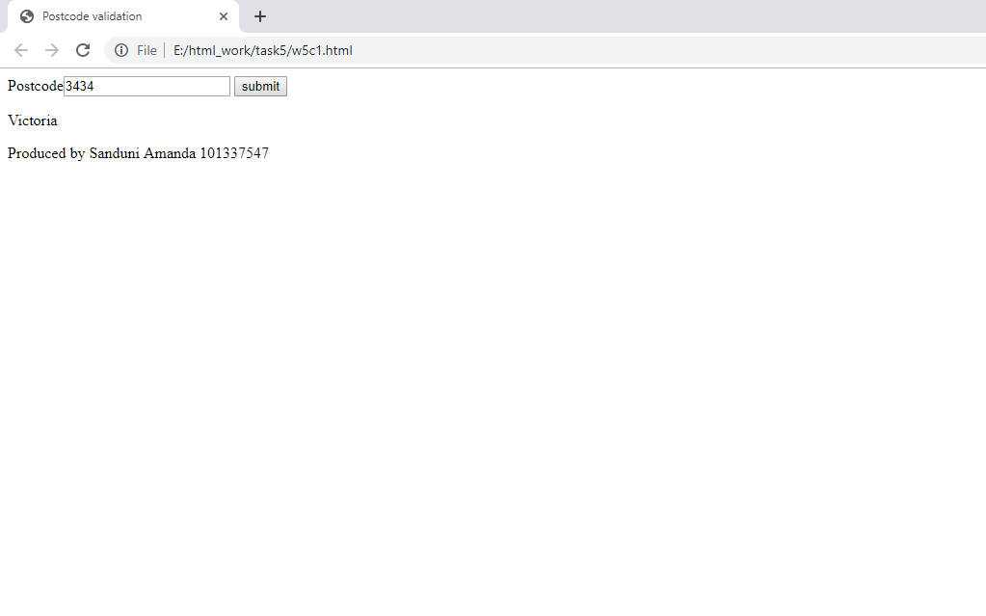

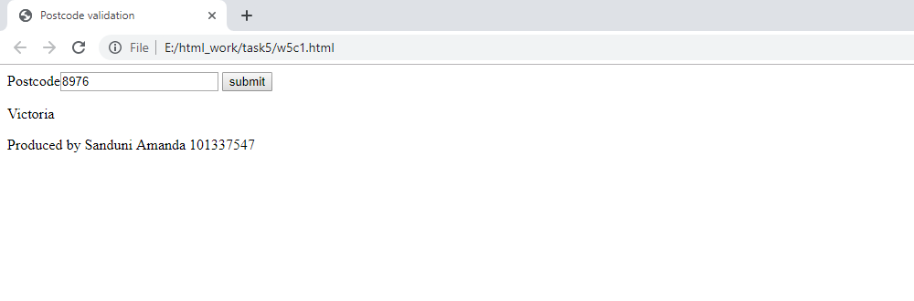

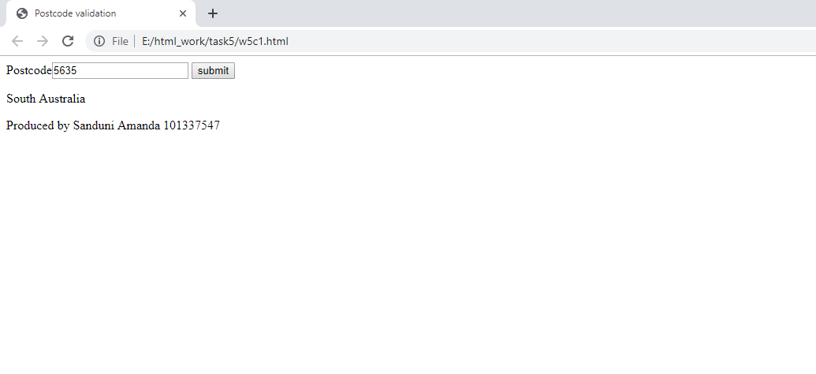

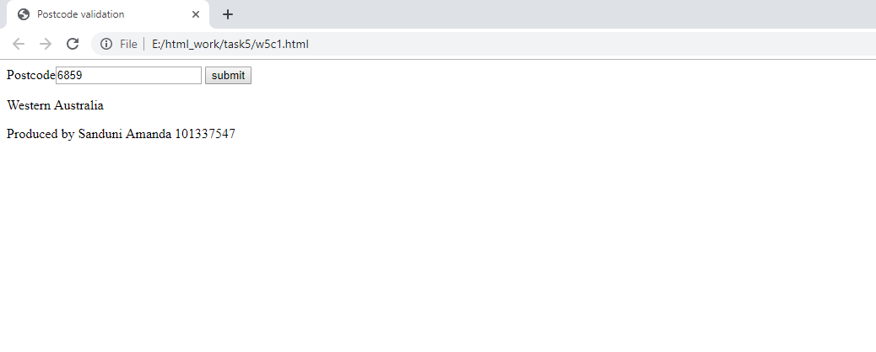

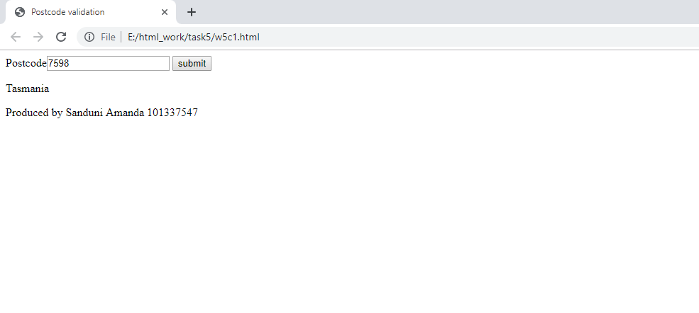

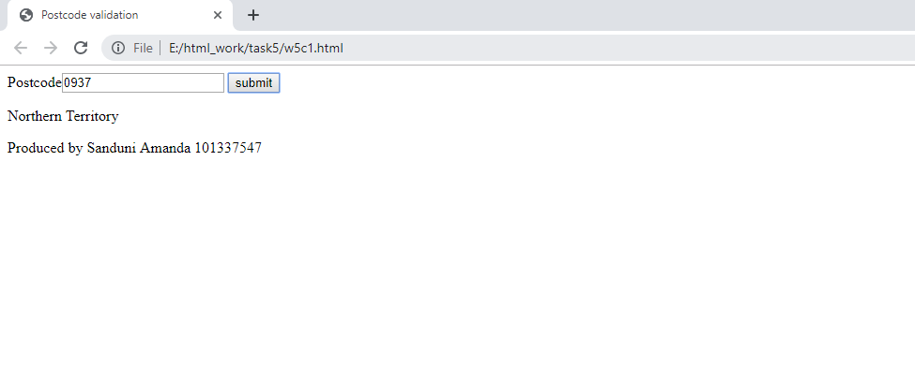

Content w5c1.html

<!DOCTYPE html>

<html lang="en">

<head>

<meta charset="utf-8" />

<meta name="description" content="Credit level task" />

<meta name="keywords" content="Think which keywords!!!" />

<meta name="author" content="Sanduni Amanda 101337547" />

<title>Postcode validation</title>

</head>

<script src="w5c1.js"></script>

<body>

<header>

</header>

<article>

<form>

<label>Postcode<input type="text" id="postcode"/></label>

<button type="button" id="check">submit</button>

</form>

<p id="msg"></p>

</article>

<footer><p>Produced by Sanduni Amanda 101337547</p></footer>

</body>

</html>

Content w5c1.js

function init() {

var btn = document.getElementById("check");

btn.onclick = validateInput;

}

function validatePCode(postcode) {

var valid = true;

if (postcode.length !=4){

valid = false;

}else

if (isNaN(postcode)){

valid = false;

}

else

valid = true;

return valid;

}

function pcodeToState(postcode) {

var state;

var firstDigit;

var firstDigit = postcode.substr(0,1);

switch(firstDigit) {

case '2':

state="NSW";

break;

case '3':

state="Victoria"

break;

case '8':

state="Victoria"

break;

case '4':

state="Queensland"

break;

case '9':

state="Queensland"

break;

case '5':

state="South Australia"

break;

case '6':

state="Western Australia"

break;

case '7':

state="Tasmania"

break;

case '0':

state="Northern Territory"

break;

default:

}

return state;

}

function validateInput() {

var pcode = document.getElementById("postcode").value;

var isPCodeValid;

var PCodeOut;

var ausState;

isPCodeValid = validatePCode(pcode);

if(isPCodeValid == true){

ausState=pcodeToState(pcode);

PCodeOut = document.getElementById("msg");

PCodeOut.innerHTML = ausState;

}else{

PCodeOut = document.getElementById("msg");

PCodeOut.innerHTML = "Postcode invalid";

}

}

window.onload = init;