Swinburne University of Technology

Programming Concepts OnCampus Sem1 2019

Doubtfire Submission

**Task 5.6C**

*Submitted By:*

Sanduni Amanda Galhenage *Tutor:*

101337547 Somkiat Kitjongthawonkul

2019/05/21 11:11

May 21, 2019



Produced by Doubtfire

Programming Concepts

Week 5 **CREDIT** Submission Tasks Template

Student ID: _101337547____________________

Student Name: __Sanduni Amanda ____________________________

Pass Task 6 HTML code page

Paste the HTML code of the web page here.

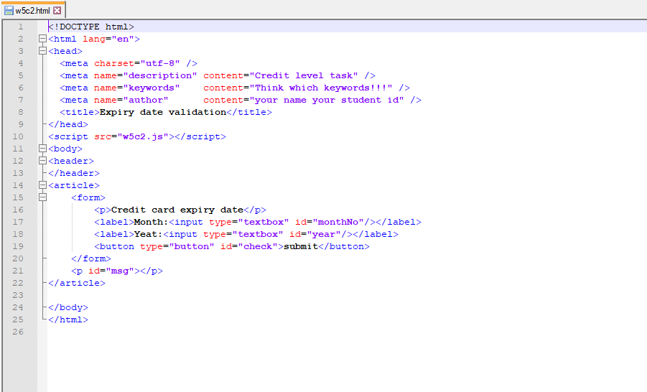

Pass Task 6 JavaScript code

Paste the JavaScript code of the same page here.

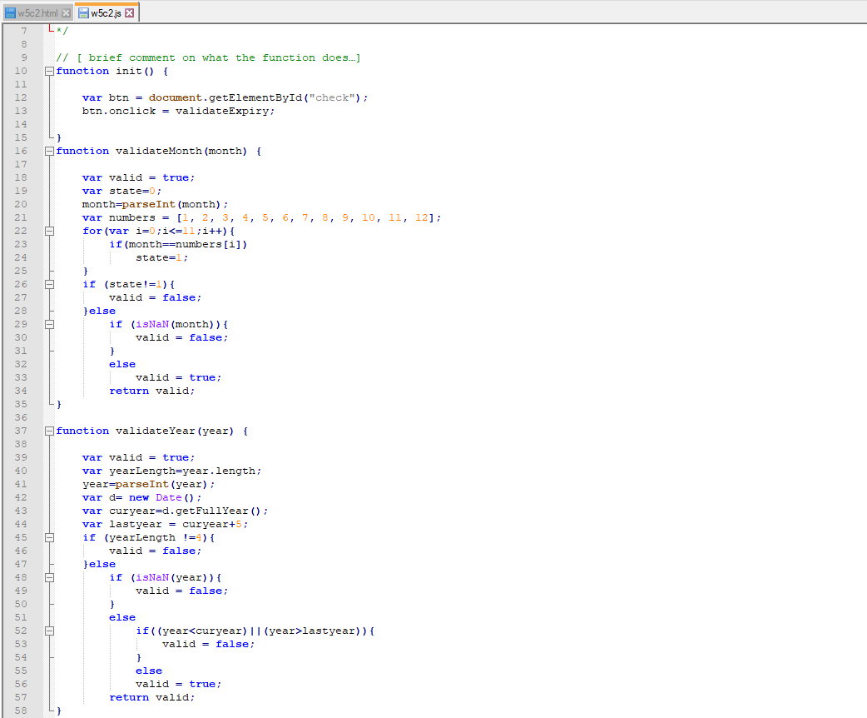

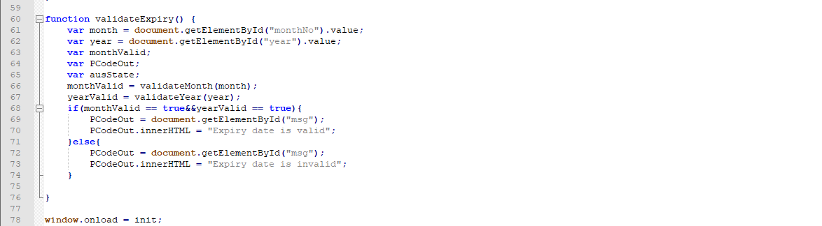

Pass Task 6 web page testing (month and year exactly )

Paste the screen captures of your testing web page here.

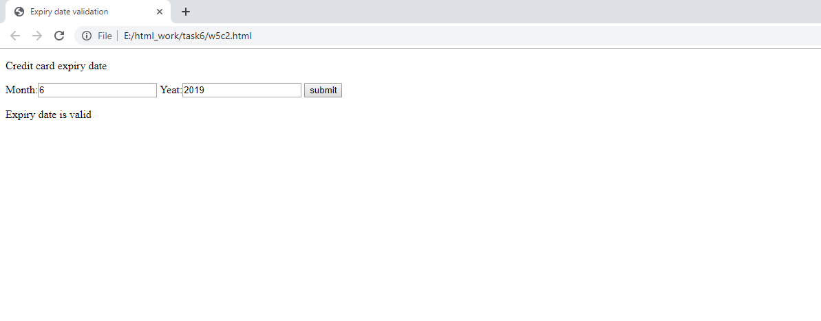

Pass Task 4 web page testing (year and month don’t exactly)

Paste the screen captures of your testing web page here.

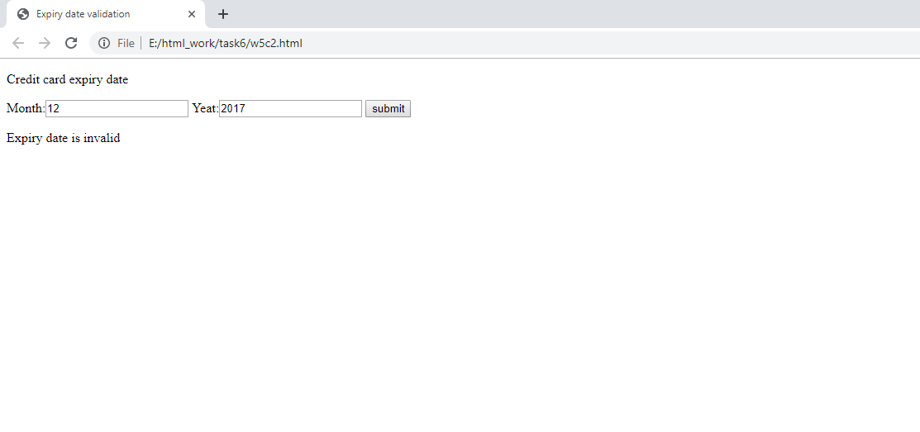

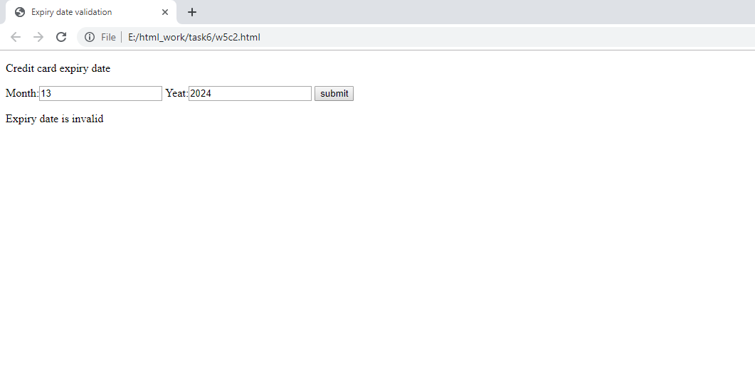

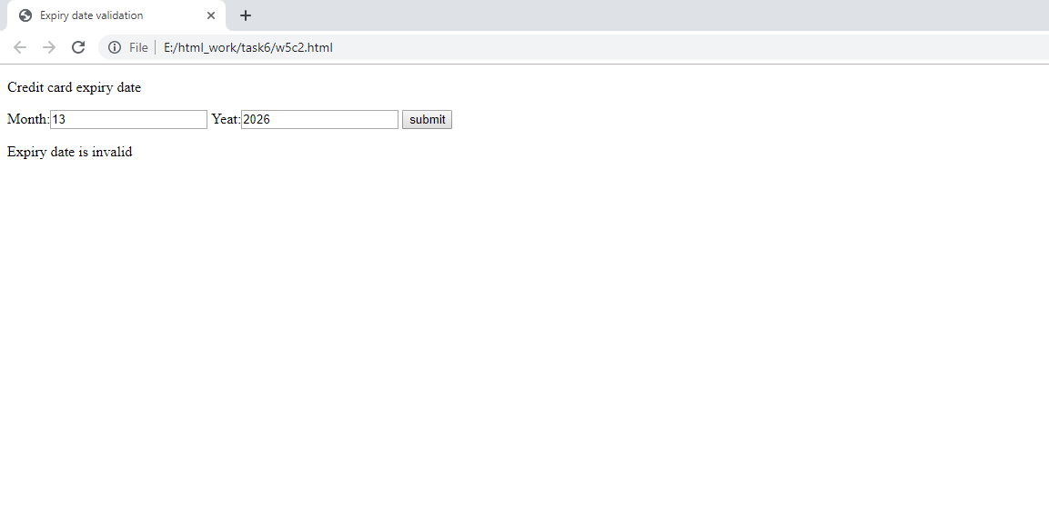

Content w5c2.html

<!DOCTYPE html>

<html lang="en">

<head>

<meta charset="utf-8" />

<meta name="description" content="Credit level task" />

<meta name="keywords" content="Think which keywords!!!" />

<meta name="author" content="your name your student id" />

<title>Expiry date validation</title>

</head>

<script src="w5c2.js"></script>

<body>

<header>

</header>

<article>

<form>

<p>Credit card expiry date</p>

<label>Month:<input type="textbox" id="monthNo"/></label>

<label>Yeat:<input type="textbox" id="year"/></label>

<button type="button" id="check">submit</button>

</form>

<p id="msg"></p>

</article>

</body>

</html>

Content w5c2.js

function init() {

var btn = document.getElementById("check");

btn.onclick = validateExpiry;

}

function validateMonth(month) {

var valid = true;

var state=0;

month=parseInt(month);

var numbers = [1, 2, 3, 4, 5, 6, 7, 8, 9, 10, 11, 12];

for(var i=0;i<=11;i++){

if(month==numbers[i])

state=1;

}

if (state!=1){

valid = false;

}else

if (isNaN(month)){

valid = false;

}

else

valid = true;

return valid;

}

function validateYear(year) {

var valid = true;

var yearLength=year.length;

year=parseInt(year);

var d= new Date();

var curyear=d.getFullYear();

var lastyear = curyear+5;

if (yearLength !=4){

valid = false;

}else

if (isNaN(year)){

valid = false;

}

else

if((year<curyear)||(year>lastyear)){

valid = false;

}

else

valid = true;

return valid;

}

function validateExpiry() {

var month = document.getElementById("monthNo").value;

var year = document.getElementById("year").value;

var monthValid;

var PCodeOut;

var ausState;

monthValid = validateMonth(month);

yearValid = validateYear(year);

if(monthValid == true&&yearValid == true){

PCodeOut = document.getElementById("msg");

PCodeOut.innerHTML = "Expiry date is valid";

}else{

PCodeOut = document.getElementById("msg");

PCodeOut.innerHTML = "Expiry date is invalid";

}

}

window.onload = init;