Swinburne University of Technology

Programming Concepts OnCampus Sem1 2019

Doubtfire Submission

**Task 8.11C**

*Submitted By:*

Sanduni Amanda Galhenage *Tutor:*

101337547 Somkiat Kitjongthawonkul

2019/05/21 11:11

May 21, 2019



Produced by Doubtfire

Programming Concepts

Week 8 CreditSubmission Tasks Template

Student ID: _101337547____________________

Student Name: __Sanduni Amanda ____________________________

Credt Task 5HTML code page

Paste the HTML code of the web page here.

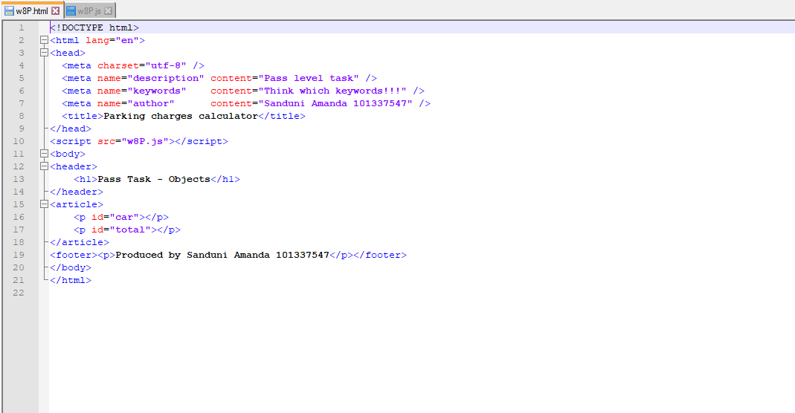

Credt Task 11 JavaScript code

Paste the JavaScript code of the same page here.

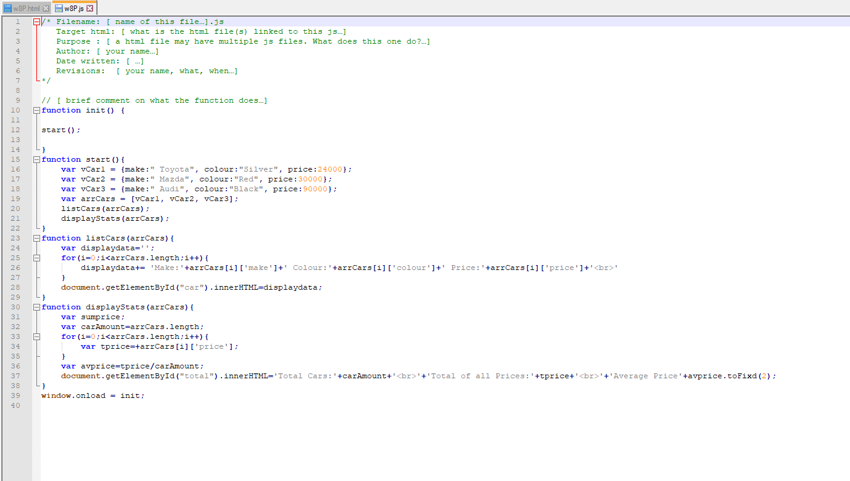

Pass Task 10 web page testing

Paste the screen captures of your testing web page here.

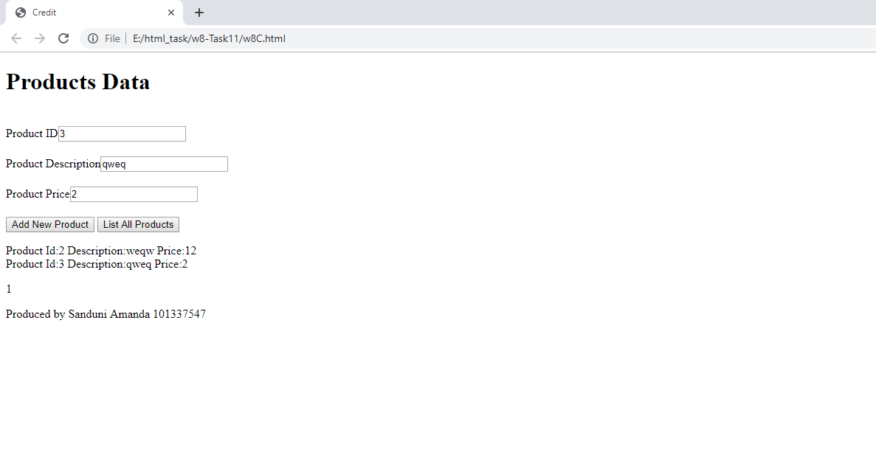

Content W8C.html

<!DOCTYPE html>

<html lang="en">

<head>

<meta charset="utf-8" />

<meta name="description" content="Credit level task" />

<meta name="keywords" content="Think which keywords!!!" />

<meta name="author" content="Sanduni Amanda 101337547" />

<title>Credit</title>

</head>

<script src="w8C.js"></script>

<body>

<header>

<h1>Products Data</h1>

</header>

<article>

<form>

<div style="padding-top:20px">

<label class="name">Product ID<input type="text" id="id"/></label>

</div>

<div style="padding-top:20px">

<label class="name">Product Description<input type="text" id="description"/></label>

</div>

<div style="padding-top:20px;padding-bottom: 20px">

<label class="name">Product Price<input type="text" id="price"/></label>

</div>

<button type="button" id="new">Add New Product</button>

<button type="button" id="list">List All Products</button>

</form>

<p id='output'></p>

<p id='count'></p>

</article>

<footer><p>Produced by Sanduni Amanda 101337547</p></footer>

</body>

</html>

Content w8C.js

/* Filename: [ name of this file…].js

Target html: [ what is the html file(s) linked to this js…]

Purpose : [ a html file may have multiple js files. What does this one do?…]

Author: [ your name…]

Date written: [ …]

Revisions: [ your name, what, when…]

*/

// [ brief comment on what the function does…]

//var garrProducts=array();

var garrProducts = [];

function init() {

var btn = document.getElementById("new");

btn.onclick = addProduct;

var list_btn = document.getElementById("list");

list_btn.onclick = listProducts;

}

function addProduct(){

var id = document.getElementById("id").value;

var description = document.getElementById("description").value;

var price = document.getElementById("price").value;

var data={id:"",description:"",price:""};

data['id']=id;

data['description']=description;

data['price']=price;

garrProducts.push(data);

}

function listProducts(){

document.getElementById("output").innerHTM="";

var displaydata='';

for(i=0;i<garrProducts.length;i++){

displaydata+= 'Product Id:'+garrProducts[i]['id']+' Description:'+garrProducts[i]['description']+' Price:'+garrProducts[i]['price']+'<br>'

}

document.getElementById("output").innerHTML=displaydata;

document.getElementById("count").innerHTML="Number of items under $5:"+countCheap();

}

function countCheap(){

var count=0;

for(i=0;i<garrProducts.length;i++){

if(garrProducts[i]['price']<=5){

count++;

}

}

return count;

}

window.onload = init;