Swinburne University of Technology

Programming Concepts OnCampus Sem1 2019

Doubtfire Submission

**Task 8.10P**

*Submitted By:*

Sanduni Amanda Galhenage *Tutor:*

101337547 Somkiat Kitjongthawonkul

2019/05/21 11:11

May 21, 2019



Produced by Doubtfire

Programming Concepts

Week 8 PassSubmission Tasks Template

Student ID: _101337547____________________

Student Name: __Sanduni Amanda ____________________________

Pass Task 5HTML code page

Paste the HTML code of the web page here.

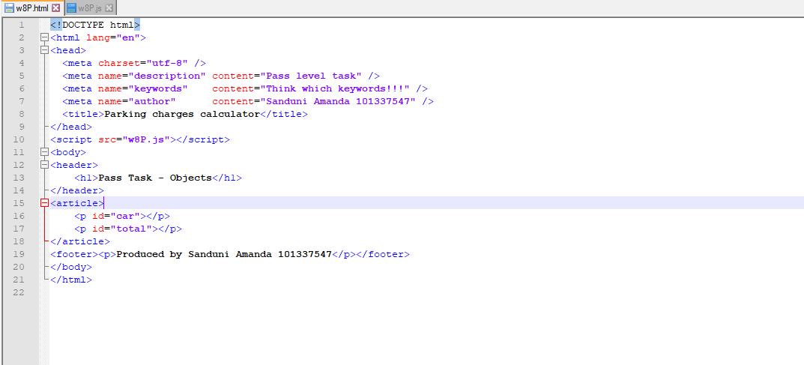

Pass Task 10 JavaScript code

Paste the JavaScript code of the same page here.

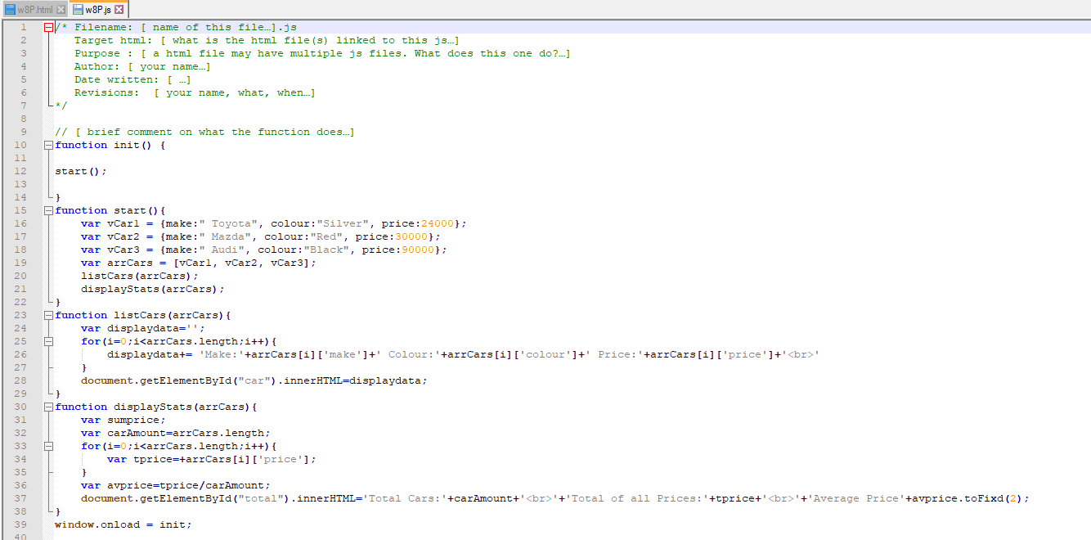

Pass Task 10 web page testing

Paste the screen captures of your testing web page here.

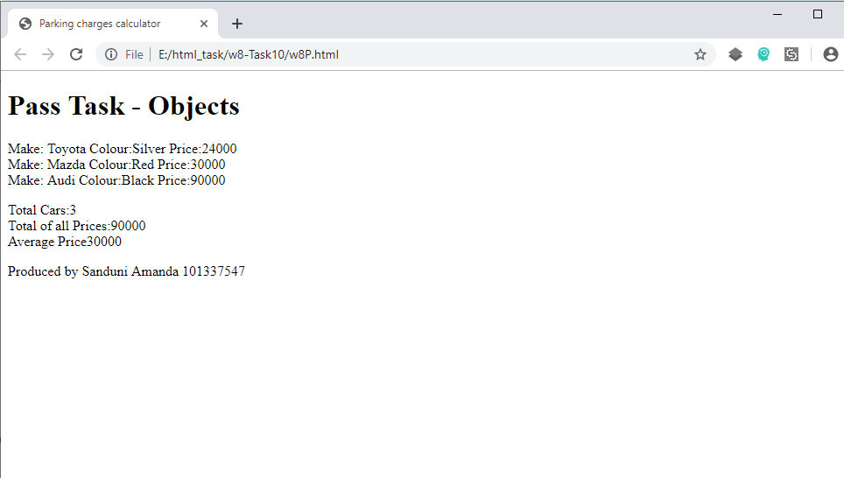

Content W8P.html

<!DOCTYPE html>

<html lang="en">

<head>

<meta charset="utf-8" />

<meta name="description" content="Pass level task" />

<meta name="keywords" content="Think which keywords!!!" />

<meta name="author" content="Sanduni Amanda 101337547" />

<title>Parking charges calculator</title>

</head>

<script src="w8P.js"></script>

<body>

<header>

<h1>Pass Task - Objects</h1>

</header>

<article>

<p id="car"></p>

<p id="total"></p>

</article>

<footer><p>Produced by Sanduni Amanda 101337547</p></footer>

</body>

</html>

Content w8P.js

/* Filename: [ name of this file…].js

Target html: [ what is the html file(s) linked to this js…]

Purpose : [ a html file may have multiple js files. What does this one do?…]

Author: [ your name…]

Date written: [ …]

Revisions: [ your name, what, when…]

*/

// [ brief comment on what the function does…]

function init() {

start();

}

function start(){

var vCar1 = {make:" Toyota", colour:"Silver", price:24000};

var vCar2 = {make:" Mazda", colour:"Red", price:30000};

var vCar3 = {make:" Audi", colour:"Black", price:90000};

var arrCars = [vCar1, vCar2, vCar3];

listCars(arrCars);

displayStats(arrCars);

}

function listCars(arrCars){

var displaydata='';

for(i=0;i<arrCars.length;i++){

displaydata+= 'Make:'+arrCars[i]['make']+' Colour:'+arrCars[i]['colour']+' Price:'+arrCars[i]['price']+'<br>'

}

document.getElementById("car").innerHTML=displaydata;

}

function displayStats(arrCars){

var sumprice;

var carAmount=arrCars.length;

for(i=0;i<arrCars.length;i++){

var tprice=+arrCars[i]['price'];

}

var avprice=tprice/carAmount;

document.getElementById("total").innerHTML='Total Cars:'+carAmount+'<br>'+'Total of all Prices:'+tprice+'<br>'+'Average Price'+avprice.toFixd(2);

}

window.onload = init;