Swinburne University of Technology

Programming Concepts OnCampus Sem1 2019

Doubtfire Submission

**Task 9.10C**

*Submitted By:*

Sanduni Amanda Galhenage *Tutor:*

101337547 Somkiat Kitjongthawonkul

2019/05/21 11:11

May 21, 2019



Produced by Doubtfire

Programming Concepts

Week 9 CreditSubmission Tasks Template

Student ID: _101337547____________________

Student Name: __Sanduni Amanda ____________________________

Credit Task 10HTML code page

Paste the HTML code of the web page here.

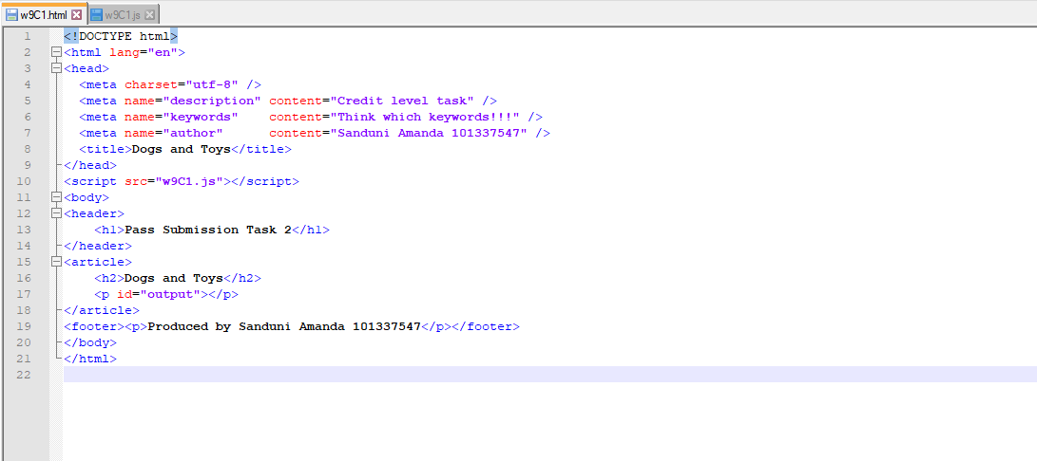

Credit Task 10 JavaScript code

Paste the JavaScript code of the same page here.

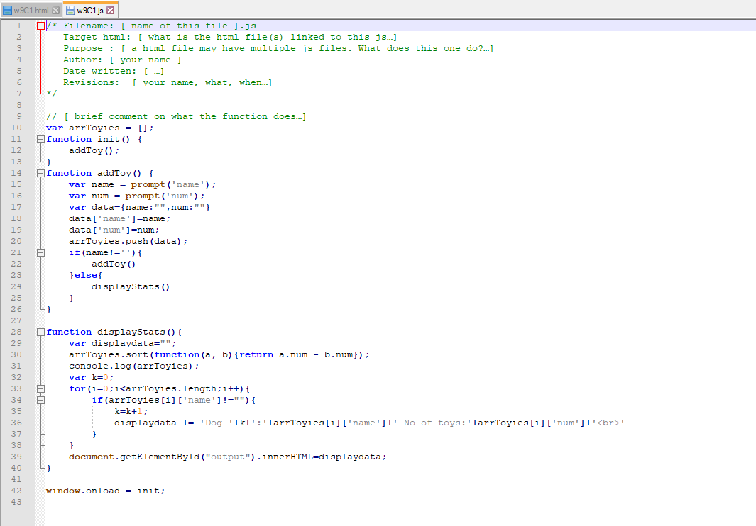

Credit Task 10 web page testing

Paste the screen captures of your testing web page here.

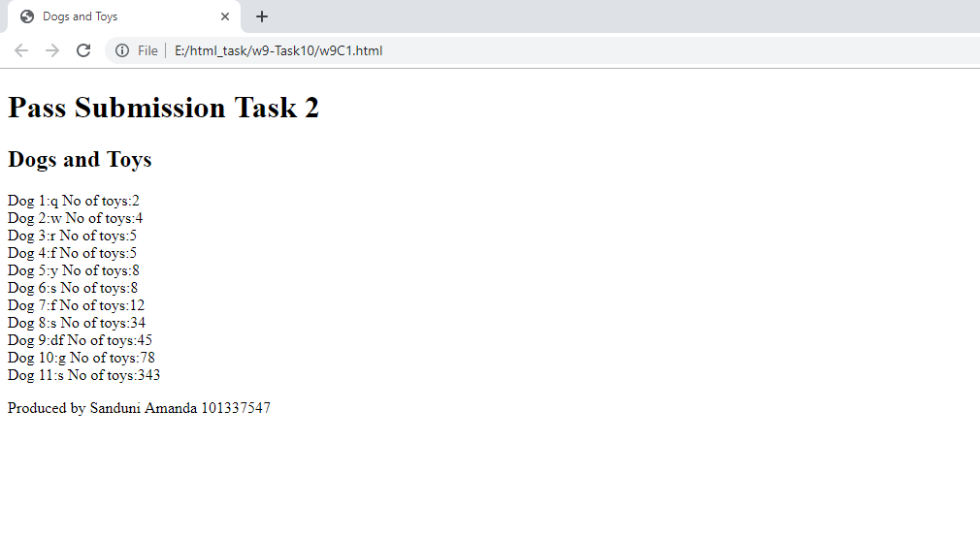

Content W9C1.html

<!DOCTYPE html>

<html lang="en">

<head>

<meta charset="utf-8" />

<meta name="description" content="Credit level task" />

<meta name="keywords" content="Think which keywords!!!" />

<meta name="author" content="Sanduni Amanda 101337547" />

<title>Dogs and Toys</title>

</head>

<script src="w9C1.js"></script>

<body>

<header>

<h1>Pass Submission Task 2</h1>

</header>

<article>

<h2>Dogs and Toys</h2>

<p id="output"></p>

</article>

<footer><p>Produced by Sanduni Amanda 101337547</p></footer>

</body>

</html>

Content w9C1.js

/* Filename: [ name of this file…].js

Target html: [ what is the html file(s) linked to this js…]

Purpose : [ a html file may have multiple js files. What does this one do?…]

Author: [ your name…]

Date written: [ …]

Revisions: [ your name, what, when…]

*/

// [ brief comment on what the function does…]

var arrToyies = [];

function init() {

addToy();

}

function addToy() {

var name = prompt('name');

var num = prompt('num');

var data={name:"",num:""}

data['name']=name;

data['num']=num;

arrToyies.push(data);

if(name!=''){

addToy()

}else{

displayStats()

}

}

function displayStats(){

var displaydata="";

arrToyies.sort(function(a, b){return a.num - b.num});

console.log(arrToyies);

var k=0;

for(i=0;i<arrToyies.length;i++){

if(arrToyies[i]['name']!=""){

k=k+1;

displaydata += 'Dog '+k+':'+arrToyies[i]['name']+' No of toys:'+arrToyies[i]['num']+'<br>'

}

}

document.getElementById("output").innerHTML=displaydata;

}

window.onload = init;