Swinburne University of Technology

Programming Concepts OnCampus Sem1 2019

Doubtfire Submission

**Task 9.4P**

*Submitted By:*

Sanduni Amanda Galhenage *Tutor:*

101337547 Somkiat Kitjongthawonkul

2019/05/21 11:11

May 21, 2019



Produced by Doubtfire

Programming Concepts

Week 9 PassSubmission Tasks Template

Student ID: _101337547____________________

Student Name: __Sanduni Amanda ____________________________

Pass Task 4HTML code page

Paste the HTML code of the web page here.

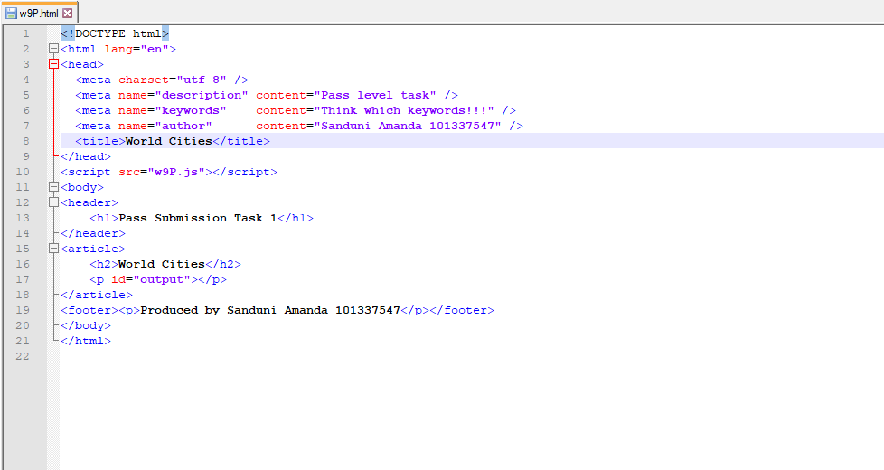

Pass Task 4 JavaScript code

Paste the JavaScript code of the same page here.

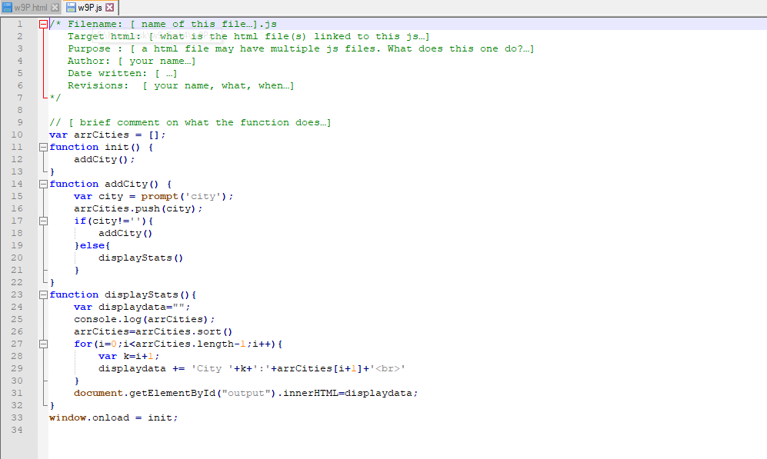

Pass Task 4 web page testing

Paste the screen captures of your testing web page here.

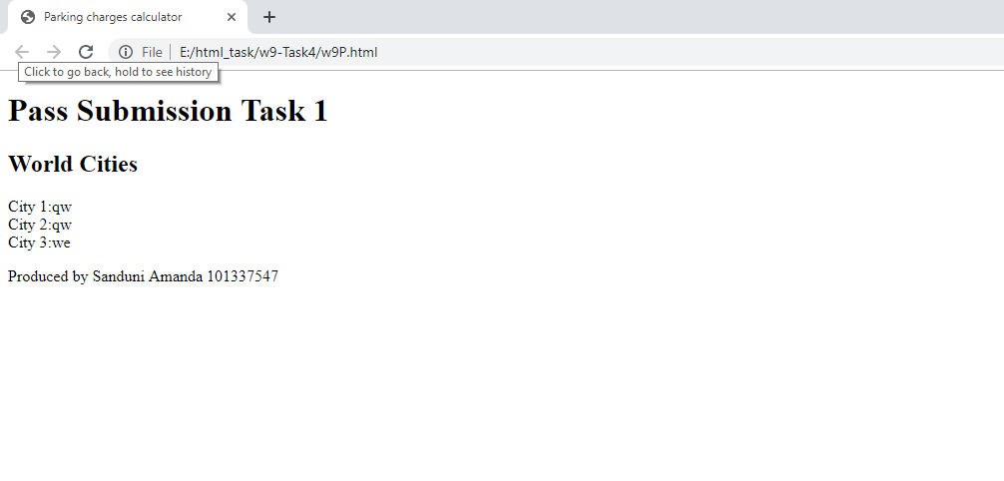

Content W9P.html

<!DOCTYPE html>

<html lang="en">

<head>

<meta charset="utf-8" />

<meta name="description" content="Pass level task" />

<meta name="keywords" content="Think which keywords!!!" />

<meta name="author" content="Sanduni Amanda 101337547" />

<title>World Cities</title>

</head>

<script src="w9P.js"></script>

<body>

<header>

<h1>Pass Submission Task 1</h1>

</header>

<article>

<h2>World Cities</h2>

<p id="output"></p>

</article>

<footer><p>Produced by Sanduni Amanda 101337547</p></footer>

</body>

</html>

Content w9P.js

/* Filename: [ name of this file…].js

Target html: [ what is the html file(s) linked to this js…]

Purpose : [ a html file may have multiple js files. What does this one do?…]

Author: [ your name…]

Date written: [ …]

Revisions: [ your name, what, when…]

*/

// [ brief comment on what the function does…]

var arrCities = [];

function init() {

addCity();

}

function addCity() {

var city = prompt('city');

arrCities.push(city);

if(city!=''){

addCity()

}else{

displayStats()

}

}

function displayStats(){

var displaydata="";

console.log(arrCities);

arrCities=arrCities.sort()

for(i=0;i<arrCities.length-1;i++){

var k=i+1;

displaydata += 'City '+k+':'+arrCities[i+1]+'<br>'

}

document.getElementById("output").innerHTML=displaydata;

}

window.onload = init;